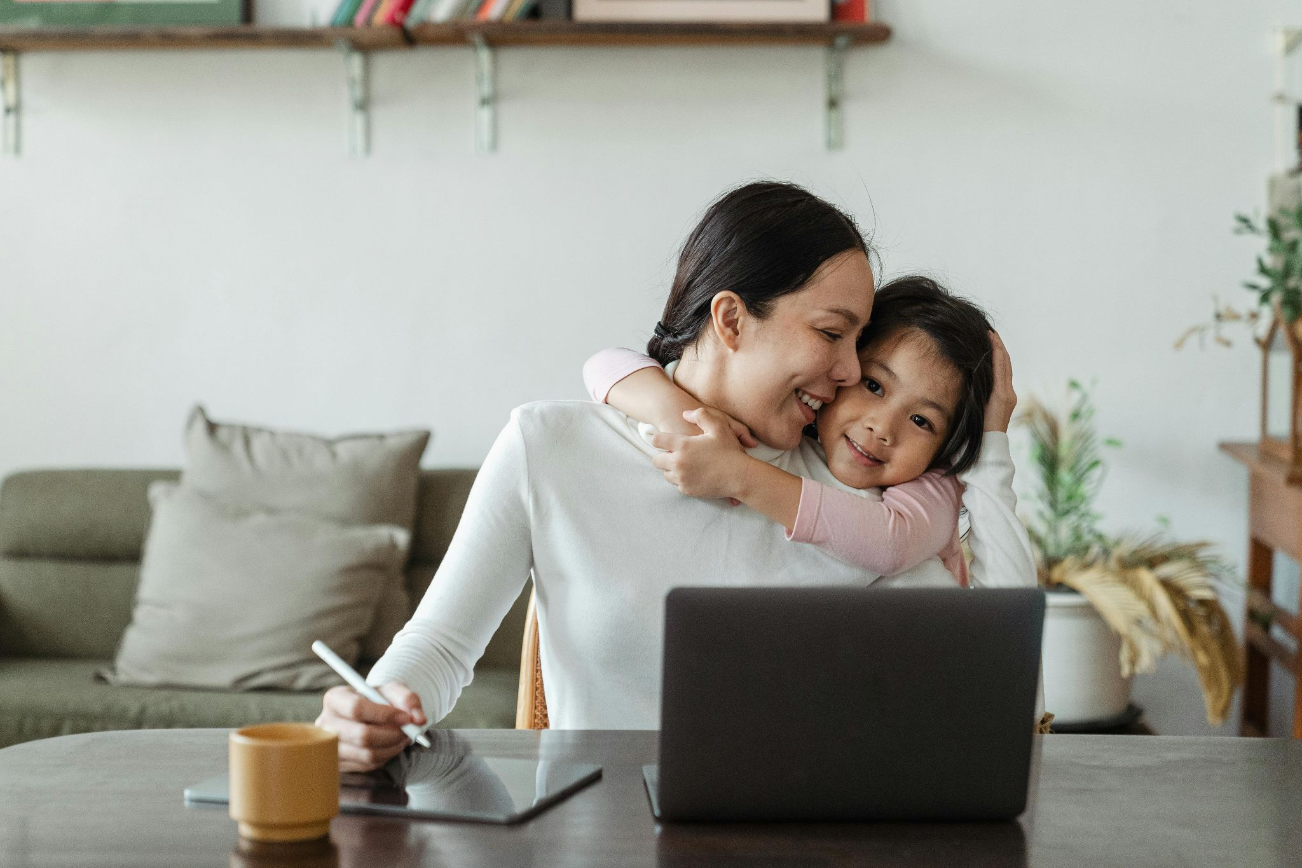
Image via Pexels

Written by Aimee Lyons, DIYdarlin.com, 7 January 2026.
How to Raise Health-Conscious Kids While Homeschooling
Some days go by in a blur: meals, math, laundry, a short walk, maybe a meltdown. And still, health builds itself in those moments. Not from rules, but from rhythms. Children watching, repeating, absorbing. The goal isn't perfect balance every day — it's internal calibration over time. When homeschooling, there's a rare window to shape what “normal” looks like. Not just academically, but in how a child sees their body, their time, their choices.
Structure Comes First, Then Fluency
Before habits take hold, structure sets the tone. Days with even light scaffolding tend to run smoother — not just for productivity, but for wellness. Something as simple as a midmorning stretch, a hydrating snack, or stepping outside between subjects creates rhythm without rigidity. The idea isn’t control, but consistency. Patterns reduce decision friction and support emotional regulation. There are practical ways to support healthy routines for children that don’t turn the home into a drill camp. A few anchors each day go further than endless instructions.
Weave Health Into the Day, Not Around It
Health education shouldn’t exist only in the “extra” folder. It deserves airtime in the center. Fold it into your core flow. Budgeting lessons through snack planning. Anatomy through everyday observations. Conversations about rest, food, boundaries — not as lectures, but as part of living together. Tools that offer free homeschool health curriculum options can help blend structure into this approach. When learning health becomes a lived behavior, kids remember it.
Let Tech Elevate, Not Erode
Screens can drain or develop. Direction matters. In middle school and beyond, students begin looking outward. Tech, when used well, becomes a bridge — to complexity, to exploration, to independence. Pair screen use with purpose. Frame it as a tool, not a trap. For learners leaning into STEM or problem-solving, exploring fields like a bachelor of computer science can spark long-term thinking. That’s part of health, too: building the mental stamina to chase a meaningful path.
Movement Must Be Lived, Not Prescribed
The default posture of modern life is stillness. That’s a problem — especially for children whose brains are powered by motion. Energy doesn’t disappear when it’s ignored; it redirects. Instead of bottling it, channel it. Let movement shape memory. There’s no need for gym equipment or apps. Even ten minutes of family play can shift focus and mood. Toward the end of your lesson block, rotate in some creative homeschool P.E. activities kids enjoy and let them choose. Choice builds ownership. Repetition builds rhythm.
Nutrition Begins with What Feels Possible
Healthy eating starts before the plate. It lives in the tone of the conversation, the framing of options, the permission to explore. Pressure turns food into power. Curiosity turns it into discovery. Create snack plans together. Try things no one’s ever heard of. Then ask, “How does this make you feel?” not “Is this good or bad?” Real ownership comes from understanding consequences without shame. One way in is through 10 healthy snacks kids will love. Start small, build slowly.
Wellness Also Means Inner Language
Resilience doesn’t shout. It shows up in the quiet — in the way a child thinks through struggle. Internal stories drive external behavior. What they whisper to themselves after a mistake is more predictive than any motivational poster. Create space for honest emotion. Model repair, not perfection. Mental wellness emerges when vulnerability isn’t punished, and pauses are normal. At any age, students can learn about physical and mental health from home without judgment. Resources help. So do daily micro-conversations.
Make Family Culture the Delivery System
Habits fade when isolated. They hold when rooted in belonging. Families that eat together, walk together, and decompress together — those patterns last. The goal isn’t moral superiority or lifestyle branding. It’s cohesion. A shared sense that we take care of ourselves and each other. That identity travels with a child. Decades later, they may not remember every diagram or rule — but they’ll remember the feeling of being in a household that creates a foundation for overall wellness at home.
Health isn’t a single choice — it’s a practiced fluency. Children raised in homes where health is modeled, not mandated, tend to internalize the rhythm. They eat when they’re hungry, pause when they’re overwhelmed, move when they’re restless, and speak when something’s off. It’s not always graceful, but it’s grounded. Homeschooling offers the time and flexibility to make these habits visible, repeatable, and livable. And the best part? You don’t need to master it. You just need to stay in it, together.
Explore the rich tapestry of the Toomey family legacy and discover a wealth of resources in STEM, genealogy, and more at Toomey.org!

