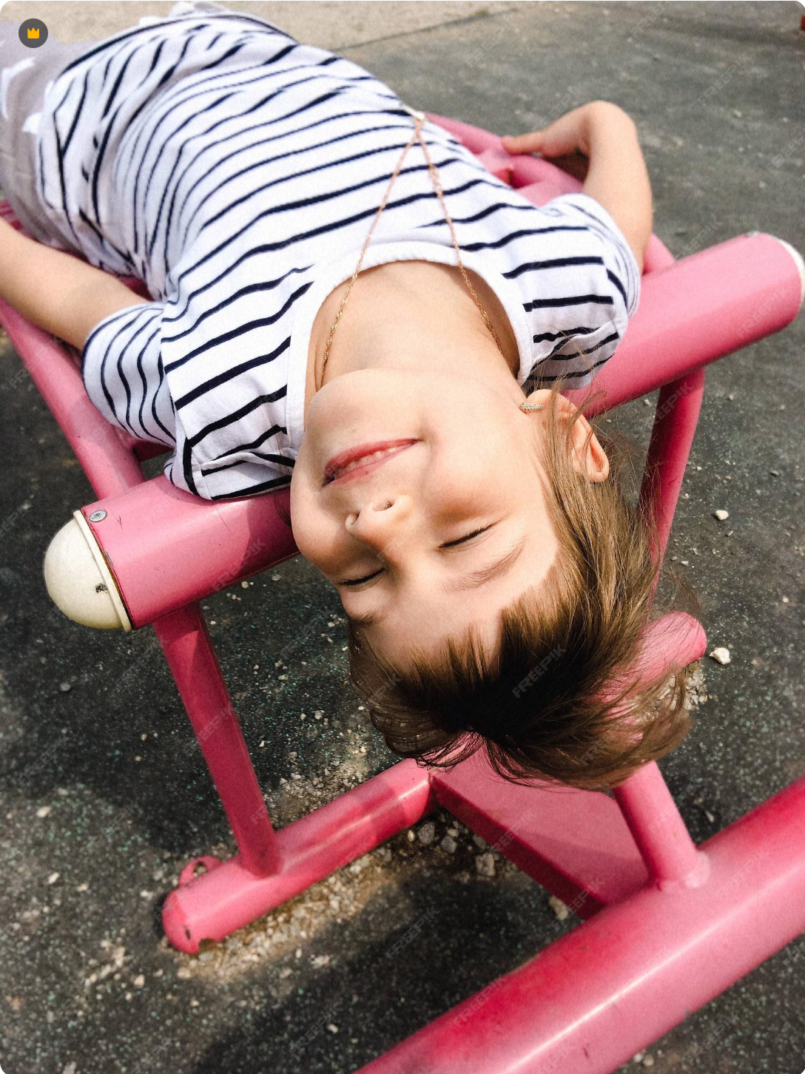
Image by Freepik
Written by Aimee Lyons, DIYdarlin.com, 14 January 2026

Simple Ways to Balance Activity and Rest for Kids
Some weeks feel like a tactical operation. You’re coordinating rides, watching the clock, juggling recitals, games, assignments, and the evening rush that somehow always arrives early. There’s no bad intention behind it. Parents want the best for their kids: enrichment, experience, and community. But what starts as an opportunity can easily become a momentum problem. Time gets filled faster than it gets questioned. And what falls away first? Stillness. Imagination. Recovery. Kids aren’t burning out from just one thing; they’re wilting under the accumulation. The days aren’t just full, they’re overfull. And in that squeeze, the parts of childhood that happen off script quietly disappear.
When Too Much Feels Normal
Overscheduling doesn’t always announce itself. It creeps in with good intentions—a new sport to try, a music class that fits perfectly between pickup and dinner. But eventually, the logistics run the house. Parents start to see the shift when a kid loses interest not in one thing, but in everything. Some days, it’s just obvious that too many activities can backfire. You catch yourself thinking “just get through today” more often than you'd like. That’s the red flag. Sometimes, it’s not about doing less in theory; it’s about making one weeknight sacred or drawing a hard line around Sundays. Those boundaries don’t kill opportunity; they protect the parts of life that don’t fit in a Google Calendar.
Creative Breaks That Don’t Feel Like Work
It helps to offer release valves that don’t require a full lifestyle overhaul. One way to do that is through playful, expressive tech. Try using digital creativity as a bridge, not to cram in more learning, but to create quick, no-pressure breathing room. You can hand over a tablet and let your kid try an AI cartoon generator, which turns text or photos into silly, colorful cartoons or short animated scenes. It’s fast, novel, and doesn’t ask kids to “produce” anything serious. The point isn’t to master anything; it’s to pause the day’s forward motion and just explore something light. These micro-moments can restore energy and imagination without adding tasks to anyone’s plate.
When Homework Crosses the Line
No one doubts that practice matters. But in real life, homework often overflows into evenings already packed tight. And it doesn’t just cost time. It shifts your home’s energy. Parents end up managing meltdowns, not math. What seemed like a reasonable assignment turns into a friction point, another deadline, another tug-of-war. When school demands spill into home life and eat into the few open windows left, something has to give. Some families triage: they set a cutoff time, switch to oral review instead of written work, or drop certain assignments altogether after communicating with teachers. The goal isn’t rebellion, it’s preservation.
Imagination Doesn’t Run on a Timer
What’s missing from most overfull days isn’t just rest, it’s autonomy. It’s the space to make choices without immediate structure. Kids need pockets of time that aren’t optimized, monetized, or monitored. The absence of a plan is the plan. This is where freeform time that strengthens imagination does the real work. It’s when the living room becomes a spaceship or a sibling becomes a boss in a pretend company. That mental leap, from boredom to invention, is crucial. And it rarely happens on command. Parents who protect this kind of space aren’t ignoring their kids. They’re trusting them to fill the silence with something only a kid could invent.
Resetting the Pulse of the Day
You don’t have to be a schedule minimalist to benefit from rhythm. In fact, the more that’s going on, the more useful the rhythm becomes. Not rigid routines, but predictable beats in the day, moments that help everyone exhale, can shift the whole household. That might mean no talking during the first ten minutes after school. Or always eating breakfast in the same chair. These tiny, repeated moments act like anchors. They signal safety. They give kids something to hold onto when the rest of the day is variable. Rhythm doesn’t remove chaos; it helps you float through it without drowning.
Reading Can Quiet the System
Not every kid wants to talk after a long day. And not every screen winds them down. Sometimes the answer is lower-tech: a favorite story, a blanket, a dog at their feet. Families that build routines around reading rituals that help kids reset know that it's less about reading and more about resting. The repetition, the slow pace, the familiar voices, it all gives kids a way to transition without confrontation. You’re not asking them to explain their feelings or recount their day. You’re just offering a low-key off-ramp from the noise.
Downtime That Doesn’t Require Planning
You don’t have to choreograph every moment to make space for recovery. Some of the best resets are so ordinary they go unnoticed, which is exactly why they work. A snack shared without talking. A window seat with nothing to do. Parents who recognize simple ways kids can decompress at home tend to protect them without over-labeling them. It’s not “mindfulness” or “self-care.” It’s just a kid lying on the floor staring at the ceiling for six minutes, and being allowed to do it without comment. Not every quiet moment needs to become a strategy. Some just need to be left alone.
The goal isn’t balance for the sake of balance. It’s balance so kids have enough left in the tank to be themselves. You can’t always predict when a great conversation, goofy game, or breakthrough idea will show up. But you can make sure your child has the time and energy for it if it does. That doesn’t mean rejecting structure. It means choosing it carefully. Leaving open space in the week isn’t a failure to plan; it’s a decision to protect something else: presence. And the truth is, kids will remember the moments they felt relaxed and safe a lot longer than the ones they performed their schedule perfectly.

Explore the rich tapestry of the Toomey family legacy and discover a wealth of resources on genealogy, STEM tutoring, and more at Toomey.org!

