Harold’s Boolean Algebra
Cheat Sheet
8 September 2025

Boolean Algebra

Boolean Law | Boolean Expression | Equivalent Circuit | Description
Idempotent | $$A+A=A$$ | 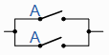 | A in parallel with A = “A”
Idempotent | $$A•A=A$$ | 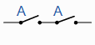 | A in series with A = “A”
Associative | $$A+\left(B+C\right)$$  $$=\left(A+B\right)+C$$  $$=A+B+C$$ |  | Allows the removal of brackets from an expression and the regrouping of the variables
Associative | $$A•\left(B•C\right)$$  $$=\left(A•B\right)•C$$  $$=A•B•C$$
Commutative | $$A+B=B+A$$ | 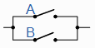 | A in parallel with B = B in parallel with A
Commutative | $$A•B=B•A$$ | 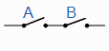 | A in series with B = B in series with A
Distributive | $$A•\left(B+C\right)$$  $$=A•B+A•C$$ |  | Permits the multiplying or factoring out of an expression
Distributive | $$A+B•C=$$  $$(A+B)•(A+C)$$ |  | Permits the multiplying or factoring out of an expression
Identity | $$A+0=A$$ | 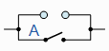 | A in parallel with open = “A”
Identity | $$A•1=A$$ | 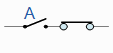 | A in series with closed = “A”
Domination  (Annulment) | $$A+1=1$$ | 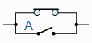 | A in parallel with closed = “CLOSED”
Domination  (Annulment) | $$A•0=0$$ | 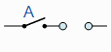 | A in series with open = “OPEN”
Double Compliment  (Double Negation) | $$\overline{ \overline{A }}=A$$ | 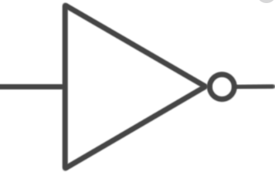 | NOT NOT A (double negative) = “A”
Complement | $$A+\overline{A}=1$$ | 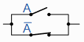 | A in parallel with NOT A = “CLOSED”
Complement | $$A•\overline{A}=0$$ | 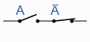 | A in series with NOT A = “OPEN”
De Morgan’s | $$\overline{\left(A+B\right)}=\overline{A}•\overline{B}$$ |  | Invert and replace OR with AND
De Morgan’s | $$\overline{A•B}=\overline{A}+\overline{B}$$ |  | Invert and replace AND with OR
Absorption  (Absorptive) | $$A+\left(AB\right)=A$$ |  | Enables a reduction in a complicated expression to a simpler one by absorbing like terms
Absorption  (Absorptive) | $$A\left(A+B\right)=A$$
Absorption  (Absorptive) | $$A+\overline{A}B=A+B$$ |  | Reduces a complicated expression to a simpler one by absorbing complement term

Precedence Rules
# | Operator | Symbol | Precedence
1 | Parenthesis | ( ) | Highest precedence
2 | NOT | ~
3 | Quantifiers | ∀, ∃
4 | AND | • | Applied Left to Right
5 | OR | ∨
6 | Conditional | ⊃
7 | Biconditional | ↔ | Lowest precedence

Boolean Logic Gates

Boolean Logic | Notation | Gate | Description
IDENTITY | 1  T  True  S | 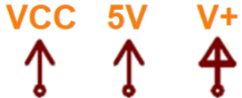 | On, Tautology, High voltage (typically +5V)
NULL | 0  F  False  ⊥  ∅ | GND  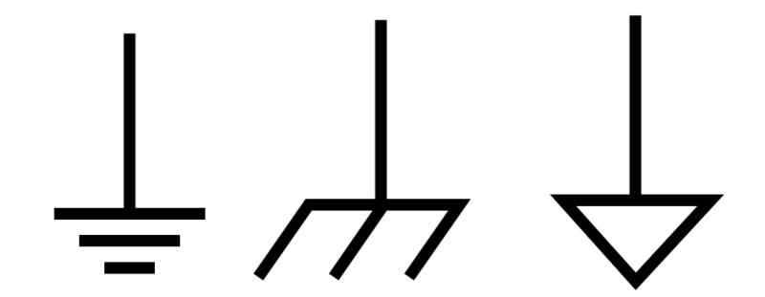 | Off, Contradiction, Low voltage (typically 0V)
Input | A, B, C, D |  | Line, Wire, Connects to
Output | W, X, Y, Z |  | Line, Wire, Connects from
AND | $$A⋅B$$  $$AB$$  $$A.B$$  A ∧ B  A ∩ B | 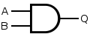 | AND, BUT, Multiply, Conjunction, Intersection
OR | $$A+B$$  A ∨ B  A ∪ B  A | B | 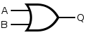 | Inclusive-OR, Add, Disjunction, Union
NOT | $$\overline{A}$$  $$A^$$  $$A'$$  $$¬A$$  $$\sim A$$  $$!A$$ | 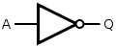 | NOT, Invert, Negation, Change, Difference
NAND | $$\overline{A⋅B}$$  $$\overline{AB}$$  A ⊼ B  A | B* | 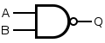 | Not AND
NOR | $$\overline{A+B}$$  A ⊽ B  A ↓ B | 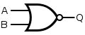 | Not OR
XOR | A ⊕ B  A ⊻ B  $$A\overline{B}+\overline{A}B$$ | 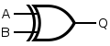 | Exclusive-OR, Both A and B are different
XNOR | A ⊙ B  $$\overline{A⊕B}$$  $$AB+\overline{A}\overline{B}$$ | 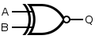 | Exclusive-NOR, Both A and B are the same

NOTE: The laws of Boolean algebra are the same in propositional and set logic.
Boolean Logic Truth Tables
Inputs |  | Outputs
A | B | AND  $$⋅$$ | NAND  ⊼ | OR  + | NOR  ⊽ | XOR  ⊕ | XNOR  ⊙ | NOT  $$\overline{A}$$ | VCC  1 | GND  0
0 | 0 | 0 | 1 | 0 | 1 | 0 | 1 | A=1 | 1 | 0
0 | 1 | 0 | 1 | 1 | 0 | 1 | 0 | A=1 | 1 | 0
1 | 0 | 0 | 1 | 1 | 0 | 1 | 0 | A=0 | 1 | 0
1 | 1 | 1 | 0 | 1 | 0 | 0 | 1 | A=0 | 1 | 0

Blank Truth Tables

Inputs |  | Output
A | B | X
0 | 0
0 | 1
1 | 0
1 | 1

Inputs |  |  | Output
A | B | C | X | Y
0 | 0 | 0
0 | 0 | 1
0 | 1 | 0
0 | 1 | 1
1 | 0 | 0
1 | 0 | 1
1 | 1 | 0
1 | 1 | 1

Inputs |  |  |  | Output
A | B | C | D | X | Y | Z
0 | 0 | 0 | 0
0 | 0 | 0 | 1
0 | 0 | 1 | 0
0 | 0 | 1 | 1
0 | 1 | 0 | 0
0 | 1 | 0 | 1
0 | 1 | 1 | 0
0 | 1 | 1 | 1
1 | 0 | 0 | 0
1 | 0 | 0 | 1
1 | 0 | 1 | 0
1 | 0 | 1 | 1
1 | 1 | 0 | 0
1 | 1 | 0 | 1
1 | 1 | 1 | 0
1 | 1 | 1 | 1

Karnaugh Mapping (K-Map)

2-Bit  K-Map |  | A
 |  | 0 | 1
B | 0
B | 1

3-Bit  K-Map |  | AB
 |  | 00 | 01 | 11 | 10
C | 0
C | 1

4-Bit  K-Map |  | AB
 |  | 00 | 01 | 11 | 10
CD | 00
CD | 01
CD | 11
CD | 10

2x2 Group
1x4 Group

K-Map Rules

1) Circle only 1s (ones) and don’t cares for Sum of Products (SOP), $e.g. \overline{A} \overline{B} \overline{C}+\overline{A}BC+AB\overline{C}$.
a. Circle only 0s (zeros) and don’t cares for Product of Sums (POS), $e.g. (A+\overline{B})(\overline{A}+B)$.
b. Don’t cares may be used or ignored.
2) No diagonals, only horizontal or vertical connections.
3) Group only adjacent cells in groups with powers of 2 (1x1, 1x2, 2x1, 2x2, 2x4, 4x2, 1x4, 4x1).
4) Make groups as large as possible.
5) Must group all 1s (ones) for SOP or all 0s (zeros) for POS.
6) Overlapping is allowed.
7) Wrapping around all edges allowed, both top-bottom edges and left-right edges.
8) Fewest groups possible (OPTIMAL).
9) For each circle, determine which inputs do not contribute to the logic (is both 0 and 1).
10) Write down the equation as a SOP, $e.g. \overline{A} \overline{B} \overline{C}+\overline{A}BC+AB\overline{C}$

Sources
- SNHU MAT 230 - Discrete Mathematics, zyBooks.
- https://www.electronics-tutorials.ws/boolean/bool_6.html
- Toomey, H. A. (2024). Logical Connective Laws, Harold’s Logic Cheat Sheet, https://www.toomey.org/tutor/discrete_math.html
See Also
- Harold’s Logic Cheat Sheet
- Harold’s Logic (Philosophy) Cheat Sheet
- Harold’s Sets Cheat Sheet
- Harold’s Boolean Algebra Cheat Sheet
- Harold’s Proofs Cheat Sheet

