Harold’s Business Calculus
Cheat Sheet
6 November 2025

Algebra Reference
Exponents
Multiplication | $$a^{n}a^{m}=a^{n+m}$$ | $$\frac{a^{n}}{a^{m}}=a^{n-m}=\frac{1}{a^{m-n}}$$
Power to a Power | $${(a^{n})}^{m}=a^{nm}$$
Distributive | $${\left(ab\right)}^{n}=a^{n}b^{n}$$ | $${\left(\frac{a}{b}\right)}^{n}=\frac{a^{n}}{b^{n}}$$
Zero Power | $$a^{0}=1 if a≠0$$
Power Sign Change | $$a^{-n}=\frac{1}{a^{n}}$$ | $$\frac{1}{a^{-n}}=a^{n}$$
Negative Powers | $${\left(\frac{a}{b}\right)}^{-n}={\left(\frac{b}{a}\right)}^{n}=\frac{b^{n}}{a^{n}}$$ | $$a^{\frac{n}{m}}={\left(a^{\frac{1}{m}}\right)}^{n}={\left(a^{n}\right)}^{\frac{1}{m}}$$

Radicals
Convert to Power | $$\sqrt[n]{a}=a^{\frac{1}{n}}$$ | $$\sqrt[n]{ab}=\sqrt[n]{a} \sqrt[n]{b}$$
Root of a Root | $$\sqrt[m]{\sqrt[n]{a}}=\sqrt[nm]{a}$$ | $$\sqrt[n]{\frac{a}{b}}=\frac{\sqrt[n]{a}}{\sqrt[n]{b}}$$

Logarithms
Definition | Log $≡$ Exponential
Definition | $$\log_{b}{x}=y ≡ x{=b}^{y}$$
Example | $\log_{5}{125}=3$ $≡$ ${125=5}^{3}$
Common Log | $${\log{x}=log}_{10}{x}$$ | Base e assumed in pre-1955 math textbooks.  Base 2 assumed in computer science textbooks.
Natural Log | $${\ln{x}=log}_{e}{x}$$ |  | where $e≈2.718281828...$
Powers (x²) | $$\log_{b}\left(x^{r}\right)=r\log_{b}{x}$$ |  | $$\ln{x^{r}}=r\ln{x}$$
Multiplication ($×$) | $$\log_{b}\left(xy\right)=\log_{b}{x}+\log_{b}{y}$$ |  | $$\ln\left(xy\right)=\ln{x}+\ln{y}$$
Division ($÷$) | $$\log_{b}\left(\frac{x}{y}\right)=\log_{b}{x}-\log_{b}{y}$$ |  | $$\ln\left(\frac{x}{y}\right)=\ln{x}-\ln{y}$$
Zero (0) and One (1) | $$\log_{b}{1}=0$$ |  | $$\log_{b}{b}=1$$
Inverse Functions | $$\log_{b}{b^{x}}=x$$ |  | $$b^{\log_{b}{x}}=x$$
Change of Base | $$\log_{b}{x}=\frac{\log_{a}{x}}{\log_{a}{b}}=\frac{\ln{x}}{\ln{b}}$$ |  | TI-84:  [MATH] + [A: logBASE( ] $→\log_{}\left(\right)$
3.1 Limits
Property | (Map to Larson’s 1-pager of common derivatives)
Definition of Limit | Let $f$ be a function and let $a$ and $L$ be real numbers. If  1. as $x$ takes values closer and closer (but not equal) to $a$ on both sides of $a$, the corresponding values of $f(x)$ get closer and closer (and perhaps equal) to $L$; and  2. the value of $f(x)$ can be made as close to $L$ as desired by taking values of $x$ close enough to $a$;  then $L$ is the limit of $f(x)$ as x approaches $a$, written  $$\lim_{x→a}{f(x)}=L$$
Existence of Limits | The limit of $f$ as $x$ approaches $a$ may not exist.  1. If $f(x)$ becomes infinitely large in magnitude (positive or negative) as $x$ approaches the number $a$ from either side, we write  $$\lim_{x→a}{f\left(x\right)}=∞$$  or  $$\lim_{x→a}{f\left(x\right)}=-∞$$  In either case the limit does not exist.  2. If $f(x)$ becomes infinitely large in magnitude (positive) as $x$ approaches $a$ from one side and infinitely large in magnitude (negative) as $x$ approaches $a$ from the other side, then $\lim_{x→a}{f(x)}$ does not exist.  3. If $\lim_{x→a^{-}}{f(x)}=L$ and $\lim_{x→a^{+}}{f(x)}=M$ , and $L≠M$, then $\lim_{x→a}{f(x)}$ does not exist.
Limits at Infinity | $$\lim_{x→∞}{\frac{1}{x^{n}}}=0$$ | $$\lim_{x→-∞}{\frac{1}{x^{n}}}=0$$
Finding Limits at Infinity | If $f(x)=\frac{p(x)}{q(x)}$, for polynomials $p(x)$ and $q(x), q(x)≠0$,  $\lim_{x→+∞}{f\left(x\right)}$ and$\lim_{x→-∞}{f\left(x\right)}$ can be found as follows.  1. Divide $p(x)$ and $q(x)$ by the highest power of $x$ in $q(x)$.  2. Use the rules for limits, including the rules for limits at infinity,  $$\lim_{x→∞}{\frac{1}{x^{n}}}=0$$  and  $$\lim_{x→-∞}{\frac{1}{x^{n}}}=0$$  to find the limit of the result from Step 1.
Rules for Limits
Rule | (Map to Larson’s 1-pager of common derivatives)
Given | Let $a$, $A$, and $B$ be real numbers, and let $f$ and $g$ be functions such that  $\lim_{x→a}{f(x)}=A$  and  $\lim_{x→a}{g(x)}=B$.
1. Constant (c) | If $c$ is a constant, then  $$\lim_{x→a}{c}=c$$  and  $$\lim_{x→a}{[c∙f(x)]}=c∙\lim_{x→a}{f(x)}=c∙A$$
2. Sum or Difference (+, $-$) | The limit of a sum or difference is the sum or difference of the limits.  $$\lim_{x→a}\left[f(x)±g(x)\right]=\lim_{x→a}{f(x)}±\lim_{x→a}{g(x)}=A±B$$
3. Product ($×$) | The limit of products is the product of the limits.  $$\lim_{x→a}\left[f(x)∙g(x)\right]=\lim_{x→a}{f(x)}∙\lim_{x→a}{g(x)}=A∙B$$
4. Quotient ($÷$) | The limit of a quotient is the quotient of the limits, provided the limit of the denominator is not zero.  $$\lim_{x→a}{\frac{f(x)}{g(x)}}=\frac{\lim_{x→a}{f(x)}}{\lim_{x→a}{g(x)}}=\frac{A}{B}$$  if $B≠0$.
5. Polynomial ($P(x)$) | If $p(x)$ is a polynomial, then  $$\lim_{x→a}{p(x)}=p(a)$$
6. Exponent (x^{k}) | For any real number $k$,  $$\lim_{x→a}{{\left[f(x)\right]}^{k}}={\left[\lim_{x→a}{f(x)}\right]}^{k}=A^{k}$$  provided that this limit exists.
7. Equivalent Functions (=) | $$\lim_{x→a}{f\left(x\right)}=\lim_{x→a}{g\left(x\right)}$$  If $f(x)=g(x)$ for all $x≠a$.
8. Function Exponent | For any real number $b>0$,  $$\lim_{x→a}{b^{f(x)}}=b^{\lim_{x→a}{f(x)}}=b^{A}$$
9. Logorithm | For any real number $b$ such that $0<b<1$ or $1<b$,  $$\lim_{x→a}\left[\log_{b}{f\left(x\right)}\right]=\log_{b}\left[\lim_{x→a}{f\left(x\right)}\right]=\log_{b}{A}$$  if $A>0$.

3.2 Continuity
Term | Definition
Continuity at $x=c$ | A function $f$ is continuous at $x=c$ if the following three condistions are satisfied:  1. $f(c)$ is defined,  $2. \lim_{x→c}{f(x)}$ exists, and  3. $\lim_{x→c}{f\left(x\right)}=f\left(c\right).$  If $f$ is not continuous at $c$, it is discontinuous there.
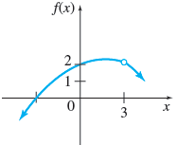

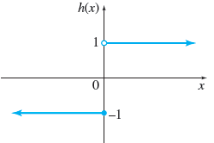
Continuity on a Closed Interval | A function is continuous on a closed interval $[a,b]$ if  1. It is continuous on the open interval $(a,b)$,  2. It is continuous from the right at $x=a$, and  3. It is continuous from the left at $x=b$.

3.3 Rates of Change
Term | Equation
Average Rate of Change | The average rate of change of $f(x)$ with respect to $x$ for a function as $x$ changes from $a$ to $b$ is  $$\frac{f(b)-f(a)}{b-a}$$
Instantaneous Rate of Change | The instantaneous rate of change for a function $f$ when $x=a$ is  $$\lim_{h→0}{\frac{f(a+h)-f(a)}{h}}$$  or  $$\lim_{b→a}{\frac{f(b)-f(a)}{b-a}}$$  provided this limit exists.

3.4 Definition of the Derivative
Term | Definition
Slope of the Tangent Line | The tangent line of the graph of $y=f(x)$ at the point $(a, f(a))$ is the line through this point having slope  $$\lim_{h→0}{\frac{f(a+h)-f(a)}{h}}$$  provided this limit exists.  If the limit does not exist, then there is no tangent at that point.
Derivative | The derivative of the function $f$ at $x$ is defined as  $$f^{'}(x)=\lim_{h→0}{\frac{f(x+h)-f(x)}{h}}$$  or  $$f^{'}(x)=\lim_{b→x}{\frac{f(b)-f(x)}{b-x}}$$  provided this limit exists.  The derivative is the slope generating function at any point x.  It is usually set = 0 to find minimum (loss) and maximum (profit) values of $f(x)$.
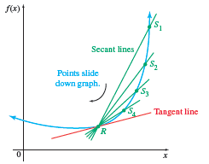
Notations for the Derivative of  $$y=f(x)$$ | $$\frac{dy}{dx}=y^{'}$$  $$\frac{d}{dx}\left[f\left(x\right)\right]=f^{'}\left(x\right)$$ |  | $${ f}^{\left(n\right)}\left(x\right)$$  $${ D}_{x}[y]$$
Equivalent Expressions for the Change in $x$ | $$x_{2}-x_{1}$$ | Useful for describing the equation of a line through two points.
Equivalent Expressions for the Change in $x$ | $$b-a$$ | A way to write $x_{2}-x_{1}$ without the subscripts.
Equivalent Expressions for the Change in $x$ | $∆$x | Useful for describing the change in $x$ without referring to the individual points.
Equivalent Expressions for the Change in $x$ | h | A way to write $∆$x with just one symbol.
Equation of the Tangent Line | The tangent line to the graph of $y=f(x)$ at the point $(x_{1}, f(x_{1}))$ is given by the equation  $$y-f(x_{1})=f^{'}(x_{1})(x-x_{1}),$$  provided $f^{'}(x)$ exists.
Existence of the Derivative | The derivative exists when a function $f$ satisfies all of the following conditions at a point.  1. $f$ is continuous,  2. $f$ is smooth, and  3. $f$ does not have a vertical tangent line.  The derivative does not exist when any of the following conditions are true for a function at a point.  1. $f$ is discontinuous,  2. $f$ has a sharp corner, or  3. $f$ has a vertical tangent line.
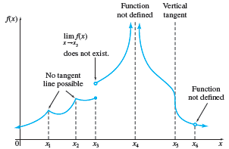
4. Derivative Formulas
Rule | Formula
1. Chain Rule () | $$\frac{d}{dx}\left[f∘g\left(x\right)\right]= \frac{d}{dx}\left[f\left(g\left(x\right)\right)\right]=f^{'}\left(g\left(x\right)\right)∙g^{'}\left(x\right)$$
2. Constant Rule (c) | $$\frac{d}{dx}\left[c\right]=0$$  $$(think c=cx^{0}→c0x^{-1}=0 after applying rule \#7)$$
3. Constant Multiple Rule (c) | $$\frac{d}{dx}\left[cf(x)\right]=cf^{'}(x)$$
4. Sum and Difference Rule (+, $-$) | $$\frac{d}{dx}\left[f±g\right]=f^{'}±g^{'}$$
5. Product Rule ($×$) | $$\frac{d}{dx}\left[fg\right]=fg^{'}+gf^{'}$$
6. Quotient Rule ($÷$) | $$\frac{d}{dx}\left[\frac{f}{g}\right]=\frac{gf^{'}-fg^{'}}{g^{2}}$$  $$(same as \frac{f}{g}= fg^{-1} then apply rule \#4)$$
7. Power Rule (x^{n}) | $$\frac{d}{dx}\left[cx^{n}\right]=cnx^{n-1}$$
8. General Power Rule (x^{n}) | $$\frac{d}{dx}\left[f^{n}\right]=nf^{n-1}{ f}^{'}$$
9. Power Rule for $f(x)=x$ | $$\frac{d}{dx}\left[x\right]=1$$  $$(think x=x^{1}→{1x}^{0}=1 after applying rule \#7)$$
10. Natural Exponential Rule | $$\frac{d}{dx}\left[e^{x}\right]=e^{x}$$
11. General Natural Exponential Rule | $$\frac{d}{dx}\left[e^{g(x)}\right]=e^{g(x)}∙g^{'}(x)$$
12. Exponential Rule | $$\frac{d}{dx}\left[a^{x}\right]=(ln{a)}∙a^{x}$$
13. General Exponential Rule | $$\frac{d}{dx}\left[a^{g(x)}\right]=(\ln{a})∙a^{g(x)}∙g^{'}(x)$$
14. Natural Logorithm Rule | $$\frac{d}{dx}\left[\ln{x}\right]=\frac{1}{x}$$
15. General Natural Logorithm Rule | $$\frac{d}{dx}\left[\ln{f(x)}\right]=\frac{1}{f(x)}∙f^{'}(x)$$
16. Logorithm Rule | $$\frac{d}{dx}\left[\log_{a}{x}\right]=\frac{1}{(ln{a}) x}$$
17. General Logorithm Rule | $$\frac{d}{dx}\left[\log_{a}{f(x)}\right]=\frac{1}{\ln{a}}∙\frac{f^{'}(x)}{f(x)}$$

Equation of a Line
Form | Equation
Genreal Form | $$ax+by+c=0$$
Slope-Intercept Form | $$y=mx+b$$
Point-Slope Form | $$y-y_{0}=m\left(x-x_{0}\right)$$  $$where {m=f}^{'}\left(x_{0}\right) at point \left(x_{0},y_{0}\right)$$
Calculus Form | $$y=f^{'}\left(c\right)\left(x-c\right)+f\left(c\right)$$
Slope | $$m=\frac{rise}{run}=\frac{y_{2}-y_{1}}{x_{2}-x_{1}}=\frac{∆y}{∆x}→\frac{dy}{dx}=f^{'}\left(x\right)$$

4.1 Derivative Applications
Application | Business Case
Average Cost | If the total cost to manufacture $x$ items is given by $C(x)$, then the average cost per item is $\overline{C}(x)=C(x)/x$.
Marginal Average Cost | The marginal average cost is the derivative of the average cost function, $\overline{C}'(x)$.
 | 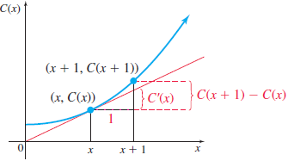
Profit | Profit equals total Revenue minus Cost or Expenses.  $$P(x)=R(x)-C(x)$$
 | 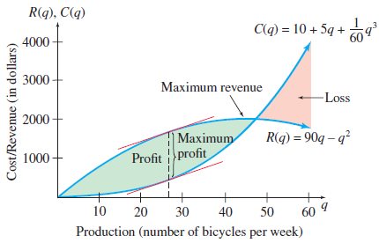

5. Graphing with Derivatives

Term | Definition
Test for Increasing and Decreasing Functions | 1. If $f^{'}\left(x\right)>0$, then $f$ is increasing (slope up). ↗  2. If $f^{'}\left(x\right)<0$, then $f$ is decreasing (slope down). ↘  3. If $f^{'}\left(x\right)=0$, then $f$ is constant (zero slope). →
Critical Numbers | The critical numbers for a function $f$ are those numbers $c$ in the domain of $f$ for which $f'(c)=0$ or $f'(c)$ does not exist.
Critical Point | A critical point is a point whose $x$-coordinate is the critical number $c$ and whose $y$-coordinate is$f(c)$.
First Derivative  (Slope Formula) | $f'\left(x\right)=0$ finds critical points (min. and max.).  Don’t forget to check the boundaries: $f(a)$ and $f(b)$.
First Derivative Test | 1. If $f^{'}\left(x\right)$ changes from – to + at c, then $f$ has a relative minimum at $(c, f(c))$.  2. If $f^{'}\left(x\right)$ changes from + to - at c, then $f$ has a relative maximum at $(c, f(c))$.  3. If $f^{'}\left(x\right)$, is + c + or − c −, then $f\left(c\right)$ is neither.
Test for Concavity | 1. If $f^{''}\left(x\right)>0$ for all $x$, then the graph is concave up. ⋃  2. If $f^{''}\left(x\right)<0$for all $x$, then the graph is concave down. ⋂
Second Deriviative Test  Let f ’(c)=0, and f ”(x) exists, then | 1. If $f^{''}\left(x\right)>0$, then $f$ has a relative minimum at $\left(c,f(c)\right)$.  2. If $f^{''}\left(x\right)<0$, then $f$ has a relative maximum at $\left(c,f(c)\right)$.  3. If $f^{''}\left(x\right)=0$, then the test fails (See $1^{st}$ derivative test).  If $f''(x)→+$, then cup up $⋃$ (min.)  If$f''\left(x\right)→-$, then cup down $⋂$ (max.)
Points of Inflection  Change in concavity | If $\left(c,f(c)\right)$ is a point of inflection of $f\left(x\right)$, then either  1. $f^{''}\left(c\right)=0$ or  2. $f^{''}\left(x\right)$ does not exist at x = c.
 | 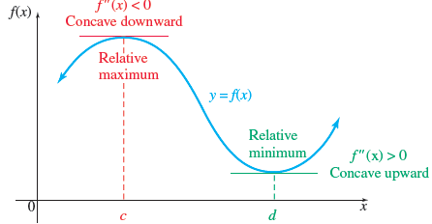

5.4 Curve Sketching

Step | Description
To sketch the graph of a function $f$:
1. | Consider the domain of the function, and note any restrictions.  (That is, avoid dividing by 0, taking a square root, or any even root, of a negative number, or taking the logarithm of 0 or a negative number.)
2. | Find the $y$-intercept (if it exists) by substituting $x=0$ into $f(x)$.  Find any $x$-intercepts by solving $f(x)=0$ if this is not too difficult.
3. | (a) If $f$ is a rational function, find any vertical asymptotes (VA) by investigating where the denominator is 0, and find any horizontal asymptotes (HA) by finding the limits as $x→∞$ and $x→-∞$.  (b) If $f$ is an exponential function, find any horizontal asymptotes (HA);  If $f$ is a logarithmic function, find any vertical asymptotes (VA).
4. | Investigate symmetry.  If $f(-x)=f(x)$, the function is even, so the graph is symmetric about the y-axis.  If $f(-x)=-f(x)$,, the function is odd, so the graph is symmetric about the origin.
5. | Find $f^{'}\left(x\right)$.  Locate any critical points by solving the equation $f'(x)=0$ and determining where $f'(x)$ does not exist, but $f(x)$ does.  Find any relative extrema and determine where $f$ is increasing or decreasing.
6. | Find $f''(x)$.  Locate potential inflection points by solving the equation $f''(x)=0$ and determining where $f''(x)$ does not exist.  Determine where $f$ is concave upward or concave downward.
7. | Plot the $x$ and $y$ intercepts, the critical points, the inflection points, the asymptotes, and other points as needed.  Take advantage of any symmetry found in Step 4.
8. | Connect the points with a smooth curve using the correct concavity, being careful not to connect points where the function is not defined.
9. | Check your graph using a graphing calculator or desmos.  If the picture looks very different from what you’ve drawn, see in what ways the picture differs and use that information to help find your mistakes.
Example Chart |  | 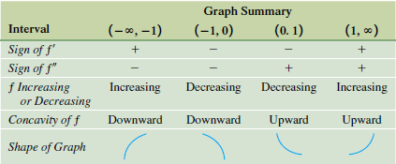

6.1 Absolute Extrema
Term | Definition
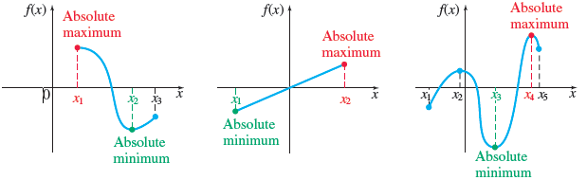
Absolute Maximum | Let ƒ be a function defined on some interval.  Let $c$ be a number in the interval.  Then $f(c)$ is the absolute maximum of $f$ on the interval if  $$f(x)≤f(c)$$  for every $x$ in the interval.
Absolute Minimum | Let ƒ be a function defined on some interval.  Let $c$ be a number in the interval.  Then $f(c)$ is the absolute minimum of $f$ on the interval if  $$f(x)≥f(c)$$  for every $x$ in the interval.
Absolute Extremum (Extrima) | A function $f$ has an absolute extremum (plural: extrema) at $c$ if it has either an absolute maximum or an absolute minimum there.
Extreme Value Theorem | A function $f$ that is continuous on a closed interval [a, b] will have both an absolute maximum and an absolute minimum on the interval.
Finding Absolute Extrema | To find absolute extrema for a function $f$ continuous on a closed interval [a, b]:  1. Find all critical numbers for $f$ in (a, b).  2. Evaluate $f$ for all critical numbers in (a, b).  3. Evaluate $f$ for the endpoints a and b of the interval [a, b].  4. The largest value found in Step 2 or 3 is the absolute maximum for $f$ on [a, b], and the smallest value found is the absolute minimum for $f$ on [a, b].
Critical Point Theorem | Suppose a function $f$ is continuous on an interval I and that $f$ has exactly one critical number in the interval I, located at $x=c$.  If $f$ has a relative maximum at $x=c$, then this relative maximum is the absolute maximum of $f$ on the interval I.  If $f$ has a relative minimum at $x=c$, then this relative minimum is the absolute minimum of $f$ on the interval I.

6.2 Applications of Extrema
Step | Description
Solving an Applied Extrema Problem
1. | Read the problem carefully.  Make sure you understand what is given and what is unknown.
2. | If possible, sketch a diagram.  Label the various parts.
3. | Decide which variable must be maximized or minimized.  Express that variable as a function of one other variable.
4. | Find the domain of the function.
5. | Find the critical points for the function from Step 3.
6. | If the domain is a closed interval, evaluate the function at the endpoints and at each critical number to see which yields the absolute maximum or minimum.  If the domain is an open interval, apply the critical point theorem when there is only one critical number.  If there is more than one critical number, evaluate the function at the critical numbers and find the limit as the endpoints of the interval are approached to determine if an absolute maximum or minimum exists at one of the critical points.

6.3 Further Business Application
Economic Lot Size, Economic Order Quantity, Elasticity of Demand
Elasticity of Demand | Let $q=f(p)$, where $q$ is demand at a price $p$. The elasticity of demand is  $$E=-\frac{p}{q}∙\frac{dq}{dp}.$$  Demand is inelastic if $E<1$.  Demand is elastic if $E>1$.  Demand has unit elasticity if $E=1$.
 | 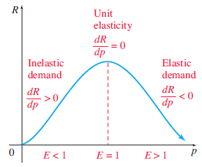
Revenue and Elasticity | 1. If the demand is inelastic, total revenue increases as price increases.  2. If the demand is elastic, total revenue decreases as price increases.  3. Total revenue is maximized at the price where demand has unit elasticity.
6.4 Implicit Differentiation
Term | Definition
Implicit Differentiation | To find $dy/dx$ for an equation containing $x$ and $y$:  1. Differentiate on both sides of the equation with respect to $x$, keeping in mind that $y$ is assumed to be a function of $x$.  2. Using algebra, place all terms with $dy/dx$ on one side of the equals sign and all terms without $dy/dx$ on the other side.  3. Factor out $dy/dx$, and then divide to solve for $dy/dx$.
Example  $$\frac{d}{dx}[cx^{n}y^{m}=k]$$ | $$c\left[\left(x^{n}\right){\left(y^{m}\right)}^{'}+\left(y^{m}\right){\left(x^{n}\right)}^{'}\right]=0$$  $$c\left[\left(x^{n}\right)\left(my^{m-1}y^{'}\right)+\left(y^{m}\right)\left(nx^{n-1}x^{'}\right)\right]=0$$  $$cmx^{n}y^{m-1}y^{'}+cny^{m}x^{n-1}=0$$  $$cmx^{n}y^{m-1}y^{'}=-cnx^{n-1}y^{m}$$  $$y^{'}=-\frac{cnx^{n-1}y^{m}}{cmx^{n}y^{m-1}}$$  $$y^{'}=-\frac{nx^{n-1}y^{m}}{mx^{n}y^{m-1}}$$  $$y^{'}=-\frac{n}{m}x^{n-1-n}y^{m-\left(m-1\right)}$$  $$y^{'}=-\frac{n}{m}x^{-1}y^{1}$$  $$y^{'}=-\frac{ny}{mx}$$ | Product Rule  Chain Rule  Distribute. $x^{'}=1$  Subtract  Divide  Cancel common term ($c$)  Bring powers to numerator  Simplify  Cleanup negative and unit exponents

6.5 Related Rates
Term | Definition
Solving a Related Rates Problem | 1. Identify all given quantities, as well as the quantities to be found. Draw a sketch when possible.  2. Write an equation relating the variables of the problem.  3. Use implicit differentiation to find the derivative of both sides of the equation in Step 2 with respect to time ($t$).  4. Solve for the derivative giving the unknown rate of change and substitute the given values.
Example | Steps to solve:  - Identify the known variables and rates of change.  $$x=15 m$$  $$y=20 m$$  $$x^{'}=2\frac{m}{s}$$  $$y^{'}= ? \frac{m}{s}$$  - Construct an equation relating these quantities.  $$x^{2}+y^{2}=r^{2}$$  - Differentiate both sides of the equation.  $$2xx^{'}+2yy^{'}=0$$  - Solve for the desired rate of change.  $$y^{'}=-\frac{x}{y} x^{'}$$  - Substitute the known rates of change and quantities into the equation.  $$y^{'}=-\frac{15}{20}⦁ 2=\frac{3}{2} \frac{m}{s}$$
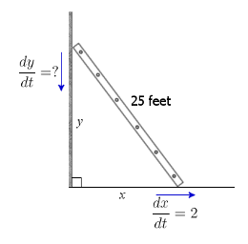

6.6 Differentials: Linear Approximation
Differentials | Formula
Differentials | For a function $y=f(x)$ whose derivative exists, the differential of $x$, written $dx$, is an arbitrary real number (usually small compared with $x$); the differential of $y$, written $dy$, is the product of $f'(x)$ and $dx$, or  $$dy=f^{'}\left(x\right) dx$$  or  $$∆y=f^{'}\left(x\right) ∆x$$
Relative Error | Relative Error $=\frac{∆f}{f}$ in %
Linear Approximation | Let $f$ be a function whose derivative exists.  For small nonzero values of $∆x$,  $$dy≈∆y$$  and  $$f\left(x+∆x\right)≈f\left(x\right)+dy=f\left(x\right)+f^{'}\left(x\right) dx$$  or  $$f\left(x+∆x\right)≈f\left(x\right)+∆y≈f\left(x\right)+f^{'}\left(x\right) ∆x$$
 | 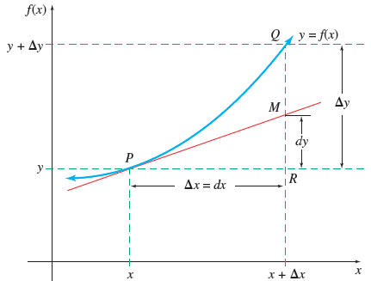
Example | Solve for $\sqrt[4]{82}$  Rewrite as $f\left(x\right)=\sqrt[4]{x}$  $$f\left(x+∆x\right)=f\left(81+1\right)$$  $$≈f\left(x\right)+f^{'}\left(x\right) ∆x$$  $$f^{'}\left(x\right)=\frac{1}{4}\left(x^{-\frac{3}{4}}\right)=\left(\frac{1}{4{\left(x\right)}^{\frac{3}{4}}}\right)$$  $$f^{'}\left(x\right)=\sqrt[4]{81}+\left(\frac{1}{4{\left(81\right)}^{\frac{3}{4}}}\right)$$  $$=3+\left(\frac{1}{4{\left(3\right)}^{3}}\right)$$  $$=3+\frac{1}{108}=\frac{325}{108}≈3.009259$$  $$Estimate=3.009259$$  $$Actual=3.009217$$

7.1 Antiderivative / Integration
Rule | Formulas
Antiderivative | If $F'(x)=f(x)$, then $F(x)$ is an antiderivative of $f(x)$.
Notation | $$\int{f\left(x\right) dx=F\left(x\right)+C}$$
Concept | If $F(x)$ and $G(x)$ are both antiderivatives of a function $f(x)$ on an interval, then there is a constant C such that  $$F(x)-G(x)=C$$  (Two antiderivatives of a function can differ only by a constant.)  The arbitrary real number C is called an integration constant.
Indefinite Integral | If $F'(x) =f(x)$, then  $$\int{f\left(x\right) dx=F\left(x\right)+C}$$  for any real number C.
Power Rule ($x^{n}$) | For any real number $n≠-1$,  $$\int{cx^{n} dx}=c\frac{x^{n+1}}{n+1}+C$$
Constant Multiple Rule ($c$) | $$\int{c∙f\left(x\right) dx}=c\int{f\left(x\right) dx}$$
Sum or Difference Rule (+, $-$) | $$\int{\left[f\left(x\right)±g\left(x\right)\right] dx}=\int{f\left(x\right) dx}±\int{g\left(x\right) dx}$$
Indefinite Integrals of Exponential Functions ($e^{x}$) | $$\int{e^{x} dx=e^{x}+C}$$  $$\int{e^{kx} dx=\frac{e^{kx}}{k}+C}$$  For $a>0, a≠1$:  $$\int{a^{x} dx=\frac{a^{x}}{\ln{a}}+C}$$  $$\int{a^{kx} dx=\frac{a^{kx}}{k(\ln{a})}+C}, k≠0$$
Natural Exponential Rule ($e^{f}$) | $$\int{ke^{f} dx=k\frac{e^{f}}{f^{'}}+C}$$
Indefinite Integral of ${f(x)=x}^{-1}$ | $$\int{x^{-1} dx}=\int{\frac{1}{x} dx}=\ln\left|x\right|+C$$  $$\int{\frac{dCabin}{Cabin}}=Log Cabin by the sea$$

7.2 Integral Substitution
Method | Formula
Substitution | Each of the following forms can be integrated using the substitution $u=f(x)$.
Substitution |  | Form of the Integral | Result
Substitution | 1. | $$\int{{\left[f(x)\right]}^{n}}f^{'}(x) dx, n≠-1$$ | $$\int{u^{n} dx}=\frac{u^{n+1}}{n+1}+C=\frac{{\left[f(x)\right]}^{n+1}}{n+1}+C$$
Substitution | 2. | $$\int{\frac{f^{'}(x)}{f(x)}}dx$$ | $$\int{\frac{1}{u} dx}=\ln\left|u\right|+C=\ln\left|f(x)\right|+C$$
Substitution | 3. | $$\int{e^{f(x)}f^{'}(x) dx}$$ | $$\int{e^{u} dx=e^{u}+C}=e^{f(x)}+C$$
Substitution Method | In general there are three cases.  We choose $u$ to be one of the following:  1. the quantity under a root or raised to a power;  2. the quantity in the denominator;  3. the exponent on $e$.  Always capture the constant in $u$, such as $u=g(x)±c$.  Remember that some integrands may need to be rearranged to fit one of these cases.
Substitution Method | $u=$ $__ part of f\left(x\right) (see above)__$  $du=$ __$remaining part of f\left(x\right)_$ $dx$

7.3 Area and the Definite Integral
Definition | Formula
The Definite Integral | If $f$ is defined on the interval [$a$, $b$], the definite integral of $f$ from $a$ to $b$ is given by  $$\int_{a}^{b}{f\left(x\right) dx}=\lim_{n→∞}{\sum_{i=1}^{n}{f(x_{i}) ∆x}},$$  provided the limit exists, where  $$∆x=\frac{(b-a)}{n}$$  and $x_{i}$ is any value of $x$ in the ith interval.  aka Riemann sum.
Total Change in $F(x)$ | If $f(x)$ gives the rate of change of $F(x)$ for $x$ in [$a$, $b$], then the total change in $F(x)$ as $x$ goes from $a$ to $b$ is given by  $$\lim_{n→∞}{\sum_{i=1}^{n}{f(x_{i})∆x}}=\int_{a}^{b}{f\left(x\right) dx}.$$

7.4 The Fundamental Theorem of Calculus
Definition | Formula
Fundamental Theorem of Calculus | Let $f$ be continuous on the interval [a, b], and let $F$ be any antiderivative of $f$. Then  $$\int_{a}^{b}{f\left(x\right) dx}=F\left(b\right)-F\left(a\right)=F(x)\left|{b \atop a}\right. .$$
1. Constant Multiple of a Function ($c$) | $$\int_{a}^{b}{c∙f\left(x\right) dx}=c\int_{a}^{b}{f\left(x\right) dx}$$
2. Sum or Difference of Functions (+, $-$) | $$\int_{a}^{b}{\left[f\left(x\right)±g\left(x\right)\right] dx}=\int_{a}^{b}{f\left(x\right) dx}±\int_{a}^{b}{g\left(x\right) dx}$$
3. Same Bounds | $$\int_{a}^{a}{f(x)}=0$$
4. Split Bounds | $$\int_{a}^{b}{f(x)}=\int_{a}^{c}{f(x)}+\int_{c}^{b}{f(x)}$$
5. Swap Bounds | $$\int_{a}^{b}{f(x)}=-\int_{b}^{a}{f(x)}$$
Finding Area | In summary, to find the area bounded by $f(x), x=a, x=b$, and the $x$-axis, use the following steps.  1. Sketch a graph.  2. Find any $x$-intercepts of $f(x)$ in [a, b].  These divide the total region into subregions.  3. The definite integral will be positive for subregions above the $x$-axis and negative for subregions below the $x$-axis.  Use separate integrals to find the (positive) areas of the subregions.  4. The total area is the sum of the areas of all of the subregions.
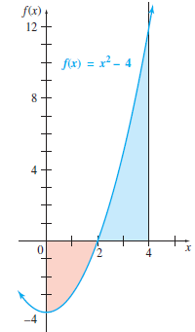

7.5 The Area Between Two Curves
Definition | Formula
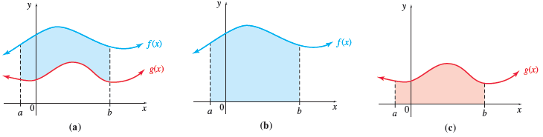
Area Between Two Curves | If $f$ and $g$ are continuous functions and $f(x)≥g(x)$ on [a, b], then the area between the curves $f(x)$ and $g(x)$ from $x=a$ to $x=b$ is given by  $$\int_{a}^{b}{\left[f(x)-g(x)\right] dx.}$$
Consumers’ Surplus | If $D(q)$ is a demand function with equilibrium price $p_{0}$ and equilibrium demand $q_{0}$, then Customers’ Surplus is given by
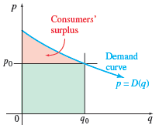 | $$\int_{0}^{q_{0}}{\left[D(q)-p_{0}\right]} dq.$$
Producers’ Surplus | If $S(q)$ is a supply function with equilibrium price $p_{0}$ and equilibrium supply $q_{0}$, then Producer’s Surplus is given by
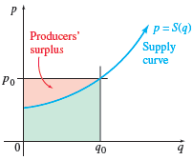 | $$\int_{0}^{q_{0}}{S(q)} dq.$$

7.6 Numerical Integration
Rule |  | Formula
Trapezoidal Rule |  | Let $f$ be a continuous function on [a, b] and let [a, b] be divided into n equal subintervals by the points a = x₀, x₁, x₂, ... , x_{n} = b.  Then, by the trapezoidal rule,  $$\int_{a}^{b}{f\left(x\right) dx}≈$$  $$\left(\frac{b-a}{n}\right)\left[\frac{1}{2}f\left(x_{0}\right)+f\left(x_{1}\right)+f\left(x_{3}\right)+…+f\left(x_{n-1}\right)+\frac{1}{2}f\left(x_{n}\right)\right]$$  and  $$x_{i}=a+i\left(\frac{b-a}{n}\right)$$
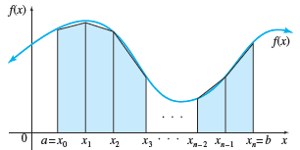
Simpson’s Rule |  | Let $f$ be a continuous function on [a, b] and let [a, b] be divided into n equal subintervals by the points a = x₀, x₁, x₂, ... , x_{n} = b.  Then by Simpson’s rule,  $$\int_{a}^{b}{f\left(x\right) dx}≈$$  $$\left(\frac{b-a}{3n}\right)\left[f\left(x_{0}\right)+4f\left(x_{1}\right)+2f\left(x_{2}\right)+4f\left(x_{3}\right)+…+2f\left(x_{n-2}\right)+4f\left(x_{n-1}\right)+f\left(x_{n}\right)\right]$$  Where $n$ is even and  $$x_{i}=a+i\left(\frac{b-a}{n}\right)$$
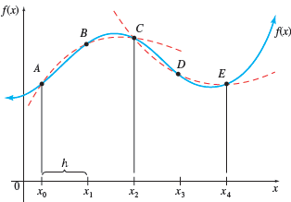
TI-84 | 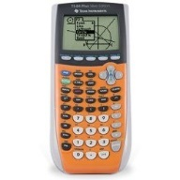 | [MATH] fnInt(f(x),x,a,b), [MATH] [1] [ENTER]  Example: [MATH] fnInt(x^2,x,0,1)  $$\int_{0}^{1}{x^{2} dx}=\frac{1}{3}$$
TI-Nspire CAS |  | [MENU] [4] Calculus [3] Integral  [TAB] [TAB]  [X] [^] [2] [TAB]  [TAB] [X] [ENTER]  Shortcut: [ALPHA] [WINDOWS] [4]

Source
- All highlighted formulas copied from chapters 3−7 of “Calculus with Applications”, 11th Edition (Global Edition), by Margaret L. Lial, Raymond N. Greenwell, and Nathan P. Ritchey, Pearson, 2017.
- Used in MATH 1325 Calculus for Business, Collin College, McKinney, Texas.

