Harold’s CISSP
Cheat Sheet
21 January 2026

Cybersecurity Certifications

Cert | Organization | Short Description
CISSP | ISC2 | Broad, senior-level security credential covering governance, risk, architecture, operations, and security program leadership.
CISM | ISACA | Management-focused certification centered on information security governance, program development, and risk management leadership.
CEH | EC-Council | Ethical hacking overview covering common attack vectors, tools, and techniques used to assess security posture.
Security+ | CompTIA | Entry-level, vendor-neutral baseline covering core security concepts, threats, risk management, and basic defensive practices.
CySA+ | CompTIA | Defensive, analyst-focused credential emphasizing threat detection, monitoring, vulnerability management, and incident response.
PenTest+ | CompTIA | Hands-on penetration testing fundamentals: planning/scoping, exploitation techniques, reporting, and remediation guidance.
CCSP | ISC2 | Cloud security certification that is focused on cloud architecture, governance, risk, compliance, and security operations in cloud environments.
SSCP | ISC2 | Practitioner-level systems security operations credential for implementing, monitoring, and administering security controls.
CISA | ISACA | Audit and assurance credential focusing on assessing controls, governance, and risk across information systems.
CRISC | ISACA | Risk-focused certification emphasizing enterprise IT risk identification, assessment, response, and control monitoring.

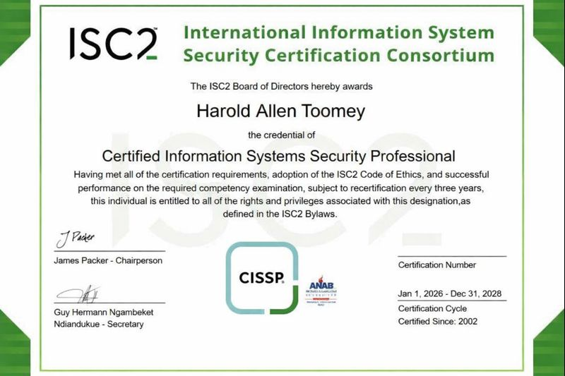
CISSP Overview

Aspect | Description
CISSP | Certified Information Systems Security Professional (CISSP) from ISC2 | 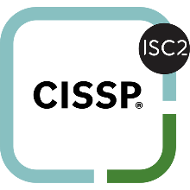
ISC2 | International Information System Security Certification Consortium (ISC2)  (Rebranded from (ISC)² in 2023)
Description | CISSP is a globally recognized, senior-level, vendor-neutral cybersecurity certification focused on designing, managing, and governing an organization’s overall security program.  It’s often treated as a benchmark credential for security leadership and experienced practitioners.
Target Audience | Best suited to people in roles like:  - Security engineer / security architect  - Security manager / security lead  - GRC (governance, risk, compliance)  - IT director / CISO-track professionals  It’s not an entry-level cert—most candidates already have several years in IT/security.
8 Domains (CBK) | CISSP spans broad security knowledge across eight areas (CBKs):  - Security & Risk Management  - Asset Security  - Security Architecture & Engineering  - Communication & Network Security  - Identity & Access Management (IAM)  - Security Assessment & Testing  - Security Operations  - Software Development Security
Experience Requirement | - To become fully certified, you typically need 5 years of paid work experience in 2 or more CISSP domains.  - Some education/certs can reduce this requirement by 1 year.  - If you pass the exam without the required experience, you can become an Associate of (ISC)² until you meet it.
The Exam | - Cost: $599  - Retakes:  - After 1st failed attempt: wait 30 days  - After 2nd failed attempt: wait 60 days  - After 3rd + failed attempts: wait 90 days  - Computerized exam (English uses adaptive testing)  - Mix of multiple-choice and advanced question formats  - Tests both concepts and real-world judgment: risk tradeoffs, governance decisions, architecture thinking, etc.
Credibility | - The #1 most recognized cybersecurity certification  - Signals broad security competency across the enterprise

CISSP Study Tools

Tool | Cost | Strengths
Boson ExSim-Max for CISSP | $99 (1 year) | Provides a full practice-exam simulator (multiple full-length exams).  Provides detailed explanations, scoring, and reporting.
Quantum Exams | Free samples  $139.99 (1 year)  $199.99 (1 year) w/CAT | Offers a Computer Adaptive Test (CAT) with a 3-hour time limit and variable-length exam (100–150 questions).  Gives detailed explanations.
Crucial Exams | Free demo  $19.99 (1 month)  $44.99 (3 months)  $119.99 (1 year)  $189.99 (lifetime pass) | Can generate timed, custom exams to simulate the real test.  Study Mode provides detailed explanations.  Runs on the website with a “practice test” flow and timer settings.
ISC2 Official App by LearnZapp | $4.99 (1 week)  $16.99 (1 month)  $44.99 (3 months)  $79.99 (6 months)  $139.99 (1 year) | Designed for smartphones.  Includes thousands of practice questions with detailed explanations.
Pocket Prep | Free to try  $20.99 (1 month)  $49.99 (3 months)  $124.99 (12 months) | Designed for smartphones.  Provides detailed explanations.
Sybex/Wiley Official Study Guide (10th Ed.) | $56.00 (eBook)  $70.00 (print) | Best core textbook.  Updated for the 2024 CISSP exam.  Includes 900+ practice questions with complete answer explanations.
ISC2 CISSP Official Practice Tests (Sybex), 4th Edition | $34.00 (eBook)  $42.00 (print) | Best companion book (practice questions in book form).  Official practice-test book aligned to the 2024 CISSP domains.  Includes access to Sybex’s online test environment.
The Official ISC2 CISSP CBK Reference, 6th Edition | $76.00 (eBook)  $95.00 (print) | Best “official reference” (deep lookup, not the easiest first read).  ISC2’s comprehensive CBK reference (authoritative, but more “reference manual” than exam-prep narrative).

CISSP Common Body of Knowledge (CBK)

1. Security & Risk Management

Topic | Diagrams and Lists

2. Asset Security

Topic | Diagrams and Lists

3. Security Architecture & Engineering

Topic | Diagrams and Lists

4. Communication & Network Security

Topic | Diagrams and Lists
OSI Model | ISO Open Source Interconnection 7-layer model
ASCII | American Standard Code for Information Interchange (ASCII)
Extended ASCII | ASCII extended by 128 characters for non-English languages
Unicode | Multi-byte character codes used internationally. Take more computer storage but offer unique characters for all of the world’s languages + emojis.

ISO OSI Model
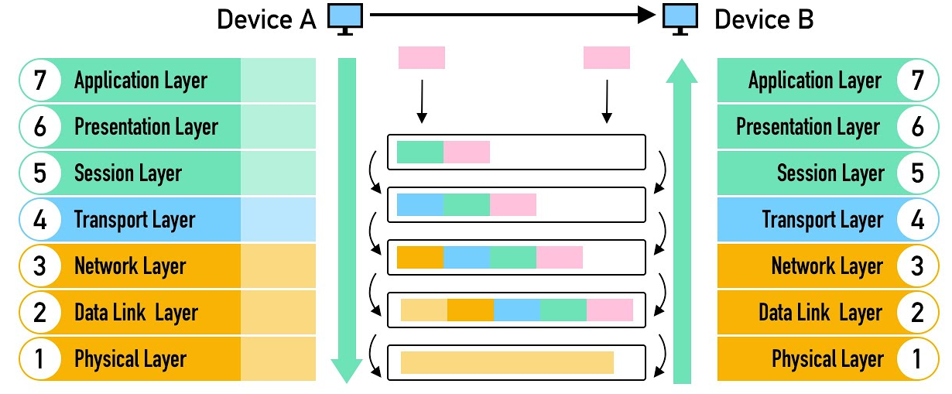

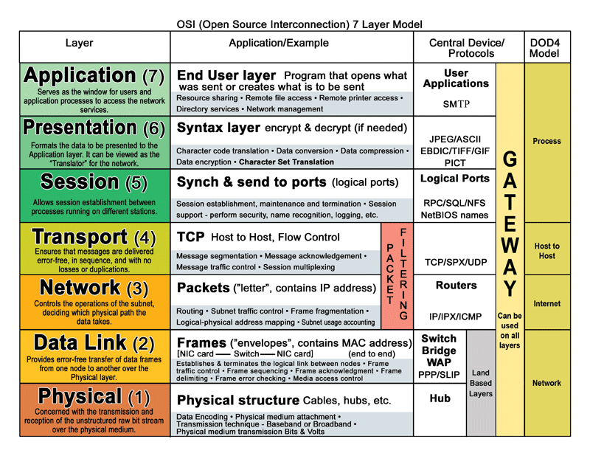
ASCII Table

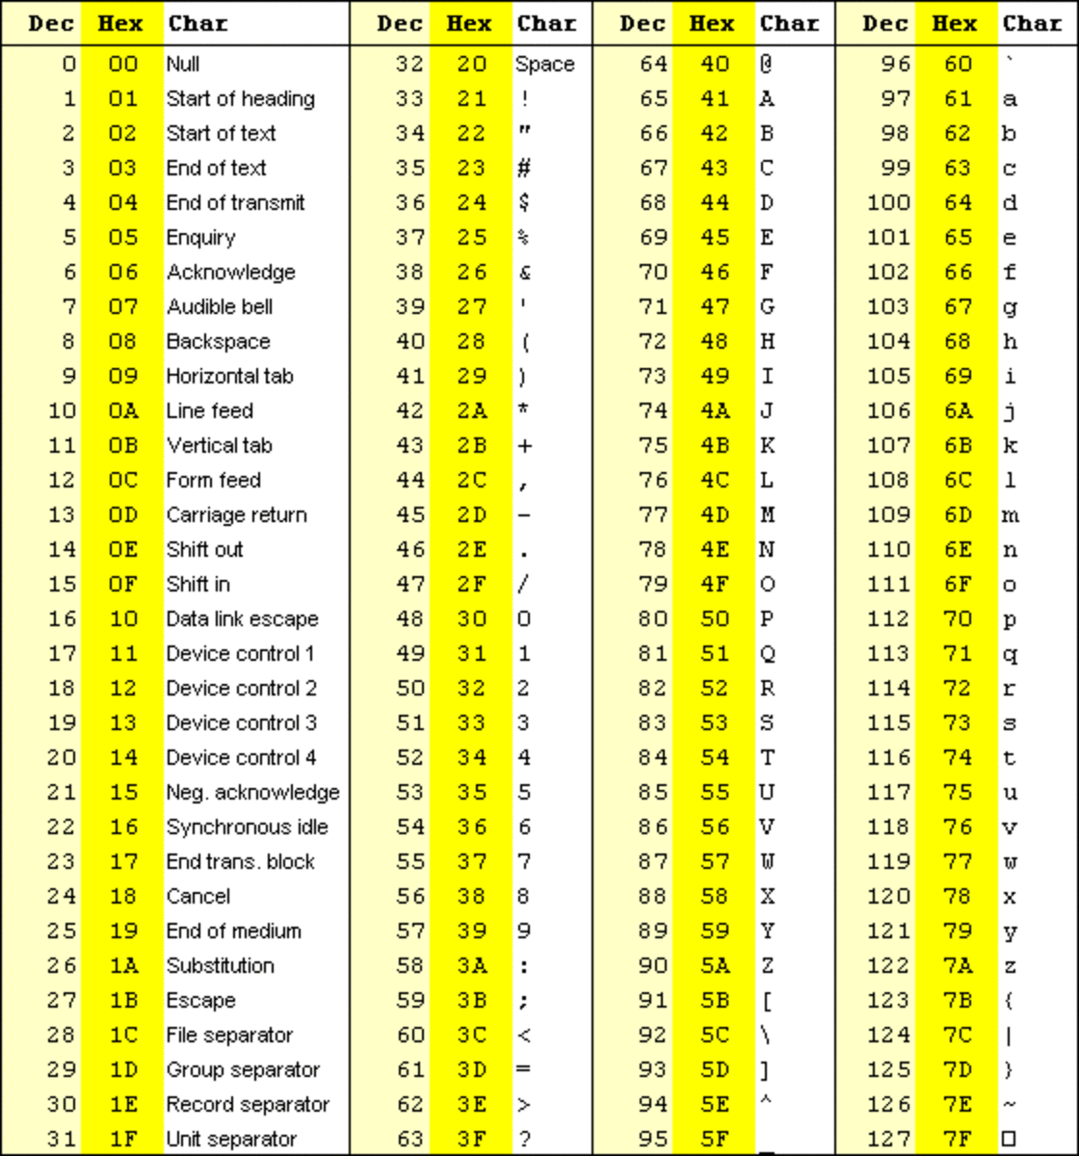

Extended ASCII Table

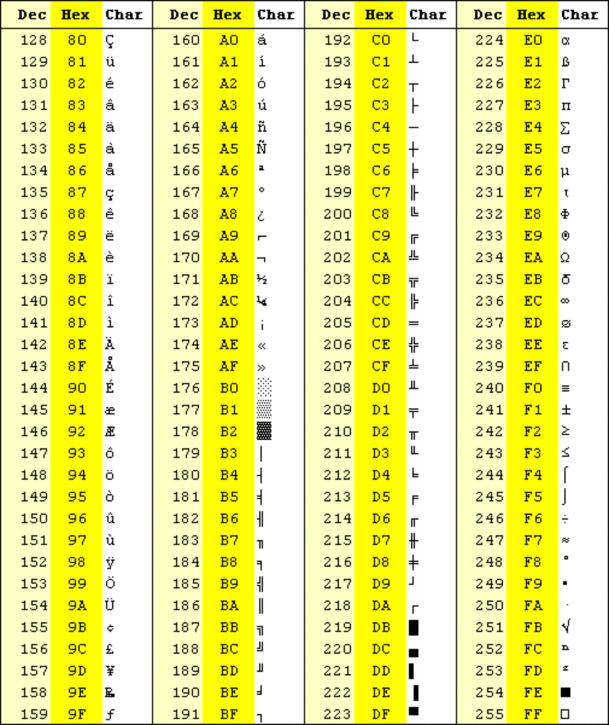

Intel x86 CPU Opcodes

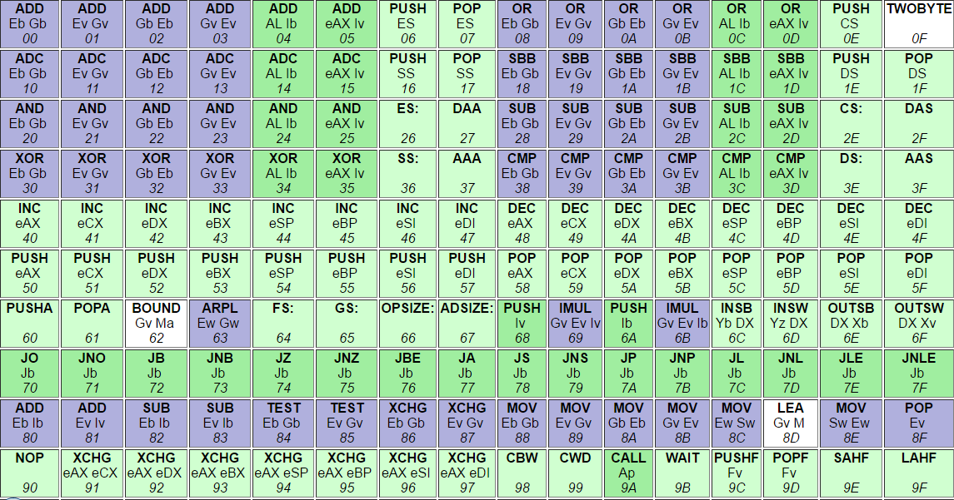

5. Identity & Access Management (IAM)

Topic | Diagrams and Lists

6. Security Assessment & Testing

Topic | Diagrams and Lists

7. Security Operations

Topic | Diagrams and Lists

8. Software Development Security

Topic | Diagrams and Lists

TBD

Topic | Diagrams and Lists

Sources
- <Author> (year). <Title>. <Link>

TBD

TBD | TBD | TBD | TBD

TBD

Certs | Description

