Harold’s Directed Graphs
Cheat Sheet
22 October 2022

Definitions

Term | Definition | Example
Vertices  (Nodes) | An individual element of V is called a vertex. | Set $V=\{a, b, c, d, e\}$  ① or ●
Edges  (Arcs) | A directed edge (u, v) ∈ E, is pictured as an arrow going from one vertex to another. | Set E ⊆ V x V  $$E=\{(a, b), (a, c), ..., (d, e)\}$$  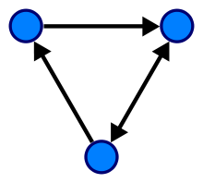
Directed Graph  (Digraph) | A finite set of dots called vertices (or nodes) that are connected by links called edges (or arcs). Consists of a pair (V, E).  A sequence of vertices in which there is a (directed) edge pointing from each vertex in the sequence to its successor in the sequence, with no repeated edges. | 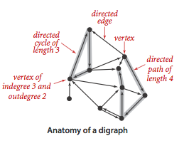
Self-Loop (Loop) | An edge that connects a vertex to itself. | 
In-Degree | The number of edges pointing into, to, or with v as their terminal vertex. | $$in-degree\left(v\right)=$$  $$|\{ u | (u, v) ∈ E \}|$$
Out-Degree | The number of edges pointing out of, from, or with v as their initial vertex. | $$out-degree\left(v\right)=$$  $$|\{ u | (v, u) ∈ E \}|$$
Walk | A sequence of alternating vertices and edges that starts and ends with a vertex. | $$〈v_{0}, (v_{0}, v_{1}), v_{1}, (v_{1}, v_{2}), v_{2}, ..., v_{l}〉$$  $$〈v_{0}, v_{1}, v_{2}, ..., v_{l}〉$$
Open Walk | A walk in which the first and last vertices are not the same. | $$〈a, ... , z〉$$
Closed Walk | A walk in which the first and last vertices are the same. | $$〈a, ... , a〉$$
Length | l, the number of edges in the walk, path, or cycle. | $$I=\left|E\right|$$
Trail | An open walk in which no edge occurs more than once. | $$〈a, b, c, d, c, b, a〉$$
Circuit | A closed walk in which no edge occurs more than once. | $$〈a, b, a, c, a〉$$
Path | A trail in which no vertex occurs more than once. | $$〈a, b, c, d〉$$
Cycle | A circuit of length at least 1 in which no vertex occurs more than once, except the first and last vertices which are the same. | $$〈a, b, c, a〉$$
DAG | A directed acyclic graph (or DAG) is a digraph with no directed cycles. | 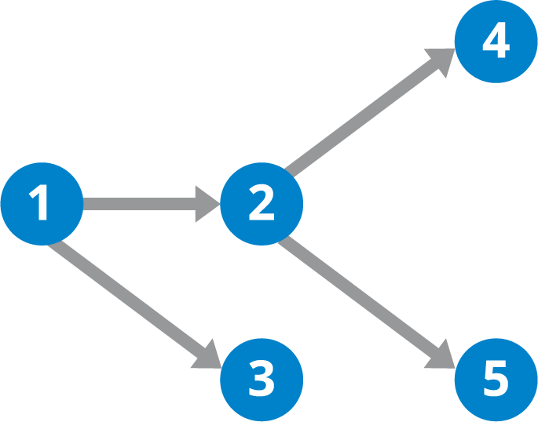

Digraph Theorems

Theorem | Definition and Examples
Graph Power Theorem (G^{k}) | Let G be a directed graph.  Let u and v be any two vertices in G.  There is an edge from u to v in G^{k} if and only if there is a walk of length k from u to v in G.
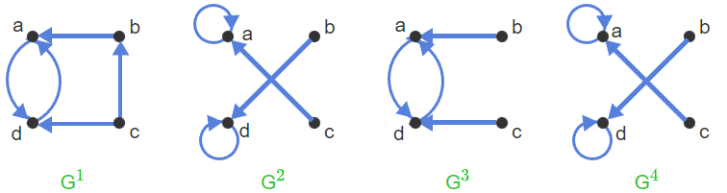

Transitive Closure | The union of G^{k} for all k ≥ 1 (denoted G⁺) represents reachability by walks of any length in G.  G⁺ = G¹ U G² U G³ U G⁴ … (infinite or up to |V|)  G⁺ = G¹ U G² U G³ U … U G^{n} (finite with n vertices)  R⁺ = R¹ U R² U R³ U … U R^{n} (finite with n elements)
Transitive Closure | 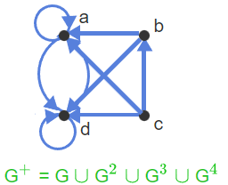
Procedure to find the transitive closure of a relation R on a set A | Repeat the following step until no pair is added to R:  ● If there are three elements x, y, z ∈ A such that (x, y) ∈ R, (y, z) ∈ R and (x, z) ∉ R, then add (x, z) to R.
 | 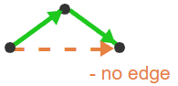

Boolean Matrix Operations

Term | Description
Adjacency Matrix | A directed graph G with n vertices that is represented by an n × n matrix over the set {0, 1}.  A_{i,j} = 1 if there is an edge from vertex i to vertex j in G, otherwise, A_{i,j} = 0.
Adjacency Matrix | 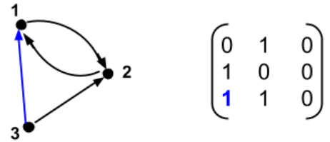
Boolean Matrix  {0, 1} | A matrix whose entries are from the set {0, 1}.  Purpose: Matrix addition and multiplication for square Boolean matrices are used to compute the transitive closure of a graph.
Dot Product | For Boolean matrices, if the dot product (sum of products) ≥ 1, then dot product = 1.
Matrix Product  (AB) | The product of two matrices, A and B, is well defined only if the number of columns in A is equal to the number of rows in B.  Associative, but not commutative.
k^{th} Power of a Matrix  (A^{k}) | $$A^{2}=A•A$$  $$A^{3}=A^{2}•A$$
Matrix A^{k} is the Adjacency Matrix for Graph G^{k} | Let G be a directed graph with n vertices and let A be the adjacency matrix for G. Then for any k ≥ 1, A^{k} is the adjacency matrix of G^{k}, where Boolean addition and multiplication are used to compute A^{k}.  There is a walk of length k in G from vertex v to vertex w if and only if the entry in row v, column w in A^{k} is 1.
Matrix A^{k} is the Adjacency Matrix for Graph G^{k} | How to read it:  There is a walk of length 3 in G from vertex 1 to vertex 3 if and only if there is an edge from 1 to 3 in G³. If row 1, column 3 of A³ is 0, then no such walk exists.
Matrix Sum  (A+B) | The sum of two matrices A and B is well defined if A and B have the same number of rows and the same number of columns.
Matrix Sum  (A+B) | For Boolean matrices, if the sum ≥ 1, then sum = 1.
Addition and Graph Union | Let G and H be two directed graphs with the same vertex set. Let A be the adjacency matrix for G and B the adjacency matrix for H. Then the adjacency matrix for G U H = A + B, where Boolean addition is used on the entries of matrices A and B.
Transitive Closure of G⁺ | Includes both Boolean multiplication and addition.  G⁺ = G¹ U G² U G³ U … U G^{n}  A⁺ = A¹ U A² U A³ U … U A^{n}  A⁺ shows every possible walk in G⁺ up to length n.
Order Properties of Binary Relations with Two Sets

Property | Logical Statement | Description
Reflexive | xRx  (x, x) ∈ R  ∀x ∈ A (xRx)  ∀x ∈ A ((x, x) ∈ R) | - i_{A} ⊆ R  where i_{A} is the identity relation of set A or i_{A} = {(x, x) | x ∈ A}  - Directed graph: Loop  
Anti-Reflexive | ¬ (xRx)  ∀x ∈ A ¬ (xRx) | - Directed graph: No loops
Symmetric | xRy ⟶ yRx  ∀x ∈ A ∀y ∈ A (xRy ⟶ yRx) | - R = R⁻¹  - Directed graph: 2-way arrow (edges come in pairs) or no arrows
Anti-Symmetric | (xRy ∧ yRx) ⟶ (x = y)  (x ≠ y) ⟶ ¬ (xRy) ∨ ¬ (yRx)  ∀x ∈ A ∀y ∈ A ((xRy ∧ yRx) ⟶ (x = y)) | - Equivalence  - Directed graph: An arrow from x to y implies that there is no arrow from y to x  
Asymmetric | xRy ⟶ ¬ (yRx)  ∀x ∈ A ∀y ∈ A ∀z ∈ A (xRy ⟶ ¬ (yRx)) | - Fails the vertical line test, so not a proper function, f(x)  - Directed graph: 1-way arrow
Transitive | (xRy ∧ yRz) ⟶ xRz  ∀x ∀y ∀z ((xRy ∧ yRz) ⟶ xRz)  ∀x ∈ A ∀y ∈ A ∀z ∈ A ((xRy ∧ yRz) ⟶ xRz) | - R ◦ R ⊆ R  - Similar to S ◦ R  - Directed graph: Two routes from every vertex A to every vertex B, 1-hop and 2-hops  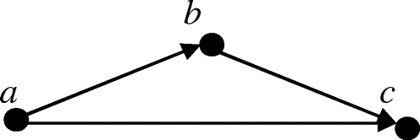
Total | xRy ∨ yRx  ∀x ∈ A ∀y ∈ A (xRy ∨ yRx) | - Either-or
Density | xRy ⟶ ∃z | xRz ∧ zRy  ∀x ∈ A ∀y (xRy) ⟶ ∃z | xRz ∧ zRy | - A middle-man exists
Binary | R⁻¹ ◦ R = Relation on set A  R ◦ R⁻¹ = Relation on set C | - Relation on set <set>  - Binary relation on set <set>
Identity | i_{A} = {(x, y) ∈ A × A | x = y}  i_{A} = {(x, x) | x ∈ A} | - Similar to a diagonal matrix
Composition  (S ∘ R) | S ◦ R = (a, c) ∈ S ◦ R ⟷ ∃b | (a, b) ∈ R and (b, c) ∈ S  {(a, c) ∈ A × C | ∃b ∈ B ((a, b) ∈ R and (b, c) ∈ S)}  aRb and bSc  {(a, c) ∈ A × C | ∃b ∈ B (aRb ∧ bSc)} | - The composition of S and R is the relation S ◦ R from A to C  - aRb and bSc, meaning R:a ⟶ R:b ⟶ S:b ⟶ S:c, so (R:a, S:c)  - Ring operator
Partial Orders

Term | Description | Additional
Partial Order | A relation R on a set A that is reflexive, transitive, and anti-symmetric.  A partial order acts like a ≤ operator on the elements of A. | aRb = a ⪯ b  "a is at most b"
Example | The ≤ operator acting on the set of integers is a partial order, denoted by (Z, ≤). The relation is:  - Reflexive (x ≤ x)  - Anti-symmetric (if x ≤ y and y ≤ x then x = y).  - Transitive (x ≤ y and y ≤ z implies that x ≤ z). | 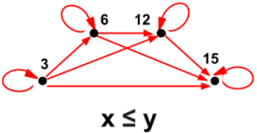
Poset | Partially Ordered Set  The domain along with a partial order defined on it is denoted (A, ⪯). | (A, ⪯)
Comparable | If x ⪯ y or y ⪯ x. | Example: (Z, ≤)
Incomparable | Not comparable.  Neither x ⪯ y nor y ⪯ x.  Either they are not connected at all by a path of line segments or the only paths between x and y require a change in direction from up to down or from down to up. | c and f are incomparable.  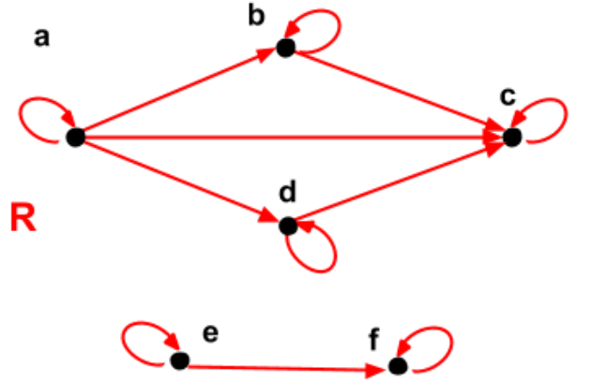
Total Order | If every two elements in the domain are comparable. | Example: (Z, ≤)
Minimal | An element x is a minimal element if there is no y ≠ x such that y ⪯ x.  Vertex x has in-degree = 0. | All edges are leaving the vertex.  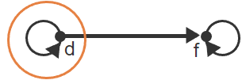
Maximal | An element x is a maximal element if there is no y ≠ x such that x ⪯ y.  Vertex x has out-degree = 0. | All edges are entering the vertex.  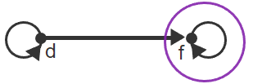
Hasse Diagram | Ordered from top to bottom to identify if comparable.  Incomparable if up then down or vice versa is needed.  Incomparable if “air gaped”. | 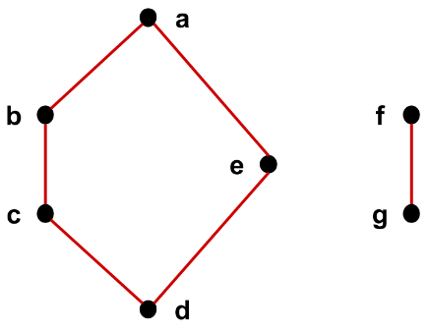

Strict Orders
Term | Description | Additional
Strict Order | A relation R on a set A that is transitive and anti-reflexive. Every strict order is anti-symmetric (assumed).  A strict order acts like a < operator on the elements of A. | aRb = a ≺ b  "a is less than b"
Example | The real numbers (R) along with the < relation is a strict order. The relation is:  - Transitive (if a < b and b < c, then a < c)  - Anti-reflexive (there is no real a such that a < a) | Examples:  (R, <)  (P(A), ⊂)
Comparable | Same as a partial order above, except:  Partial Order: ⪯  Strict Order: ≺ | The arrow diagram for a strict order is basically an arrow diagram for a partial order without the self-loops.
Incomparable
Total Order
Minimal
Maximal

Directed Acyclic Graphs (DAG)

Term | Description | Additional
DAG | Directed Acyclic Graph (DAG)  A directed graph (digraph) that has no directed cycles or positive length cycles.  Note that since a single vertex is a cycle of zero length.  Acyclic = No Cycles | 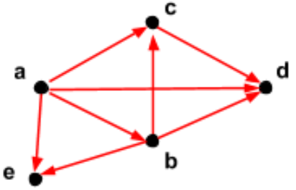
Example | Useful for representing precedence relationships or constraints. | College course prerequisites graph or software module dependencies.
Theorem: DAGs and Strict Orders | Let G be a directed graph.  G has no positive length cycles if and only if G⁺ is a strict order. | If G is a DAG, then G⁺ is a strict order.  If G⁺ is a strict order, then G is a DAG.
Topological Sort | If there is an edge (u, v), then u appears earlier than v. | A topological sort for a DAG G is also a topological sort for G⁺.
Example | One way to construct a topological sort for a DAG G is to:  1) Pick a vertex x with in-degree 0 and remove x from G.  2) Then pick another vertex with in-degree 0 from among the remaining vertices.  3) Keep selecting vertices until there are no vertices left.
Equivalence Relations

Term | Description | Additional
Equivalence Relation | A relation R is an equivalence relation if R is reflexive, symmetric, and transitive. | aRb = a ~ b  "a is equivalent to b"
Example | The domain is the set of all people.  Define relation B such that xBy if person x and person y have the same birthday. The relation B is:  - Reflexive since every person has the same birthday as himself/herself.  - Symmetric because if x has the same birthday as y, then y has the same birthday as x.  - Transitive because if x and y share a birthday and y and z share a birthday, then x and z must also share a birthday.
Equivalence Class | If A is the domain of an equivalence relation and a ∈ A, then [a] is defined to be the set of all x ∈ A such that a ~ x. | The set [a].  a ∈ A ⟶ [a] ⊆ A
Theorem: Structure of Equivalence Relations | Consider an equivalence relation on a set A. Let x, y ∈ A:  - If x ~ y then [x] = [y] (identical)  - If it is not the case that x ~ y, then [x] ∩ [y] = ∅ (completely disjoint) | The vertices of the network can be partitioned into sets of vertices that can all communicate with each other.
Partition | Consider an equivalence relation over a set A.  The set of all distinct equivalence classes defines a partition of A.  The term "distinct" means that if there are two equal equivalence classes [a] = [b], the set [a] is only included once. | Equivalence Relation ⟶ Equivalent Class ⟶ Partition ⟶  Set A
Example | 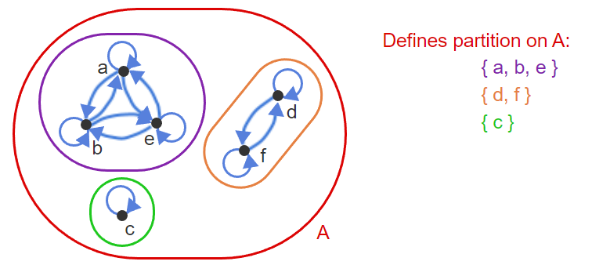
Pairwise Disjoint | The intersection of any pair of the sets is empty.
Strong Connectivity | Strong connectivity is an equivalence relation on the set of vertices:  - Reflexive: Every vertex v is strongly connected to itself.  - Symmetric: If v is strongly connected to w, then w is strongly connected to v.  - Transitive: If v is strongly connected to w and w is strongly connected to x, then v is also strongly connected to x.

Sources:
- SNHU MAT 230 - Discrete Mathematics, zyBooks.
- See also “Harold’s Undirected Graphs and Trees Cheat Sheet”.
- See also pages 9 & 10 of “Harold’s Sets Cheat Sheet” for Relations.

