Harold’s Greek & Math Symbols
Cheat Sheet
28 January 2026

Greek Alphabet

UC | LC | Name | Physics Variables | ALT Codes | LaTeX
Α |  | Alpha | Angular acceleration A (mechanics)  Finite increment notation A | ALT+0913 | \Alpha
 | α | Alpha | Coefficient of thermal expansion α  Fine‑structure constant α (non‑mech) | ALT+224  ALT+0945 | \alpha
Β |  | Beta |  | ALT+0914 | \Beta
 | β | Beta | Velocity ratio v/c β (non‑mech)  Beta radiation β | ALT+0946 | \beta
Γ |  | Gamma |  | ALT+0915 | \Gamma
 | γ | Gamma | Lorentz factor γ (relativistic kinematics)  Shear rate (rheology) γ | ALT+226  ALT+0947 | \gamma
Δ |  | Delta | Finite change (Δx, Δv)  Laplacian (older usage) Δ | ALT+0916 | \Delta
 | δ, δ | Delta | Infinitesimal change δ  Small deflection/offset δ | ALT+235  ALT+0948 | \delta
Ε |  | Epsilon |  | ALT+0917 | \Epsilon
 | ε, 𝜖 | Epsilon | Normal strain ε | ALT+238  ALT+0949 | \epsilon  \varepsilon
Ζ |  | Zeta |  | ALT+0918 | \Zeta
 | ζ | Zeta | Damping ratio ζ | ALT+0950 | \zeta
Η |  | Eta |  | ALT+0919 | \Eta
 | η | Eta | Efficiency η  Dynamic viscosity η | ALT+0951 | \eta
Θ |  | Theta | Heaviside step Θ (signals) | ALT+233  ALT+0920 | \Theta
 | θ, ϑ | Theta | Angular position θ  Plane angle ϑ | ALT+0952 | \theta  \vartheta
Ι |  | Iota |  | ALT+0921 | \Iota
 | ι | Iota | Very small quantity ι (informal) | ALT+0953 | \iota
Κ |  | Kappa |  | ALT+0922 | \Kappa
 | κ, ϰ | Kappa | Curvature κ | ALT+0954 | \kappa  \varkappa
Λ |  | Lambda |  | ALT+0923 | \Lambda
 | λ | Lambda | Wavelength λ  Eigenvalue λ | ALT+0955 | \lambda
Μ |  | Mu |  | ALT+0924 | \Mu
 | μ | Mu | Coefficient of friction μ  Reduced mass μ | ALT+230  ALT+0956 | \mu
Ν |  | Nu |  | ALT+0925 | \Nu
 | ν | Nu | Kinematic viscosity ν | ALT+0957 | \nu
Ξ |  | Xi |  | ALT+0926 | \Xi
 | ξ | Xi | Modal/beam coordinate ξ (FEM) | ALT+0958 | \xi
Ο |  | Omicron |  | ALT+0927 | O
 | ο | Omicron |  | ALT+0959 | o
Π |  | Pi | Product operator Π | ALT+0928 | \Pi
 | π, ϖ | Pi | Circle constant π | ALT+227  ALT+0960 | \pi  \varpi
Ρ |  | Rho |  | ALT+0929 | \Rho
 | ρ, ϱ | Rho | Mass density ρ | ALT+0961 | \rho  \varrho
Σ |  | Sigma | Summation operator Σ | ALT+228  ALT+0931 | \Sigma
 | σ, ς | Sigma | Normal stress σ | ALT+229  ALT+0963 | \sigma  \varsigma
Τ |  | Tau |  | ALT+0932 | \Tau
 | τ | Tau | Torque/Shear stress τ  Time constant τ | ALT+231  ALT+0964 | \tau
Υ |  | Upsilon | Upsilon particle Υ (HEP) | ALT+0933 | \Upsilon
 | υ | Upsilon | Specific volume υ (thermo/fluids) | ALT+0965 | \upsilon
Φ |  | Phi | Magnetic flux Φ  Work function Φ | ALT+232  ALT+0934 | \Phi
 | φ, φ | Phi | Azimuth angle φ  Rotation angle φ | ALT+237  ALT+0966 | \phi  \varphi
Χ |  | Chi |  | ALT+0935 | \Chi
 | χ | Chi | Material susceptibility χ  Chi‑squared χ² | ALT+0967 | \chi
Ψ |  | Psi |  | ALT+0936 | \Psi
 | ψ | Psi | Stream function ψ  Yaw/attitude angle ψ | ALT+0968 | \psi
Ω |  | Omega | Solid angle Ω  Electrical resistance unit symbol Ω | ALT+234  ALT+0937 | \Omega
 | ω | Omega | Angular velocity/frequency ω | ALT+0969 | \omega

Basic Math Symbols

Math Symbol | Name | ALT Codes | LaTeX
× | Multiplication  Cross product | ALT+158  ALT+0215 | \times
÷ | Division | ALT+246  ALT+0247 | \div
• | Bullet | ALT+8226  ALT+8729 | \bullet
◦ | Hollow dot | ALT+9702 | \circ
· | Middle dot  Dot operator  Dot product | ALT+0183  ALT+8729  ALT+8901 | \cdot
° | Degree | ALT+248  ALT+0176 | ^\circ
± | Plus-minus | ALT+241  ALT+0177 | \pm
∓ | Minus-plus | ALT+8723 | \mp
≤ | Less-or-equal | ALT+8804 | \leq (or \le)
≥ | Greater-or-equal | ALT+8805 | \geq (or \ge)
≰ | Not less-or-equal | ALT+8816 | \nleq
≱ | Not greater-or-equal | ALT+8817 | \ngeq
< | Less than | ALT+60 | <
≪ | Much less than | ALT+8810 | \ll
> | Greater than | ALT+62 | >
≫ | Much greater than | ALT+8811 | \gg
≠ | Not equal to | ALT+8800 | \neq
≈ | Approximately equal | ALT+8776 | \approx
≉ | Not approximately equal | ALT+8777 | \not\approx
≅ | Congruent to | ALT+8773 | \cong
≇ | Not congruent to | ALT+8775 | \ncong
≡ | Identically equal to  Definition symbol | ALT+8801 | \equiv
≢ | Not identically equal to | ALT+8802 | \not\equiv  \nequiv
∝ | Proportional to | ALT+8733 | \propto
< | Less than | ALT+60 | <
≪ | Much less than | ALT+8810 | \ll
> | Greater than | ALT+62 | >
≫ | Much greater than | ALT+8811 | \gg
← | Left arrow | ALT+8592 | \leftarrow
→ | Right arrow | ALT+8594 | \rightarrow
↑ | Up arrow | ALT+8593 | \uparrow
↓ | Down arrow | ALT+8595 | \downarrow
↔ | Left-right arrow | ALT+8596 | \leftrightarrow
↕ | Up-down arrow | ALT+8597 | \updownarrow
Ø | Empty set | ALT+157  ALT+0216 | \emptyset
∩ | Intersection | ALT+8745 | \cap
∪ | Union | ALT+8746 | \cup
∧ | Logic and | ALT+9743 | \land
∨ | Logic or | ALT+8744 | \lor
⊆ | Subset | ALT+8838 | \subseteq
⊂ | Proper subset | ALT+8834 | \subset
⊇ | Superset | ALT+8839 | \supseteq
⊃ | Proper superset | ALT+8835 | \supset
⊈ | Not a subset | ALT+8840 | \nsubseteq
⊄ | Not a proper subset | ALT+8836 | \nsubset
⊉ | Not a superset | ALT+8841 | \nsupseteq
⊅ | Not a proper superset | ALT+8837 | \nsupset
∈ | An element of | ALT+8712 | \in
∉ | Not an element of | ALT+8713 | \notin
⊙ | Circled dot  Dot product | ALT+8857 | \odot
⊗ | Tensor  Vector cross | ALT+8855 | \otimes
⊕ | Circle plus | ALT+9953 | \oplus
∫ | Integral | ALT+8747 | \int
⌠ | Top integral | ALT+8992 | \int
⌡ | Bottom integral | ALT+8993 | \int
∂ | Partial derivative | ALT+8706 | \partial
∇ | Nabla  Gradient | ALT+8711 | \nabla
∡ | Measured angle | ALT+8737 | \measuredangle
ħ | Reduced Planck constant | ALT+0295 | \hbar
ℓ, ℓ, 𝓁 | Script small L | ALT+8467  1D459 Alt+X  1D4C1 Alt+X | \ell
√ | Square root | ALT+251  ALT+8730 | \sqrt{}
∛ | Cube root | ALT+8731 | \sqrt[3]{}
∜ | Fourth root | ALT+8732 | \sqrt[4]{}
∞ | Infinity | ALT+236  ALT+8734 | \infty
¼ | One quarter | ALT+171  ALT+0188 | \frac{1}{4}
½ | One half | ALT+172  ALT+0189 | \frac{1}{2}
¾ | Three quarters | ALT+243  ALT+0190 | \frac{3}{4}
¹ | Superscript 1 | ALT+0185 | ^{1}
² | Superscript 2 | ALT+0178 | ^{2}
³ | Superscript 3 | ALT+0179 | ^{3}
ⁿ | Superscript n | ALT+8319 | ^{n}

Inserting ALT Codes (ddd, dddd)
- Ensure that Num Lock is enabled on your keyboard.
- Press and hold the ALT key and type the 3-digit ASCII character code on the numeric keypad.
or
- Press and hold the ALT key and type the 4-digit Windows ALT code character on the numeric keypad.
Inserting Unicode Characters (U+dddd)
- Type the character code where you want to insert the Unicode symbol.
- Press ALT+X to convert the code to the symbol.

MS Word Equation Editor
Greek Alphabet
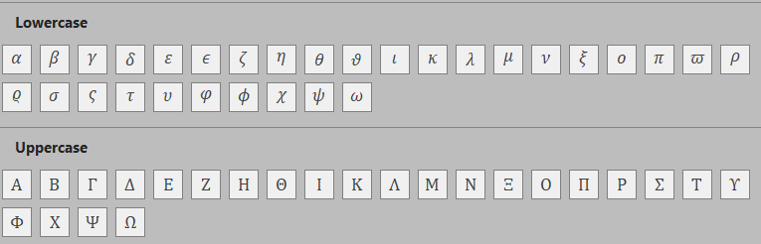

Basic Math Symbols
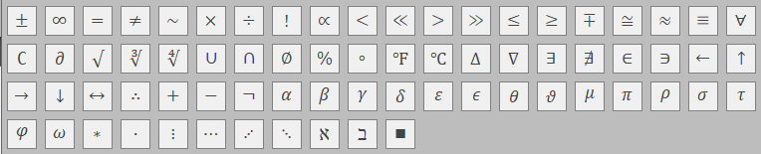

Operators
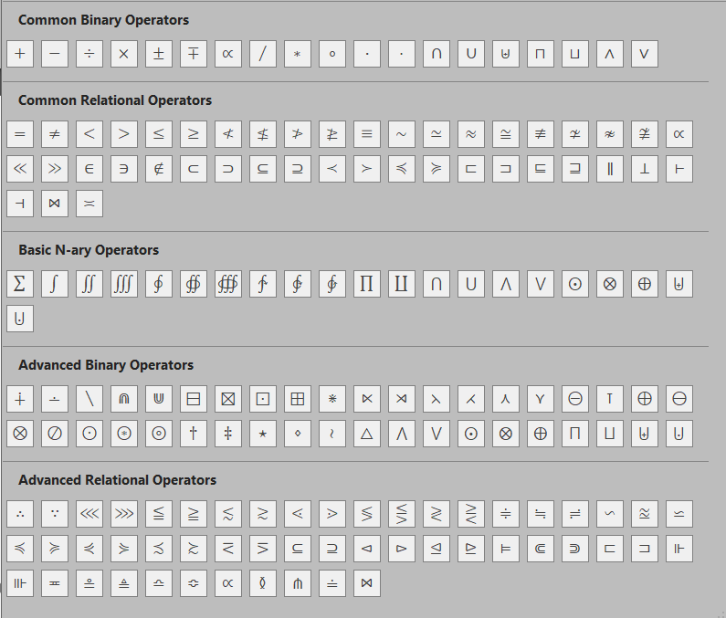

Sources
- Microsoft Copilot Chatbot (2026).
  - Create a table of upper and lowercase Greek characters with names, ALT codes, and physics usage.
  - Create a table of all common math characters from the ASCII tables with ALT codes, description, and category.
https://m365.cloud.microsoft/chat/
- Microsoft Corp. (2026). Microsoft Word, Equation Editor.

