Harold’s High School Chemistry
Cheat Sheet
22 October 2025

Chapter 1: Measuring Up

Term | Equation | Note
Rulers | When using a ruler that is marked off in 16ths of an inch, report your answers to a hundredth of an inch.
Units | The unit of measurement is just as important as the number.  You must always list the units, followed by the compound!  Example: 6.28 mL H₂O
Significant Figures | - All non-zero figures (1, 2, 3, 4, 5, 6, 7, 8, and 9) are significant.  - A zero (0) is significant if it is between two significant digits.  - A zero (0) is also significant if it’s at the end of the number and to the right of the decimal point.
Using SigFigs | - When adding and subtracting measurements, you must report your answer to the same precision as the least precise number in the problem.  - When multiplying and dividing measurements, you must report your answer with the same number of significant figures as the measurement that has the fewest significant figures.  - There is always some error in the last significant figure of a measurement.
Precision vs. Accuracy | - Precision: The consistency and reproducibility of measurements (e.g., 10 decimal places).  - Accuracy: How close a measurement is to the true or accepted value.
Prefixes
  Prefix | Abbreviation | Meaning | Scientific
  giga | G | 1,000,000,000 | 10⁹
  mega | M | 1,000,000 | 10⁶
  kilo | k | 1,000 | 10³
  hector | H | 100 | 10²
  deca | Da | 10 | 10¹
  centi | c | 0.01 | 10⁻²
  milli | m | 0.001 | 10⁻³
  micro | μ | 0.000001 | 10⁻⁶
  nano | n | 0.000000001 | 10⁻⁹
Scientific Notation | 14,000,000 = 1.4 ⨯ 10⁷ = 1.4E7 | 0.00000014 = 1.4 ⨯ 10⁻⁷ = 1.4E–7
Measuring | Volume ($L$) | 1 cm³ = 1 mL
Measuring | Mass ($g$) | weight = mass ⨯ gravity
Measuring | Density (ρ) | $$density=\frac{mass}{volume} or ρ=\frac{m}{V}$$
Unit Conversion (Train Track Method) | 0.1436 mL = ? m³
  143.6 L | 1000 mL | 1 cm³ | (1 m)³ | 0.1436 m³
   | 1 L | 1 mL | (100 cm)³
Chapter 2: What’s The Matter

Term | Equation | Note

Chapter 3: Making Sense of Atoms and Elements

Term | Equation | Note

Chapter 4: The Modern View of Atoms and Their Chemistry

Term | Equation | Note
Wave
Particle
Orbitals | 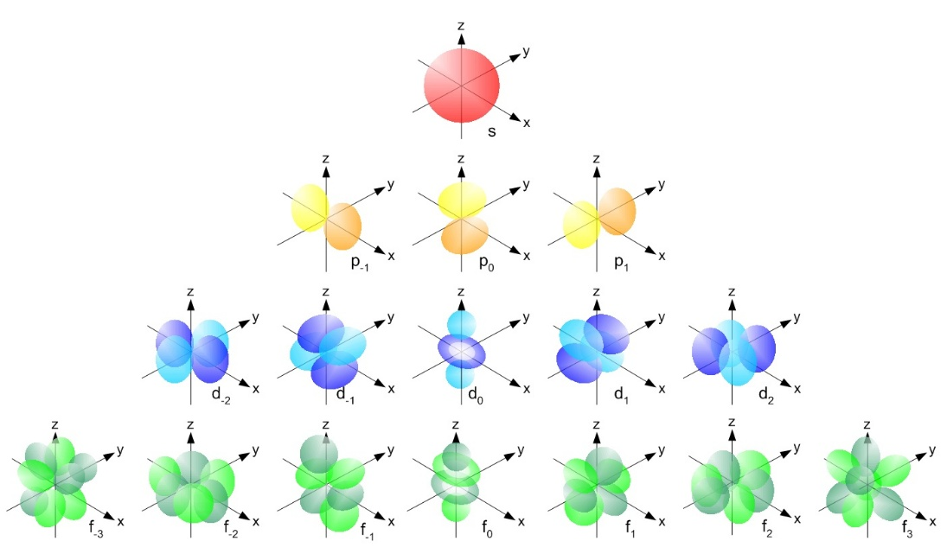

Chapter 5: Covalent Compounds and Their Molecular Geometry

Term | Equation | Note

Chapter 6: Physical and Chemical Changes

Term | Equation | Note

Chapter 7: Stoichiometry

Term | Equation | Note

Chapter 8: Still More on Stoichiometry

Common Polyatomic Ions (Memorize)

# | Name | Ion
1 | Ammonium | $$NH_{4}^{+}$$
2 | Hydronium | $$H_{3}O^{+}$$
3 | Acetate | $$C_{2}H_{3}O_{2}^{-}$$
4 | Cyanide | $$CN^{-}$$
5 | Bicarbonate | $$HCO_{3}^{-}$$
6 | Carbonate | $$CO_{3}^{2-}$$
7 | Hydroxide | $$OH^{-}$$
8 | Nitrite | $$NO_{2}^{-}$$
9 | Nitrate | $$NO_{3}^{-}$$
10 | Sulfite | $$SO_{3}^{2-}$$
11 | Sulfate | $$SO_{4}^{2-}$$
12 | Phosphate | $$PO_{4}^{3-}$$
13 | Chlorite | $$ClO_{2}^{-}$$
14 | Manganate | $$MnO_{4}^{2-}$$

Chapter 9: Chemists Have Solutions

Term | Description | Equation
Dissolving Compounds | - When ionic compounds dissolve, they split up into their individual atoms.  - When polar covalent compounds dissolve, they split up into their individual molecules.
Solubility of Solutes | .
  State | Temperature | Pressure
  Solid | ⬆ | -
  Liquid | - | -
  Gas | ⬇ | ⬆
Concentration | The behavior of a chemical often depends on concentration.
Molarity | $$Molarity=\frac{moles of solute}{liters of solution} M$$ | Liters
Molality | $$Molality=\frac{moles of solute}{kilograms of solvent} m$$ | Kilograms
Freezing Point Depression | $$∆T=-i∙K_{f}∙m$$ | $$K_{f_H_{2}O}=1.86 °C/m$$
Boiling Point Elevation | $$∆T=i∙K_{b}∙m$$ | $$K_{b_H_{2}O}=0.512 °C/m$$

Chapter 10: It’s a Gas!

Term | Equation | Note
Ideal Gas Law | $$PV=nRT$$ | $$P=Pressure \left(atm\right)$$  $$V=Volume (L)$$  $$n=\# Moles of gas$$  Ideal Gas Constant (R):  $$R=0.0821\frac{L atm}{mole K}$$  $$T=Temperature (K)$$
Boyle’s Law | $$P_{1}V_{1}=P_{2}V_{2}$$ | Assumes $T=constant$
Charle’s Law | $$\frac{V_{1}}{T_{1}}=\frac{V_{2}}{T_{2}}$$ | Assumes $P=constant$
Combined Gas Law | $$\frac{P_{1} V_{1}}{T_{1}}=\frac{{P_{2} V}_{2}}{T_{2}}$$ | Since $nR=constant$
Avagadro’s Law | $$n=\frac{PV}{RT}$$ | Same number of molecules or atoms
Volumes of Gases | $$V=\frac{nRT}{P}$$ | Relationship between volumes of those gases
Kelvin (T) | $$K=°C+273.15$$  $$0 K=Absolute Zero$$ | $$°F=\left(\frac{9}{5}\right)°C+32 [32°-212°]$$  $$°C=\left(\frac{5}{9}\right)\left(°F-32\right) [0°-100°]$$
Pressure (P) | $$P=\frac{F}{A}$$ | $$Pressure=\frac{Force}{Area}$$
Pressure (P) | $$1 atm=760 torr$$  $$1 torr=1 mmHg$$  $$1 mmHg=133.322 Pa$$  $$1 atm=101,325 Pascals (Pa)$$ | Units can be torr, atm, or Pa
Ideal Gas | - The molecules or atoms that make up the gas occupy no volume.  - The molecules or atoms that make up the gas are not attracted to each other.  - The collisions that occur between the molecules or atoms that make up the gas are elastic, which means no energy is lost in such a collision. This is also true for any collisions between the molecules or atoms that make up the gas and the walls of the container in which the gas is held.
STP | A gas is at STP if its pressure is 1 atm and its temperature is $0°C$. | Standard Temperature and Pressure
Dalton’s Law | $$P_{total}=P_{a}+P_{b}+P_{c}+…$$ | Partial pressures
Mole Fraction | $$X_{a}=\frac{P_{a}}{P_{total}}$$ | $$X_{a}=\frac{moles of compound a}{total moles in the mixture}$$
Vapor Pressure | Boiling point = The temperature at which a liquid’s vapor pressure is equal to the external air pressure.
Extrapolation | Extending a trend in data to situations for which no measurements have been made. Usually linear approximations.

Vapor Pressure of Water

Temperature  (°C) | Vapor Pressure (torr) |  | Temperature  (°C) | Vapor Pressure (torr)
0 | 4.6 |  | 39 | 52.4
2 | 5.3 |  | 40 | 55.3
4 | 6.1 |  | 42 | 61.5
6 | 7.0 |  | 44 | 68.3
8 | 8.0 |  | 46 | 75.5
10 | 9.2 |  | 48 | 83.7
12 | 10.5 |  | 50 | 92.5
14 | 12.0 |  | 52 | 102.1
15 | 12.8 |  | 54 | 112.5
16 | 13.6 |  | 56 | 123.8
17 | 14.5 |  | 58 | 136.1
18 | 15.5 |  | 60 | 149.4
19 | 16.5 |  | 62 | 163.8
20 | 17.5 |  | 64 | 179.3
21 | 18.7 |  | 66 | 196.1
22 | 19.8 |  | 68 | 214.2
23 | 21.1 |  | 70 | 233.7
24 | 22.4 |  | 72 | 254.6
25 | 23.8 |  | 74 | 277.2
26 | 25.2 |  | 76 | 301.4
27 | 26.7 |  | 78 | 327.3
28 | 28.3 |  | 80 | 355.1
29 | 30.0 |  | 82 | 384.9
30 | 31.8 |  | 84 | 416.8
31 | 33.7 |  | 86 | 450.9
32 | 35.7 |  | 88 | 487.1
33 | 37.7 |  | 90 | 525.8
34 | 39.9 |  | 92 | 567.0
35 | 42.2 |  | 94 | 610.9
36 | 44.6 |  | 96 | 657.6
37 | 47.1 |  | 98 | 707.3
 | 49.7 |  | 100 | 760.0

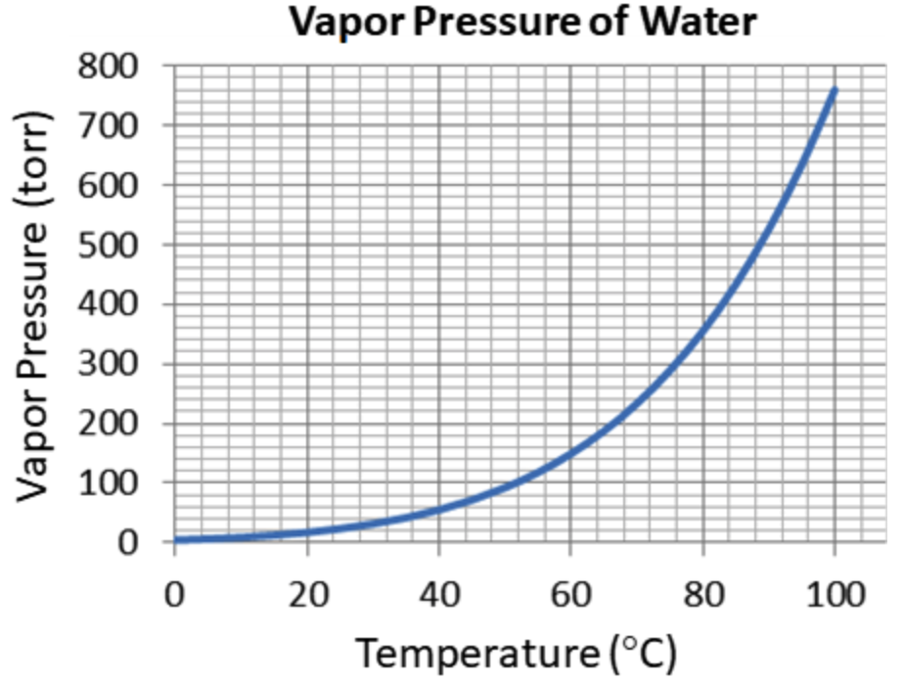
Chapter 11: Some Pretty Basic (and Acidic) Chemicals

Term | Equation / Definition | Note
Acids  (Acidic) | A chemical that donates an H⁺.  Have more H⁺ ions. | - Tend to taste sour  - Are covalent electrolytes  - Turn blue litmus paper red
Bases  (Alkaline) | A chemical that accepts an H⁺.  Have more OH– ions. | - Tend to taste bitter  - Tend to feel slippery when mixed with water  - Turn red litmus paper blue
Litmus | An acid/base indicator that is usually on a strip of paper
Amphoteric  (Amphiprotic) | Capable of reacting as either an acid or a base ($H_{2}O$, metal oxides)
Covalent Electrolytes | hydrofluoric acid + water ⟶ fluoride ion + hydronium ion  $$HF+H_{2}O⟶F^{-}+H_{3}O^{-}$$  acid base .
Covalent Electrolytes | ammonium hydroxide (ammonia) + water ammonium ion + hydroxide ion  $$NH_{3}+H_{2}O⟶NH_{4}^{+}+OH^{-}$$  base acid .
Ionic Electrolytes | hydrochloric acid + sodium hydroxide (lye) water + salt  $$HCl \left(aq\right)+NaOH \left(aq\right)⟶H_{2}O\left(l\right)+NaCl (aq)$$  acid base $\left(Na^{+}OH^{-}\right)$ $\left(Na^{+}Cl^{-}\right)$ .
Acid/Base Identification Rules | - Ammonia ($NH_{3}$) is a covalent base.  - If a covalent compound starts with an $H$, it can usually act like an acid.  - Ionic compounds that contain the hydroxide ion $\left(OH^{-}\right)$ can act as bases.  - An acid reacts with an ionic base to make water ($H_{2}O$) and salt ($NaCl$).
pH Scale | Potential hydrogen (pH).  Amount of hydronium ion ($H_{3}O^{-}$) in the solution. | 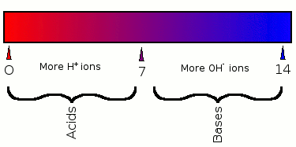
pH Scale | pH of 0: highly acidic  pH of 7: neutral .  pH of 14: highly alkaline
Polyprotic Acid | An acid that can donate two or more H⁺ ions. Examples:  hydrogen sulfate ($H_{2}SO_{4}$), carbonic acid ($H_{2}CO_{3})$  $$CO_{2} \left(g\right)+H_{2}O \left(l\right)⟶H_{2}CO_{3} \left(aq\right) acid rain$$
Titration | The process by which an acid of known concentration is added to a base of unknown concentration (or vice versa) until a neutral pH is reached to determine the unknown concentration.

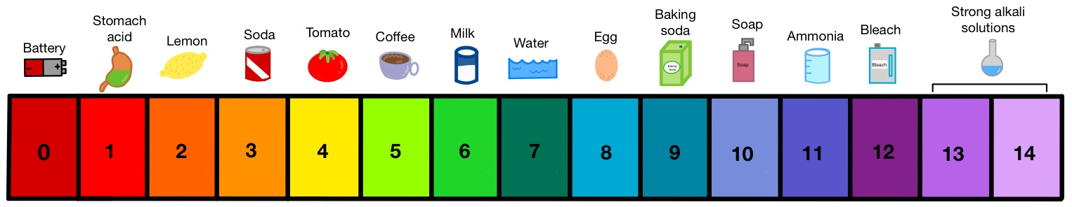
pH of Acids |  |  |  |  |  | pH of Bases
Acid | Name | 1 mM | 10 mM | 100 mM |  | Base | Name | 1 mM | 10 mM | 100 mM
H₂SeO₄ | selenic acid | 2.74 | 1.83 | 1 |  | Ba(OH)₂ | barium hydroxide | 11.27 | 12.22 | 13.08
H₂SO₄ | sulfuric acid  (oil of vitriol) | 2.75 | 1.87 | 1 |  | Sr(OH)₂ | strontium hydroxide (caustic alkali) | 11.27 | 12.22 | 13.09
HI | hydroiodic acid (muriatic acid) | 3.01 | 2.04 | 1.1 |  | NaOH | sodium hydroxide  (lye) | 10.98 | 11.95 | 12.88
HBr | hydrobromic acid | 3.01 | 2.04 | 1.1 |  | KOH | potassium hydroxide (caustic potash) | 10.98 | 11.95 | 12.88
HCl | hydrochloric acid  (gastric acid) | 3.01 | 2.04 | 1.1 |  | Na₂SiO₃ | sodium metasilicate | 11 | 11.91 | 12.62
HNO₃ | nitric acid | 3.01 | 2.04 | 1.1 |  | Ca(OH)₂  (CaO:H₂O) | calcium hydroxide  (lime) | 11.27 | 12.2 | 12.46
H₃PO₄ | orthophosphoric acid | 3.06 | 2.26 | 1.6 |  | Na₃PO₄ | trisodium phosphate  (food additive) | 10.95 | 11.71 | 12.12
H₃AsO₄ | arsenic acid | 3.08 | 2.31 | 1.7 |  | K₂CO₃ | potassium carbonate (potash or pearl ash) | 10.52 | 11 | 11.36
H₂SeO₃ | selenous acid | 3.15 | 2.47 | 1.9 |  | Na₂CO₃ | sodium carbonate  (soda ash) | 10.52 | 10.97 | 11.26
H₂CrO₄ | chromic acid | 3.03 | 2.33 | 2.1 |  | NH₄OH  (NH₃:H₂O) | ammonium hydroxide (Windex) | 10.09 | 10.61 | 11.12
C₆H₈O₇ | citric acid (lemon juice) | 3.24 | 2.62 | 2.1 |  | Mg(OH)₂  (MgO:H₂O) | magnesium hydroxide | 10.4 | 10.4 | 10.4
HF | hydrofluoric acid | 3.27 | 2.65 | 2.1 |  | CaCO₃ | calcium carbonate (limestone or calcite) | 9.91 | 9.91 | 9.91
HNO₂ | nitrous acid | 3.28 | 2.67 | 2.1 |  | Fe(OH)₂ | iron(II) hydroxide  (ferrous hydroxide) | 9.45 | 9.45 | 9.45
HOCN | isocyanic acid | 3.35 | 2.76 | 2.2 |  | Cd(OH)₂ | cadmium hydroxide | 9.36 | 9.36 | 9.36
CH₂O₂ | formic acid, (formic or methanoic acid) | 3.47 | 2.91 | 2.4 |  | Na₂B₄O₇ | sodium borate  (Borax) | 9.21 | 9.17 | 9.05
H₂Se | hydrogen selenide | 3.49 | 2.93 | 2.4 |  | Co(OH)₂ | cobalt(II) hydroxide | 9.15 | 9.15 | 9.15
H₂MoO₄ | molybdic acid | 3.46 | 2.94 | 2.4 |  | Zn(OH)₂ | zinc hydroxide | 8.88 | 8.88 | 8.88
C₃H₆O₃ | lactic acid  (milk acid) | 3.51 | 2.96 | 2.4 |  | Ni(OH)₂ | nickel(II) hydroxide | 8.37 | 8.37 | 8.37
C₂H₄O₂ | acetic acid  (vinegar) | 3.91 | 3.39 | 2.9 |  | CH₃COOK | potassium acetate  (diuretic salt) | 7.87 | 8.33 | 8.75
H₂CO₃ | carbonic acid | 4.68 | 4.18 | 3.7 |  | CH₃COONa | sodium acetate  (acetic acid) | 7.87 | 8.33 | 8.75
H₂S | hydrogen sulfide | 4.97 | 4.47 | 4 |  | KHCO₃ | potassium hydrogen carbonate | 8.27 | 8.25 | 8.13
H₃AsO₃ | arsenious acid | 6.07 | 5.58 | 5.1 |  | NaHCO₃ | sodium hydrogen carbonate  (baking soda) | 8.27 | 8.22 | 8.02
HCN | hydrocyanic acid | 6.11 | 5.62 | 5.1 |  | Be(OH)₂ | beryllium hydroxide | 7.9 | 7.9 | 7.9
H₃BO₃ | boric acid | 6.12 | 5.62 | 5.1 |  | Cu(OH)₂ | copper(II) hydroxide | 7.69 | 7.69 | 7.69
H₄SiO₄ | silicic acid | 6.4 | 5.91 | 5.4 |  | Pb(OH)₂ | lead(II) hydroxide | 7.54 | 7.54 | 7.54
H₄SiO₄ | silicic acid | 6.4 | 6.26 | 6.3 |  | Cr(OH)₃ | chromium(III) hydroxide | 7.04 | 7.04 | 7.04
H₂O | pure water | 7.0 | 7.0 | 7.0 |  | Hg(OH)₂ | mercury(II) hydroxide | 7.03 | 7.03 | 7.03

Source: aqion (27 Oct 2024), pH of Common Acids and Bases, https://www.aqion.de/

Chapter 12: Reduction and Oxidation

Term | Description |  | Equation
Chemical Reaction Types | - Synthesis (Formation)  - Decomposition  - Single Displacement  - Double Displacement  - Combustion  - Acid-Base  - Reduction-Oxidation |  | - A + B ⟶ AB  - AB ⟶ A + B  - A + BC ⟶ AC + B  - AB + CD ⟶ AD + CB  - C₃H₈ + 5O₂ ⟶ 3CO₂ + 4H₂O + heat (propane)  - HA + BOH ⟶ BA + H₂O  - $Fe^{0}+O_{2}^{0}⟶Fe_{2}^{3+}+O_{3}^{2-}$
Oxidation State | The charge on an ion, or for a molecule, the charge that an atom would have, if the shared electrons in a bond were always given to the more electronegative atom.  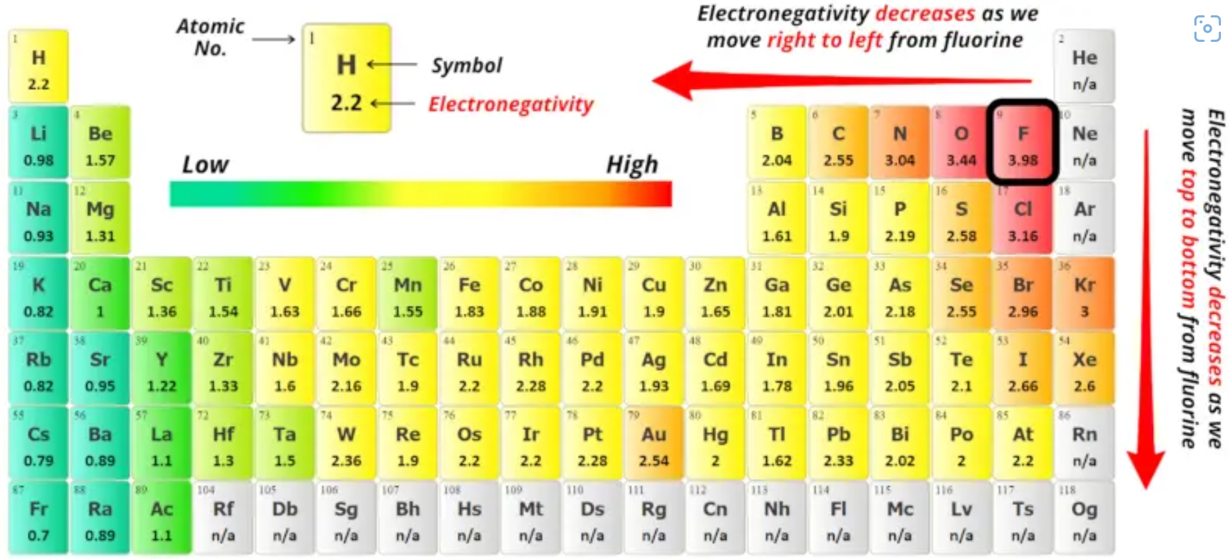
Oxidation State | Covalent |  |  | Ionic
Oxidation State | CF₄ ⟶ C⁴⁺ + 4F– | 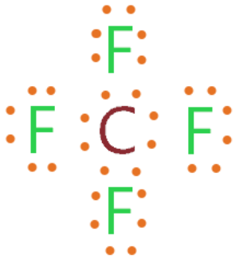 |  | Al₂O₃ ⟶ 2Al³⁺ + 3O^{2–} | 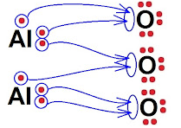
Oxidation State Rules | These rules are always true:  - For ions composed of only one atom, the oxidation state is equal to the charge on the ion.  - For all elements and homonuclear molecules, the oxidation state of each atom is 0.  - For molecules and polyatomic ions, the sum of the oxidation states must equal the total charge.  - The oxidation state of F in any compound is 1-.  - In covalent compounds and polyatomic ions, H has an oxidation state of 1+.  These rules are usually true:  - In most compounds, O has an oxidation state of 2-.  - Group 7A elements (especially Cl) usually have an oxidation state of 1-.

Reduction-Oxidation (Redox) | 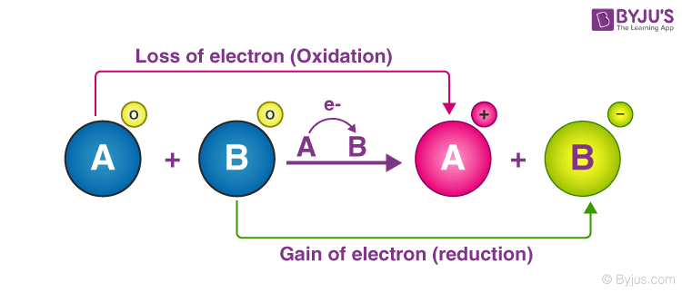  Reactions that transfer electrons from one set of atoms to another.  LEO says GER.
Oxidized | Atom loses an electron | “Lose Electrons Oxidation” (LEO)
Reduced | Atom gains an electron | “Gain Electrons Reduction” (GER)
 | 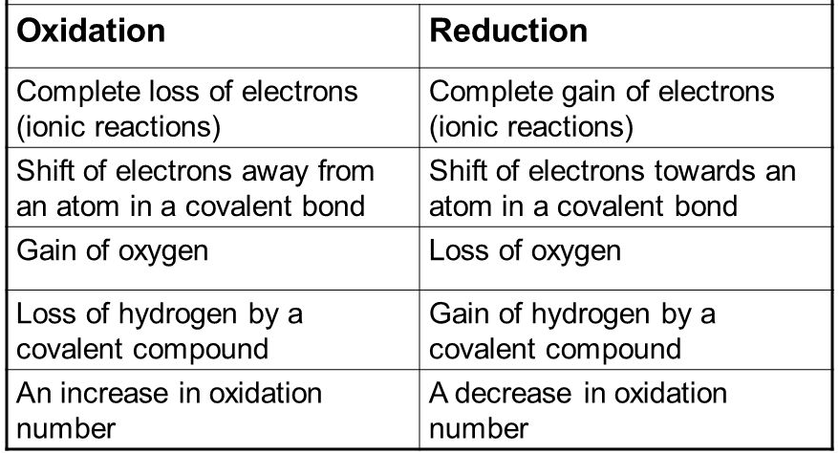
Oxidizing Agent | If a reactant is reduced, it is called the oxidizing agent, because it oxidizes another reactant.
Reducing Agent | If a reactant is oxidized, it is called the reducing agent, because it reduces another reactant.
Batteries | Galvanic Cell (battery) | A system that uses a redox reaction to produce electrical energy.
Batteries | Anode | The negative electrode in a Galvanic cell.
Batteries | Cathode | The positive electrode in a Galvanic cell.
Batteries | 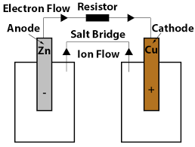
Balancing Charge | For a chemical equation to be balanced, the total charge on each side of the equation must be the same.
Electroplating | Using reduction (usually powered by electricity) to coat an object with a metal.
Corrosion | The chemical deterioration of a substance, usually by oxidation. (rust)
Chapter 13: The Heat Is On

Term | Equation | Note
Energy | $$E=W+q+K+∆U$$ | The ability to do work.  Units are energy are always in Joules ($J$).  Conservation of energy $\left(E_{i}=E_{f}\right)$.
Work | $$W=Fd$$ | The application of a force to move an object over a distance.
Heat | $$q$$ | Energy that is exchanged because of a difference in temperature or a phase change.
Kinetic Energy | $$K=\frac{1}{2}mv^{2}$$ | Energy that is in motion.
Potential Energy | $$∆U_{g}=mgh$$ | Energy that is stored.
calorie | $$1 calorie=4.184 J$$ | The amount of heat required to raise 1 gram of water 1 degree Celsius.
Calorie | 1 Food Calorie = 1,000 chemist calories | Big ‘C’ vs. little ‘c’.
Specific Heat Capacity (c) | $$c_{H_{2}O}=4.184 \frac{J}{g °C}$$ | The amount of heat it takes to raise a specific mass of a substance 1 °C.
Heat Capacity (C) | $$q=C·∆T$$ | The amount of heat it takes to raise an entire object 1 °C.  Takes the mass of the object into account.
Measuring Heat | $q=m·c·∆T$ .  where:  $$m=mass$$  $$c=specific heat capacity$$  $$∆T=T_{final}-T_{initial}$$
Calorimeter | 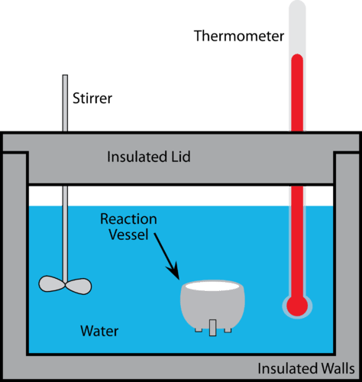
Calorimeter | $$-q_{object}=q_{liquid}+q_{calorimeter}$$ | In a calorimeter experiment, the temperature of the liquid and the calorimeter are always the same.  In addition, the final temperature of the liquid, calorimeter, and object are all the same.
Latent Heat | $$q=m∙L$$  where:  $$L_{f}=Latent heat of fusion$$  $$L_{v}=Latent heat of vaporization$$ | The amount of heat absorbed or released by a substance during a phase change.  $$-zation$$
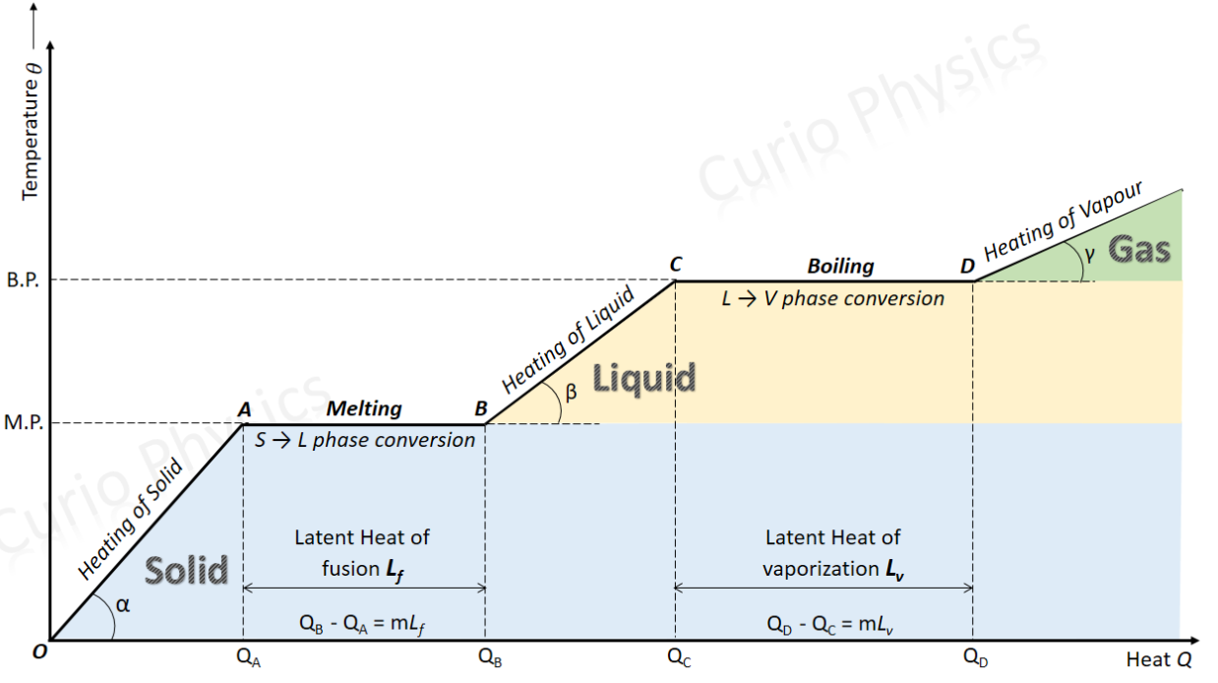
Exothermic Reaction | 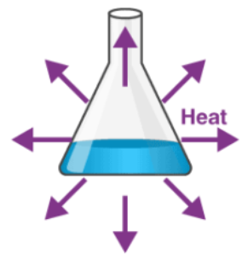 | A chemical reaction that releases energy.  e.g., Dilution of sulfuric acid $\left(H_{2}SO_{4}\right)$ in water.
Endothermic Reaction | 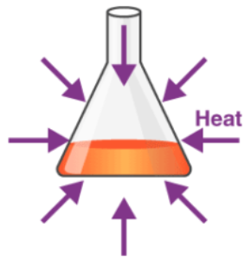 | A chemical reaction that absorbs energy.  e.g., Dissolving ammonium nitrate  $(NH_{4}NO_{3})$ in water.

Specific Heat Capacities of Different Substances

Substance | Specific Heat J/g$°$C |  | Substance | Specific Heat J/g$°$C
Water (l) | 4.184 |  | Nickel (s) | 0.440
Water (s) | 2.093 |  | Zinc (s) | 0.387
Vegetable Oil | 2.000 |  | Copper (s) | 0.386
Air | 1.020 |  | Brass (s) | 0.380
Magnesium (s) | 1.020 |  | Sand | 0.290
Aluminum (s) | 0.900 |  | Silver (s) | 0.240
Glass | 0.840 |  | Tin (s) | 0.210
Potassium (s) | 0.757 |  | Lead(s) | 0.160
Calcium (s) | 0.650 |  | Mercury (l) | 0.140
Iron (s) | 0.444 |  | Gold (s) | 0.126

Chapter 14: Thermodynamics
Term | Description | Equation
Enthalpy ($ΔH$) | The energy change that accompanies a chemical or physical change.
Enthalpy Observations | - For exothermic reactions, $ΔH$ is negative (–).  - For endothermic reactions, $ΔH$ is positive (+).
Enthalpy | $ΔH$ = (Energy for breaking bonds) – (Energy from making bonds)
Bond Energy | The energy required to break a mole of a given type of bond.
State Function | A property that is independent of the path.
Default Enthalpy | The $ΔH_{f}^{°}$ of any element in its natural phase is zero.
Hess’s Law | Chemical reaction: $aA+bB→cC+dD$  $$ΔH={ΔH}_{Products}-{ΔH}_{Reactants}$$  $$ΔH=\left(c∙ΔH_{f}^{°}\left(C\right)+d∙ΔH_{f}^{°}\left(D\right)\right)-\left(a∙ΔH_{f}^{°}\left(A\right)+b∙ΔH_{f}^{°}\left(B\right)\right)$$
Activation Energy | The energy required to initiate a chemical reaction.  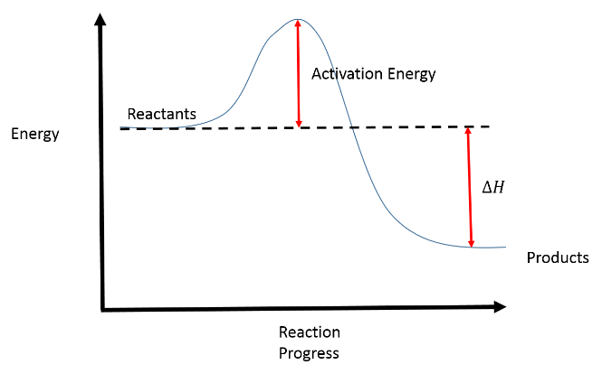
Thermodynamics | The study of the relationships and conversions between different forms of energy.  - 1st Law: Energy cannot be created or destroyed. It can only change form.  - 2nd Law: The entropy of the universe can never decrease. It must always stay the same or increase.

Entropy ($Δ$S) | A measure of the amount of thermal energy in a system that is not available to do useful work.  Because work is obtained from ordered molecular motion, entropy is also a measure of the molecular disorder, or randomness, of a system.
Change in Entropy | $$ΔS_{system}+ΔS_{surroundings}≥0$$
Entropy Observations | - The solid phase is the lowest-entropy phase.  - The gas phase is the highest-entropy phase.  - The larger the number of molecules, the higher the entropy.
Entropy Reactions | Chemical reaction: $aA+bB→cC+dD$  $$ΔS={ΔS}_{Products}-{ΔS}_{Reactants}$$  $$ΔS=\left(c∙S^{°}\left(C\right)+d∙S^{°}\left(D\right)\right)-\left(a∙S^{°}\left(A\right)+b∙S^{°}\left(B\right)\right)$$
Gibbs Free Energy ($Δ$G) | $$ΔG=ΔH-T∙ΔS$$
Gibbs Free Energy ($Δ$G) | 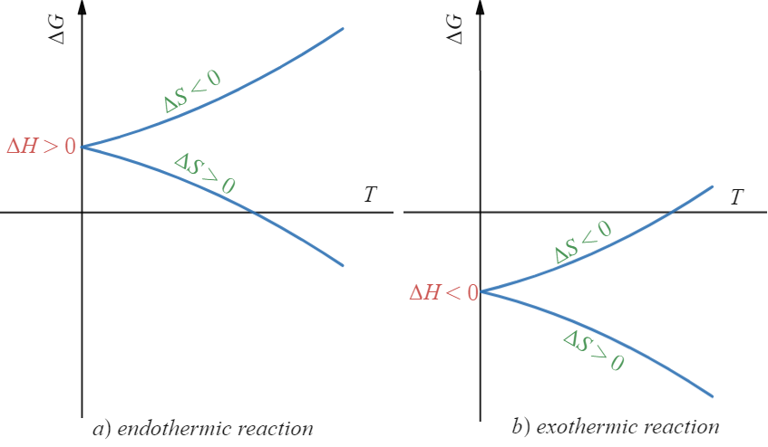
Efficiency | $ΔG$ can predict chemical reaction efficiency.  $$Efficienncy=\frac{ΔG}{ΔH} × 100\%$$
Gibbs Observations | - When $ΔG$ is negative (–), the reaction is spontaneous.  - When $ΔG$ is positive (+), the reaction is not spontaneous.  - The $ΔG_{f}^{°}$of any element in its natural phase is zero.
Gibbs Reactions | Chemical reaction: $aA+bB→cC+dD$  $$ΔG={ΔG}_{Products}-{ΔG}_{Reactants}$$  $$ΔG=\left(c∙ΔG_{f}^{°}\left(C\right)+d∙ΔG_{f}^{°}\left(D\right)\right)-\left(a∙ΔG_{f}^{°}\left(A\right)+b∙ΔG_{f}^{°}\left(B\right)\right)$$

Bond Energies

Bond | Energy  ( kJ/mole) |  | Bond | Energy  ( kJ/mole) |  | Bond | Energy  ( kJ/mole)
$$H-H$$ | 436 |  | $$C-C$$ | 350 |  | $$F-F$$ | 159
$$H-C$$ | 410 |  | $$C-F$$ | 450 |  | $$Cl-Cl$$ | 243
$$H-O$$ | 460 |  | $$C-Cl$$ | 330 |  | $$S-H$$ | 340
$$H-Cl$$ | 432 |  | $$C-O$$ | 350 |  | $$S-F$$ | 310
$$H-N$$ | 390 |  | $$C-N$$ | 300 |  | $$O-Cl$$ | 200
$$C=C$$ | 611 |  | $$C=O$$ | 732 |  | $$N≡N$$ | 945
$$N=O$$ | 607 |  | $$O=O$$ | 498 |  | $$C≡O$$ | 1072

Standard Enthalpies of Formation

Compound | $$ΔH_{f}^{°}$$  ( kJ/mole) |  | Compound | $$ΔH_{f}^{°}$$  ( kJ/mole) |  | Compound | $$ΔH_{f}^{°}$$  ( kJ/mole)
$$CH_{4} (g)$$ | -74.9 |  | $$C_{2}H_{6}O (l)$$ | -277.7 |  | $$H_{2}O_{2} (aq)$$ | -191.2
$$C_{2}H_{6} (g)$$ | -84.7 |  | $$CO_{2} (g)$$ | -393.5 |  | $$HCl (g)$$ | -92.3
$$C_{6}H_{6} (g)$$ | 82.6 |  | $$CO (g)$$ | -110.5 |  | $$HCl (aq)$$ | -167.2
$$C_{6}H_{6} (l)$$ | 49.0 |  | $$CS_{2} (g)$$ | 116.9 |  | $$NH_{3} (g)$$ | -45.9
$$CH_{4}O (g)$$ | -200.7 |  | $$CS_{2} (l)$$ | 89.7 |  | $$NH_{3} (aq)$$ | -80.3
$$CH_{4}O (l)$$ | -238.7 |  | $$H_{2}O (g)$$ | -241.8 |  | $$NH_{4}Cl (s)$$ | -314.6
$$C_{2}H_{6}O (g)$$ | -235.1 |  | $$H_{2}O (l)$$ | -285.8 |  | $$NaOH (s)$$ | -425.9

Absolute Entropies

Substance | $$S^{°}$$  ( J/mole·K) |  | Substance | $$S^{°}$$  ( J/mole·K) |  | Substance | $$S^{°}$$  ( J/mole·K)
$$CH_{4} (g)$$ | 186.1 |  | $$C_{2}H_{6}O (l)$$ | 160.7 |  | $$H_{2}O_{2} (aq)$$ | 143.9
$$C_{2}H_{6} (g)$$ | 229.5 |  | $$CO_{2} (g)$$ | 213.7 |  | $$HCl (g)$$ | 186.8
$$C_{6}H_{6} (g)$$ | 269.2 |  | $$CO (g)$$ | 197.5 |  | $$HCl (aq)$$ | 56.5
$$C_{6}H_{6} (l)$$ | 173.4 |  | $$CS_{2} (g)$$ | 237.9 |  | $$NH_{3} (g)$$ | 192.7
$$CH_{4}O (g)$$ | 239.7 |  | $$CS_{2} (l)$$ | 153.1 |  | $$NH_{3} (aq)$$ | 111.3
$$CH_{4}O (l)$$ | 126.8 |  | $$H_{2}O (g)$$ | 188.7 |  | $$NH_{4}Cl (s)$$ | 94.9
$$C_{2}H_{6}O (g)$$ | 282.6 |  | $$H_{2}O (l)$$ | 70.0 |  | $$NaOH (s)$$ | 64.4
$$C (graphite)$$ | 5.7 |  | $$H_{2} (g)$$ | 130.6 |  | $${Cl}_{2} (g)$$ | 223.0
$$C (g)$$ | 158.0 |  | $$O_{2} (g)$$ | 205.0 |  | $$N_{2} (g)$$ | 191.6

Standard Gibbs Free Energy of Formation

Compound | $$ΔG_{f}^{°}$$  ( kJ/mole) |  | Compound | $$ΔG_{f}^{°}$$  ( kJ/mole) |  | Compound | $$ΔG_{f}^{°}$$  ( kJ/mole)
$$CH_{4} (g)$$ | -50.8 |  | $$C_{2}H_{6}O (l)$$ | -174.9 |  | $$H_{2}O_{2} (aq)$$ | -134.1
$$C_{2}H_{6} (g)$$ | -32.9 |  | $$CO_{2} (g)$$ | -394.4 |  | $$HCl (g)$$ | -95.3
$$C_{6}H_{6} (g)$$ | 129.7 |  | $$CO (g)$$ | -137.2 |  | $$HCl (aq)$$ | -131.3
$$C_{6}H_{6} (l)$$ | 124.4 |  | $$CS_{2} (g)$$ | 66.9 |  | $$NH_{3} (g)$$ | -16.4
$$CH_{4}O (g)$$ | -162.0 |  | $$CS_{2} (l)$$ | 65.3 |  | $$NH_{3} (aq)$$ | -26.6
$$CH_{4}O (l)$$ | -166.4 |  | $$H_{2}O (g)$$ | -228.6 |  | $$NH_{4}Cl (s)$$ | -203.1
$$C_{2}H_{6}O (g)$$ | -168.8 |  | $$H_{2}O (l)$$ | -237.1 |  | $$NaOH (s)$$ | -379.7

Chapter 15: Kinetics
Term | Equation | Note
Kinetics | The study of chemical reaction rates.
Rate | $$Rate=\frac{Δ\left[C\right]}{Δt}$$  $$Rate=\frac{-Δ\left[A\right]}{Δt}$$ | Chemical reaction:  $$A+B→C+D$$  $$reactants→products$$  [ ] = “The concentration of”
Reaction Rate Observations | The reaction rate is usually proportional to the:  - Concentration of reactants  - Surface area over which the reaction can occur  - Temperature
Rate Equation | $$Rate=k{\left[A\right]}^{x}{\left[B\right]}^{y}$$ | Chemical reaction:  $$aA+bB→cC+dD$$  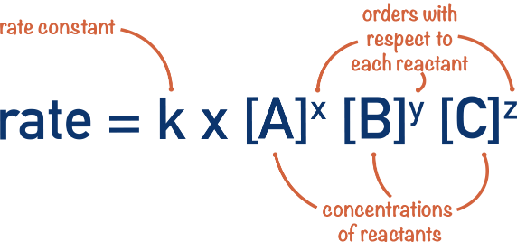
Rate Constant | - The units for the rate constant depend on the overall order of the reaction.  - The rate constant increases exponentially with increasing temperature.  - The rate constant decreases with increasing activation energy.
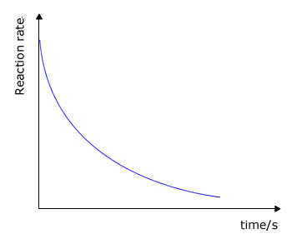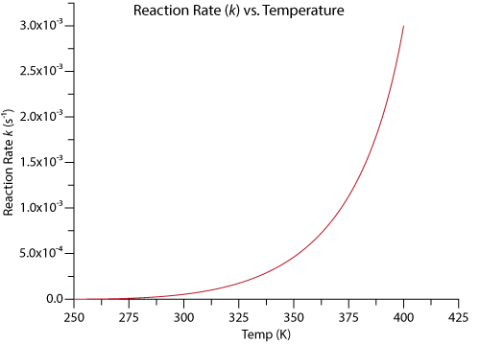
Catalyst | A chemical that increases the rate of a chemical reaction without being used up in the process.  i.e., It lowers the activation energy of the reaction by pulling the molecules closer to one another than they would normally be.  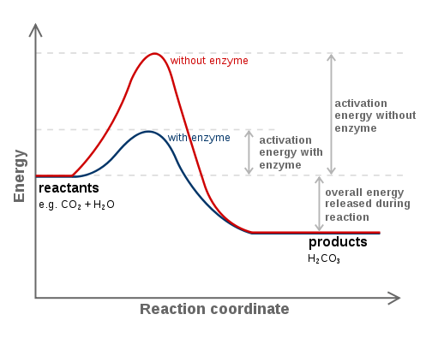
Catalase | A common enzyme found in nearly all living organisms exposed to oxygen which catalyzes the decomposition of $H_{2}O_{2}$ to $H_{2}O$ and $O_{2}$.
Heterogeneous Catalyst | A catalyst in a phase that is different from that of the reactants.  e.g., Catalytic converter (g) + (s).
Catalytic Converter  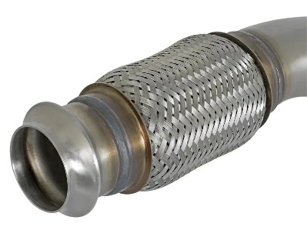 | A device attached to the exhaust of a car that speeds up the following reaction:  $$2CO \left(g\right)+O_{2} \left(g\right)→2CO_{2} (g)$$  The catalyst is the platinum-coated (solid) mesh that lowers the activation energy.  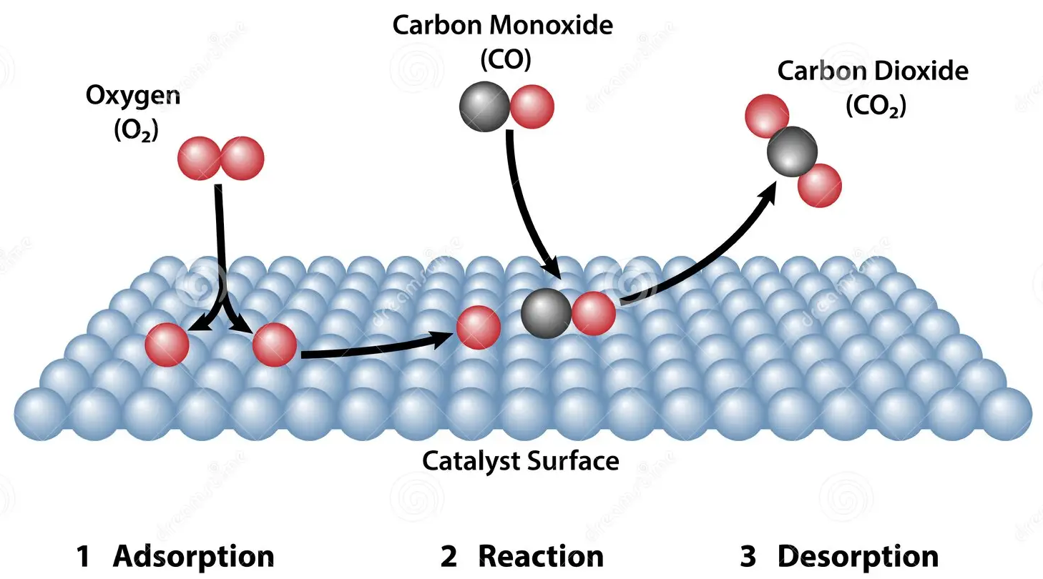
Homogeneous Catalyst | A catalyst in a phase that is the same as that of the reactants.  $$2O_{3}(g)→3O_{2}(g)$$
Reaction Mechanism | A detailed, step-by-step process that tells you exactly how a reaction occurs.  $$2O_{3}(g)→3O_{2}(g)$$  Step 1: $NO \left(g\right)+O_{3} \left(g\right)→NO_{2} \left(g\right)+O_{2} (g)$  Step 2: $O_{3} \left(g\right)→O_{2} \left(g\right)+O \left(g\right)$ due to UV light  Step 3: $NO_{2} \left(g\right)+O \left(g\right)→NO (g)+O_{2} (g)$
Chapter 16: Chemical Equilibrium

Term | Description | Equation
Chemical Equilibrium | The state that occurs in a chemical reaction when the rate of the forward reaction equals the rate of the reverse reaction.
Example | 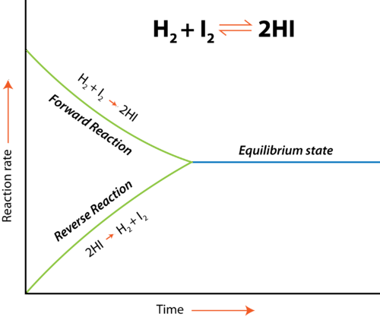
Equilibrium Constant | $$K=\frac{{\left[C\right]}_{eq}^{c} {\left[D\right]}_{eq}^{d}}{{\left[A\right]}_{eq}^{a} {\left[B\right]}_{eq}^{b}}$$ | Chemical reaction:  $$aA+bB→cC+dD$$  $$reactants→products$$
Equilibrium Constant | The value of the equilibrium constant for a given reaction changes with temperature.
Interpreting the Constant | $K<1$:  - When the equilibrium constant is small, the reaction makes fewer products and has lots of reactants.  - The smaller it is, the more reactants there are and the fewer products there are at equilibrium.  $K$ = 1:  - When the equilibrium constant is 1, the reaction is balanced between reactants and products.  $K>1$:  - When the equilibrium constant is large, the reaction makes lots of products and has few reactants.  - The larger it is, the more products there are and the fewer reactants there are at equilibrium.
Interpreting the Constant | $$K=1$$  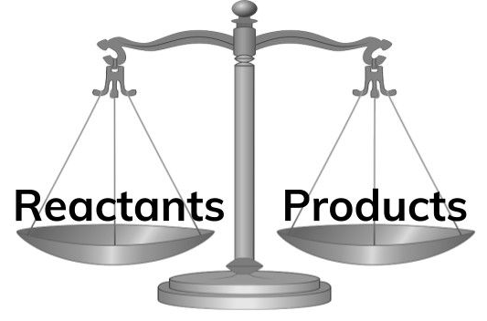 |  | $K>1$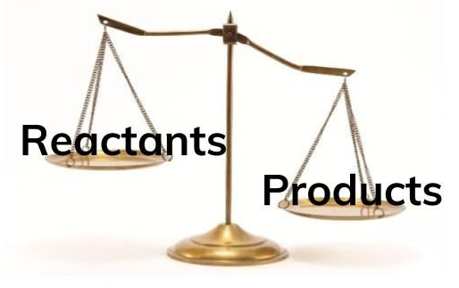
Focus on Gas | Do not include solid or liquid reactants or products in the equation for the equilibrium constant.
Interpreting $K$ Results | $$K=\frac{{\left[C\right]}_{eq}^{c} {\left[D\right]}_{eq}^{d}}{{\left[A\right]}_{eq}^{a} {\left[B\right]}_{eq}^{b}}$$
Interpreting $K$ Results | For the above equation:  - >: If the result is greater than the equilibrium constant, the reaction will shift towards the reactants.  - =: If the result is equal to the equilibrium constant, the reaction is at equilibrium.  - <: If the result is less than the equilibrium constant, the reaction will shift towards the products.
Le Chatelier’s Principle | When a system at equilibrium is stressed, it will shift in a way that relieves the stress and reestablishes equilibrium.
 | 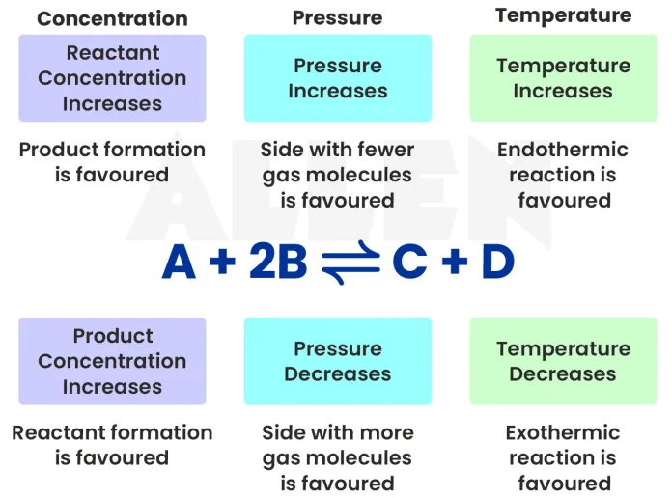
$K$ Shifting: Concentration | A system in equilibrium will:  - ⬆: shift away from the side that experiences an increase in concentration.  - ⬇: shift towards the side that experiences a decrease in concentration.
$K$ Shifting: Temperature | - ⬆: When temperature is raised, an equilibrium will shift away from the side that contains energy.  - ⬇: When temperature is lowered, it will shift towards the side that contains energy.
$K$ Shifting: Pressure | - ⬆: When pressure is raised, an equilibrium will shift away from the side that has the most gas molecules.  - ⬇: When pressure is lowered, it will shift towards the side that has the most gas molecules  - ↔: If there are no gas molecules, the equilibrium doesn’t shift when pressure is changed.
Acid Ionization Constant ($K_{a}$) | The equilibrium constant for the reaction between an acid and water.
Base Ionization Constant ($K_{b}$) | The equilibrium constant for the reaction between a base and water.

Sources
These chapters and content are from the textbook:
- Dr. Jay L. Wile (2015). Discovering Design with Chemistry, 1st Edition.

