Harold’s High School Physics
2nd Semester
Cheat Sheet
7 April 2026

Chapter 9: Momentum and Its Conservation

Term | Equations & Descriptions
Momentum | The mass of an object times its velocity.
Law of Momentum Conservation | When the net external force on a system is zero, the total momentum cannot change.
Elastic Collision | A collision in which the kinetic energy of the colliding objects is conserved (does not change).
Inelastic Collision | A collision in which the kinetic energy of the colliding objects is not conserved (lower after the collision).
Law of Angular Momentum Conservation | When the net external torque on a system is zero, the total angular momentum cannot change.

Physics Constants

Constant | Value
Gravitational Constant | $$G≈6.674 30(15)×10^{-11} \frac{m^{3}}{kg s}$$
Gravity Acceleration (Earth) | $$g≈-9.806 65 \frac{m}{s^{2}}≈-32.174 0 \frac{ft}{s^{2}}$$
Speed of Light in Vacuum | $$c=2.997 924 58×10^{8} \frac{m}{s}$$
Electron-Volt | $$1eV=1.602 176 634×10^{-19} J$$
Charge of an Electron | $$e=-1.602 176 634×10^{-19} C$$
Mass of an Electron | $$m_{e}≈9.109 383 701 5(28)×10^{-31} kg$$
Mass of a Proton | $$m_{p}≈1.672 621 923 69(51)×10^{-27} kg$$
Mass of a Neutron | $$m_{n}≈1.674 927 498 04(95)×10^{-27} kg$$
Electric Permittivity | $$ε_{0}≈\frac{1}{μ_{0}c^{2}}≈8.854 187 812 8×10^{-12}\frac{C^{2}}{Nm^{2}}$$
Magnetic Permeability | $$μ_{0}≈1. 256 637 062 12(19)×10^{-6}\frac{N}{A^{2}}$$
Boltzmann Constant | $$k_{B}=1.380 649×10^{-23} \frac{J}{K}$$
Coulomb Constant | $$k_{e}=\frac{1}{4πε_{0}}≈8.987 551 792 3×10^{9} \frac{Nm^{2}}{C^{2}}$$
Faraday Constant | $$F=eN_{A}=9.648 533 212×10^{4} \frac{C}{mol}$$
Planck Constant | $$h=6.626 070 15×10^{-34} Js$$
Avogadro Constant | $$N_{A}=6.022 140 76×10^{23} / mole$$
Ideal Gas Constant | $$R=0.082 057 366 080 \frac{L atm}{mole K}=8.314 462 618 \frac{J}{mole K}$$

Momentum
(Linear Momentum)
Momentum | $$p=mv$$ | $$kg∙m/s$$
Impulse | $$∆p=F∙∆t$$  $$∆p=p_{final}-p_{initial}$$ | $N∙s$ or $kg∙m/s$  The change in momentum.
Collision Types | 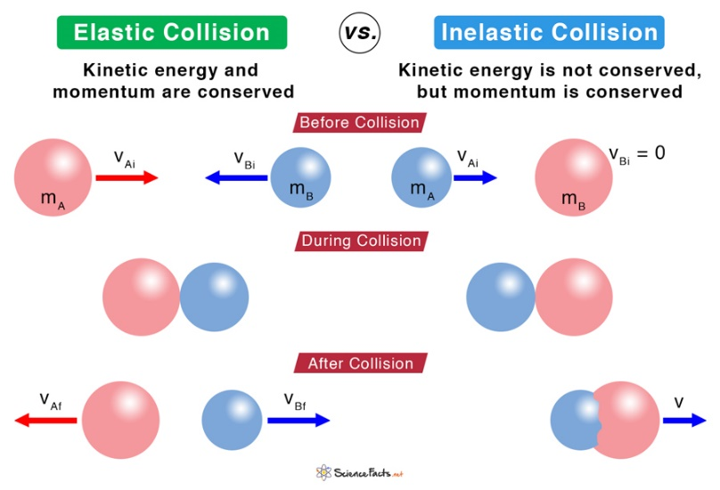
Newton’s Cradle | Example of an elastic collision

Angular Momentum
Angular Momentum | $$L=mvr$$  (point mass moving in a circle) | $$kg∙m^{2}/s$$
Spinning Tire | A spinning bicycle tire requires effort to tilt since it has angular momentum $(L)$.  You must apply a torque $(τ)$ to change the angular momentum. | 

Conservation Laws
Conservation of Linear Momentum:  $$p_{i}=p_{f}$$ | Conservation of Energy:  $$E_{i}=E_{f}$$ | Conservation of Angular Momentum:  $$L_{i}=L_{f}$$
Conservation of Energy | The capacity for doing work.  “Energy can neither be created nor destroyed”.
Conservation of Momentum | When the net external force is zero: $p_{before}=p_{after}$
Conservation of Angular Momentum | When the sum of the torques is zero: $L_{before}=L_{after}$
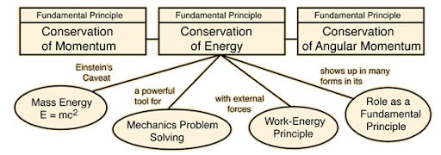
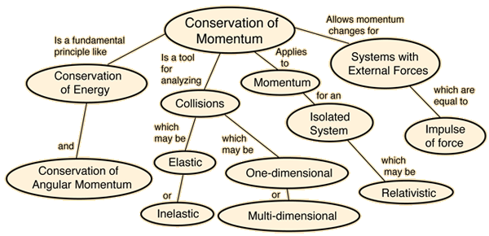
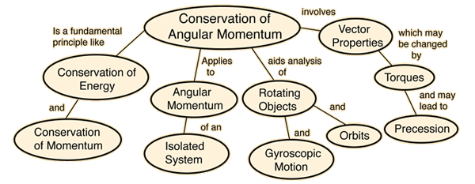
Chapter 10: Periodic Motion

Term | Equations and Descriptions
Periodic Motion | Motion that repeats itself in equal intervals of time.
Hooke’s Law | The restoring force exerted by an elastic object is directly proportional to the distance it is displaced from its equilibrium position.
Amplitude | The maximum extent of a periodic motion, defined from the equilibrium position.
Simple Harmonic Motion | Periodic motion produced by a restoring force that is directly proportional to the distance from the equilibrium position.
Damped Harmonic Motion | Periodic motion whose amplitude decreases over time.
Spring
Spring Force | $$F_{s}=-k∙Δx$$ | $$N$$
Equilibrium | 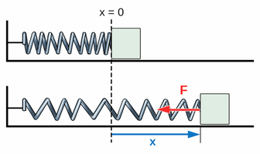
Spring Force Graph | 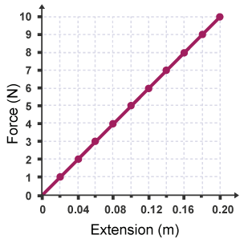 | Linear  $$y=mx+b$$  $$F=kx+0$$
Spring Period | $$T_{s}=2π\sqrt{\frac{m}{k}}$$ | $$s$$
Spring Period | The period of a mass / spring system depends on π because it is a one-dimensional projection of uniform circular motion.
Max. Spring PE | At the amplitude of a mass / spring system’s motion, the restoring force is the greatest, and the speed of the mass is zero.
Max. Spring KE | At the equilibrium position of a mass / spring system’s motion, the restoring force zero, and the speed of the mass is at its maximum value.
Spring Energy | $${PE}_{S}=\frac{1}{2}k{Δx}^{2}$$ | $${KE}_{S}=\frac{1}{2}mv^{2}$$
Spring Energy | $${TE}_{S}=\frac{1}{2}kA^{2}$$ | $A$ is amplitude in  $$x\left(t\right)=A\cos\left(2πft+ϕ\right)$$

Pendulum
Simple Pendulum | 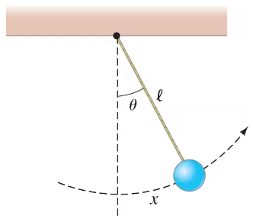
Small Displacement Simplification | A simple pendulum will exhibit simple harmonic motion if the angle that represents its amplitude is small. That is because the restoring force is directly proportional to the displacement only when $\sin{θ}≈θ$.
Pendulum Period | $$T_{p}=2π\sqrt{\frac{l}{g}}$$ | $$s$$
Simple Harmonic Motion (SHM) | 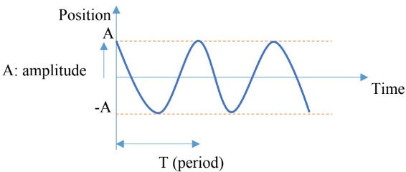
Damped Harmonic Motion | 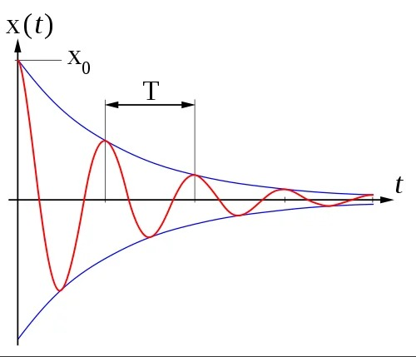
Mnemonic | “Life is Good, if you are a MonKey.”  $$T_{p}=2π\sqrt{\frac{l}{g}} and T_{s}=2π\sqrt{\frac{m}{k}}$$

Chapter 11: Sound and Light

Term | Equations & Descriptions
Oscillations | Regular variation in magnitude around a central point.
Wavelength | The distance between two crests or two troughs of a wave.
Transverse Wave | A wave whose oscillation is perpendicular to its translational motion.
Longitudinal Wave | A wave whose oscillation is parallel to its translational motion.
 | 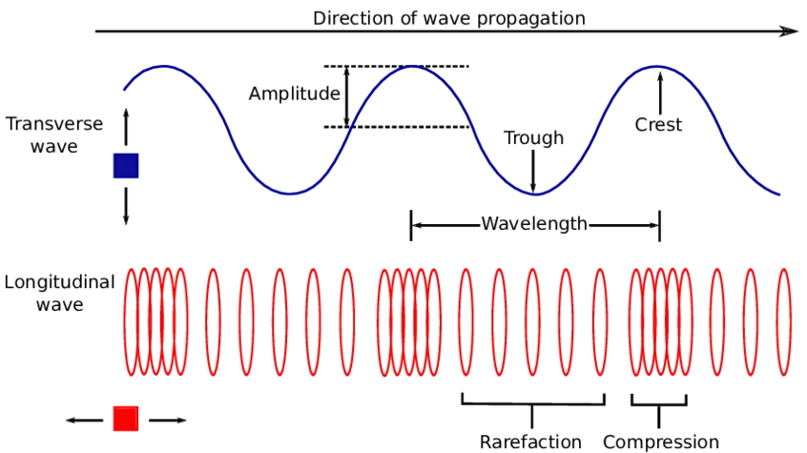
Doppler Effect | A change in the observed frequency of a wave caused by the motion of the wave’s source and/or the observer.
Sound
Sonic Waves | Waves that the typical person can hear, with frequencies of 20 Hz – 20,000 Hz.
Ultrasonic Waves | Waves with frequency greater than 20,000 Hz. $\left(f>20 kHz\right)$
Infrasonic Waves | Waves with frequency lower than 20 Hz. $\left(f<20 Hz\right)$
Timbre | The character of a sound that is not based on the frequency or amplitude of the main sound wave. Examples:  - air vs. bone conduction  - flute vs. violin
Wave-Particle Duality | The concept that light, as well as many subatomic particles, have the properties of both particles and waves.  Thomas Young’s Double-Slit Experiment  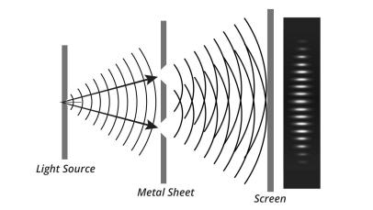
Frequency | $$f=\frac{v}{λ}$$ | Frequency and wavelength are inversely proportional; when one increases, the other decreases.
Medium | A wave oscillates a medium so that energy can move from one place to another.
Sound Volume & Frequency | - The higher the amplitude of a sound wave, the higher the volume of the sound.  - The higher the frequency of a sound wave, the higher the pitch of the sound.
Speed of Sound | $$v_{sound}=331.3\frac{m}{s}+0.606\frac{m/s}{℃}∙T_{C}$$  Where $T_{C}$ is the temperature in Celsius.
Speed of Sound | - The speed of sound increases with increasing elasticity and decreasing density.  - In general, it travels faster in solids, slower in liquids, and slowest in gases.  - For solids and gases, the lower the density, the faster the speed of sound.
  Physical State | Medium | Velocity (m/s) | Velocity (mph)
  Gas | Air (0°C) | 331 | 740
  Gas | Air (25°C) | 346 | 774
  Gas | Helium (0°C) | 972 | 2,174
  Liquid | Water (25°C) | 1,490 | 3,333
  Solid | Iron | 5,130 | 11,472
Doppler Effect (Sound) | $$f_{observed}=\left(\frac{v_{sound}±v_{observer}}{v_{sound}±v_{source} }\right)∙f_{stationary}$$  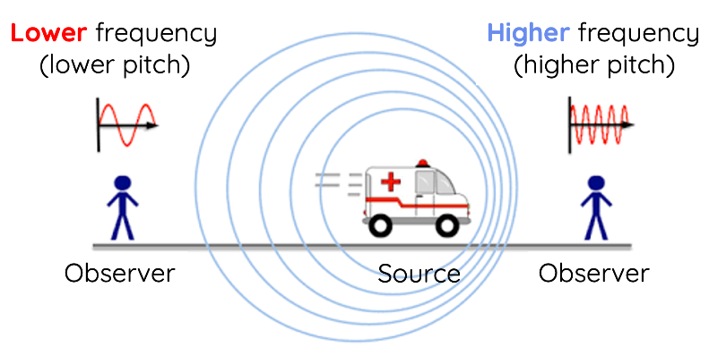
Doppler Effect (Sound) | - When a source of sound is moving, the frequency in front of the source is higher than the frequency behind the source.  - When the observer is moving, the frequency is higher as the observer moves towards the source, and it is lower as the observer moves away from the source.
Doppler Effect (Sound) | - Add $v_{obserer}$ when the observer is moving towards the source.  - Subtract it when the observer is moving away from the source.
Doppler Effect (Sound) | - Subtract $v_{source}$ when the source is moving towards the observer.  - Add it when the source is moving away from the observer.

Light
Electromagnetic Spectrum | The prefix “nano” is abbreviated with “n” and means ${10}^{-9}$. $c=fλ$  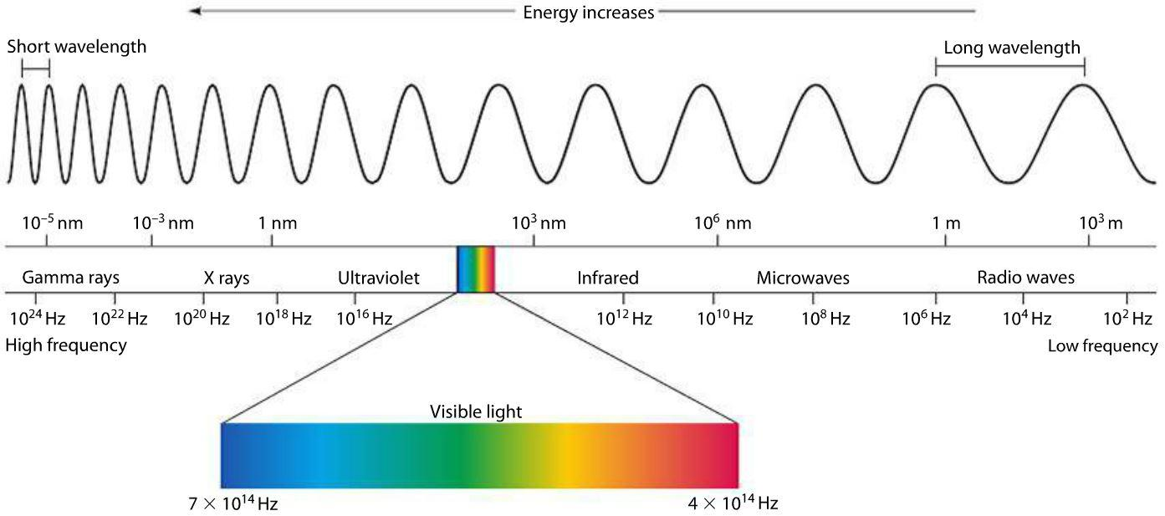  Roy G. Biv: Red, Orange, Yellow, Green, Blue, Indigo, Violet
Photoelectric Effect | $$KE_{e_max}=h∙f-ϕ$$  $KE_{e_max}$ (Max. electronic kinetic energy)  $h=4.14×{10}^{-15} eV∙s$ (Planck’s constant)  $ϕ$ (Work function) expressed in $eV$(electron-volt).  If $h<0$, then the electron cannot leave the metal when struck by a photon.  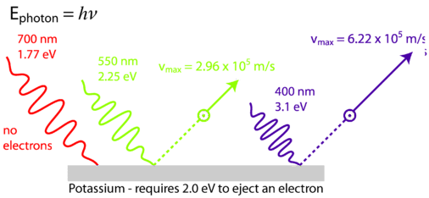
Electron-Volt | $$1 eV=1.602 ×{10}^{-19} J$$
Doppler Effect (Light) | - Blueshift: Higher frequency, so the star is moving towards the earth.  - Redshift: Lower frequency, so the star is moving away from the earth.  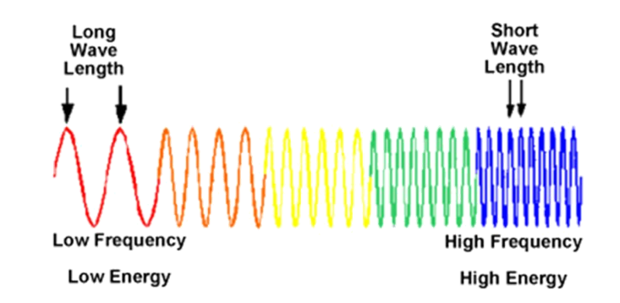

Chapter 12: Optics

Term | Equations & Descriptions
Law of Reflection | When light reflects off a surface, the angle of incidence equals the angle of reflection.
Law of Reflection | 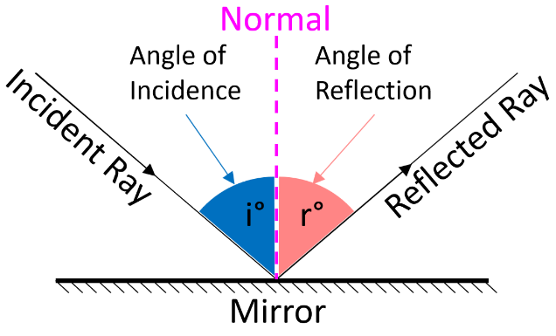
Reflection  (Throwback) | 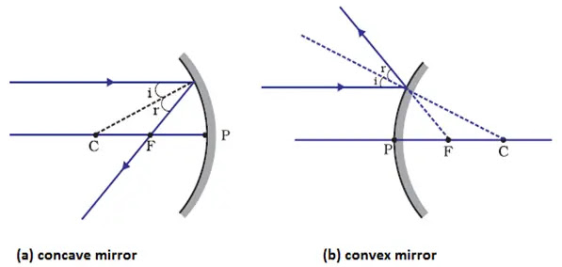
Focal Length (F) | $$F=\frac{R}{2}$$ | $R$ is the radius
Concave Spherical Mirror | 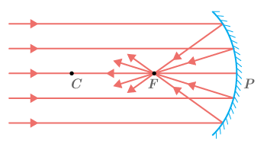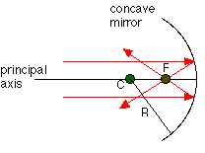
Concave Spherical Mirror | - Light that travels to a spherical mirror will be reflected so that it travels through the mirror’s focal point.  - Light that travels through the focal point and then hits the spherical mirror will be reflected so that it travels horizontally.  - Light that travels through the center that defines a spherical mirror will reflect so that it travels directly backwards, through the center again.
Convex Spherical Mirror | 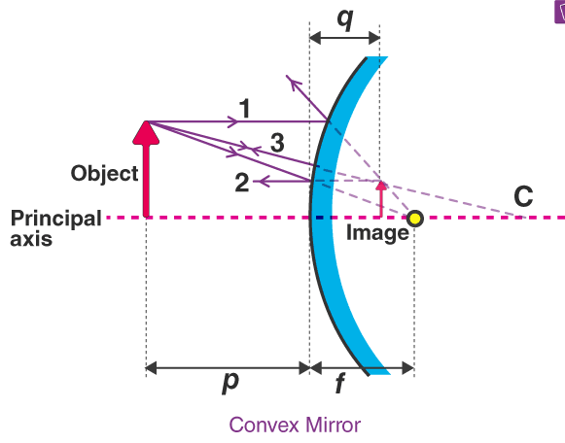
Virtual Image | An image formed from the extrapolation of light rays.
Real Image | An image formed by the intersection of reflected light rays.
Refraction  (Bend) | 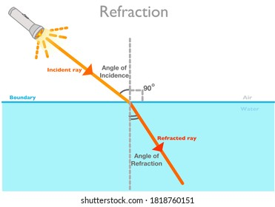
Refraction  (Bend) | A change in direction of a light ray caused by passage from one medium to another.
Index of Refraction | $$n=\frac{c}{v}$$  $$n=\frac{speed of light in a vacuum}{speed of light in the medium}$$  $$\frac{n_{1}}{n_{2}}=\frac{v_{2}}{v_{1}}$$ |  | 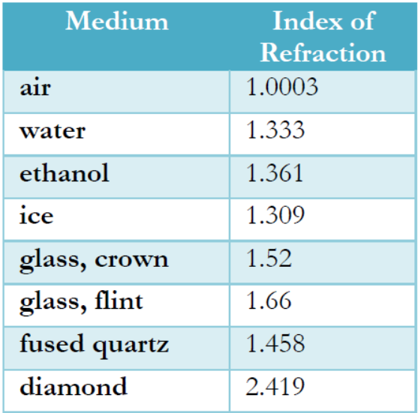
Snell’s Law | $$n_{1}\sin{θ_{1}}=n_{2}\sin{θ_{2}}$$
Spherical Aberration | A loss of definition in an image due to the spherical nature of a lens or mirror.
Chromatic Aberration | A loss of definition in an image due to different wavelengths being focused at different points.
Lenses | 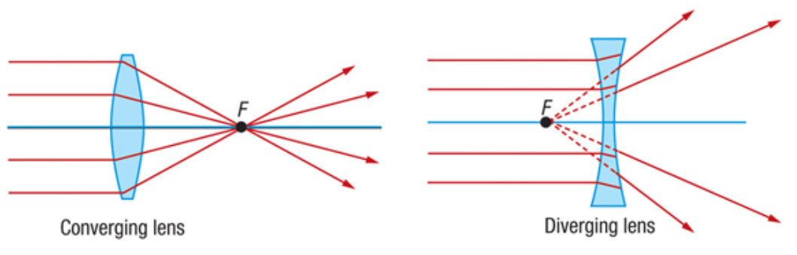
Lenses | - Lenses refract light according to Snell’s Law.  - Converging lenses have positive focal length.  - Diverging lenses have negative focal length.
Converging Lens | - Light that travels horizontally to a converging lens will travel out through the focal point on the other side of the lens.  - Light that travels through the focal point and then hits a converging lens will travel out horizontally on the other side of the lens.  - Light that travels through the very center of the lens will experience no deflection.
Diverging Lens | - Light that travels horizontally to a diverging lens will travel out of the lens as if they came from the focal point on the side from which they entered the lens.  - Light that is headed to the focal point on the other side of a diverging lens will leave the lens horizontally.  - Light that travels through the very center of the lens will experience no deflection.

Chapter 13: The Electrostatic Force

Term | Equations & Descriptions
Electrostatic Force | A force that is produced by the electric charges of two or more stationary objects.
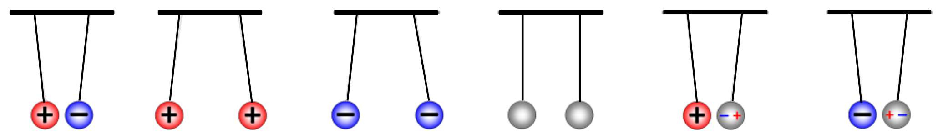
Charge of an Electron | $$e^{-}≈-1.602×10^{-19} Coulombs (C)$$
Electric Charge | $1q=1 C≈6.24 x {10}^{18} electrons$ or protons  1 C ≈ 6 billion billion e―
Triboelectric Charging  (Charging by Friction) | Producing two charged objects by rubbing them together.
Charging by Conduction | Charging an uncharged object by touching it to a charged object, allowing charges to move out of the charged object and into the uncharged object.
Charging by Induction | Charging an uncharged object by using a charged object to push charges out of the uncharged object and nor allowing those charges to return.
 | 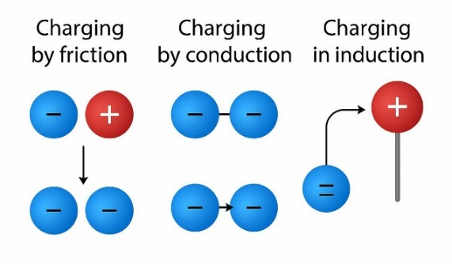
Micro | The prefix “micro” is abbreviated with “μ” and means 10⁻⁶ or 1/1,000,000.
Coulomb’s Law | $$F=k\frac{q_{1} q_{2}}{r^{2}}$$ | $$F=G\frac{m_{1} m_{2}}{r^{2}}$$
Coulomb’s Law | Coulomb’s Law has the same form as Newton’s Law of Gravitation.
Coulomb Constant | $$k≈8.99×10^{9} \frac{N·m^{2}}{C^{2}}$$ | $$G≈6.67×10^{-11} \frac{m^{3}}{kg·s}$$
Electrostatic Force with Multiple Charges | Red is +  Black or Blue is – | 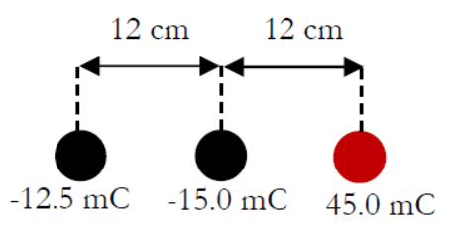
Electrostatic Force with Multiple Charges | Use trig to break down vectors into x-axis and y-axis components.  $$A_{x}=r\cos{θ} A_{y}=r\sin{θ}$$  $$C_{x}=A_{x}+B_{x} C_{y}=A_{y}+B_{y}$$  $$C=\sqrt{C_{x}^{2}+C_{y}^{2}}$$  $$θ=\tan^{-1}{\frac{C_{y}}{C_{x}}}$$ | 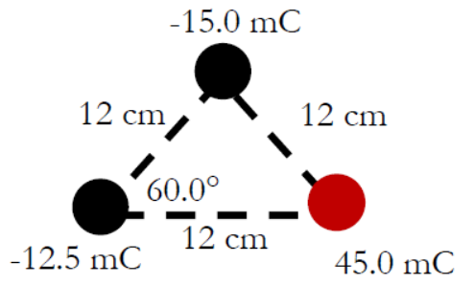
Electric Field Line Rules | - Electric field lines point directly towards negative charges and directly away from positive charges.  - The number of lines going into or out of a particle are proportional to the charge on the particle.  - Electric field lines cannot cross.  - The lines show you the direction a positive charge will accelerate, and the closeness of the lines in the charge’s vicinity is proportional to the magnitude of the force.
Rule 1 Example | 
Rule 2 Example | 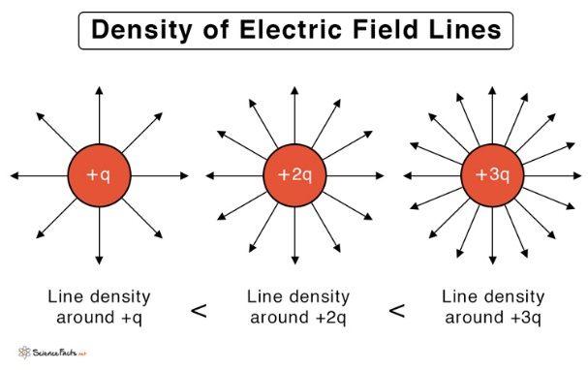 |  | 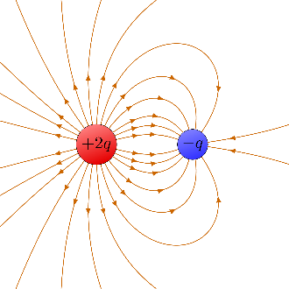
Rule 3 Example | 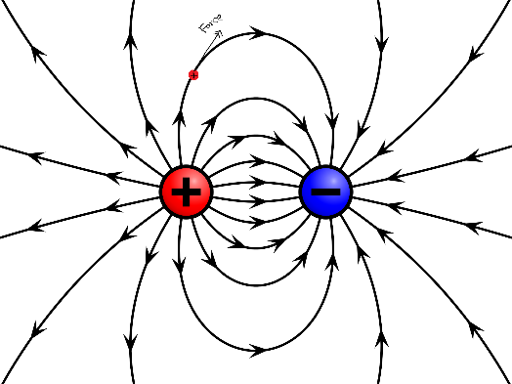
Rule 4 Example | 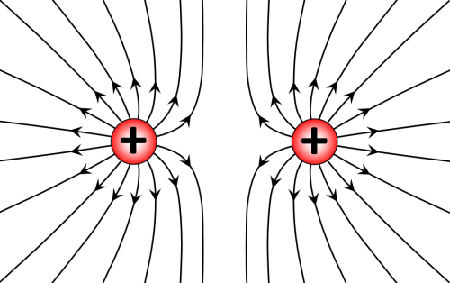 | 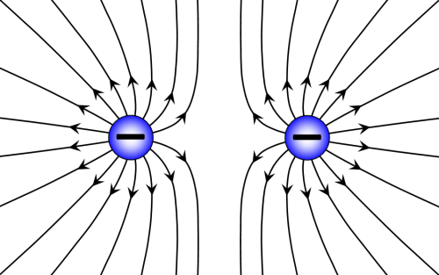
Conductor | A substance in which electrons flow freely from particle to particle.
Insulator | A substance in which electrons do not flow freely from particle to particle.
 | 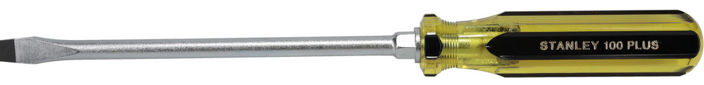
Electric Field Strength | $$F=Eq$$ | $$F=ma$$
Chapter 14: Electricity Has Potential!

Term | Equations & Descriptions
Electric Potential ($V$) | The potential energy of an electric field per unit charge. ($V$)
Voltage ($V$) | Volt ($V$) = Joule/Coulomb $\left(\frac{J}{C}\right)$ |  | 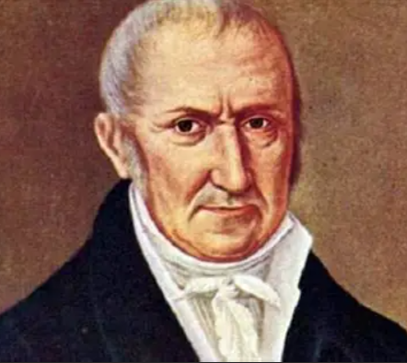  Alessandro Volta, Italian physicist
Stationary Point Charge Voltage | $$V=k\frac{Q}{r}$$ |  | $$k≈8.99×10^{9} \frac{N·m^{2}}{C^{2}}$$
Potential Energy ($PE$) | $$PE=q∙V$$  $$ΔPE=q∙ΔV$$  $$ΔPE=PE_{f}-PE_{i}=KE=\frac{1}{2}mv^{2}$$
Potential Difference ($ΔV$) | How much the potential changes between two positions in an electric field. ($V$)
Potential Difference ($ΔV$) | $$ΔV=V_{f}-V_{i}$$
Electron Volt ($eV$) | The kinetic energy an electron gains after moving through a potential difference of 1 volt.
Electron Volt ($eV$) | $$1 eV=1.602×{10}^{-19}J$$
Capacitor | A device that stores electric charge, consisting of two conductors separated by an insulator.
Capacitor | 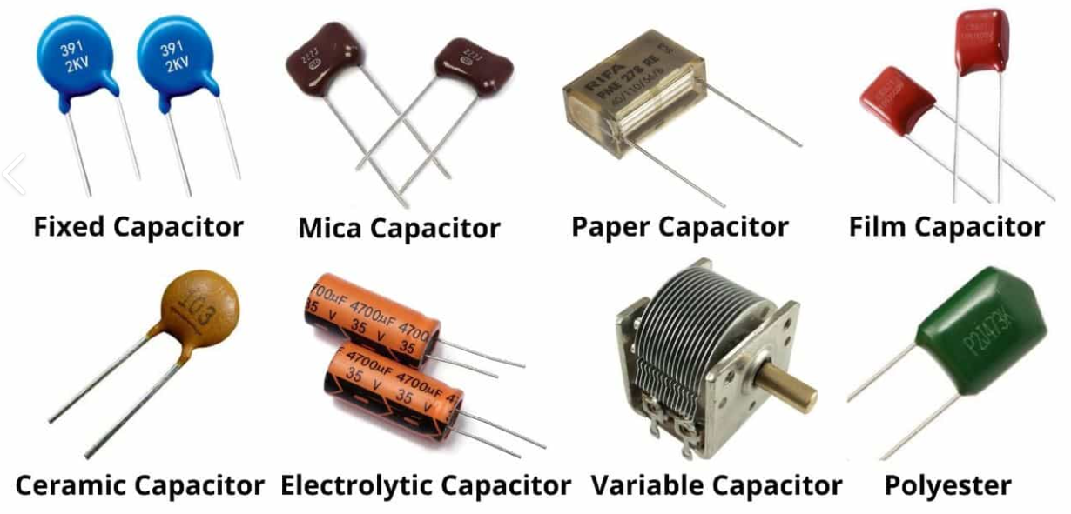
Capacitance ($C$) | A measure of how well a system can store charge. (Farads, $F$)
Electric Permittivity ($ε$) | A measure of how well a material resists the formation of an electric field.
Permittivity of Free Space ($ε_{0}$) | $$ε_{0}=8.85×10^{-12}\frac{F}{m}$$  The lowest permittivity possible.
Permittivity of Ceramic as the Dielectric | $$ε=7.08×10^{-8}\frac{F}{m}$$
Parallel Plate Capacitor | 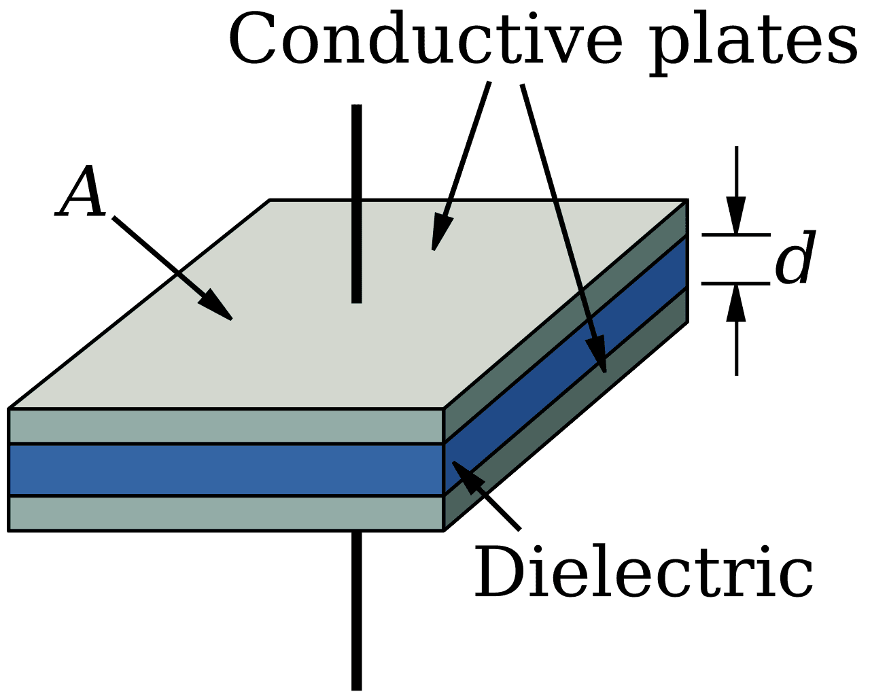 |  | 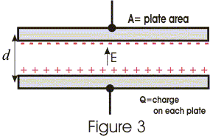
Parallel Plate Capacitor | $$C=\frac{ε∙A}{d}$$
Ground (Electrical) | An infinite source of or sink for electrons. |  |  |  | 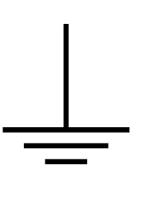
Conservation of Charge | A law that states the total charge of the universe cannot change.  e.g., Charge cannot be created or destroyed, just moved around. |  |  |   Proposed by Benjamin Franklin
Charge in a Capacitor ($Q$) | $$Q=C∙ΔV$$
Battery Charging a Capacitor | 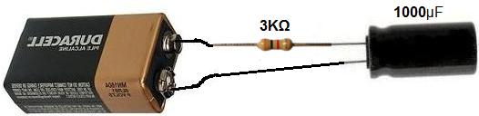 |  | 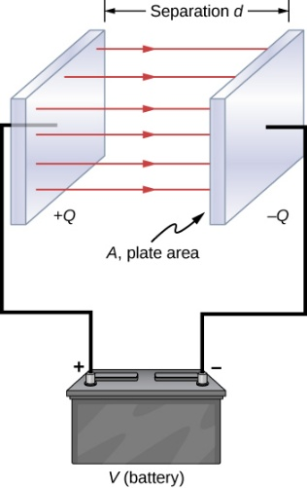
Electric Current | A stream of charges flowing through a conductor.  Analogy: Water flowing through a hose.
Conventional Current | Positive charge, as opposed to the actual flow of electrons.
Electric Circuit | A conductive path that allows electric current to flow.  Analogy: The wire is the water hose.
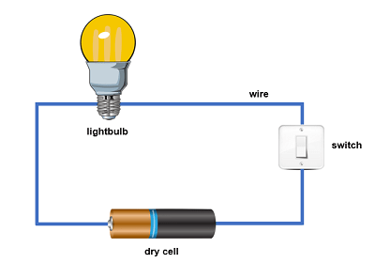 |  | 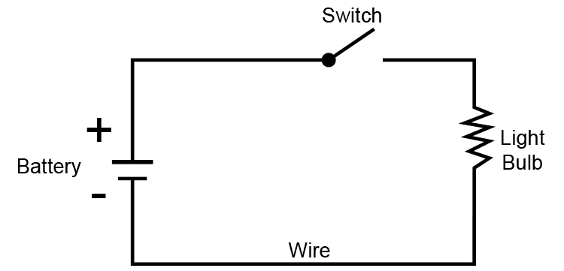
Chapter 15: Electric Circuits

Term | Equations & Descriptions
Drift Velocity
Resistor
Battery
(Voltage source)
Fuse
Capacitor
Switch
 |  | 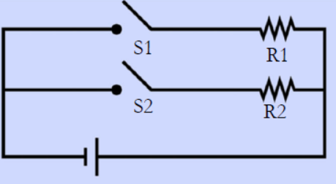
 |  | 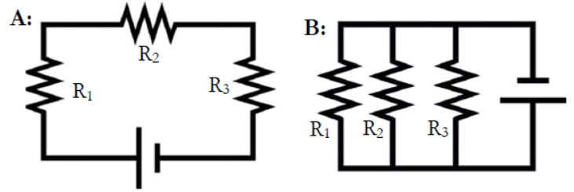
 |  | 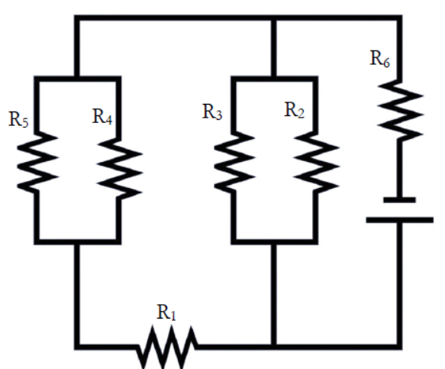
 |  | 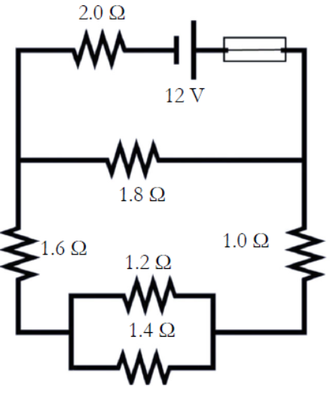
 |  | 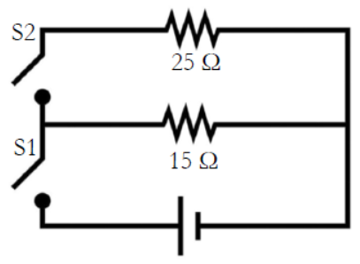
 |  | 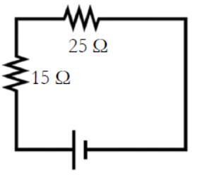
 |  | 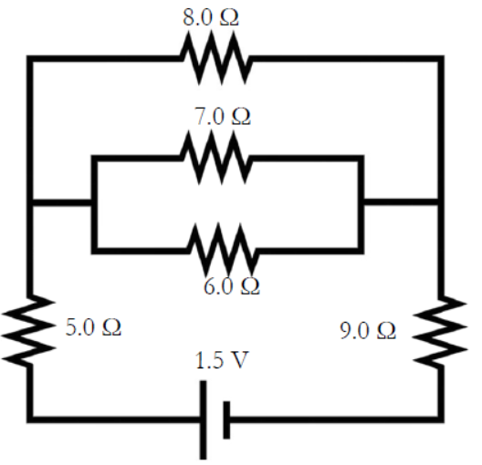
 |  | 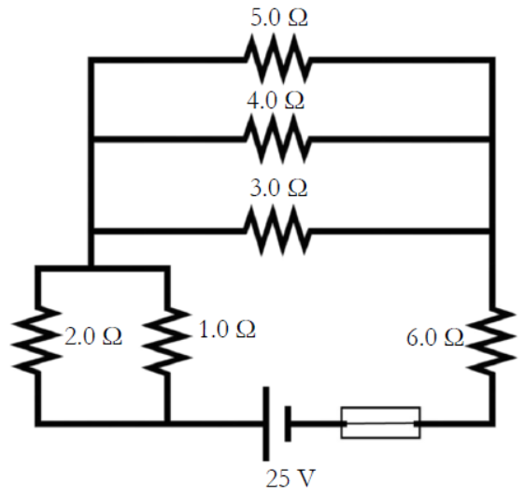

Chapter 16: Magnetism

Term | Equations & Descriptions
Basic Law of Magnetism
Magnetic Permeability ($μ$)
Right-Hand Rule
Diamagnetic Substance
Paramagnetic Substance
Ferromagnetic Substance
Faraday’s Law of Magnetic Induction
Electromotive Force
Alternating Current
Direct Current
Rectifier
Inverter
Lenz’s Law

Sources
These chapters and content are taken verbatim from the High School textbook:
- Dr. Jay L. Wile (2023). Discovering Design with Physics, 1st Edition.
Image Sources
- Dr. Carl Rod Nave (1998). HyperPhysics, Conservation of Energy. http://hyperphysics.phy-astr.gsu.edu/hbase/conser.html

