Harold’s Hyperbolics
Cheat Sheet
7 January 2026

Hyperbolic Graphs
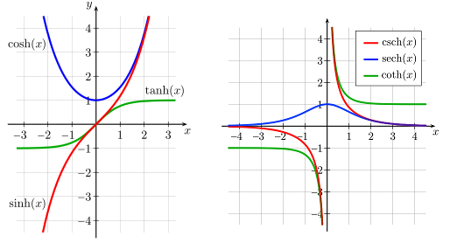
Inverse Hyperbolic Graphs
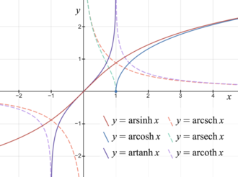

Hyperbolic Definitions |  |  | $$sinh \& cosh$$ | $$e^{x}$$ | Complex
1. Hyperbolic Sine |  | $$sinh\left(x\right)$$ | $$\frac{1}{\cosh\left(x\right)}$$ | $$\frac{e^{x}-e^{-x}}{2}$$ | $$-i\sin\left(ix\right)$$
2. Hyperbolic Cosine (catenary) |  | $$cosh\left(x\right)$$ | $$\frac{1}{\sinh\left(x\right)}$$ | $$\frac{e^{x}+e^{-x}}{2}$$ | $$\cos{(ix)}$$
3. Hyperbolic Tangent |  | $$\tanh\left(x\right)$$ | $$\frac{\sinh{(x)}}{\cosh{(x)}}$$ | $$\frac{e^{x}-e^{-x}}{e^{x}+e^{-x}}$$ | $$-i tan(ix)$$
4. Hyperbolic Cotangent |  | $$\coth\left(x\right)$$ | $$\frac{\cosh{(x)}}{\sinh{(x)}}$$ | $$\frac{e^{x}+e^{-x}}{e^{x}-e^{-x}}$$ | $$i cot(ix)$$
5. Hyperbolic Secant |  | $$\operatorname{sech}\left(x\right)$$ | $$\frac{1}{cosh (x)}$$ | $$\frac{2}{e^{x}+e^{-x}}$$ | $$\sec{(ix)}$$
6. Hyperbolic Cosecant |  | $$\operatorname{csch}\left(x\right)$$ | $$\frac{1}{sinh (x)}$$ | $$\frac{2}{e^{x}-e^{-x}}$$ | $$i\csc{(ix)}$$
7. Inverse Hyperbolic Sine |  | $$\sinh^{-1}\left(x\right)$$ | $$ln\left(x+\sqrt{x^{2}+1}\right)$$
8. Inverse Hyperbolic Cosine |  | $$\cosh^{-1}\left(x\right)$$ | $$ln\left(x+\sqrt{x^{2}-1}\right), x≥1$$
9. Inverse Hyperbolic Tangent |  | $$tanh^{-1}\left(x\right)$$ | $$\frac{1}{2}ln\left(\frac{1+x}{1-x}\right), \left|x\right|<1$$
10. Inverse Hyperbolic Cotangent |  | $$coth^{-1}\left(x\right)$$ | $$\frac{1}{2}ln\left(\frac{x+1}{x-1}\right), \left|x\right|>1$$
11. Inverse Hyperbolic Secant |  | $$sech^{-1}\left(x\right)$$ | $$ln\left(\frac{1}{x}+\sqrt{\frac{1}{x^{2}}-1}\right), 0<x≤1$$  $$ln\left(\frac{1+\sqrt{1-x^{2}}}{x}\right), 0<x≤1$$
12. Inverse Hyperbolic Cosecant |  | $$csch^{-1}\left(x\right)$$ | $$ln\left(\frac{1}{x}+\sqrt{\frac{1}{x^{2}}+1}\right), x≠0$$
Catenary | $$y=a\cosh\left(\frac{x}{a}\right)$$ |  | 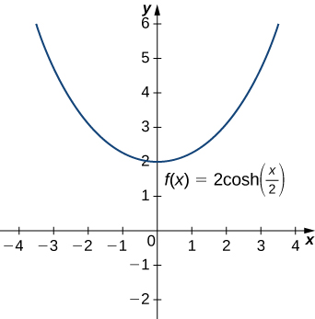

Hyperbolic Identities
Odd and Even | $$\sinh\left(-x\right)=-sinh (x)$$
Odd and Even | $$\cosh\left(-x\right)=cosh (x)$$
Odd and Even | $$\tanh\left(-x\right)=-tanh (x)$$
Pythagorean Identities | $\cosh^{2}{(x)}-\sinh^{2}\left(x\right)=1$ (Euler’s formula)
Pythagorean Identities | $${sech}^{2}{(x)}=1-\tanh^{2}\left(x\right)$$
Pythagorean Identities | $${csch}^{2}{(x)}=\coth^{2}\left(x\right)-1$$
Sums/Difference of Angles | $$\sinh\left(x±y\right)=\sinh{(x)}\cosh{(y)}±\cosh{(x)}\sinh{(y)}$$
Sums/Difference of Angles | $$\cosh\left(x±y\right)=\cosh{(x)}\cosh{(y)}±\sinh{(x)}\sinh{(y)}$$
Sums/Difference of Angles | $$\tanh\left(x±y\right)=\frac{\tanh{(x)}±\tanh{(y)}}{1±\tanh{(x)}\tanh{(y)}}$$
Double Angle | $$\sinh{(2x)}=2\sinh\left(x\right)\cosh{(x)}$$
Double Angle | $$\cosh\left(2x\right)=\sinh^{2}\left(x\right)+\cosh^{2}\left(x\right)$$  $$\cosh\left(2x\right)={2 cosh}^{2}\left(x\right)-1$$  $$\cosh{(2x)}=1+2\sinh^{2}{(x)}$$
Double Angle | $$\tanh{(2x)}=\frac{2\tanh{(x)}}{1+\tanh^{2}{(x)}}$$
Half Angle | $$\sinh\left(\frac{x}{2}\right)=\frac{\sinh{(x)}}{\sqrt{2(\cosh\left(x\right)+1)}}$$
Half Angle | $$\cosh\left(\frac{x}{2}\right)=\sqrt{\frac{\cosh{(x)}+1}{2}}$$
Half Angle | $$\tanh\left(\frac{x}{2}\right)=\frac{\sinh\left(x\right)}{\cosh\left(x\right)+1}$$  $$\tanh\left(\frac{x}{2}\right)=\frac{\cosh\left(x\right)-1}{\sinh\left(x\right)}$$  $$\tanh\left(\frac{x}{2}\right)=\coth{(x)}-\operatorname{csch}\left(x\right) if x≠0$$
Squared | $$\sinh^{2}{(x)}=\frac{1}{2}\left(\cosh{(2x)}-1\right)$$
Squared | $$\cosh^{2}{(x)}=\frac{1}{2}\left(\cosh{(2x)}+1\right)$$
Exponents (Powers) | $${\left(\cosh{(x)}+\sinh{(x)}\right)}^{n}=\cosh{(nx)}+\sinh{(nx)}$$
Natural Exponential | $$e^{x}=\cosh{(x)}+\sinh{(x)}$$
Natural Exponential | $$e^{-x}=\cosh{(x)}-\sinh{(x)}$$
Natural Logarithmic | $$\ln\left(x\right)=± \cosh^{-1}\left(\frac{x^{2}+1}{2x}\right)$$  $$\ln\left(x\right)=\sinh^{-1}\left(\frac{x^{2}-1}{2x}\right)$$  $$\ln{(x)}=\tanh^{-1}\left(\frac{x^{2}-1}{x^{2}+1}\right)$$

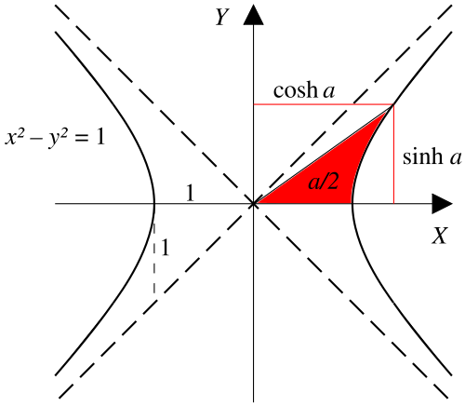
Hyperbolic Derivatives
1. Hyperbolic Sine | $$\frac{d}{dx}\left[\sinh\left(x\right)\right]=\cosh\left(x\right)$$
2. Hyperbolic Cosine | $$\frac{d}{dx}\left[cosh(x)\right]=sinh(x)$$
3. Hyperbolic Tangent | $$\frac{d}{dx}\left[\tanh\left(x\right)\right]={sech}^{2}\left(x\right)$$
4. Hyperbolic Cotangent | $$\frac{d}{dx}\left[coth(x)\right]=-{ csch}^{2}\left(x\right), x≠0$$
5. Hyperbolic Secant | $$\frac{d}{dx}\left[\operatorname{sech}\left(x\right)\right]=-\operatorname{sech}\left(x\right)tanh(x)$$
6. Hyperbolic Cosecant | $$\frac{d}{dx}\left[csch(x)\right]=-\operatorname{csch}\left(x\right)coth\left(x\right), x≠0$$
7. Hyperbolic Arcsine | $$\frac{d}{dx}\left[\sinh^{-1}{(x)}\right]=\frac{1}{\sqrt{x^{2}+1}}$$
8. Hyperbolic Arccosine | $$\frac{d}{dx}\left[\cosh^{-1}{(x)}\right]=\frac{1}{\sqrt{x^{2}-1}}, x>1$$
9. Hyperbolic Arctangent | $$\frac{d}{dx}\left[\tanh^{-1}{(x)}\right]=\frac{1}{1-x^{2}}, \left|x\right|<1$$
10. Hyperbolic Arccotangent | $$\frac{d}{dx}\left[\coth^{-1}{(x)}\right]=\frac{1}{1-x^{2}}, \left|x\right|>1$$
11. Hyperbolic Arcsecant | $$\frac{d}{dx}\left[{sech}^{-1}{(x)}\right]=\frac{-1}{x \sqrt{1-x^{2}}}, 0<x<1$$
12. Hyperbolic Arccosecant | $$\frac{d}{dx}\left[{csch}^{-1}{(x)}\right]=\frac{-1}{\left|x\right| \sqrt{1+x^{2}}}, x≠0$$

Hyperbolic 2nd Derivatives
1. Hyperbolic Sine | $$\frac{d^{2}}{dx^{2}}\left[\sinh\left(x\right)\right]=\sinh\left(x\right)$$
2. Hyperbolic Cosine | $$\frac{d^{2}}{dx^{2}}\left[cosh(x)\right]=cosh(x)$$

Hyperbolic Integrals | (See: Wikipedia, list of integrals of hyperbolic functions.)
1. Hyperbolic Sine | $$\int{sinh(x) dx}=\cosh\left(x\right)+C$$
2. Hyperbolic Cosine | $$\int{\cosh\left(x\right) dx}=\sinh\left(x\right)+C$$
3. Hyperbolic Tangent | $$\int{\tanh\left(x\right)dx}=ln|cosh⁡(x)|+C$$
4. Hyperbolic Cotangent | $$\int{\coth\left(x\right)dx}=ln|sinh⁡(x)|+C$$
5. Hyperbolic Secant | $$\int{\operatorname{sech}\left(x\right)dx}=ln\left|\operatorname{sech}\left(x\right)+tanh\left(x\right)\right|$$  $$\int{\operatorname{sech}\left(x\right)dx}=\tanh^{-1}{(\sinh{(x)})}+C$$  $$\int{\operatorname{sech}\left(x\right)dx}=2\tan^{-1}\left|\tanh\left(\frac{x}{2}\right)\right|+C$$
6. Hyperbolic Cosecant | $$\int{\operatorname{csch}\left(x\right)dx}=ln\left|\coth\left(x\right)-csch\left(x\right)\right|+C$$  $$\int{\operatorname{csch}\left(x\right)dx}=\coth^{-1}\left(\cosh\left(x\right)\right)+C$$  $$\int{\operatorname{csch}\left(x\right)dx}=\ln\left|\tanh\left(\frac{x}{2}\right)\right|$$
7. Hyperbolic Secant² | $$\int{{sech}^{2}\left(x\right)dx}=\tanh\left(x\right)+C$$
8. Hyperbolic Cosecant² | $$\int{\cosh^{2}\left(x\right)dx}=-\coth\left(x\right)+C$$
9. Hyperbolic Arcsine | $$\int{\sinh^{-1}\left(\frac{x}{c}\right) dx}=x sinh^{-1}\left(\frac{x}{c}\right)-\sqrt{x^{2}+c^{2}}+C$$
10. Hyperbolic Arccosine | $$\int{cosh^{-1}\left(\frac{x}{c}\right) dx}=x cosh^{-1}\left(\frac{x}{c}\right)-\sqrt{x^{2}-c^{2}}+C$$
11. Hyperbolic Arctangent | $$\int{\tanh^{-1}\left(\frac{x}{c}\right) dx}=x tanh^{-1}\left(\frac{x}{c}\right)+\frac{c}{2}\ln\left|c^{2}-x^{2}\right|+C, \left|x\right|<|c|$$
12. Hyperbolic Arccotangent | $$\int{\coth^{-1}\left(\frac{x}{c}\right) dx}=x coth^{-1}\left(\frac{x}{c}\right)+\frac{c}{2}\ln\left|x^{2}-c^{2}\right|+C, \left|x\right|>|c|$$
13. Hyperbolic Arcsecant | $$\int{{sech}^{-1}\left(\frac{x}{c}\right) dx}=x sech^{-1}\left(\frac{x}{c}\right)-c\tan^{-1}{\frac{x\sqrt{\frac{c-x}{c+x}}}{x-c}}+C, 0<x<c$$
14. Hyperbolic Arccosecant | $$\int{{csch}^{-1}\left(\frac{x}{c}\right) dx}=x csch^{-1}\left(\frac{x}{c}\right)+c\ln{\frac{x+\sqrt{x^{2}+c^{2}}}{c}}+C, 0<x<c$$
9. Hyperbolic Arcsine | $$\int{\frac{1}{\sqrt{a^{2}+x^{2}}} dx}=\sinh^{-1}\left(\frac{x}{c}\right)+C$$
10. Hyperbolic Arccosine | $$\int{\frac{1}{\sqrt{x^{2}-a^{2}}} dx}=\cosh^{-1}\left|\frac{x}{c}\right|+C$$
11. Hyperbolic Arctangent | $$\int{\frac{1}{a^{2}-x^{2}} dx}=\frac{1}{a} \tanh^{-1}\left(\frac{x}{c}\right)+C, x^{2}<a^{2}$$
12. Hyperbolic Arccotangent | $$\int{\frac{1}{a^{2}-x^{2}} dx}=\frac{1}{a} \coth^{-1}\left(\frac{x}{c}\right)+C, x^{2}>a^{2}$$
13. Hyperbolic Arcsecant | $$\int{\frac{1}{x \sqrt{a^{2}-x^{2}}} dx}=-\frac{1}{a} {sech}^{-1}\left|\frac{x}{c}\right|+C$$
14. Hyperbolic Arccosecant | $$\int{\frac{1}{x \sqrt{a^{2}+x^{2}}} dx}=-\frac{1}{a} {csch}^{-1}\left|\frac{x}{c}\right|+C$$

Sources
- Wikipedia (2025). Hyperbolic Functions. https://en.wikipedia.org/wiki/Hyperbolic_functions.

See Also
- Harold’s Trigonometry & Hyperbolic Parent Functions Cheat Sheet

