Harold’s Math is Fun – Part 1
Cheat Sheet
23 March 2026

Cool Graph Equations

Description | Equation | Graph
Heart – Rectangular | $$f\left(x\right)=x^{2/3}+0.9 sin\left(kx\right) \sqrt{3-x^{2}}$$  $$k=81.5$$ | 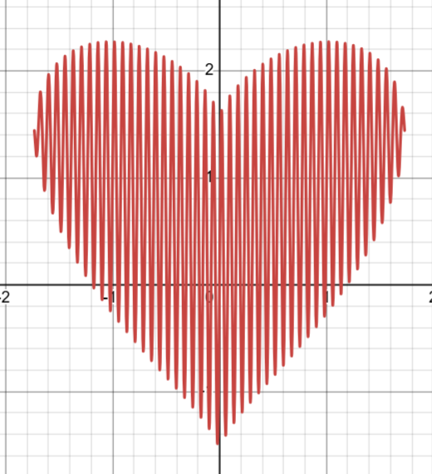
Heart – Polar | $$r=3.6-\frac{\cos\left(2θ\right)+3 sin⁡(θ)}{0.8+|cos⁡(θ)|}+1.5 cos⁡(2θ)$$ | 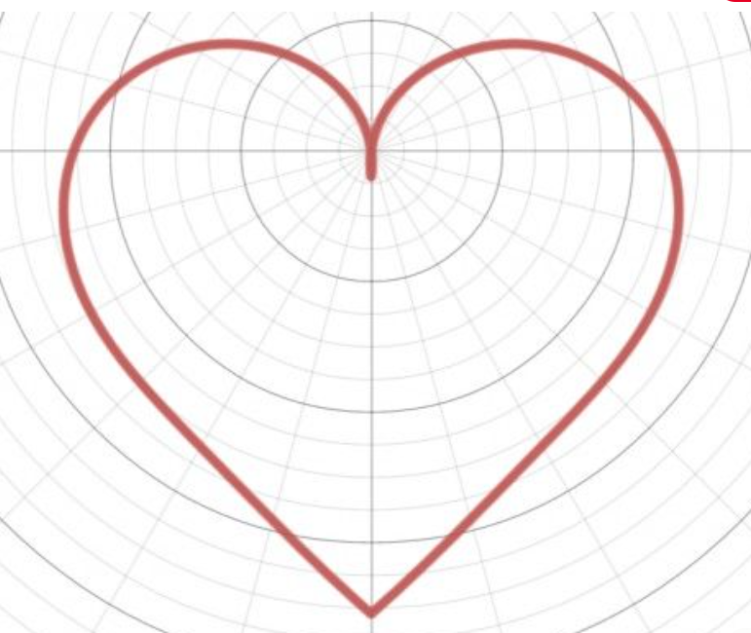
Heart – Parametric | $$x\left(t\right)=16{\left(sin t\right)}^{3}$$  $$y\left(t\right)=13 cos\left(t\right)-5 cos\left(2t\right)-2 cos(3t)-cos(4t)$$  $$0≤t≤2π$$ | 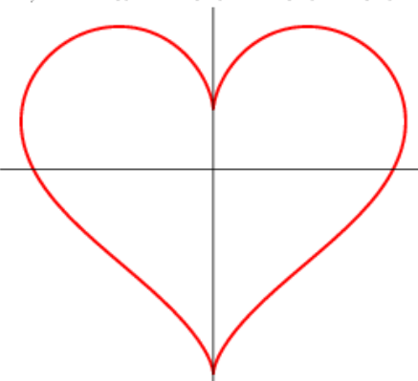
Persian Rug | sin(cos(tan(xy))) = sin(cos(tan(x))) + sin(cos(tan(y))) | 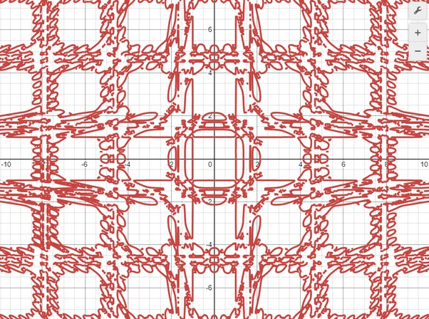
Batman Equation | 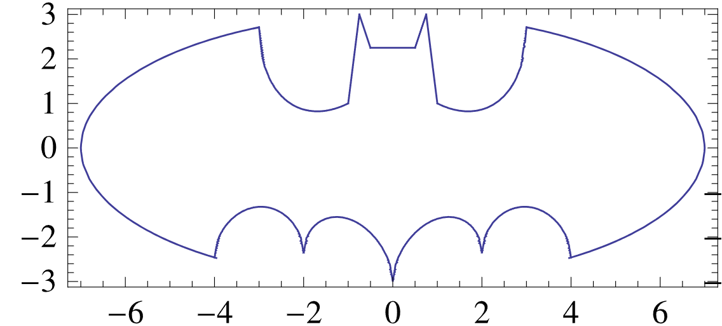
Batman Equation | Upper Part:  $$f\left(x\right)=\left(h-l\right)H\left(x+1\right)+\left(r-h\right)H\left(x-1\right)+\left(l-w\right)H\left(x+3\right)+\left(w-r\right)H\left(x-3\right)+w$$
Batman Equation | Lower Part :  $$g\left(x\right)=\frac{1}{2}\left[\left|\frac{x}{2}\right|+\sqrt{1-{\left(\left|\left|x\right|-2\right|-1\right)}^{2}}-\frac{1}{122}\left(3\sqrt{33}-7\right)x^{2}+w-3\right]∙\left[sgn\left(x+4\right)-sgn\left(x-4\right)\right]-w$$
Batman Equation | Where $H(x)$ is the Heaviside step function  $$H\left(x\right)=\left\{\begin{matrix}0 x<0 \\ \frac{1}{2} x=0 \\ 1 x>0\end{matrix}\right.$$  and  $$w=3\sqrt{1-{\left(\frac{x}{7}\right)}^{2}}$$  $$l=\frac{1}{2}\left(x+3\right)-\frac{3}{7}\sqrt{10}\sqrt{4-{\left(x+1\right)}^{2}}+\frac{6}{7}\sqrt{10}$$  $$r=\frac{1}{2}\left(3-x\right)-\frac{3}{7}\sqrt{10}\sqrt{4-{\left(x+1\right)}^{2}}+\frac{6}{7}\sqrt{10}$$  $$h=\frac{1}{2}[f\left(\left|x+\frac{1}{2}\right|+\left|x-\frac{1}{2}\right|+6\right)-11\left(x+\frac{3}{4}\right)+\left|x-\frac{3}{4}\right|]$$
Superman | Desmos | 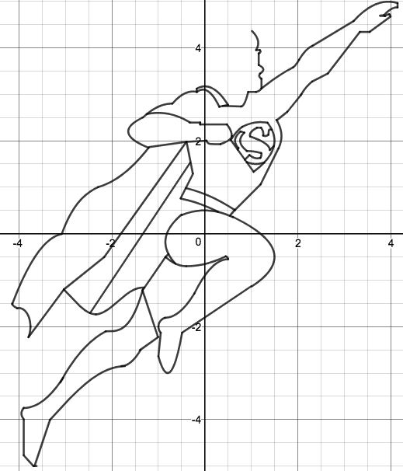
Fun Math Quotes

Description | Equation |  |  | Note
Then a Miracle Occurs | 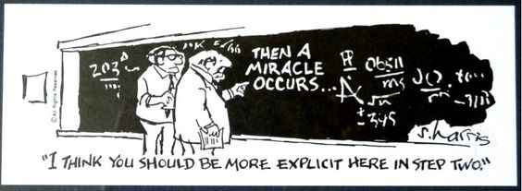
Math Teacher Signs | 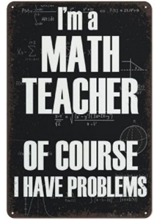 | 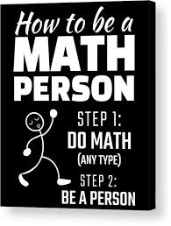 |  | 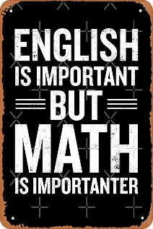 | 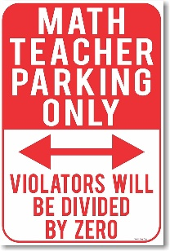
Find $x$ | $$a^{2}+b^{2}=c^{2}$$ |  |  | 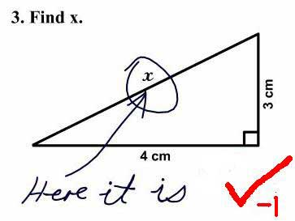
3 Types of People | “There are three types of people: those who can count and those who cannot.” - Gene Wolfe
Lottery Tax | "Lottery: A tax on people who are bad at math."
Carnivorous Integers | Q: Why was 6 afraid of 7?  A: Because 7 ate 9, since you are supposed to eat 3 squared meals a day.
Old MacDonald | "Old Macdonald had a form, eᵢ ∧ eᵢ = 0.”
Pierre de Fermat | Pierre de Fermat walks into a bar. “I have devised a most humorous punchline to this joke, but this margin is too narrow to contain it.”
Hiitchhiker | A kindergarten teacher asked students to introduce their parents.  - "My mom is a doctor. She saves lives!" "Wonderful!"  - "My dad drives for Uber. He takes people where they need to go!" "That's nice."  - "My dad kills hitchhikers and sells their valuables on eBay!" "Goodness gracious!"  - "Actually, I'm a mathematician, but how can you explain that to kids?"
Breaking Bad Parody | “I took care of it. I divided by zero.” |  | Studio C two math teachers' parody of the TV series “Breaking Bad”, where they were dealing in Math, not Meth.
Beautiful Math

Description | Equation | Note
Euler’s Identity | 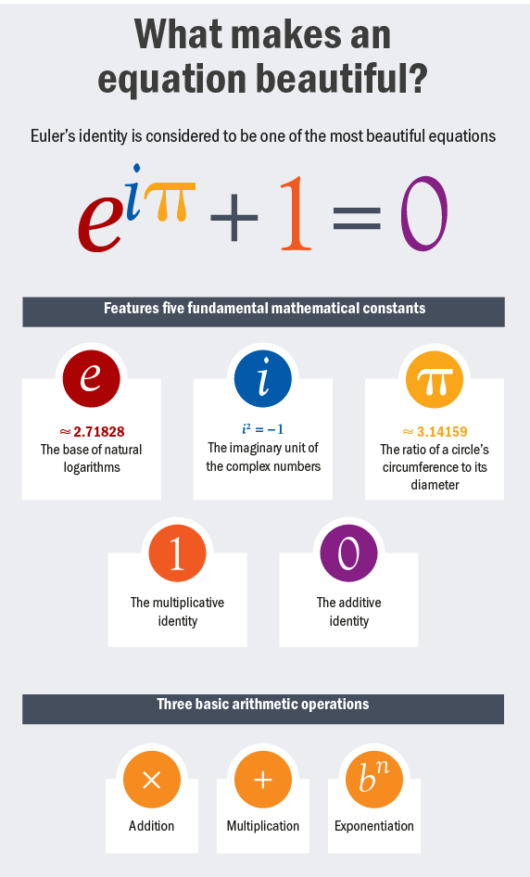
Gamma Function: Factorial of a Fraction | $$\left(\frac{1}{2}\right)!=\frac{\sqrt{π}}{2}$$

Deceptive Algebra Proofs

Description | Equation | Note
$$2=1$$ | a = b  a² = a· b  a² – b² = a· b – b²  (a + b) (a – b) = b (a – b)  a + b = b  b + b = b  2b = b  2 = 1 | Can you find the illegal operation?
$$2+2=5$$ | $$0=0$$  $$20x-20x=25x-25x$$  $$4x∙5-4x∙5=5x∙5-5x∙5$$  $$4x\left(5-5\right)=5x\left(5-5\right)$$  $$4x=5x$$  $$4=5$$  $$2+2=5$$ | That darn zero again
$$2=0$$ | $$2=1+1$$  $$2=1+\sqrt{1}$$  $$2=1+\sqrt{(-1)(-1)}$$  $$2=1+\sqrt{(-1)} •\sqrt{(-1)}$$  $$2=1+i•i$$  $$2=1+i^{2}$$  $$2=1-1$$  $$2=0$$ | Complex numbers
$$1=-1$$ | $$1=1$$  $$1=\sqrt{1}$$  $$1=\sqrt{{\left(-1\right)}^{2}}$$  $$1=\sqrt{-1} \sqrt{-1}$$  $$1=i^{2}$$  $$1=-1$$ | Imaginary numbers
$$\$1=1¢$$ | $1 = 100 cents  $1 = (10 cents)²  $1 = ($0.1)²  $1 = $0.01  $$\$1=1¢$$ | Proof that $1 = 1 cent
$$π=3$$ | $$x=\left(π+3\right)/2$$  $$2x=π+3$$  $$2x\left(π-3\right)=\left(π+3\right)\left(π-3\right)$$  $$2πx-6x=π^{2}-9$$  $$9-6x=π^{2}-2πx$$  $$9-6x+x^{2}=π^{2}-2πx+x^{2}$$  $${\left(3-x\right)}^{2}={\left(π-x\right)}^{2}$$  $$3-x=π-x$$  $$π=3$$ | "And he made a molten sea, ten cubits from the one brim to the other: it was round all about, and his height was five cubits: and a line of thirty cubits did compass it round about.".  - 1 Kings 7:23
Girls are Evil | Given:  Girls = Time x Money  Time = Money  Money = $\sqrt{Evil}$  Proof:  Girls = ${\left(Money\right)}^{2}$  Girls = ${\left(\sqrt{Evil}\right)}^{2}$  Girls = Evil | Proof that girls are evil
Dilbert’s Salary Theorem | Given:  Knowledge is Power  Time is Money  Power = Work/Time  Proof:  Knowledge = Power  Knowledge = Work/Time  Knowledge = Work/Money  Money = Work/Knowledge  $$Money=\lim_{Knowledge→0}{\frac{Work}{Knowledge}}→∞$$  Conclusion:  All else being equal, the less you know, the more money you make. | Proof relating to Knowledge, Power, and Money  If Work is held constant as a positive number, Money approaches infinity (∞) as Knowledge approaches zero (0).
Halloween = Christmas | $$OCT 31=DEC 25$$  Halloween = Christmas | Think of octal and decimal.
Merry Christmas | $$y=\frac{\ln\left(\frac{x}{m}-sa\right)}{r^{2}}$$  $$r^{2}y=\ln\left(\frac{x}{m}-sa\right)$$  $$e^{r^{2}y}=\frac{x}{m}-sa$$  $$me^{r^{2}y}=x-sam$$  $$me^{rry}=x-mas$$ | 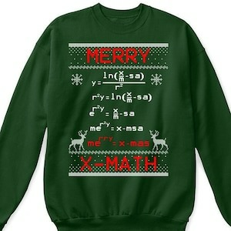
Spreadsheets | 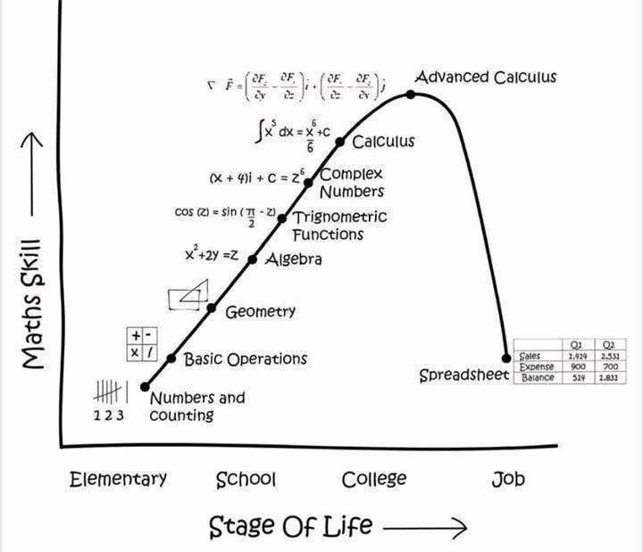
Deceptive Geometry Proofs

Description | Picture
Lost Squares | 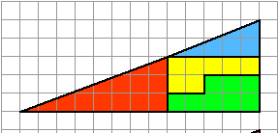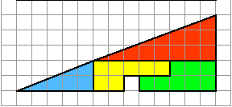
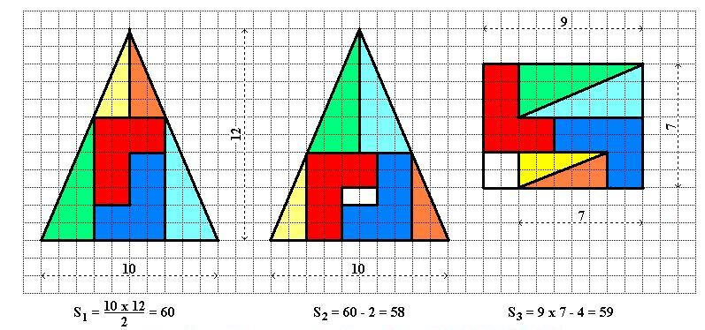
Free Chocolate | 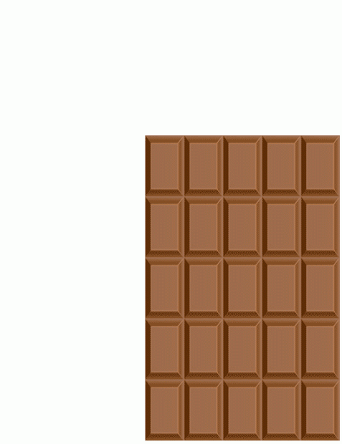

Math Puzzles

Description | Equation |  | Note
How many numbers can you see? | 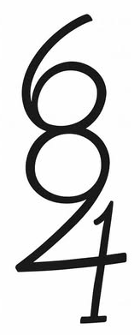 | 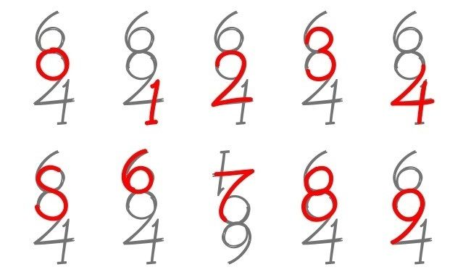
Where did the other dollar go? | Three guys in a hotel call room service and order two large pizzas.  The delivery boy brings them up with a bill for exactly $30.00.  Each guy gives him a $10.00 bill, and he leaves.  When he hands the $30.00 to the cashier, he is told that a mistake has been made.  The bill was only $25.00, not $30.00.  The cashier gives the delivery boy five $1.00 bills and tells him to take them back to the 3 guys who ordered the pizza.  On the way back to their room, the delivery boy has a thought... these guys did not give him a tip.  He figures that since there is no way to split $5.00 evenly three ways anyhow, he will keep two dollars for himself and give them back three dollars.  He knocks on the door, and one fellow answers.  He explains about a mix-up in the bill, and hands the guy the three dollars, then departs with his two-dollar tip in his pocket.  Now the fun begins!  $30 - $25 = $5  $5 - $3 = $2  Answer this:  Each of the three guys originally gave $10.00 each.  They each got back $1.00 in change.  That means they paid $9.00 each, which times three is $27.00.  The delivery boy kept $2.00 for a tip.  $27.00 plus $2.00 equals $29.00.  Where is the other dollar?
Marital Relationship Math

Description | Equation | Note
Romance | Smart man + smart woman = romance  Smart man + dumb woman = affair  Dumb man + smart woman = marriage  Dumb man + dumb woman = pregnancy
Office | Smart boss + smart employee = profit  Smart boss + dumb employee = production  Dumb boss + smart employee = promotion  Dumb boss + dumb employee = overtime
Shopping | A man will pay $2 for a $1 item he needs.  A woman will pay $1 for a $2 item that she doesn't need.
Future | A woman worries about the future until she gets a husband.  A man never worries about the future until he gets a wife.
Success | A successful man is one who makes more money than his wife can spend.  A successful woman is one who can find such a man.
Happiness | To be happy with a man, you must understand him a lot and love him a little.  To be happy with a woman, you must love her a lot and not try to understand her at all.
Longevity | Married men live longer than single men do, but married men are a lot more willing to die.
Propensity to Change | A woman marries a man expecting he will change, but he doesn't.  A man marries a woman expecting that she won't change, and she does.
Discussions | A woman has the last word in any argument.  Anything a man says after that is the beginning of a new argument.
You’re Next | Old aunts used to come up to me at weddings, poking me in the ribs and cackling, telling me, "You're next."  They stopped after I started doing the same thing to them at funerals.
Conclusion | Show this list to a smart woman who needs a laugh, and to the smart guys you know can handle it.

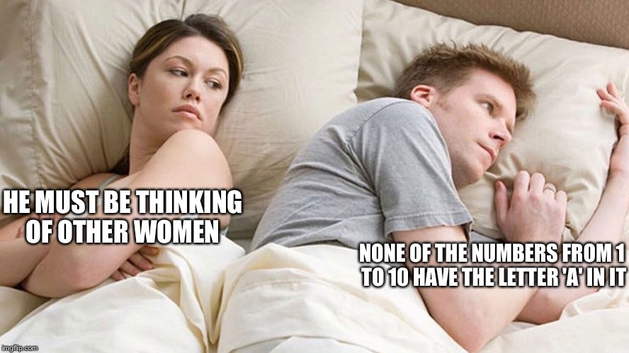
Sources
- Busch, Andrew (2025). Desmos Art! Geometry. https://www.andrewbusch.us/home/desmos-art-geometry
- Jeon, Charles (April 24, 2011). Dilbert’s Salary Theorem, University of Pennsylvania. https://www.scribd.com/document/317411126/Dilbert
- OnlineMath Learning.com (2025). Funny Math Proofs. https://www.onlinemathlearning.com/funny-math-proofs.html
- Quora (2020). What are some cool graph equations? https://www.quora.com/What-are-some-cool-graph-equations
- Reddit.com (July 28, 2011). Batman Curve. https://mathworld.wolfram.com/BatmanCurve.html
- Romance Mathematics. https://faculty.kfupm.edu.sa/COE/gutub/English_Misc/math_english.htm
- Tiwari, A. K. (June 11, 2021). What makes an equation beautiful? A. K. Tiwari Physics Classes’ post. https://www.facebook.com/abhijeetphysics/posts/in-this-post-i-will-discuss-about-one-of-the-most-beautiful-equation-of-mathemat/109163324729417/
- Wolfram World (2025). Heart Curve. https://mathworld.wolfram.com/HeartCurve.html

