Harold’s Math is Fun – Part 2
Cheat Sheet
23 March 2026

Deceptive Calculus Proofs

Description | Equation | Translation
Gabriel’s Horn | $$f\left(x\right)=\frac{1}{x}, x≥1$$ | Has a finite volume and an infinite suface area.
Gabriel’s Horn | 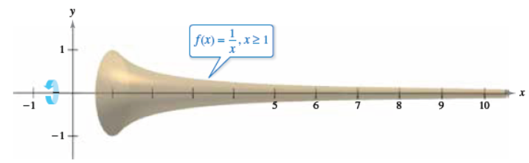
Gabriel’s Horn | Volume | Surface Area
Gabriel’s Horn | $$V=π\int_{1}^{a}{{\left(\frac{1}{x}\right)}^{2}dx}=π\left(1-\frac{1}{a}\right)$$  $$\lim_{a→∞}{V}=\lim_{a→∞}{π\left(1-\frac{1}{a}\right)}=π$$ | $$A=2π\int_{1}^{a}{\frac{1}{x}\sqrt{1+{\left(-\frac{1}{x^{2}}\right)}^{2}}dx}$$  $$>2π\int_{1}^{a}{\frac{1}{x}dx}=2π\ln{a}$$  $$\lim_{a→∞}{A}>\lim_{a→∞}{2π\ln{a}}=∞$$
Gabriel’s Horn | The mismatch comes from how slowly $\frac{1}{x}$ decays.
Log Cabin | $$\int{\frac{d Cabin}{Cabin}=ln\left(Cabin\right)+C}$$ | Log cabin by the sea.

Natural Number (e)

Description | Equation | Translation

Pi (π)

Description | Equation | Translation
Dessert | $${\left(AP_{π}\right)}^{t}$$ | A piece of pie raised to the teeth.

Sources
- Wikipedia (2026). Gabriel’s horn. https://en.wikipedia.org/wiki/Gabriel%27s_horn
- Microsoft Copilot (2026). “Deceptive Calculus Proofs like Gabriels' horn and others.”, https://copilot.microsoft.com/chats/L4fpub6DLCh9zuuj3cmue

