Harold’s Modular Arithmetic
Cheat Sheet
4 March 2025

Modular Arithmetic

Property | Condition (if) | Formula (then)
Visualization | 24-Hour Clock (mod 12)  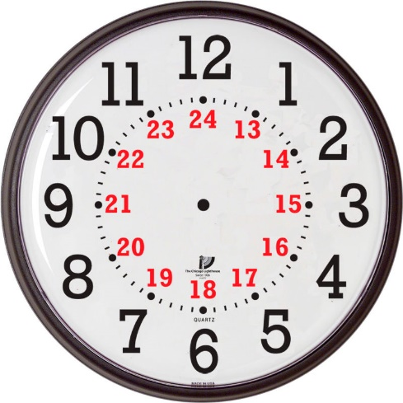 | (mod 26)  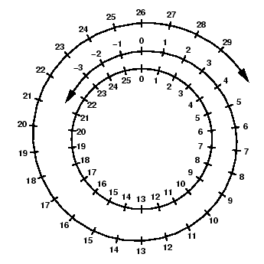
Variables | m = modulus (+ int)  r, n = residue or remainder (+ int) | a, b = integers  q, k = quotient or multiples of (int)
Modulus | $$b=qm+r$$ | $$b mod m≡r$$
Modulus | $$b=km+n$$ | $$b mod m≡n$$
Modulus | $$a≡b (mod m)$$ | $$a mod m≡b mod m$$
Modulus | b MOD m | Integers r or n
Modulus | b DIV m | Integers q or k
Congruence | ≡  $$a≡b \left(mod m\right)$$ | $$a mod m=n$$  $$b mod m=n$$
Congruence | $$\frac{a-b}{m}=n$$  m | (a - b) | a and b have the same remainder when divided by m. n is an integer.  m divides a – b.
The congruence relation satisfies all the conditions of an equivalence relation:
Reflexivity | $$a≡a (mod m)$$
Symmetry | $b≡a (mod m)$ for all a, b, and n | $$a≡b (mod m)$$
Transitivity | $$a≡b (mod m)$$  $$b≡c (mod m)$$ | $$a≡c (mod m)$$

Identities

Property | Condition (if) | Formula (then)
Addition | $$a+b=c$$ | $$a mod m+b mod m ≡c mod m$$
Computing | $$[(a mod m)+(b mod m)] mod m=[a+b] mod m=c mod m$$
Translation | $$a≡b \left(mod m\right)$$ | $$a+k≡b+k (mod m)$$  for any integer k
Combining | $a≡b \left(mod m\right)$  $$c≡d (mod m)$$ | $$a+c≡b+d (mod m)$$
Subtraction | $$a-b=c$$ | $$a mod m-b mod m≡c mod m$$
Negation | $$a≡b (mod m)$$ | $$-a≡-b (mod m)$$
Multiplication | $$a∙b=c$$ | $$a mod m∙b mod m≡c mod m$$
Computing | $$[(a mod m)(b mod m)] mod m=[ab] mod m=c mod m$$
Scaling | $$a≡b (mod m)$$ | $$ka≡kb \left(mod m\right)$$  $$ka≡kb \left(mod km\right)$$
Combining | $a≡b (mod m)$  $$c≡d (mod m)$$ | $$ac≡bd (mod m)$$
Division | $\gcd{ \left(k,m\right)}=1$  (Meaning k and m are coprime)  $$ka=kb (mod m)$$ | $$a≡b (mod m)$$
Division | $$\frac{a}{e}=\frac{b}{e} \left(mod \frac{m}{gcd⁡(m, e)}\right)$$ | where e is a positive integer that divides a and b
Exponentiation | $$a≡b (mod m)$$ | $$a^{k}≡b^{k} (mod m)$$
Exponentiation | Example: Find the last digit of ${17}^{17}$  $${17}^{17} \left(mod 10\right)$$  $$≡ {\left(7^{2}\right)}^{8}∙7 \left(mod 10\right)$$  $$≡{\left(49\right)}^{8}∙7 \left(mod 10\right)$$  $$≡{\left(9\right)}^{8}∙7 \left(mod 10\right)$$  $$≡{\left(9^{2}\right)}^{4}∙7 \left(mod 10\right)$$  $$≡{\left(81\right)}^{4}∙7 \left(mod 10\right)$$  $$≡{\left(1\right)}^{4}∙7 \left(mod 10\right)$$  $$≡7 \left(mod 10\right)$$  Hence, the last digit of ${17}^{17}=7$ | The exponentiation property only works on the base.  For powers, use Euler's theorem.
Multiplicative Inverse mod n | $$a∙a^{-1}≡1 \left(mod m\right)$$  $$\gcd\left(a,m\right)=1$$  (a and m are relatively prime)  $$1≤a, a^{-1}≤m+1$$  m ≥ 2 | $a^{-1}$ is a multiplicative inverse of a mod m
Multiplicative Inverse mod n | Example: Solve for x in 2x ≡ 3 (mod 5)  To find the inverse first solve for r:  If 2∙r ≡ 1 (mod 5) then r = 3.  So, the multiplicative inverse of 2 is 3 with (mod 5).  Since ${r=a}^{-1}$ and $a^{-1}ax≡x (mod m)$, then $\left(2\right)\left(3\right)x≡6x≡x (mod 5)$.
Multiplicative Inverse mod n | p is prime  $$0<a<p$$ | $$a^{-1}≡a^{p-2} (mod p)$$
Theorems

Theorem | Condition (if) | Formula (then)
Greatest Common Divisor (GCD) | $$gcd(x,y)=p_{1}^{min\{α_{1},β_{1}\}}·p_{2}^{min\{α_{2},β_{2}\}}·p_{k}^{min\{α_{k},β_{k}\}}$$  Largest positive integer that is a factor of both x and y.  Think Intersection (∩) of $α_{i},β_{i}$.
GCD Theorem | x and y are positive integers where x < y | gcd (x, y) = gcd (y mod x, x)
Euclid’s Algorithm | if ( y < x ) Swap (x, y);  r = y mod x;  while ( r ≠ 0 ) {  y = x;  x = r;  r = y mod x;  }  return (x); | gcd (x, y) = x_{i}
Example | 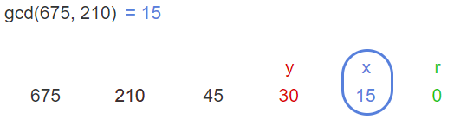
Extended Euclidean Theorem | Let x and y be integers, then there are integers s and t such that | gcd (x, y) = sx + ty
Extended Euclidean Algorithm | r = y mod x  r = y – (y div x) $·$ x  15 = 45 – (45 div 30) $·$ 30  15 = 45 – 1 ⋅ 30  Slide [y x r] window left  30 = 210 – (210 div 45) $·$ 45  30 = 210 - 4 ⋅ 45  Slide [y x r] window left  45 = 675 - 3 $·$ 210  Back substitute green into red  gcd (675, 210) = 15 = 5 ⋅ 675 – 16 ⋅ 210  Output Format: gcd (x, y) = sx + ty  where s and t are Bézout coefficients | Example:  gcd (675, 210) = 15  Do Euclid’s Algorithm first, Saving intermediate results.  Start with sliding window on right.  << [y x r]  675 210 45 30 15
Multiplicative Inverses | gcd (x, y) = sx + ty | s = x’s inverse mod y  t = y’s inverse mod x
Fermat’s Little Theorem | p is prime  a is an integer not divisible by p | $$a^{p-1}≡1 \left(mod p\right)$$  $$a^{p}≡a (mod p)$$
Fermat’s Little Theorem | Example: Find 7²²² mod 11  Since 7¹⁰ ≡ 1 (mod 11)  and (7¹⁰)^{k} ≡ 1 (mod 11)  7²²² = 7^{22•10+2} = (7¹⁰)^{22 •}7²  ≡ (1)²² • 49  ≡ 5 (mod 11)  Hence, 7²²² mod 11 = 5
Euler’s Theorem | c ≡ d (mod φ(n))  where φ is Euler's totient function | a^{c} ≡ a^{d} (mod n)  provided that a is coprime with n
Euler’s Theorem | a and m are coprime | a^{φ(n)} ≡ 1 (mod m)  where φ is Euler's totient function
Euler’s Totient Function | φ(n) = number of integers ≤ n that do not share any common factors with n
Wilson’s Theorem | p is prime if and only if (p − 1)! ≡ −1 (mod p)
Linear Congruence | $$ax≡b (mod m)$$ | Solutions are all integers x that satisfy the congruence
Chinese Remainder Theorem | m₁, m₂, …, m_{n} are pairwise relatively prime positive integers > 1  a₁, a₂, …, a_{n} are arbitrary integers | x ≡ a₁ (mod m₁)  x ≡ a₂ (mod m₂)  …  x ≡ a_{n} (mod m_{n})  has a unique solution modulo m = m₁m₂∙∙∙m_{n}.  (Meaning 0 ≤ x < m and all other solutions are congruent (≡) modulo m to this solution.)
Lagrange's Theorem | The congruence f (x) ≡ 0 (mod p), where p is prime, and f (x) = a₀ x^{n} + ... + a^{n} is a polynomial with integer coefficients such that a₀ ≠ 0 (mod p), has at most n roots.
Primitive Root Modulo m | A number g is a primitive root modulo m if, for every integer a coprime to m, there is an integer k such that g^{k} ≡ a (mod m).  A primitive root modulo m exists if and only if n is equal to 2, 4, p^{k}, or 2p^{k}, where p is an odd prime number and k is a positive integer.  If a primitive root modulo m exists, then there are exactly φ(φ(m)) such primitive roots, where φ is the Euler's totient function.

Sources:
- SNHU MAT 260 - Cryptology, Invitation to Cryptology, 1st Edition, Thomas Barr, 2001.
- SNHU MAT 230 - Discrete Mathematics, zyBooks.
- https://brilliant.org/wiki/modular-arithmetic/
- https://en.wikipedia.org/wiki/Modular_arithmetic
- https://artofproblemsolving.com/wiki/index.php/Modular_arithmetic/Introduction

