Harold’s Physics Attwood Machine
Cheat Sheet
3 November 2025

Two Masses on a Pully
Diagram | 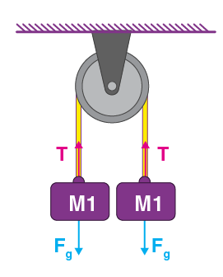 | 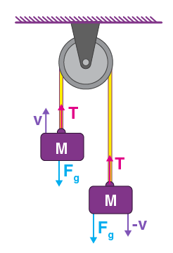 |  | 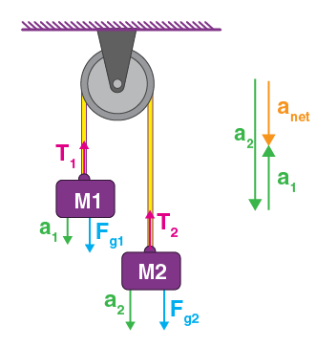
Scenario | $$v=0$$ | $$v=constant$$ |  | $$a=constant$$
Givens | $$μ_{pully}=0$$  $$m_{string}=0 kg$$
Givens | $$M_{1}=0.20 kg$$  $$v=0\frac{m}{s} or=constant \frac{m}{s}$$ |  |  | $$M_{1}=0.20 kg$$  $$M_{2}=0.50 kg$$
Unknowns | $$T= ? N$$ |  |  | $$|T_{1}|= ? N$$  $$a_{net}= ? \frac{m}{s^{2}}$$
Observations | $$\left|T\right|=\left|-T\right|$$  $$a=0 \frac{m}{s^{2}}$$ |  |  | $$\left|T_{1}\right|=\left|-T_{2}\right|=\left|T\right|$$  $$a=constant \frac{m}{s^{2}}$$
Observations | $$g=9.81\frac{m}{s^{2}}$$
Equations | $$\sum{F}=F_{a}=Ma$$  $$T_{1}-T_{2}=0$$
Equations | $$F_{net}=2F_{g}-T=0$$ |  |  | $$F_{g1}=M_{1}g$$  $$F_{g2}=M_{2}g$$  $$F_{g2}-F_{g1}=F_{a}$$  $$M=M_{1}+M_{2}$$  $$a_{2}-a_{1}=a_{net}$$  $$T-F_{g1}=M_{1}a_{net}$$  $$T-F_{g2}=M_{2}a_{net}$$
Solve | $$F_{g}=M_{1}g$$  $$T=2F_{g}$$ |  | $$\frac{\begin{matrix}(T-M_{1}g=M_{1}a_{net}) \\ -(T-M_{2}g={-M}_{2}a_{net})\end{matrix}}{({-M}_{1}g+M_{2}g=M_{1}a_{net}+M_{2}a)}$$  $$\left(M_{2}-M_{1}\right)g=\left(M_{1}+M_{2}\right)a_{net}$$  $$a_{net}=\frac{(M_{2}-M_{1})}{(M_{2}+M_{1})}g$$
Substitute | $$F_{g}=\left(0.20 kg\right)\left(9.81\frac{m}{s^{2}}\right)$$  $$F_{g}=1.96 N$$  $$T=2F_{g}=3.92 N$$ |  | $$F_{g1}=\left(0.20 kg\right)\left(9.81\frac{m}{s^{2}}\right)=1.96 N$$  $$F_{g2}=\left(0.50 kg\right)\left(9.81\frac{m}{s^{2}}\right)=4.91 N$$  $$F_{a}=F_{g2}-F_{g1}=4.91 N-1.96 N=2.94 N$$  $$M=M_{1}+M_{2}=0.20 kg+0.50 kg=0.70 kg$$  $$F_{a}=Ma_{net}$$  $$a_{net}=\frac{F_{a}}{M}=\frac{2.94 N}{0.70 kg}=4.20\frac{m}{s^{2}}$$  $$T_{1}-T_{2}=0$$  $$\left|T_{1}\right|=\left|T_{2}\right|=\left|Mg\right|$$  $$\left|T_{1}\right|=\left(0.70 kg\right)\left(9.81\frac{m}{s^{2}}\right)=6.87 N$$  $$a_{net}=\frac{\left(M_{2}-M_{1}\right)}{\left(M_{2}+M_{1}\right)}g=\frac{\left(0.50-0.20\right)}{\left(0.50+0.20\right)}g=\frac{3}{7}g=4.20\frac{m}{s^{2}}$$

Sources
- Attwood Machine (2025). https://ucscphysicsdemo.wordpress.com/atwood-machine/
- BYJU’s (2025). What is Atwood’s Machine? https://byjus.com/physics/atwood-machine/

