Harold’s Center of Mass
Cheat Sheet
14 January 2026

Center of Mass Terms

Term | Description | Units
$$\overline{x}$$  $$\left(\overline{x}, \overline{y}\right)$$  $$(\overline{x}, \overline{y}, \overline{z})$$ | Center of Mass (CoM). The coordinates (point) where the object is perfectly balanced. (Centroid) | $$m or ft$$
$$\overline{x}$$ | Center of Mass along the x-axis. Same as $x_{cm}$. | $$m or ft$$
$$\overline{y}$$ | Center of Mass along the y-axis. | $$m or ft$$
$$\overline{z}$$ | Center of Mass along the z-axis. | $$m or ft$$
$$M$$ | Total mass. How heavy the object is. Is equal to its area or volume if uniform density. (similar to Weight) | $$kg or lb$$
$$M_{x} and M_{y}$$ | A moment is the line or axis on which the object can spin perfectly balanced. | $$kg or lb$$
$$M_{x}$$ | Moment about the x-axis | $$kg or lb$$
$$M_{y}$$ | Moment about the y-axis | $$kg or lb$$
$$ρ$$ | Greek symbol rho for density or mass/volume or mass/area. | $$ρ=\frac{kg}{m^{3}} or \frac{lb}{{ft}^{3}}$$
$$A$$ | Area of lamina or plate | $$m^{2} or {ft}^{2}$$
$$V$$ | Volume of a body or solid | $$m^{3} or {ft}^{3}$$
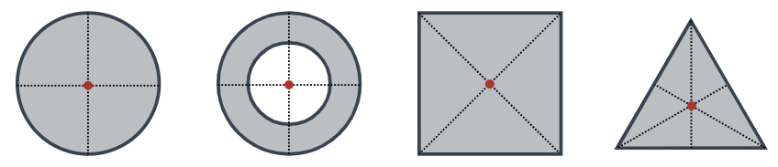
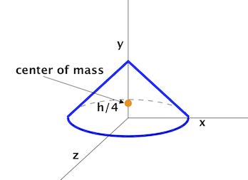

Center of Mass: Discrete or for Particles

Term | 1D | 2D | 3D
$$\overline{x}$$ | $$\overline{x}=\frac{m_{1}x_{1}+m_{2}x_{2}}{m_{1}+m_{2}}$$ | $$\overline{x}=\frac{M_{y}}{M}$$ | $$\overline{x}=\frac{1}{M} \sum_{i=1}^{N}{m_{i} x_{i} }$$
$$\overline{y}$$ | $$\overline{y}=\frac{m_{1}y_{1}+m_{2}y_{2}}{m_{1}+m_{2}}$$ | $$\overline{y}=\frac{M_{x}}{M}$$ | $$\overline{y}=\frac{1}{M} \sum_{i=1}^{N}{m_{i} y_{i} }$$
$$\overline{z}$$ | $$\overline{z}=\frac{m_{1}z_{1}+m_{2}z_{2}}{m_{1}+m_{2}}$$ | NA | $$\overline{z}=\frac{1}{M} \sum_{i=1}^{N}{m_{i} z_{i} }$$
$$M$$ | $$M= \sum_{i=1}^{N}{m_{i}}=\int{dm}$$
$$M_{x}$$ | $$M_{x}=\sum_{i=1}^{N}{m_{i} y_{i} }=\int{y dm}$$
$$M_{y}$$ | $$M_{y}=\sum_{i=1}^{N}{m_{i} x_{i}}=\int{x dm}$$
1D
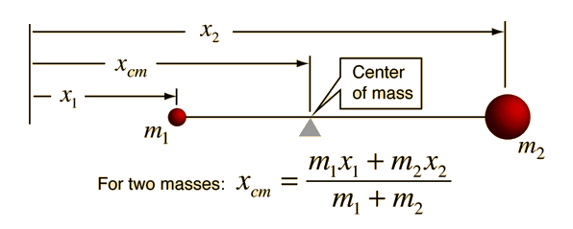
2D
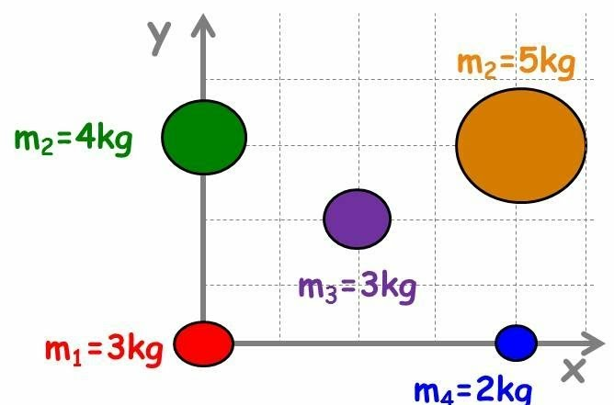

TIP: Pick the xy-axis origin to be at the corner of a right angle (e.g., red mass m₁).
Center of Mass: Continuous

Term | 2D | 3D
$$\overline{x}$$ | $$\overline{x}=\frac{M_{y}}{M}$$ | $$\overline{x}=\frac{1}{M} \int_{0}^{M}{x dm}=\frac{1}{M} \int_{0}^{M}{x \frac{M}{L}dx}=\frac{M_{yz}}{M}$$
$$\overline{y}$$ | $$\overline{y}=\frac{M_{x}}{M}$$ | $$\overline{y}=\frac{1}{M} \int_{0}^{M}{y dm}=\frac{M_{xz}}{M}$$
$$\overline{z}$$ | NA | $$\overline{z}=\frac{1}{M} \int_{0}^{M}{z dm}=\frac{M_{xy}}{M}$$  $$\overline{z}=\frac{1}{V} \int_{z_{min}}^{z_{max}}{z dV}$$
$$M$$ | $$M=ρ (Area)$$  $$M= ρ\int_{a}^{b}{f\left(x\right) dx}$$  $$M=\iint_{R}^{ }{dm}=\iint_{R}^{ }{ρ\left(x,y\right) dA}$$  $$dm=ρ(x,y) dy dx$$ | $$M=ρ (Volume)$$  $$M=\iiint_{Q}^{ }{dm}=\iiint_{Q}^{ }{ρ\left(x,y,z\right) dV}$$  $$dm=ρ\left(x,y,z\right) dz dy dx$$
$$M_{x}$$ | $$M_{x}=ρ\iint_{R}^{ }{y dA}= ρ\int_{a}^{b}{\frac{1}{2}\left({\left[f\left(x\right)\right]}^{2}\right)} dx$$ | $$M_{xy}=\iiint_{Q}^{ }{z ρ\left(x,y,z\right) dV}$$
$$M_{y}$$ | $$M_{y}=ρ\iint_{R}^{ }{x dA}= ρ\int_{a}^{b}{x f(x)} dx$$ | $$M_{yz}=\iiint_{Q}^{ }{x ρ\left(x,y,z\right) dV}$$
$$M_{z}$$ | NA | $$M_{xz}=\iiint_{Q}^{ }{y ρ\left(x,y,z\right) dV}$$
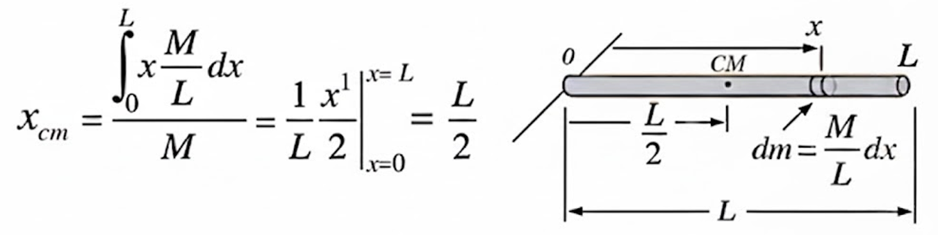

Center of Mass of Common 2D Plane Areas and Curves

Shape | Diagram | Formulas
Triangle | 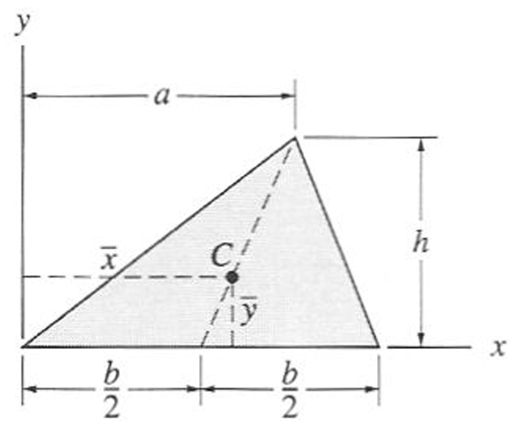 | $$\overline{x}=\frac{1}{3}\left(a+b\right)$$  $$\overline{y}=\frac{1}{3}h$$  $$A=\frac{1}{2}bh$$
Quarter Circle | 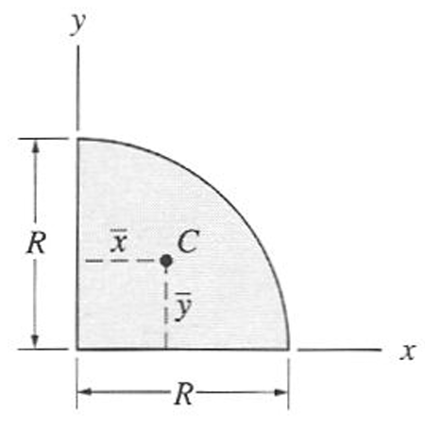 | $$\overline{x}=\frac{4}{3π}R$$  $$\overline{y}=\frac{4}{3π}R$$  $$A=\frac{1}{4}πR^{2}$$
Quarter Ellipse | 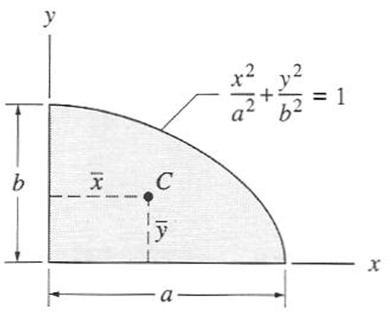 | $$\overline{x}=\frac{4}{3π}a$$  $$\overline{y}=\frac{4}{3π}b$$  $$A=\frac{1}{4}πab$$
Half Parabolic Complement | 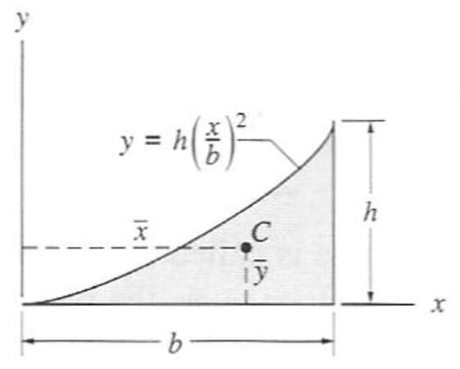 | $$\overline{x}=\frac{3}{4}b$$  $$\overline{y}=\frac{3}{10}h$$  $$A=\frac{1}{3}bh$$
Half Parabola | 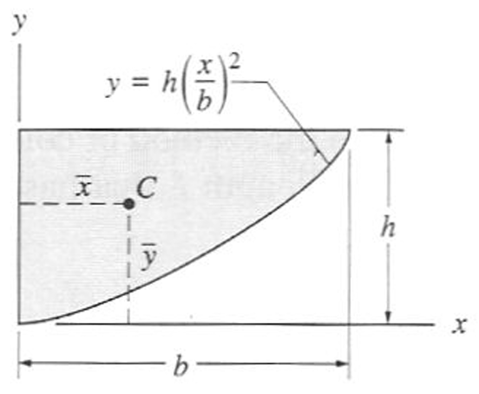 | $$\overline{x}=\frac{3}{8}b$$  $$\overline{y}=\frac{3}{5}h$$  $$A=\frac{2}{3}bh$$
Circular Sector | 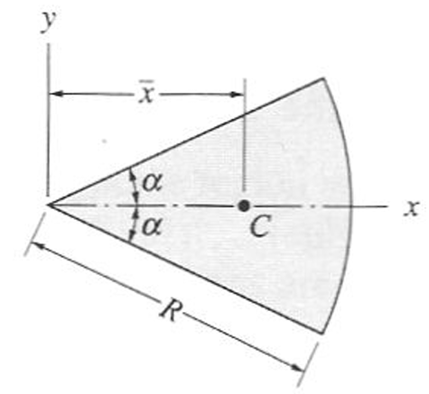 | $$\overline{x}=\frac{2R\sin{α}}{3α}$$  $$A=αR^{2}$$
Quarter Circle Arc | 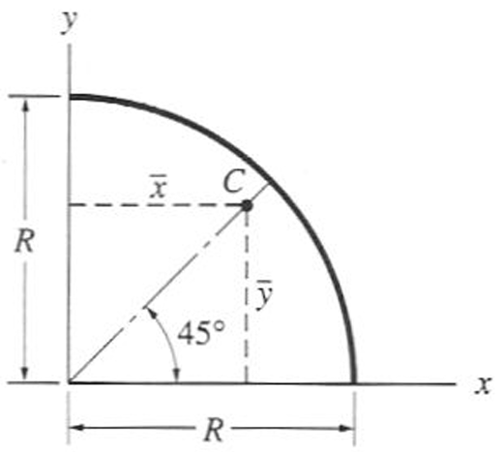 | $$\overline{x}=\frac{2}{π}R$$  $$\overline{y}=\frac{2}{π}R$$  $$L=\frac{1}{2}πR$$
Circular Arc | 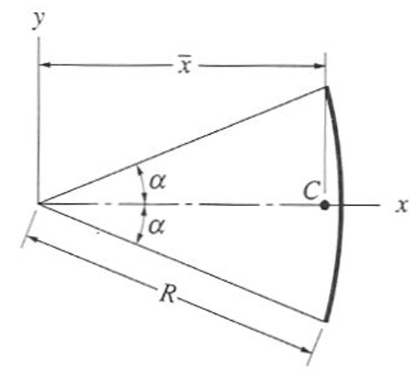 | $$\overline{x}=\frac{R\sin{α}}{α}$$  $$L=αR$$
Note: All formulas shown assume objects of uniform mass density.
Center of Mass of Common 3D Volumes and Surfaces

Shape | Diagram | Formulas
Right Tetrahedron | 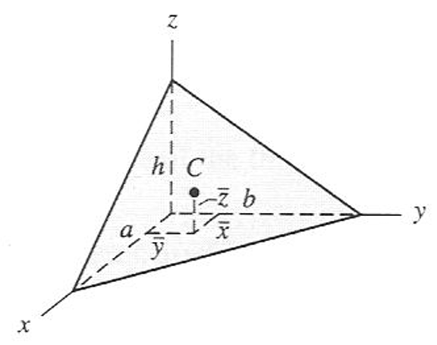 | $$\overline{x}=\frac{1}{4}a$$  $$\overline{y}=\frac{1}{4}b$$  $$\overline{z}=\frac{1}{4}h$$  $$V=\frac{1}{6}abh$$
Pyramid | 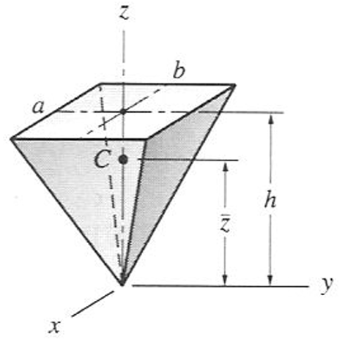 | $$\overline{z}=\frac{3}{4}h$$  $$V=\frac{1}{3}abh$$
Cone | 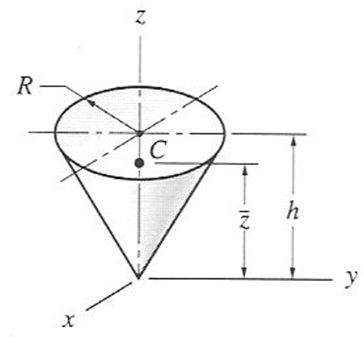 | $$\overline{z}=\frac{3}{4}h$$  $$V=\frac{1}{3}πR^{2}h$$
Hemisphere | 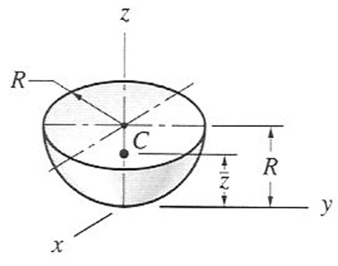 | $$\overline{z}=\frac{5}{8}R$$  $$V=\frac{2}{3}{πR}^{3}$$
Semi-Ellipsoid of Revolution | 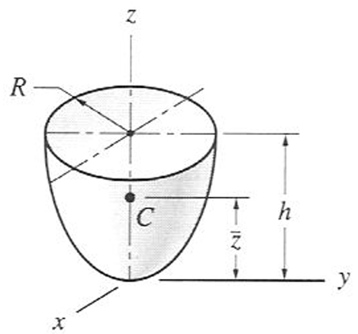 | $$\overline{z}=\frac{5}{8}R$$  $$V=\frac{2}{3}{πR}^{2}h$$
Paraboloid of Revolution | 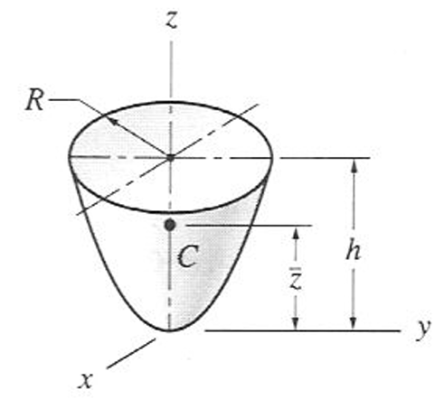 | $$\overline{z}=\frac{2}{3}h$$  $$V=\frac{1}{2}{πR}^{2}h$$
Conical Surface | 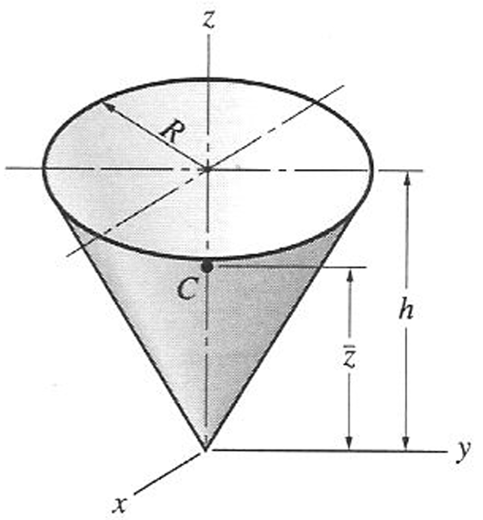 | $$\overline{z}=\frac{2}{3}h$$  $$A=πR\sqrt{R^{2}+h^{2}}$$
Hemispherical Surface | 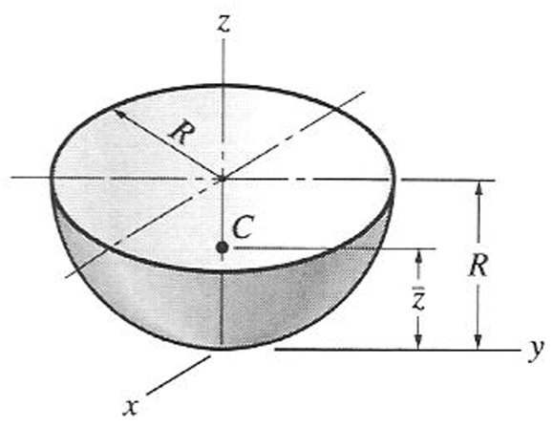 | $$\overline{z}=\frac{1}{2}R$$  $$A=2{πR}^{2}$$
Note: All formulas shown assume objects of uniform mass density.

Sources
- Mechanics Map – Open Text Project (2026). Center of Mass and Mass Moments of Inertia for Homogeneous Bodies. https://mechanicsmap.psu.edu/websites/centroidtables/centroids3D/centroids3D.html
- University of Utah, Dept. of Mechanical Engineering (2026). ME 1300 - Statics & Strength of Materials, Selected Centroid and Moment of Inertia Shapes. https://my.mech.utah.edu/~me1300/Selected.pdf
See Also
- Harold’s Physics Center of Mass Cheat Sheet
- Harold’s Physics Moment of Inertia Cheat Sheet

