Harold’s Physics Formulas
Cheat Sheet
7 April 2026

 | Mechanics:  Linear Translation | Mechanics:  Angular / Rotational Motion | Electricity / Magnetism | Fluid Mechanics / Thermodynamics |  | Atomic and Nuclear /  Waves and Optics
Kinematics | Bold = Vector  Red = Calculus  Purple = Memorize | See Harold’s Physics Units of Measure Cheat Sheet  See Harold’s Physics of Projectiles Cheat Sheet |  |  | See Harold’s Physics Optics Cheat Sheet  See Math and Greek Symbols
Position  (m)  (rad) | Horizontal:  $$x=x_{0}+v_{0x}t+\frac{1}{2}at^{2}$$  Vertical:  $$y=y_{0}+v_{0y}t+\frac{1}{2}gt^{2}$$  $$∆x=x_{f}-x_{0}$$  $$x=x_{0}+vt$$  $$x=\int{v}dt$$ | Circular:  $$θ=θ_{0}+ω_{0}t+\frac{1}{2}αt^{2}$$  $$∆θ=θ_{f}-θ_{0}$$  $$θ=θ_{0}+ωt$$  $$θ=\int{ω}dt$$ | $${10}^{-100}=googolth$$  $${10}^{-24}=yocto­$$  $${10}^{-21}=zepto­$$  $${10}^{-18}=atto­$$  $${10}^{-15}=femto­$$  $${10}^{-12}=pico­$$  $${10}^{-9}=nano­$$  $${10}^{-6}=micro­$$  $${10}^{-3}=milli­$$  $${10}^{-2}=centi­$$  $${10}^{-1}=deci­$$  $${10}^{0}=1$$  $${10}^{1}=deca­$$  $${10}^{2}=hecto­$$  $${10}^{3}=kilo­$$  $${10}^{6}=mega­$$  $${10}^{9}=giga­$$  $${10}^{12}=tera­$$  $${10}^{15}=peta­$$  $${10}^{18}=exa­$$  $${10}^{21}=zetta­$$  $${10}^{24}=yotta­$$  $${10}^{100}=googol$$  $${10}^{1000} =googolplex$$ | Fluid Mechanics:  $$ρ=\frac{m}{V}$$  $$∆l=αl_{0}∆T$$ |  | Optics:  $$f=\frac{v}{λ}$$  $$\frac{1}{d_{o}}+\frac{1}{d_{i}}=\frac{1}{f}$$  Refraction:  (bend)  $$n=\frac{c}{v}$$  Snell’s Law:  $$n_{1}\sin{θ_{1}}=n_{2}\sin{θ_{2}}$$  $$\frac{n_{1}}{n_{2}}=\frac{v_{2}}{v_{1}}$$  Diffraction:  (spread out)  $$∆L=d\sin{θ}$$  $$mλ=d\sin{θ}$$
Position  (m)  (rad) | $$s=rθ$$
Position  (m)  (rad) | $$x(t)=A\cos\left(ωt+ϕ\right)$$  $$x\left(t\right)=A\cos\left(2πft+ϕ\right)$$  Waves:  $$f(x,t)=A sin⁡(2π\left(ft-\frac{x}{λ}\right)+ϕ)+k$$ |  |  | Optics:  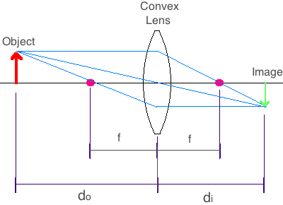
Velocity  (m/s)  Angular Velocity / Angular Frequency  (rad/s) | $$v=\frac{d}{t}=\frac{∆x}{∆t}→\frac{dx}{dt}$$  $$∆v=v_{f}-v_{0}$$  $$v= v_{0}+at$$  $$v^{2}=v_{0}^{2}+2a∆x$$  $$\overline{v}=\frac{v_{0}+v}{2}$$  $$v=\int{a}dt$$ | $$ω=\frac{θ}{t}=\frac{∆θ}{∆t}→\frac{dθ}{dt}$$  $$∆ω=ω_{f}-ω_{0}$$  $$ω=ω_{0}+αt$$  $$ω^{2}=ω_{0}^{2}+2α∆θ$$  $$\overline{ω}=\frac{ω_{0}+ω}{2}$$  $$ω=\int{α}dt$$  $$ω=\frac{2π}{T}=2πf$$  Spring:  $$ω=\sqrt{\frac{k}{m}}$$  Pendulum:  $$ω=\sqrt{\frac{g}{l}}$$ | Speed of Light:  $$c≈3.00×{10}^{8} \frac{m}{s}$$ | Fluid Mechanics:  Continuity:  $$A_{1}v_{1}=A_{2}v_{2}$$  $$v_{rms}=\sqrt{\frac{3RT}{M}}$$  $$v_{rms}=\sqrt{\frac{3k_{B}T}{μ}}$$  Torricelli’s Law:  $$v=\sqrt{2gh}$$  Speed of fluid exiting a hole in a tank. |  | Waves and Optics:  $$v=fλ$$  Reflection:  (throwback)  Critical angle:  $$\sin{θ_{c}}=\frac{n_{1}}{n_{2}}$$  Maxima for a thin film:  Constructive  $$2d=\frac{λ}{2n},3\frac{λ}{2n},5\frac{λ}{2n}…$$  $$=\left(m+\frac{1}{2}\right)\frac{λ}{n}$$  Destructive  $$2d=\frac{m}{n}λ$$
 |  |  | 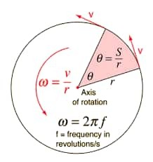
$$v=ωr$$
$$v=ω×r$$

$$v(t)=-Aω\sin\left(ωt+ϕ\right)$$

$$v(t)=-A(2πf)\sin\left(2πft+ϕ\right)$$

Acceleration  (m/$s^{2}$)  (rad/$s^{2}$) | Linear:  $$a=\frac{v}{t}=\frac{∆v}{∆t}→\frac{dv}{dt}$$  $$a=\frac{\sum{F}}{m}=\frac{F_{net}}{m}$$  Tangential (linear):  $$a=a_{t}$$  $$gravity (g)$$ | Angular:  $$α=\frac{ω}{t}=\frac{∆ω}{∆t}→\frac{dω}{dt}$$  $$α=\frac{\sum{τ}}{I}=\frac{τ_{net}}{I}$$  Centripetal (center):  $$a_{c}= \frac{v^{2}}{r}=ω^{2}r$$ | Constants:  Gravitational Constant $G≈6.674 30(15)×10^{-11} \frac{m^{3}}{kg s}$  Gravity Acceleration (Earth) $g≈-9.806 65 \frac{m}{s^{2}}≈-32.174 0 \frac{ft}{s^{2}}$  Speed of Light in Vacuum $c=2.997 924 58×10^{8} \frac{m}{s}$  Electron-Volt $1eV=1.602 176 634×10^{-19} J$  Charge of an Electron $e=-1.602 176 634×10^{-19} C$  Mass of an Electron $m_{e}≈9.109 383 701 5(28)×10^{-31} kg$  Mass of a Proton $m_{p}≈1.672 621 923 69(51)×10^{-27} kg$  Mass of a Neutron $m_{n}≈1.674 927 498 04(95)×10^{-27} kg$  Electric Permittivity $ε_{0}≈\frac{1}{μ_{0}c^{2}}≈8.854 187 812 8×10^{-12}\frac{C^{2}}{Nm^{2}}$  Magnetic Permeability $μ_{0}≈1. 256 637 062 12(19)×10^{-6}\frac{N}{A^{2}}$  Boltzmann Constant $k_{B}=1.380 649×10^{-23} \frac{J}{K}$  Coulomb Constant $k_{e}=\frac{1}{4πε_{0}}≈8.987 551 792 3×10^{9} \frac{Nm^{2}}{C^{2}}$  Faraday Constant $F=eN_{A}=9.648 533 212×10^{4} \frac{C}{mol}$  Planck Constant $h=6.626 070 15×10^{-34} Js$  Avogadro Constant $N_{A}=6.022 140 76×10^{23} / mole$  Ideal Gas Constant $R=0.082 057 366 080 \frac{L atm}{mole K}$  “ $R=8.314 462 618 \frac{J}{mole K}$  pi $π≈3.141 592 653 589 793 238 462 ..$.
Acceleration  (m/$s^{2}$)  (rad/$s^{2}$) | 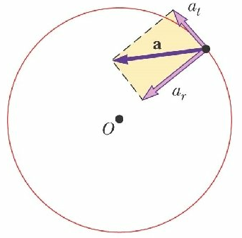  Net:  $$a_{net}^{2}=a_{t}^{2}+a_{c}^{2}$$
Acceleration  (m/$s^{2}$)  (rad/$s^{2}$) | $$a=αr$$  $$a(t)=-Aω^{2}\cos\left(ωt+ϕ\right)$$
Jerk (Jolt)  (m/$s^{3}$)  (rad/$s^{3}$) | $$\vec{j}=\frac{a}{t}=\frac{∆a}{∆t}→\frac{da}{dt}$$ | $$ζ=\frac{α}{t}=\frac{∆α}{∆t}→\frac{dα}{dt}$$
Dynamics |  | See Harold’s Physics Forces on an Incline Cheat Sheet  See Harold’s Physics Forces on an Incline with Pully Cheat Sheet  See Harold’s Physics Attwood Machine Cheat Sheet
Mass  (kg)  /  Moment of Inertia  ($kg•m^{2}$) | $m$ = actual mass  $I$ = effective mass  (Inertia is an object’s resistance to changes in its state of motion.) | $$I=\sum{mr^{2}}$$  $$I=\int{r^{2}}dm$$  $$I=\int{r•r dm}$$ | $$m_{p}≈m_{n}$$  $$m_{p}≈{1,836 m}_{e}$$ | Density:  $$ρ=\frac{m}{V}$$  $$ρ_{H_{2}O} =1000 kg/m^{3}$$ |  | Magnification:  $$\left|M\right|=\left|\frac{d_{i}}{d_{o}}\right|=\left|\frac{h_{i}}{h_{o}}\right|$$  $$M_{Telescope}=-\frac{f_{objective lens}}{f_{eyepiece}}$$
Momentum  (kg$•$m/s)  ($kg•m^{2}/s$) | $$p=mv$$  $$∆p=m∆v$$  Conservation of Linear Momentum:  $$p_{i}=p_{f}$$  $$\sum{mv_{i}}=\sum{mv_{f}}$$  $$p=ω×m$$  $$∆p=J=\int_{t_{1}}^{t_{2}}{F dt}$$ | $$L=Iω$$  $$L=rmv$$  Conservation of Angular Momentum:  $$L_{i}=L_{f}$$  $$\sum{Iω_{i}}=\sum{Iω_{f}}$$  $$L=r×p$$  $$L=mr×v$$  $$L=\int{r×v} dm$$  $$∆L=\int{τ} dt$$ |  | Fluid Mechanics:  $$∇p=ρg$$ |  | Atomic and Nuclear:  $$λ=\frac{h}{p}$$
Momentum  (kg$•$m/s)  ($kg•m^{2}/s$) |  |  | 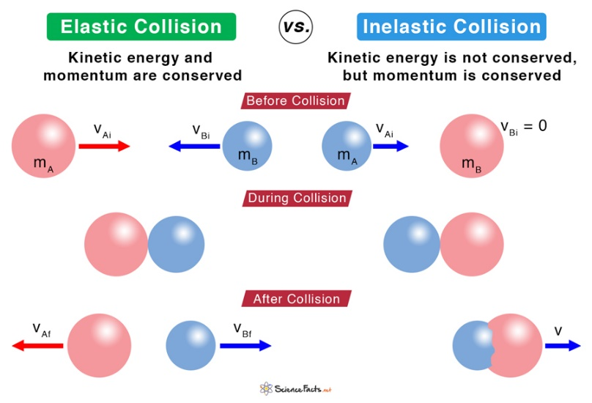
Force  (N = kg$•$m/$s^{2}$)  /  Torque  (J = N$•$m) | $$F=ma$$  $$F_{g}=mg$$  $$\sum{F}=F_{net}=ma$$  $$F=\frac{p}{t}=\frac{∆p}{∆t}$$  $$F=\frac{dp}{dt}=\frac{d}{dt}(mv)$$  Friction:  $$F_{f}≤μN$$  $$0≤μ_{k}≤μ_{s}≤1$$  Gravitational Force:  $$F_{G}=-G\frac{m_{1}{ m}_{2}}{r^{2}}$$  $$F_{G}=-G\frac{m_{1}{ m}_{2}}{r^{2}} \hat{r}$$ | $$τ=Iα$$  $$τ=rF=rF\sin{θ}$$  $$τ=r×F$$  $$\sum{τ}=τ_{net}=Iα$$  $$τ=\frac{L}{t}=\frac{∆L}{∆t}$$  $$τ=\frac{dL}{dt}=I\frac{dω}{dt}$$  $$F=ma_{c}$$  $$F=\frac{{mv}^{2}}{r}$$  $$F=mrω^{2}$$  Hooke’s Law:  $$F_{s}=-kΔx$$ | Electricity:  Coulomb’s Law:  $$F=k\frac{q_{1} q_{2}}{r^{2}}$$  $$F=\frac{1}{4πϵ_{0}} \frac{q_{1} q_{2}}{r^{2}}$$  $$F=Eq$$  Magnetism:  $$F_{B}=qvB\sin{θ}$$  $$F_{B}=BIl\sin{θ}$$  $$F_{B}=qv×B$$  $$F_{B}=Il×B$$  $$F=\int{I dl}×B$$ | Fluid Mechanics:  $$F=PA$$  $$P=\frac{F}{A}=ρhg$$  $$F_{buoy}=ρVg$$  Universal Gas Law:  $$PV=nRT=Nk_{B}T$$ |  | Strong Nuclear Force:  $$F=-\frac{g^{2}}{4πc^{2}} \frac{e^{-mr}}{r}$$  Weak Nuclear Force:  $$n→p^{+}+e^{-}+\overline{ve}$$  (Beta Decay)  where $\overline{ve}$ is an antineutrino
 |  |  |  | Reynolds Number:  $$Re=\frac{uL}{v}=\frac{ρuL}{μ}$$  - Low $Re→$ laminar (sheet-like) flow  - High $Re→$ turbulent flow (cavitation) |  | 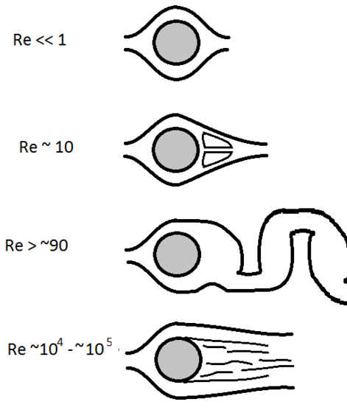
Impulse  (N$•$s)  (N$•$m$•$s) | $$J=F ∆t=∆p=m ∆v$$  $$J=∆p=\int{F dt}$$ | $$H=τ ∆t=∆L=I ∆ω$$  $$H=∆L=\int{τ dt}$$ | Electricity:  Unit Impulse:  (Dirac Delta Function)  $$δ\left(x\right)=\left\{\begin{aligned}0, x≠0 \\ ∞, x=0\end{aligned}\right.$$  such that  $$\int_{-∞}^{∞}{δ\left(x\right) dx}=1$$ |  |  | 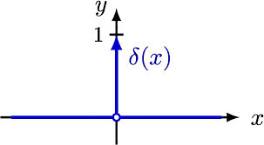
Yank  (N/$s^{2}$)  /  Rotatum  (J/s) | $$Y=m J$$  $$Y=\frac{F}{t}=\frac{∆F}{∆t}→\frac{dF}{dt}$$ | $$P=I ζ$$  $$P=r×Y$$  $$P=\frac{τ}{t}=\frac{∆τ}{∆t}→\frac{dτ}{dt}=Iζ$$
Energy
Work  (J = N$•$m) | $$W=Fd$$  $$W=F∆x\cos{θ}$$  $$W=\int{F•dr}$$ | $$W=τ ∆θ$$  $$W=\int{τ•dθ}$$ | $$W=QV$$ | Thermodynamics:  $$W=-P ∆V$$  $$e=\left|\frac{W}{Q_{H}}\right|$$  $$e_{c}=\frac{T_{H}-T_{C}}{T_{H}}$$
Kinetic  Energy  (J) | Translational:  $$K=KE=\frac{1}{2}mv^{2}$$ | Rotational:  $$K=KE=\frac{1}{2}Iω^{2}$$ | $$1 eV≈1.60×{10}^{-19} J$$ | Fluid Mechanics:  Bernoulli’s Equation:  $$P_{1}+ρgy_{1}+\frac{1}{2}ρ{v_{1}}^{2}=P_{2}+ρgy_{2}+\frac{1}{2}ρ{v_{2}}^{2}$$  Thermodynamics:  $$K_{avg}=\frac{3}{2}k_{B}T$$ |  | Atomic and Nuclear:  $$K_{max}=hf-ϕ$$  Electron Energy Levels:  $$E_{n}=\frac{-13.6 eV}{n^{2}}$$  n = principal quantum number (1, 2, 3, etc.)
Potential  Energy  (J) | $$∆U_{g}=PE=mgh$$  $$U_{G}=-G\frac{m_{1}m_{2}}{r}$$  $$G≈6.67×{10}^{-11} \frac{Nm^{2}}{{kg}^{2}}$$ | Coiled Spring:  $$U_{S}=\frac{1}{2}k{Δx}^{2}$$  Mechanical Energy:  $$ME=KE+PE$$ | $$U_{E}=qV$$  $$U_{E}=\frac{1}{4πϵ_{0}} \frac{q_{1}q_{2}}{r}$$  $$U_{C}=\frac{1}{2}QV$$  $$U_{C}=\frac{1}{2}CV^{2}$$  $$U_{L}=\frac{1}{2}LI^{2}$$ | Fluid Mechanics:  $$P=P_{0}+ρgh$$  Continuity of Mass:  $$ρ_{1}A_{1}v_{1}=ρ_{2}A_{2}v_{2}$$  Continuity of Volume:  $$A_{1}v_{1}=A_{2}v_{2}$$  Thermodynamics:  $$∆U=Q-W$$ |  | Atomic and Nuclear:  $$E=hf$$  $$E=mc^{2}$$  $$∆E=(∆m)c^{2}$$  Relativity:  $$E=mc^{2}\left(\frac{1}{\sqrt{1-\frac{v^{2}}{c^{2}}}}\right)$$
Heat  Energy  (J) | Conservation of Energy:  $$E_{i}=E_{f}$$  $$\sum{E_{i}}=\sum{E_{f}}$$  $$E=W+Q+K+∆U_{g}+U_{G}+U_{S}+U_{E}+U_{C}+U_{L}+…=constant$$ |  |  | Thermodynamics:  $$H=\frac{kA∆T}{L}$$  $$Q=mH_{f}$$  $$Q=mH_{v}$$  $$∆E=Q=mC∆T$$  $$mC∆T=mC\left(T_{f}-T_{i}\right)$$  $$C_{H_{2}O}=4,184 \frac{J}{kg °K}$$
Heat  Energy  (J) |  |  |  | $$T_{f}=\frac{m_{1}C_{1}∆T_{1i}+m_{2}C_{2}∆T_{2i}}{m_{1}C_{1}+m_{2}C_{2}}$$
Power  (W) | $$P=\frac{W}{t}=Fv$$  $$P=\frac{∆E}{∆t}→\frac{dE}{dt}$$  $$P=Fv\cos{θ}$$  $$P=F•v$$ | $$P=\frac{W}{t}=τω$$  $$P=\frac{∆W}{∆t}→\frac{dW}{dt}$$  $$P=τω\cos{θ}$$  $$P=τ•ω$$ | $$P=IV$$  $$P=I^{2}R$$  $$P=\frac{V^{2}}{R}$$ | $$P=pQ$$  Where:  $$p=pressure \left(\frac{N}{m^{2}}\right)$$  $$Q=volumetric$$  $$flow rate \left(\frac{m^{3}}{s}\right)$$

Engineering Application |  | See Harold’s Center of Mass / Moment of Inertia Cheat Sheet  See Harold’s Physics Doppler Effect Cheat Sheet
Period / Frequency  (Hz) | $$T=\frac{1}{f}$$  $$f=\frac{1}{T}$$  Kepler’s Third Law:  $$T^{2}=\left(\frac{4π^{2}}{GM}\right)r^{3}$$ | $$T=\frac{1}{f}=\frac{2π}{ω}=\frac{2πr}{v}$$  $$T_{s}=2π\sqrt{\frac{m}{k}}$$  $$T_{p}=2π\sqrt{\frac{l}{g}}$$ | $$T=\frac{2π}{b}$$  For:  $$y=\sin\left(bθ\right)$$  $$y=\cos\left(bθ\right)$$ | 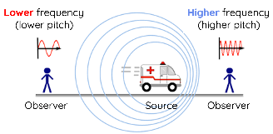 |  | Waves and Optics:  $$f=\frac{v}{λ}$$  Doppler Effect:  $$f_{r}=f_{s}\left(\frac{v±v_{r}}{v∓v_{s}}\right)$$
Center  of Mass  (m) | $$x_{CM}=\frac{m_{1}x_{1}+m_{2}x_{2}}{m_{1}+m_{2}}$$  $$r_{CM}=\frac{\sum{mr}}{\sum{m}}$$  $$\overline{x}=\frac{1}{M} \int_{0}^{M}{x dm}$$  where $M=\int_{0}^{M}{dm}$  and $dm=ρ dz dy dx$ |  |  |  | $$x_{CM}=\frac{\sum{m_{i}x_{i}}}{\sum{m_{i}}}$$ | $$y_{CM}=\frac{\sum{m_{i}y_{i}}}{\sum{m_{i}}}$$
Center  of Mass  (m) |  | 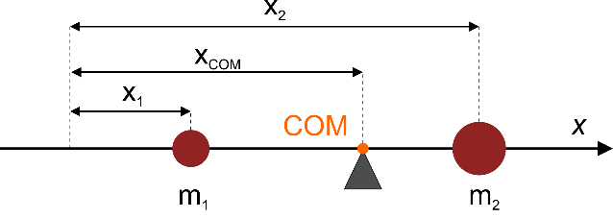 |  |  | 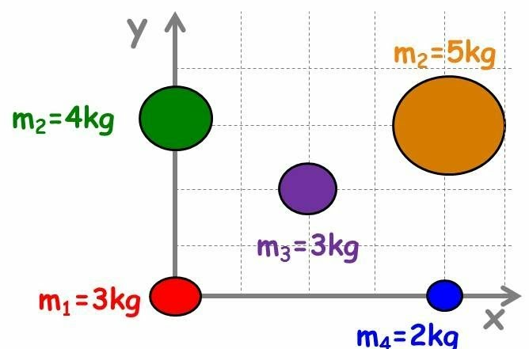
Rigid Bodies  (Statics) | $$\sum{F_{y}=\sum{mg=}0}$$  (Down = ‘−‘) | $$\sum{τ=\sum{F_{y}{ x}_{CM}=0}}$$  (CW = ‘−‘) | 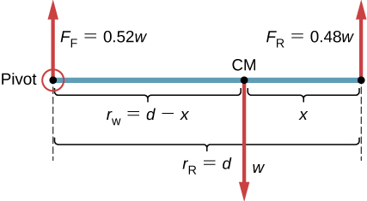
Conservation Laws
Fundamental Principle | Conservation of  Linear Momentum | Conservation of  Angular Momentum | Conservation of  Electric Charge | Conservation of  Mass (or Matter) |  | Conservation of  Energy
Discipline | Physics | Physics | Chemistry & Circuits | Chemistry & Fluid Mechanics |  | Physics
Formula | $$\sum{p_{i}}=\sum{p_{f}}$$  $$\sum{mv_{i}}=\sum{mv_{f}}$$ | $$\sum{L_{i}}=\sum{L_{f}}$$  $$\sum{Iω_{i}}=\sum{Iω_{f}}$$ | $$\sum{Q_{i}}=\sum{Q_{f}}$$ | $$\sum{m_{i}}=\sum{m_{f}}$$ |  | $$\sum{E_{i}}=\sum{E_{f}}$$
Example |  |  | Kirchhoff's Current Law (KCL):  $$\sum_{i=1}^{n}{I_{i}}=0$$ | Bernoulli’s Equation:  $$P_{1}+ρgy_{1}+\frac{1}{2}ρv_{1}^{2}=P_{2}+ρgy_{2}+\frac{1}{2}ρv_{2}^{2}$$ |  | $$E=W+Q+K+∆U_{g}+U_{G}+U_{s}+U_{E}+U_{c}+U_{L}+…=constant$$
 | 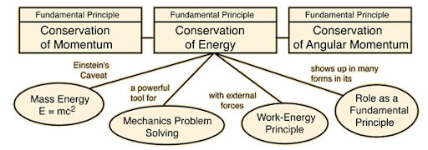

Electricity
Terms | Formulas | See Harold’s Electromatic Spectrum Cheat Sheet  See Harold’s DC Circuits Cheat Sheet
Electric Field  (V/m or N/C) | $$E=\frac{F}{q}$$  $$E_{avg}=-\frac{V}{d}$$  $$E=-\frac{∆V}{∆r}$$ | $$E=ρJ$$  $$E=-\frac{dV}{dr}$$ | Gauss’s Law:  $$ϕ=\oint{E•dA=\frac{Q_{enc}}{ϵ_{0}}}$$
Potential / Voltage  (V) | $$V=IR$$  $$V=\frac{Q}{C}$$ | $$V=k\sum_{i}{\frac{q_{i}}{r_{i}}}=\frac{1}{4πϵ_{0}}\sum_{i}{\frac{q_{i}}{r_{i}}}$$ | 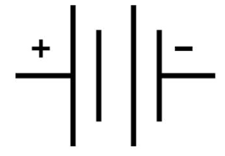
Current  (A) | $$I=\frac{∆Q}{∆t}$$  $$I=\frac{V}{R}$$ | $$I=\frac{dQ}{dt}$$  $$I=Nev_{d}A$$ | 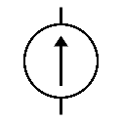
Circuits |  | Series | Parallel
Circuit Terms | 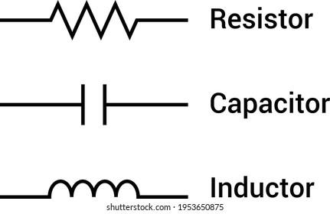 | 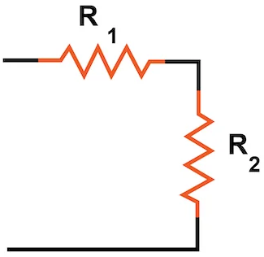 | 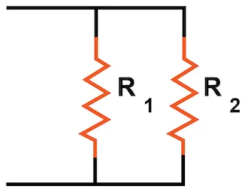
Resistance  (Ω) | $$R=\frac{V}{I}$$  $$R=\frac{ρl}{A}$$ | $$R_{s}= \sum_{i}{R_{i}}$$ | $$\frac{1}{R_{p}}= \sum_{i}{\frac{1}{R_{i}}}$$  $$R_{p}=\frac{R_{1}R_{2}}{R_{1}+R_{2}}$$
Inductance  (H) | $$L=N\frac{Φ}{I}$$  $$L=\frac{V_{L}}{{dI}/{dt}}$$  $$L=μ_{0}\frac{N^{2}A}{l}$$ | $$L_{s}= \sum_{i}{L_{i}}$$ | $$\frac{1}{L_{p}}= \sum_{i}{\frac{1}{L_{i}}}$$
Capacitance  (F) | $$C=\frac{Q}{V}$$  $$C=\frac{ϵ_{0}A}{d}=\frac{κϵ_{0}A}{d}$$ | $$\frac{1}{C_{s}}= \sum_{i}{\frac{1}{C_{i}}}$$ | $$C_{p}= \sum_{i}{C_{i}}$$
Kirchhoff's Current Law (KCL) | $$\sum_{i=1}^{n}{I_{i}}=0$$  The algebraic sum of currents in a network of conductors meeting at a point (node) is zero. |  | 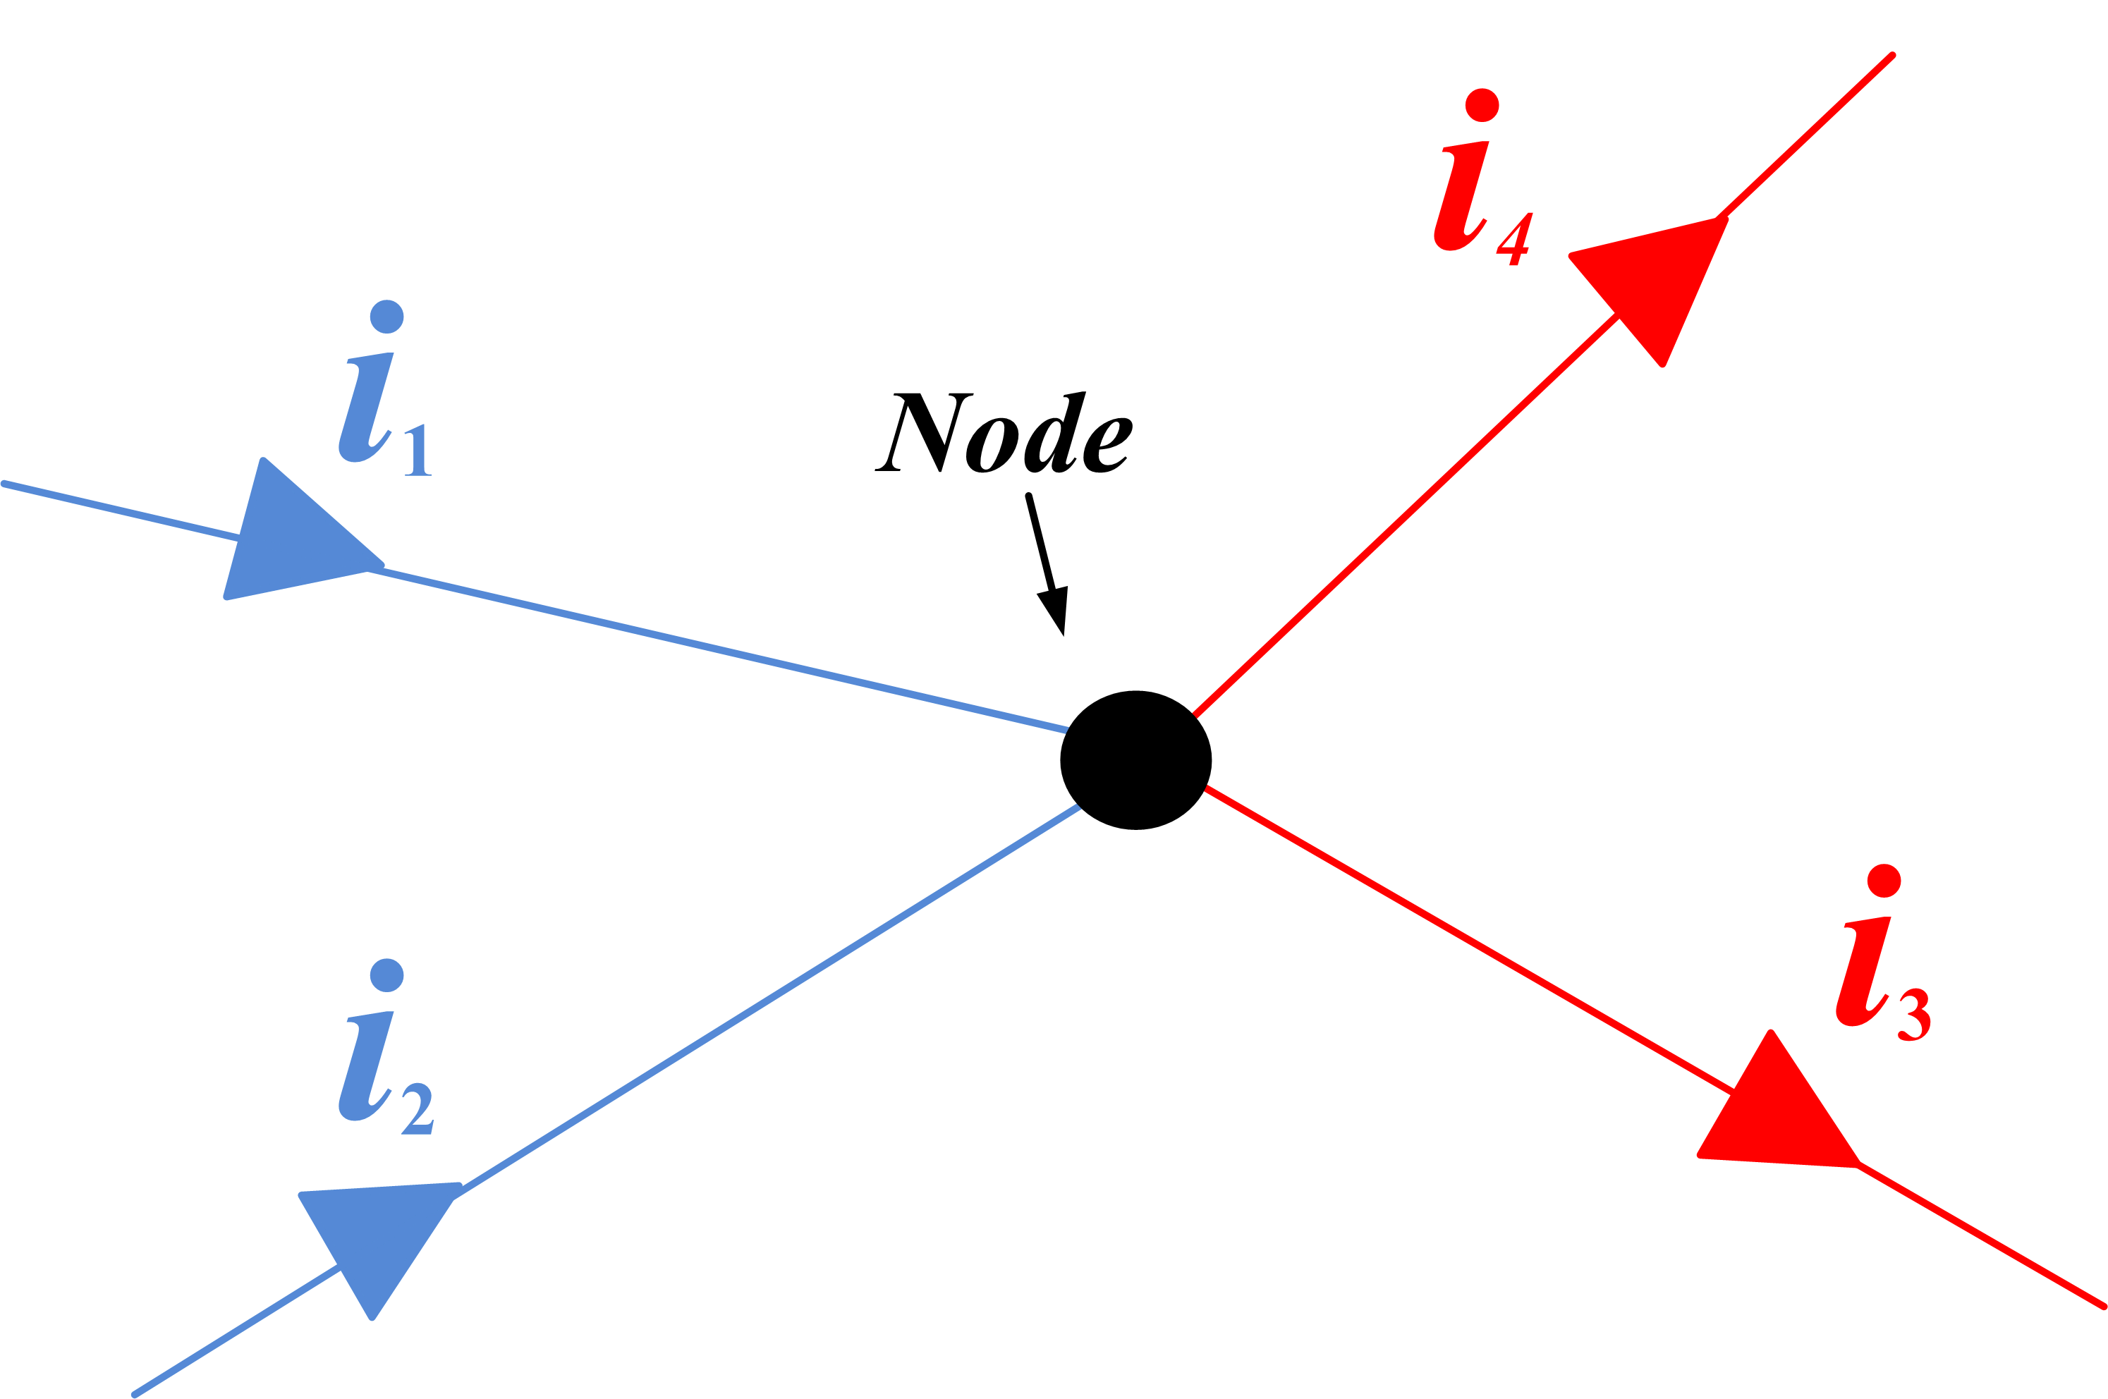
Kirchhoff's Voltage Law (KVL) | $$\sum_{i=1}^{n}{V_{i}}=0$$  The directed sum of the potential differences (voltages) around any closed loop is zero. |  | 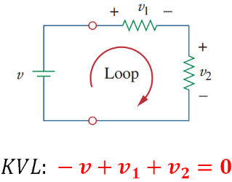

Magnetism
 | See Harold’s Physics Maxwell’s Equations Cheat Sheet
Term | Formulas | Laws
Magnetic  Field  (T) | $$B=\frac{μ_{0}}{2π} \frac{I}{r}$$  $$Solenoid:$$  $$B_{s}=μ_{0}nI$$  $$where n=\frac{N}{l} turns per meter$$  $$B=\frac{μ_{0}}{4π} \frac{q\vec{v}×\vec{r}}{r^{3}}$$  $$B=\frac{μ_{0}}{4π} \frac{q\vec{v}×\hat{r}}{r^{2}}$$ | Ampere’s Circuit Law:  $$\oint{B•dl=μ_{o}I}+μ_{0}ε_{0}\frac{dϕ_{E}}{dt}$$  Gauss’s Law for Magnetism:  $$\oint{B•dA=0}$$  $$dB=\frac{μ_{0}}{4π} \frac{I dl×\vec{r}}{r^{3}}$$
Magnetic  Flux  (Wb) | $$ϕ_{B}=BA\cos{θ}$$  $$ϕ_{B}=B•A$$ | Gauss’s Law for Magnetism:  $$ϕ_{B}=\int{B•dA}$$
EMF  (V) | $$ε_{avg}= - \frac{∆ϕ_{B}}{∆t}$$  $$ε=\oint{E•ds=} -\frac{dϕ_{B}}{dt}$$  $$ε=Blv$$ | Faraday’s Law of Induction:  $$\oint{E•dl=-\frac{∆ϕ_{B}}{∆t}}$$  $$ε=-L\frac{dI}{dt}$$

Sources
- NIST SP 961 (May 2019). CODATA Recommended Values of the Fundamental Physical Constants: 2018. https://physics.nist.gov/cuu/pdf/wall_2018.pdf
- Wikipedia (2025).
  - Metric prefix. https://en.wikipedia.org/wiki/Metric_prefix
  - Reynolds number. https://en.wikipedia.org/wiki/Reynolds_number
  - SI derived unit. https://en.wikipedia.org/wiki/SI_derived_unit

