Harold’s Maxwell’s Equations
Cheat Sheet
15 January 2026

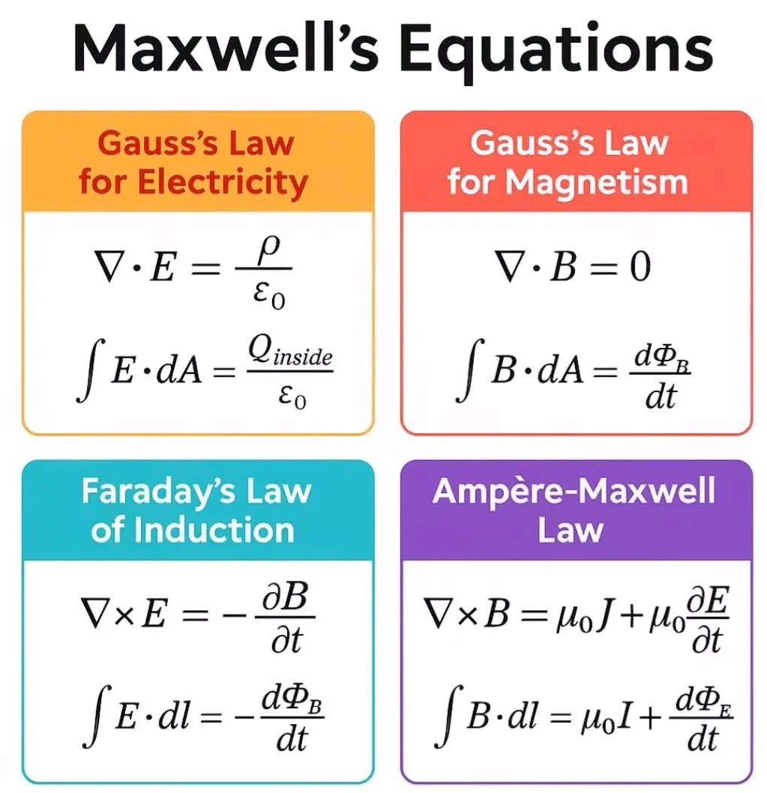

Maxwell’s Equations

Name | Differential Form | Integral Form
Maxwell’s Equations in Electromagnetism | A set of four pivotal laws that describe the interactions between electric charges, magnetic fields, and electric currents. | 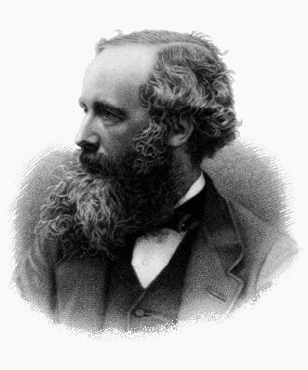  James Clerk Maxwell
1. Gauss’ Law for Electricity | $$∇∙E=\frac{ρ}{ϵ_{0}}$$  $$∇∙D=ρ_{f}$$ | $$ϕ_{E}=∯{E∙dS}=\frac{Q\left(V\right)}{ϵ_{0}}$$  $$=\frac{1}{ϵ_{0}}\iiint_{Ω}^{ }{ρ dV}$$  $$ϕ_{E}=∯{D∙dS}=Q_{f}(V)$$
2. Gauss’ Law for Magnetism | $$∇∙B=0$$ | $$ϕ_{B}=∯{B∙dS}=0$$
3. Faraday’s Law of Induction  (Maxwell-Faraday Equation) | $$∇×E=-\frac{∂B}{∂t}$$ | $$\oint{E∙dl}=-\iint{\frac{∂B}{∂t}}∙dS$$  $$=-\frac{d}{dx}\iint{B∙dS}$$  $$=-\frac{∆ϕ_{B}}{∆t}$$
4. Ampère-Maxwell Law | $$∇×B=μ_{0}\left(ϵ_{0}\frac{∂E}{∂t}+J\right)$$  $$∇×H=\frac{∂D}{∂t}+J_{f}$$ | $$\oint{B∙dl}=μ_{o}I+μ_{0}ε_{0}\iint{\frac{∂E}{∂t}}∙dS$$  $$=μ_{o}\iint_{Σ}^{ }{J∙dS}+μ_{0}ε_{0}\frac{d}{dx}\iint{E∙dS}$$  $$=μ_{o}I+μ_{0}ε_{0}\frac{dϕ_{E}}{dt}$$  $$\oint{H∙dl=I_{f}}+μ_{0}ε_{0}\iint{\frac{∂E}{∂t}}∙dS$$  $$=μ_{o}I+μ_{0}ε_{0}\frac{dϕ_{E}}{dt}$$

Maxwell’s Equations Diagrams

Name | Application | Diagram
1. Gauss’ Law of Electricity | 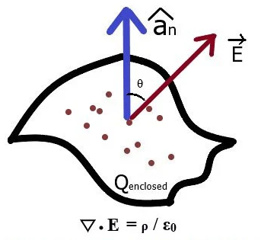 | 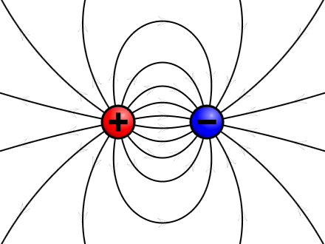
2. Gauss’ Law of Magnetism | 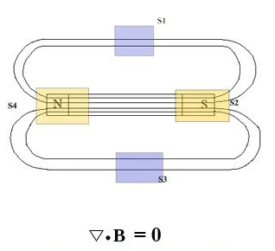 | 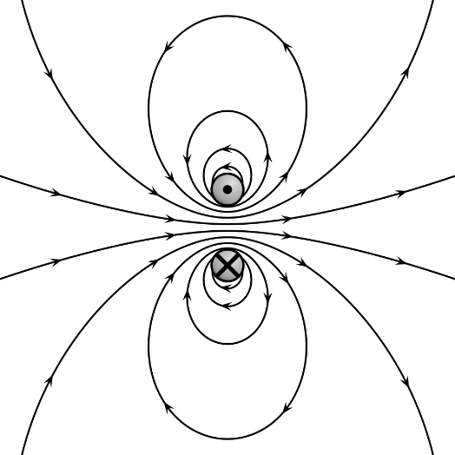
3. Faraday’s Law of Induction  (Maxwell-Faraday Equation) | 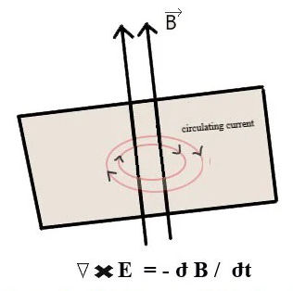 | 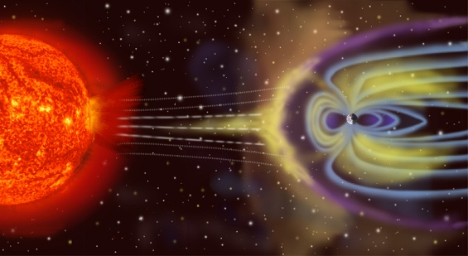
4. Ampère-Maxwell Law | 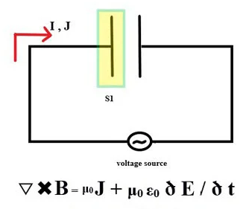 | 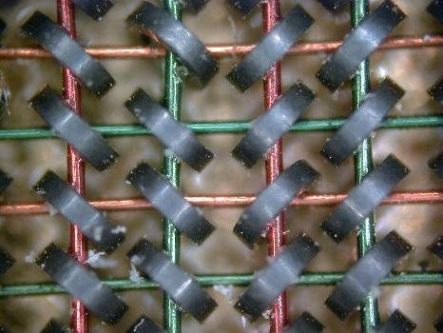

Symbols and Terms

Term Name | Variable | Value
Vector | <bold> | Magnitude and direction
Scalar | <italics> | Magnitude only
Electric Field | $$E$$
Magnetic Field | $$B$$
Displacement Field | $$D$$
Magnetization Field | $$H$$
Electric Charge Density | $$ρ$$ | Total charge per unit volume
Electric Current Density | $$J$$ | Total current per unit area
Permittivity of free space | $$ϵ_{0}$$
Permeability of free space | $$μ_{0}$$
Speed of Light | $$c$$ | $$c={\left(ϵ_{0} μ_{0}\right)}^{-\frac{1}{2}}$$
Nabia Symbol | $$∇$$ | Three-dimensional gradient operator, del.
Divergence Operator | $$∇∙$$ | del dot
Curl Operator | $$∇×$$ | del cross
Surface Integral |  | With a loop indicating the surface is closed
Volume Integral
Line Integral |  | With a loop indicating the curve is closed
Surface Integral
Net Electric Flux | $$ϕ_{E}$$ | $$ϕ_{E}=∯{B∙dS}$$
Net Magnetic Flux | $$ϕ_{B}$$ | $$ϕ_{B}=∯{B∙dS}$$
Net Electric Current | $$I$$ | $$I=\iint_{Σ}^{ }{J∙dS}$$
Surface Area | $$dS$$ | Differential vector element of surface area S, normal to surface Σ.
Time | $$t$$ | seconds
Length | $$l$$ | meters
Free Charge | $$Q_{f}$$ | Volts
Free Current | $$I_{f}$$ | Amperes

Sources
- BlogSpot.com (17 February 2013). Laws of Electric/Electrical Engineering, Maxwell’s Equations. https://electrical-laws.blogspot.com/2013/02/maxwells-equations.html
- Wikipedia (11 January 2026). Maxwell’s Equations. https://en.wikipedia.org/wiki/Maxwell's_equations

