Harold’s Moment of Inertia
Cheat Sheet
14 January 2026

Moment of Inertia Terms

Term | Description | Units
CoM vs. MoI | - Center of Mass (CoM) describes where mass is concentrated. Linear motion.  - Moment of Inertia (MoI) describes how mass resists rotational motion. Rotational motion. | $$m vs. kg∙m^{2}$$
$$I$$ | Moment of Inertia, mass moment of Inertia, or rotational inertia of a body.  Inertia is the tendency of a body to resist changes in its velocity. | $$kg∙m^{2} or lb∙ft^{2}$$
$$I_{x}$$ | Moment of Inertia about the x-axis | $$kg∙m^{2}$$
$$I_{y}$$ | Moment of Inertia about the y-axis | $$kg∙m^{2}$$
$$I_{z}$$ | Moment of Inertia about the z-axis | $$kg∙m^{2}$$
$$I_{0}$$ | Moment of Inertia about the origin (Polar) | $$kg∙m^{2}$$
$$I_{xy}$$ | Moment of Inertia about the x-axis & y-axis diagonal line | $$kg∙m^{2}$$
$$M$$ | Total mass. How heavy the object is. Is equal to its area or volume if uniform density. (similar to Weight) | $$kg or lb$$
$$L$$ | Length of the object | $$m$$
$$A$$ | Area of the object | $$m^{2}$$
$$ρ$$ | Greek symbol rho for density or mass / volume or mass / area. | $$ρ=\frac{kg}{m^{3}} or \frac{lb}{{ft}^{3}}$$
 | 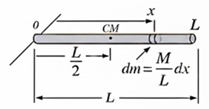

Moment of Inertia: Discrete or for Particles

Term | 1D | 2D | 3D
$$I$$ | $$I=m r^{2}=\frac{L}{⍵}$$ | $$I= \sum_{i=1}^{N}{m_{i} r_{i}^{2}}=\int{r^{2} dm}$$ | NA
$$I_{x}$$ | $$I_{x}=\sum_{i=1}^{j}{x_{i}^{2}\frac{M}{L}∆x}$$ | $$I_{x}=\sum_{i=1}^{k}{\sum_{j=1}^{l}{y^{2} ρ\left(x,y\right) ∆A}}$$ | $$I_{x}=\sum_{i=1}^{l}{\sum_{j=1}^{m}{\sum_{k=1}^{n}{(y^{2}+z^{2}) ρ\left(x,y,z\right) ∆V}}}$$
$$I_{y}$$ | NA | $$I_{y}=\sum_{i=1}^{k}{\sum_{j=1}^{l}{x^{2} ρ\left(x,y\right) ∆A}}$$ | $$I_{y}=Above with \left(x^{2}+z^{2}\right)$$
$$I_{z}$$ | NA | NA | $$I_{z}=Above with \left(x^{2}+y^{2}\right)$$
$$I_{0}$$ | $$I_{0}=I_{x}$$ | $$I_{0}=I_{x}+I_{y}$$ | $$I_{0}=I_{x}+I_{y}+I_{z}$$

Moment of Inertia: Continuous

Term | 2D | 3D
$$I$$ | $$I=\int_{0}^{a}{m r^{2} dr}$$  $$I=\iint_{A}^{ }{ρ\left(r\right){ d(r)}^{2} dA(r)}$$ | $$I= \iiint_{V}^{ }{ρ\left(r\right){ d(r)}^{2} dV(r)}$$
$$I_{x}$$ | $$I_{x}=\iint_{R}^{ }{y^{2} ρ\left(x,y\right) dA}$$ | $$I_{x}=\iiint_{Q}^{ }{(y^{2}+z^{2}) ρ\left(x,y,z\right) dV}$$
$$I_{y}$$ | $$I_{y}=\iint_{R}^{ }{x^{2} ρ\left(x,y\right) dA}$$ | $$I_{y}=\iiint_{Q}^{ }{(x^{2}+z^{2}) ρ\left(x,y,z\right) dV}$$
$$I_{z}$$ | NA | $$I_{z}=\iiint_{Q}^{ }{(x^{2}+y^{2}) ρ\left(x,y,z\right) dV}$$

Moments of Inertia of Common 2D Plane Areas

Shape | Diagram | Formulas
Rectangle | 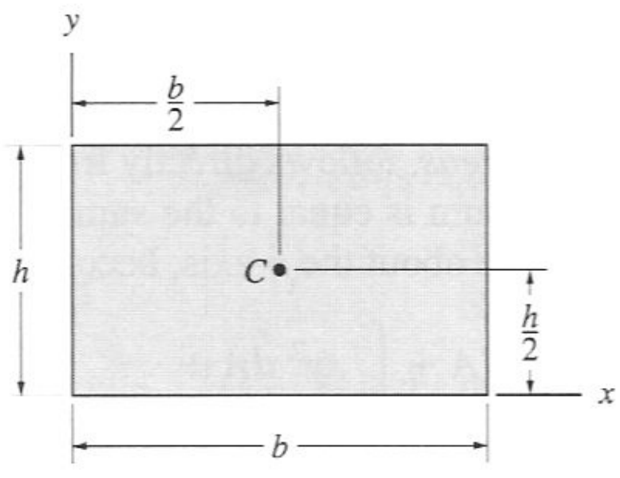 | $$I_{x}=\frac{1}{3}Ah^{2}=\frac{1}{3}bh^{3}$$  $$I_{y}=\frac{1}{3}b^{3}h$$  $$I_{xy}=\frac{1}{4}b^{2}h^{2}$$
Right Triangle | 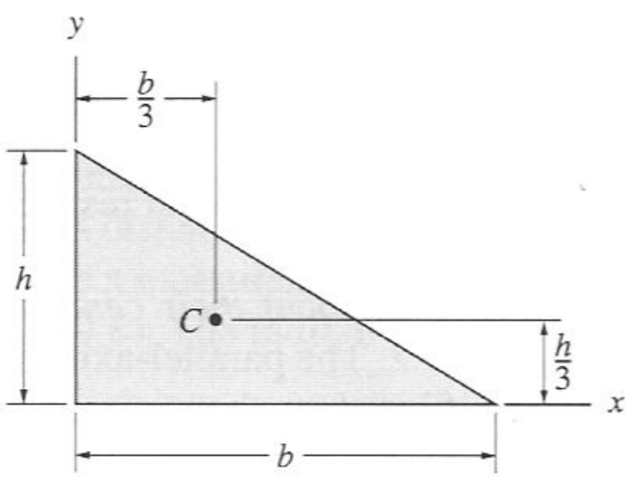 | $$I_{x}=\frac{1}{12}Ah^{2}=\frac{1}{12}bh^{3}$$  $$I_{y}=\frac{1}{12}b^{3}h$$  $$I_{xy}=\frac{1}{24}b^{2}h^{2}$$
Isosceles Triangle | 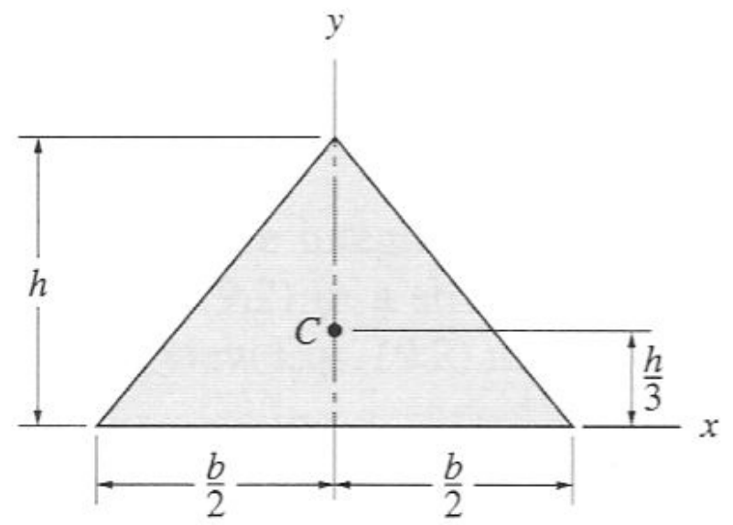 | $$I_{x}=\frac{1}{6}Ah^{2}=\frac{1}{12}bh^{3}$$  $$I_{y}=\frac{1}{16}b^{3}h$$  $$I_{xy}=0$$
Triangle | 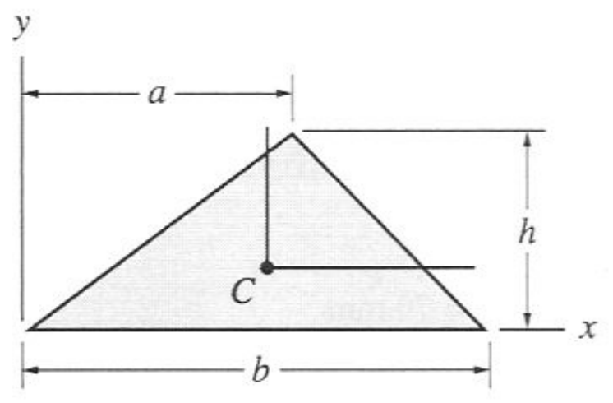 | $$I_{x}=\frac{1}{6}Ah^{2}=\frac{1}{12}bh^{3}$$  $$I_{y}=\frac{1}{12}bh(a^{2}+ab+b^{2})$$  $$I_{xy}=\frac{1}{24}h^{2}(2a-b)$$
Circle | 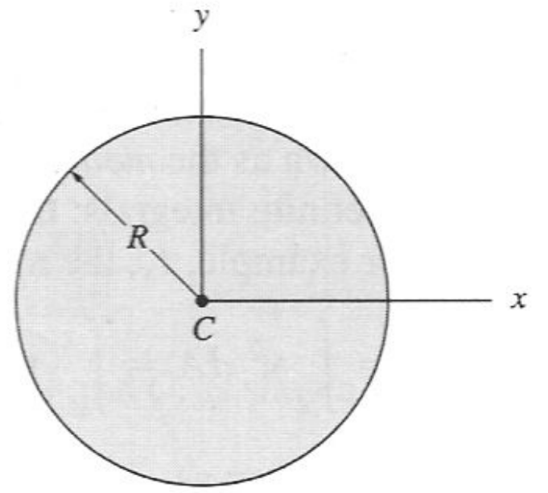 | $$I_{x}=\frac{1}{4}AR^{2}=\frac{1}{4}πR^{4}$$  $$I_{y}=\frac{1}{4}AR^{2}=\frac{1}{4}πR^{4}$$  $$I_{xy}=0$$
Semicircle | 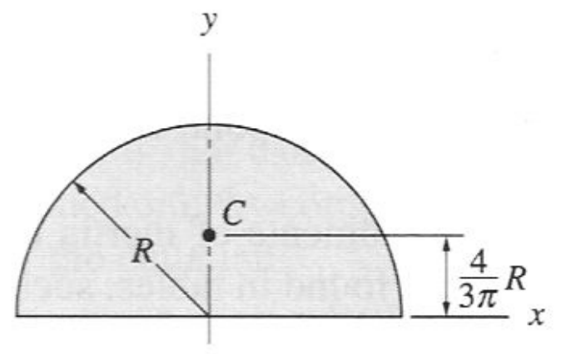 | $$I_{x}=\frac{1}{4}AR^{2}=\frac{1}{8}πR^{4}$$  $$I_{y}=\frac{1}{4}AR^{2}=\frac{1}{8}πR^{4}$$  $$I_{xy}=0$$
Quarter Circle | 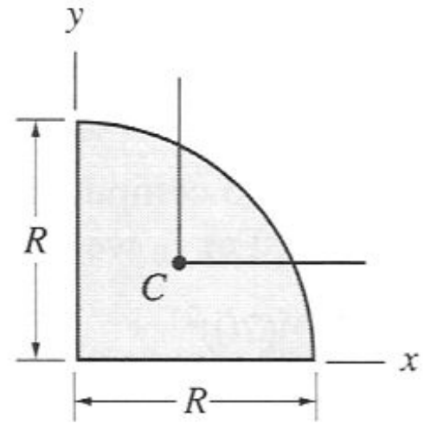 | $$I_{x}=\frac{1}{4}AR^{2}=\frac{1}{16}πR^{4}$$  $$I_{y}=\frac{1}{4}AR^{2}=\frac{1}{16}πR^{4}$$  $$I_{xy}=\frac{1}{16}R^{4}$$
Quarter Ellipse | 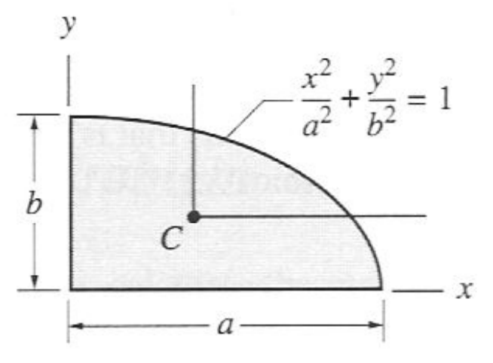 | $$I_{x}=\frac{1}{4}AR^{2}=\frac{1}{16}πab^{3}$$  $$I_{y}=\frac{1}{4}AR^{2}=\frac{1}{16}πa^{3}b$$  $$I_{xy}=\frac{1}{8}a^{2}b^{2}$$
Half Parabola Complement | 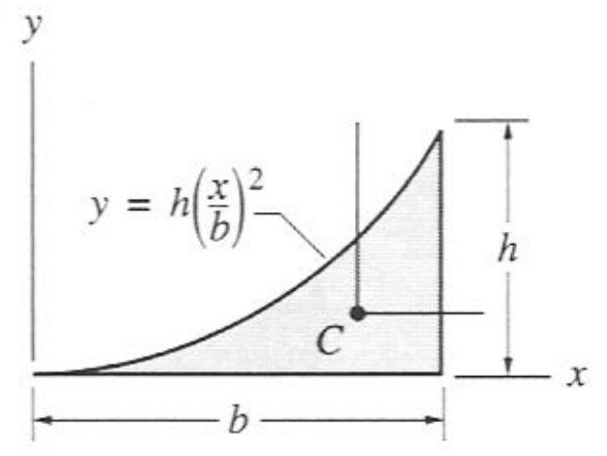 | $$I_{x}=\frac{1}{21}bh^{3}$$  $$I_{y}=\frac{1}{5}b^{3}h$$  $$I_{xy}=\frac{1}{12}b^{2}h^{2}$$
Half Parabola | 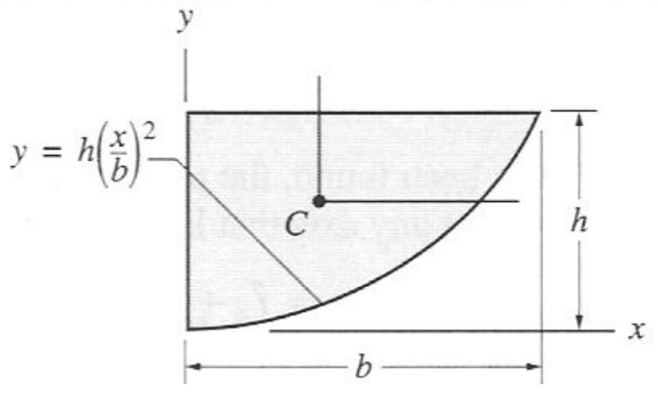 | $$I_{x}=\frac{2}{7}bh^{3}$$  $$I_{y}=\frac{2}{15}b^{3}h$$  $$I_{xy}=\frac{1}{6}b^{2}h^{2}$$
Circular Sector | 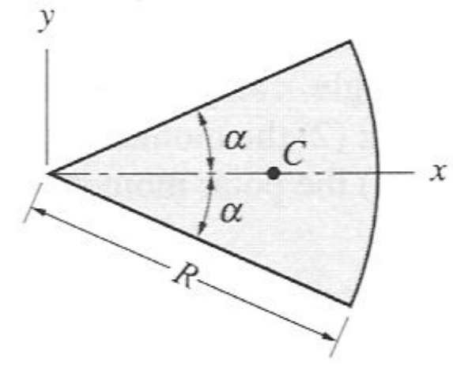 | $$I_{x}=\frac{1}{8}R^{4}(2α-\sin{2α})$$  $$I_{y}=\frac{1}{8}R^{4}(2α+\sin{2α})$$  $$I_{xy}=0$$
Note: All formulas shown assume objects of uniform mass density.

Moments of Inertia of Common 3D Solids

Shape | Diagram | Formulas
Point Mass | 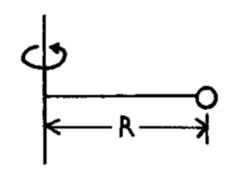 | $$I_{x}=MR^{2}$$
Slender Rod | 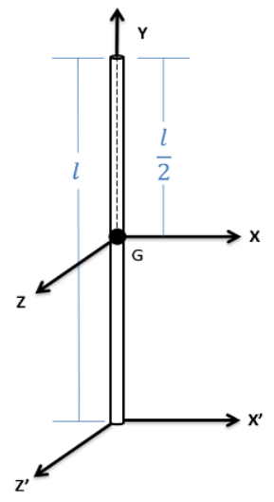 | $$I_{x}=\frac{1}{12}Ml^{2}$$  $$I_{y}=0$$  $$I_{z}=\frac{1}{12}Ml^{2}$$  $$I_{x^{'}}=\frac{1}{3}Ml^{2}$$  $$I_{z^{'}}=\frac{1}{3}Ml^{2}$$
Flat Rectangular Plate | 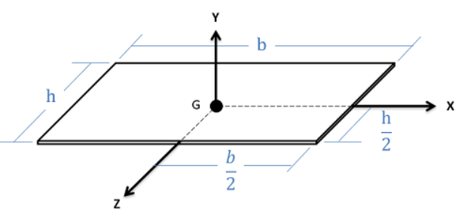 | $$I_{x}=\frac{1}{12}Mh^{2}=\frac{1}{12}bh^{3}$$  $$I_{y}=\frac{1}{12}M\left(h^{2}+b^{2}\right)$$  $$I_{z}=\frac{1}{12}Mb^{2}$$
Rectangular Prism | 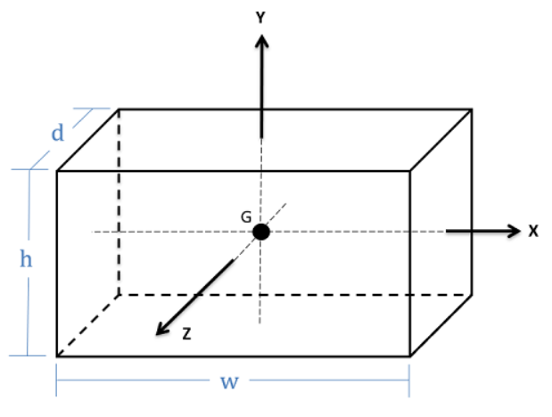 | $$I_{x}=\frac{1}{12}M\left(h^{2}+d^{2}\right)$$  $$I_{y}=\frac{1}{12}M\left(d^{2}+w^{2}\right)$$  $$I_{z}=\frac{1}{12}M\left(h^{2}+w^{2}\right)$$  $$V=dwh$$
Flat Circular Plate | 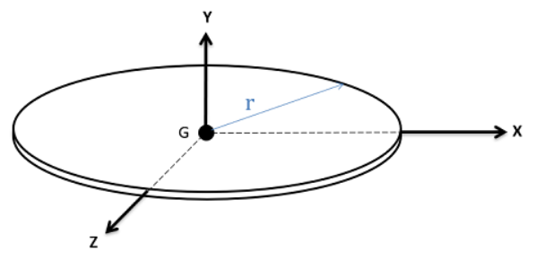 | $$I_{x}=\frac{1}{4}MR^{2}=\frac{1}{4}πR^{4}$$  $$I_{y}=\frac{1}{2}MR^{2}=\frac{1}{2}πR^{4}$$  $$I_{z}=\frac{1}{4}MR^{2}=\frac{1}{4}πR^{4}$$
Thin Circular Ring | 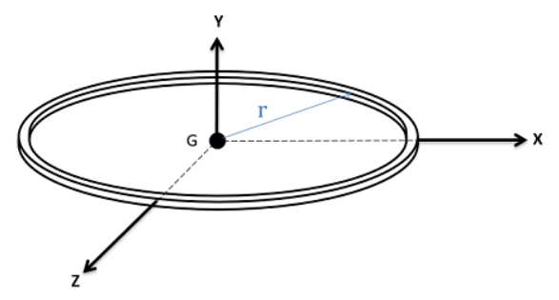 | $$I_{x}=\frac{1}{2}MR^{2}$$  $$I_{y}=MR^{2}$$  $$I_{z}=\frac{1}{2}MR^{2}$$
Solid Cylinder | 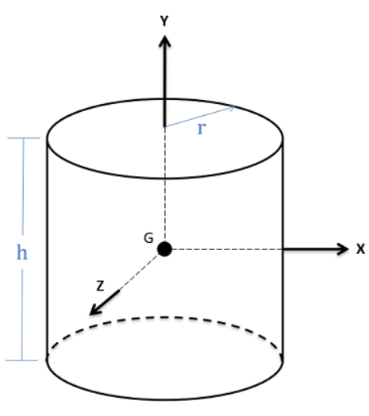 | $$I_{x}=\frac{1}{4}MR^{2}+\frac{1}{12}Mh^{2}$$  $$I_{y}=\frac{1}{2}MR^{2}$$  $$I_{z}=\frac{1}{4}MR^{2}+\frac{1}{12}Mh^{2}$$  $$V=πr^{2}h$$
Thin Cylindrical Shell | 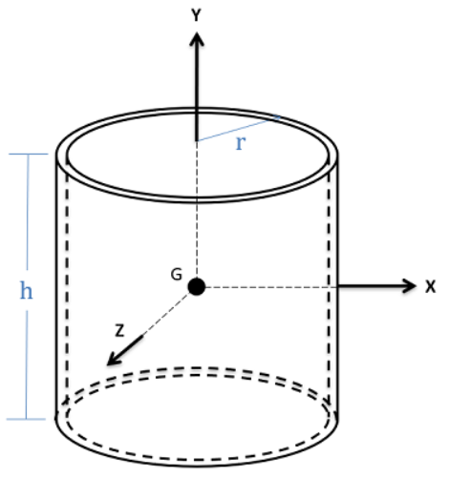 | $$I_{x}=\frac{1}{6}M\left(3R^{2}+h^{2}\right)$$  $$I_{y}=MR^{2}$$  $$I_{z}=\frac{1}{6}M\left(3R^{2}+h^{2}\right)$$
Thick Cylindrical Shell |  | $$I_{y}=\frac{1}{2}M\left(R_{2}^{2}+R_{1}^{2}\right)$$
Half Cylinder | 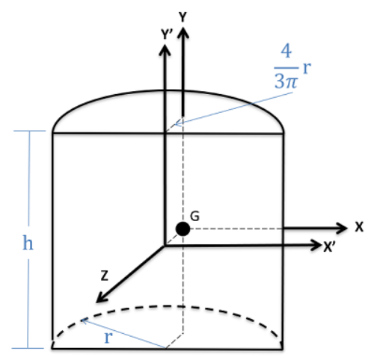 | $$I_{x}=\left(\frac{1}{4}-\frac{16}{9π^{2}}\right)MR^{2}+\frac{1}{12}Mh^{2}$$  $$I_{y}=\left(\frac{1}{2}-\frac{16}{9π^{2}}\right)MR^{2}$$  $$I_{z}=\left(\frac{1}{4}-\frac{16}{9π^{2}}\right)MR^{2}+\frac{1}{12}Mh^{2}$$  $$V=\frac{1}{2}πr^{2}h$$
Solid Sphere | 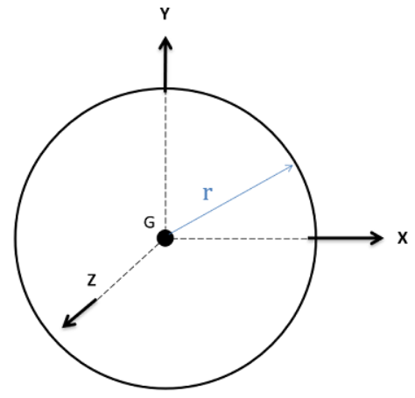 | $$I_{x}=\frac{2}{5}MR^{2}$$  $$I_{y}=\frac{2}{5}MR^{2}$$  $$I_{z}=\frac{2}{5}MR^{2}$$  $$V=\frac{4}{3}πr^{3}$$
Spherical Shell | 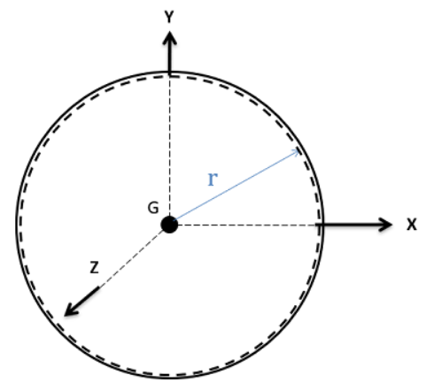 | $$I_{x}=\frac{2}{3}MR^{2}$$  $$I_{y}=\frac{2}{3}MR^{2}$$  $$I_{z}=\frac{2}{3}MR^{2}$$
Solid Hemisphere | 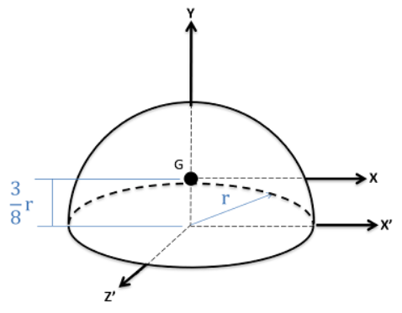 | $$I_{x}=\frac{83}{320}MR^{2}$$  $$I_{y}=\frac{2}{5}MR^{2}$$  $$I_{z}=\frac{83}{320}MR^{2}$$  $$I_{x^{'}}=\frac{2}{5}MR^{2}$$  $$I_{z^{'}}=\frac{2}{5}MR^{2}$$
Hemispherical Shell | 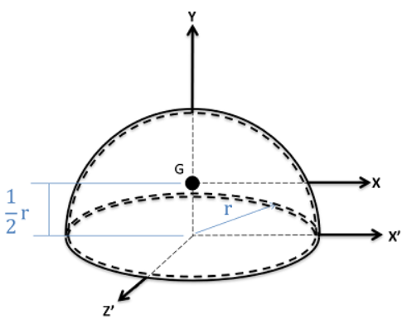 | $$I_{x}=\frac{5}{12}MR^{2}$$  $$I_{y}=\frac{2}{3}MR^{2}$$  $$I_{z}=\frac{5}{12}MR^{2}$$  $$I_{x^{'}}=\frac{2}{3}MR^{2}$$  $$I_{z^{'}}=\frac{2}{3}MR^{2}$$
Right Circular Cone | 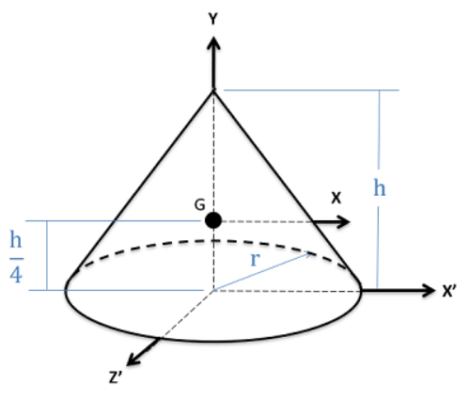 | $$I_{x}=\frac{3}{80}M\left(4R^{2}+h^{2}\right)$$  $$I_{y}=\frac{3}{10}MR^{2}$$  $$I_{z}=\frac{3}{80}M\left(4R^{2}+h^{2}\right)$$  $$I_{x^{'}}=\frac{1}{20}M\left(3R^{2}+{2h}^{2}\right)$$  $$I_{z^{'}}=\frac{1}{20}M\left(3R^{2}+{2h}^{2}\right)$$  $$V=\frac{1}{3}πr^{2}h$$
Note: All formulas shown assume objects of uniform mass density.

Sources
- Matchev, Konstantin (2026). University of Florida, Department of Physics, PHY4222, Table of Selected Moments of Inertia. https://www.phys.ufl.edu/~matchev/phy4222/momi_table.pdf
- Mechanics Map – Open Text Project (2026). Center of Mass and Mass Moments of Inertia for Homogeneous Bodies. https://mechanicsmap.psu.edu/websites/centroidtables/centroids3D/centroids3D.html
- University of Utah, Dept. of Mechanical Engineering (2026). ME 1300 - Statics & Strength of Materials, Selected Centroid and Moment of Inertia Shapes. https://my.mech.utah.edu/~me1300/Selected.pdf
See Also
- Harold’s Physics Center of Mass Cheat Sheet
- Harold’s Physics Moment of Inertia Cheat Sheet

