Harold’s Prime Numbers
Cheat Sheet
29 January 2026

Prime Numbers

Range | # | Prime Numbers
1 to 100 | 25 | 2, 3, 5, 7, 11, 13, 17, 19, 23, 29, 31, 37, 41, 43, 47, 53, 59, 61, 67, 71, 73, 79, 83, 89, 97
101-200 | 21 | 101, 103, 107, 109, 113, 127, 131, 137, 139, 149, 151, 157, 163, 167, 173, 179, 181, 191, 193, 197, 199
201-300 | 16 | 211, 223, 227, 229, 233, 239, 241, 251, 257, 263, 269, 271, 277, 281, 283, 293
301-400 | 16 | 307, 311, 313, 317, 331, 337, 347, 349, 353, 359, 367, 373, 379, 383, 389, 397
401-500 | 17 | 401, 409, 419, 421, 431, 433, 439, 443, 449, 457, 461, 463, 467, 479, 487, 491, 499
501-600 | 14 | 503, 509, 521, 523, 541, 547, 557, 563, 569, 571, 577, 587, 593, 599
601-700 | 16 | 601, 607, 613, 617, 619, 631, 641, 643, 647, 653, 659, 661, 673, 677, 683, 691
701-800 | 14 | 701, 709, 719, 727, 733, 739, 743, 751, 757, 761, 769, 773, 787, 797
801-900 | 15 | 809, 811, 821, 823, 827, 829, 839, 853, 857, 859, 863, 877, 881, 883, 887
901-1000 | 14 | 907, 911, 919, 929, 937, 941, 947, 953, 967, 971, 977, 983, 991, 997
1001-1100 | 16 | 1009, 1013, 1019, 1021, 1031, 1033, 1039, 1049, 1051, 1061, 1063, 1069, 1087, 1091, 1093, 1097
1101-1200 | 12 | 1103, 1109, 1117, 1123, 1129, 1151, 1153, 1163, 1171, 1181, 1187, 1193
1201-1300 | 15 | 1201, 1213, 1217, 1223, 1229, 1231, 1237, 1249, 1259, 1277, 1279, 1283, 1289, 1291, 1297
1301-1400 | 11 | 1301, 1303, 1307, 1319, 1321, 1327, 1361, 1367, 1373, 1381, 1399
1401-1500 | 17 | 1409, 1423, 1427, 1429, 1433, 1439, 1447, 1451, 1453, 1459, 1471, 1481, 1483, 1487, 1489, 1493, 1499
1501-1600 | 12 | 1511, 1523, 1531, 1543, 1549, 1553, 1559, 1567, 1571, 1579, 1583, 1597
1601-1700 | 15 | 1601, 1607, 1609, 1613, 1619, 1621, 1627, 1637, 1657, 1663, 1667, 1669, 1693, 1697, 1699
1701-1800 | 12 | 1709, 1721, 1723, 1733, 1741, 1747, 1753, 1759, 1777, 1783, 1787, 1789
1801-1900 | 12 | 1801, 1811, 1823, 1831, 1847, 1861, 1867, 1871, 1873, 1877, 1879, 1889
1901-2000 | 13 | 1901, 1907, 1913, 1931, 1933, 1949, 1951, 1973, 1979, 1987, 1993, 1997, 1999
2001-2100 | 14 | 2003, 2011, 2017, 2027, 2029, 2039, 2053, 2063, 2069, 2081, 2083, 2087, 2089, 2099
2101-2200 | 10 | 2111, 2113, 2129, 2131, 2137, 2141, 2143, 2153, 2161, 2179
2201-2300 | 15 | 2203, 2207, 2213, 2221, 2237, 2239, 2243, 2251, 2267, 2269, 2273, 2281, 2287, 2293, 2297
2301-2400 | 15 | 2309, 2311, 2333, 2339, 2341, 2347, 2351, 2357, 2371, 2377, 2381, 2383, 2389, 2393, 2399

Range | # | Prime Numbers
2401–2500 | 10 | 2411, 2417, 2423, 2437, 2441, 2447, 2459, 2467, 2473, 2477
2501–2600 | 11 | 2503, 2521, 2531, 2539, 2543, 2549, 2551, 2557, 2579, 2591, 2593
2601–2700 | 15 | 2609, 2617, 2621, 2633, 2647, 2657, 2659, 2663, 2671, 2677, 2683, 2687, 2689, 2693, 2699
2701–2800 | 14 | 2707, 2711, 2713, 2719, 2729, 2731, 2741, 2749, 2753, 2767, 2777, 2789, 2791, 2797
2801–2900 | 12 | 2801, 2803, 2819, 2833, 2837, 2843, 2851, 2857, 2861, 2879, 2887, 2897
2901–3000 | 11 | 2903, 2909, 2917, 2927, 2939, 2953, 2957, 2963, 2969, 2971, 2999
3001–3100 | 12 | 3001, 3011, 3019, 3023, 3037, 3041, 3049, 3061, 3067, 3079, 3083, 3089
3101–3200 | 10 | 3109, 3119, 3121, 3137, 3163, 3167, 3169, 3181, 3187, 3191
3201–3300 | 11 | 3203, 3209, 3217, 3221, 3229, 3251, 3253, 3257, 3259, 3271, 3299
3301–3400 | 15 | 3301, 3307, 3313, 3319, 3323, 3329, 3331, 3343, 3347, 3359, 3361, 3371, 3373, 3389, 3391
3401–3500 | 11 | 3407, 3413, 3433, 3449, 3457, 3461, 3463, 3467, 3469, 3491, 3499
3501–3600 | 11 | 3527, 3533, 3539, 3541, 3547, 3557, 3559, 3571, 3581, 3583, 3593
3601–3700 | 13 | 3607, 3613, 3617, 3623, 3631, 3637, 3643, 3659, 3671, 3673, 3677, 3691, 3697
3701–3800 | 12 | 3701, 3709, 3719, 3727, 3733, 3739, 3761, 3767, 3769, 3779, 3793, 3797
3801–3900 | 11 | 3803, 3821, 3823, 3833, 3847, 3851, 3853, 3863, 3877, 3881, 3889
3901–4000 | 11 | 3907, 3911, 3917, 3919, 3923, 3929, 3931, 3943, 3947, 3967, 3989
4001–4100 | 15 | 4001, 4003, 4007, 4013, 4019, 4021, 4027, 4049, 4051, 4057, 4073, 4079, 4091, 4093, 4099
4101–4200 | 8 | 4127, 4129, 4133, 4139, 4153, 4157, 4159, 4177
4201–4300 | 16 | 4201, 4211, 4217, 4219, 4229, 4231, 4241, 4243, 4253, 4259, 4261, 4271, 4273, 4283, 4289, 4297
4301–4400 | 9 | 4327, 4337, 4339, 4349, 4357, 4363, 4373, 4391, 4397
4401–4500 | 11 | 4409, 4421, 4423, 4441, 4447, 4451, 4457, 4463, 4481, 4483, 4493
4501–4600 | 11 | 4513, 4517, 4519, 4523, 4547, 4549, 4561, 4567, 4583, 4591, 4597
4601–4700 | 11 | 4621, 4637, 4639, 4643, 4649, 4651, 4657, 4663, 4673, 4679, 4691
4701–4800 | 12 | 4703, 4721, 4723, 4729, 4733, 4751, 4759, 4783, 4787, 4789, 4793, 4799
4801–4900 | 8 | 4801, 4813, 4817, 4831, 4861, 4871, 4877, 4889
4901–5000 | 15 | 4903, 4909, 4919, 4931, 4933, 4937, 4943, 4951, 4957, 4967, 4969, 4973, 4987, 4993, 4999
5000–5100 | 12 | 5003, 5009, 5011, 5021, 5023, 5039, 5051, 5059, 5077, 5081, 5087, 5099
5101–5200 | 10 | 5107, 5113, 5119, 5147, 5153, 5167, 5171, 5179, 5189, 5197
5201–5300 | 10 | 5209, 5227, 5231, 5233, 5237, 5261, 5273, 5279, 5281, 5297
5301–5400 | 10 | 5303, 5309, 5323, 5333, 5347, 5351, 5381, 5387, 5393, 5399
5401–5500 | 12 | 5413, 5417, 5419, 5431, 5437, 5441, 5443, 5449, 5471, 5477, 5479, 5483
5501–5600 | 13 | 5501, 5503, 5507, 5519, 5521, 5527, 5531, 5557, 5563, 5569, 5573, 5581, 5591
5601–5700 | 12 | 5623, 5639, 5641, 5647, 5651, 5653, 5657, 5659, 5669, 5683, 5689, 5693
5701–5800 | 10 | 5701, 5711, 5717, 5737, 5741, 5743, 5749, 5779, 5783, 5791
5801–5900 | 17 | 5801, 5807, 5813, 5821, 5827, 5839, 5843, 5849, 5851, 5857, 5861, 5867, 5869, 5879, 5881, 5897
Primes

Term | Definition or Formula
Prime Number ($p$) | - A natural number which has exactly two factors, 1 and itself.  - $p>1$
Composite Number ($n$) | - A natural number that has more than two factors.  - It can be divided by 1, itself, and by at least one other natural number.  - 1 is not a composite number.
The Fundamental Theorem of Arithmetic | - Each positive integer is either prime or the product of powers of primes.  - Every integer greater than 1 can be factored uniquely into a product of primes.  - Every positive integer, other than 1, can be expressed uniquely as a product of prime numbers where the prime factors are written in non-decreasing order.
Prime Factorization | $$n=p_{1}^{e_{1}}∙ p_{2}^{e_{2}}∙ p_{3}^{e_{3}}∙… ∙p_{k}^{e_{k}}$$  where e_{i} is the multiplicity of prime p_{i}
Greatest Common Divisor (GCD) | Given  $$x=p_{1}^{α_{1}}∙ p_{2}^{α_{2}}∙ p_{3}^{α_{3}}∙… ∙p_{k}^{α_{k}}$$  $$y=p_{1}^{β_{1}}∙ p_{2}^{β_{2}}∙ p_{3}^{β_{3}}∙… {∙p}_{k}^{β_{k}}$$  $$gcd (x,y)=p_{1}^{min\{α_{1}, { β}_{1}\}}·p_{2}^{min\{α_{2},{ β}_{2}\}}·p_{k}^{min\{α_{k},{ β}_{k}\}}$$  The largest positive integer that is a factor of both x and y.  e.g., Take the minimum exponent for each prime.  Similar to Intersection (∩) of $α_{i},β_{i}$.
Least Common Multiple (LCM) | $$lcm (x,y)=p_{1}^{max\{α_{1},{ β}_{1}\}}·p_{2}^{max\{α_{2},{ β}_{2}\}}·p_{k}^{max\{α_{k},{ β}_{k}\}}$$  The smallest positive integer that is an integer multiple of both x and y.  e.g., Take the maximum exponent for each prime.  Similar to Union (∪) of $α_{i},β_{i}$.
Relatively Prime (Coprime) | $$\gcd\left(x,y\right)=1$$

Prime Theorems

Theorem | Description
Euclid’s Theorem | There are an infinite (∞) number of primes.  Proof:  Assume finitely many primes $p_{1},…,p_{n}$.  Consider $N=p_{1}p_{2}⋯p_{n}+1.$  No listed prime divides $N$, making this a contradiction.
Prime Number Theorem (Counting) | Let π(x) be the number of primes in the range from 2 through x.  $$π(x)≈\frac{x}{ln x} or \lim_{x → ∞}{ \frac{π(x)}{x/{ln x}}}=1$$  $$\frac{x}{\ln{x}}<π\left(x\right)<1.25506 \frac{x}{\ln{x}} for x≥17$$
Chance of a Prime # | For a random, positive, n-digit integer, $P(n)=\frac{1}{n ln(10)}≈\frac{0.4343}{n}$.
n^{th} Prime Number | $$p_{n}≈ n(\ln{(n)}+ln(ln(n))-1$$
Bertrand’s Postulate (Chebyshev’s Theorem) | For every integer $n>1$, there is always a prime between $n$and $2n$.
Euler’s Quadratic | $$n^{2}+n+41$$  - Produces primes for every integer $n=0$ to $39$.
Jones–Sato–Wada–Wiens Polynomial | $$P(a,b,c,…,z,k)$$  such that:  $$k\text{ is prime }⟺ ∃a,b,c,…,z∈N\text{ with }P(a,b,c,…,z,k)=0.$$  - All primes can be generated using an explicit polynomial with 26 variables, all with integer coefficients, such that:  - A number $k$ is prime if and only if this polynomial outputs a 0 for some choice of the other 25 variables.
Wilson’s Theorem (Prime Test) | $$p\text{ is prime }⟺ \left(p-1\right)!≡-1 \left(mod p\right)$$  - Not a generator and too slow for big primes.
Mersenne Primes | $$p\text{ prime and }2^{p}-1\text{ prime}⇒\text{Mersenne prime}$$  - Generates some of the largest primes ever found.  - Works only for certain primes $p$, but when it hits, it hits big.
The “Prime Indicator” Using Sine | $$P(n)=1-\prod_{k=2}^{n-1}{\left(1-{sin⁡}^{2}\left(\frac{nπ}{k}\right)\right)}$$  - This bizarre expression equals 1 if $n$ is prime, 0 otherwise.  - Completely impractical, but fascinating.

Prime Number Spirals

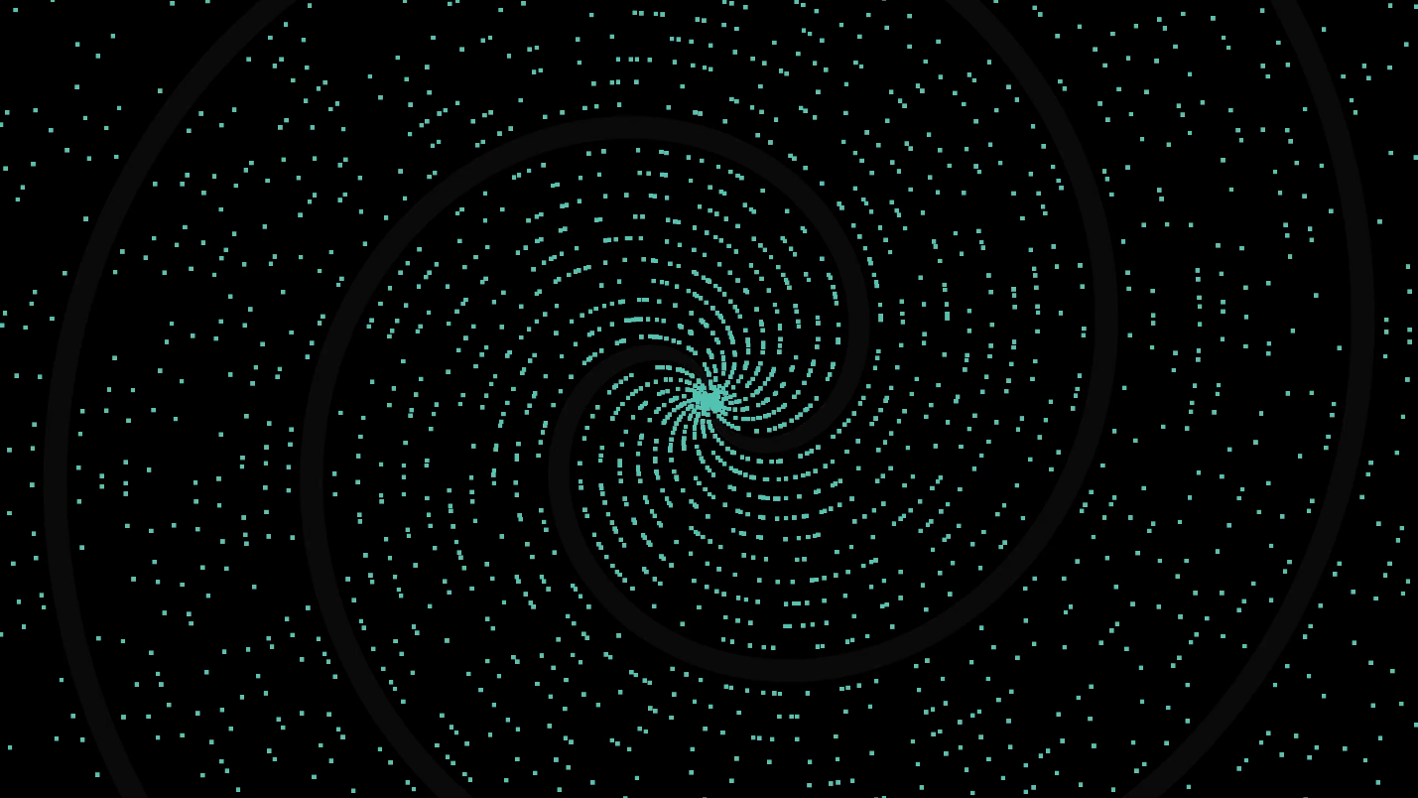
Spiral Points | $$\left(r,θ\right)=(p,p)$$
Significance of Primes | The role prime numbers play in math is similar to the role atoms play in chemistry. They're the fundamental building blocks of the integers.

Sources:
- SNHU MAT 230 - Discrete Mathematics, zyBooks.
- SNHU MAT 260 - Cryptology, Invitation to Cryptology, 1st Edition, Thomas Barr, 2001.
- The Is This Prime? Game. https://isthisprime.com/game/
- Sanderson, Grant (8 Oct 2019). 3Blue1Brown, Why do prime numbers make these spirals? https://www.3blue1brown.com/lessons/prime-spirals

