Harold’s SAT Prep
Cheat Sheet
8 April 2026

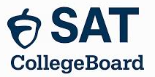
Formerly the Scholastic Aptitude Test (SAT)

When To Take Each Exam

Exam | Version | When To Take It |  | Why
PSAT Exam | PSAT 8/9 | Freshman | 9th grade | Optional early practice
PSAT Exam | PSAT 10 | Sophomore | 10th grade | Practice run
PSAT Exam | PSAT/NMSQT | October as Junior | 11th grade | October exam counts for National Merit Scholar eligibility (NMSQT). Only 1 chance.
SAT Exam | SAT | Spring as Junior | 11th grade | Ideal first attempt. Aligns with Algebra 2 completion  Gives time for retakes
SAT Exam | SAT | August between Junior and Senior year | 12th grade | Popular for students who prep over the summer
SAT Exam | SAT | Fall as Senior | 12th grade | Great for score improvement before early action (Nov 1)

Exam Dates

Exam | Dates In 2026 When SAT Exam Is Administered
PSAT 8/9 | March 2–April 30, 2026
PSAT 10 | March 2–April 30, 2026
PSAT/NMSQT | October 1–30, 2026  Schools may administer it on Saturday, October 17, 2026.
SAT | 14-Mar-26  2-May-26  6-Jun-26  15-Aug-26 | 12-Sep-26  3-Oct-26  7-Nov-26  5-Dec-26
ACT | 14-Feb-26  11-Apr-26  13-Jun-26  11-Jul-26 | 19-Sep-26  17-Oct-26  12-Dec-26
Scores

Assessment | SAT | PSAT/NMSQT | PSAT 10 | PSAT 8/9
Total Score | 400–1600 | 320–1520 | 320–1520 | 240–1440
Section Scores | 200–800 | 160–760 | 160–760 | 120–720
Additional Items | Scores are typically available 2–4 weeks after test day. | NMSC Selection Index Score on a scale of 48–228.

Texas College Admission Scores

School | Texas University Name | Typical Student SAT Score | Test Required | Level
Rice | Rice University | 1550 |  | 2. Top Tier Private
SMU | Southern Methodist University | 1400–1420 |  | 2. Top Tier Private
Trinity | Trinity University (San Antonio) | 1390–1405 |  | 2. Top Tier Private
UT | University of Texas at Austin | 1360–1390 | Test optional | 3. Top Public Research
BU | Baylor University | 1300–1400 |  | 2. Top Tier Private
TAMU | Texas A&M University (College Station) | 1260–1380 |  | 3. Top Public Research
UTD | University of Texas at Dallas | 1280–1290 |  | 3. Top Public Research
TCU | Texas Christian University | 1230–1300 |  | 2. Top Tier Private
UD | University of Dallas | 1230–1290 |  | 2. Top Tier Private
UH | University of Houston | 1240–1250 |  | 3. Top Public Research
AC | Austin College (Sherman) | 1200–1310 |  | 3. Top Liberal Arts
TTU | Texas Tech University | 1130–1310 |  | 4. Mid Tier Public
UNT | University of North Texas | 1100 |  | 4. Mid Tier Public
ACU | Abilene Christian University | 1070–1270 |  | 5. Mid Tier Private
SHSU | Sam Houston State University | 1030–1200 |  | 5. Mid Tier Public
DBU | Dallas Baptist University | 1030–1210 |  | 5. Mid Tier Private
TWU | Texas Woman’s University | 1035–1060 |  | 6. Mid Tier Public
TAMU-Corpus | Texas A&M University–Corpus Christi | 1020–1180 |  | 5. Mid-Tier Public
TXST | Texas State University | 1020–1180 |  | 5. Mid Tier Public
SFA | Stephen F. Austin University | 1000–1180 |  | 5. Mid Tier Public
CCCC | Collin County Community College | NA |  | 7. Open Admission
UTA | University of Texas at Arlington | 1010–1250 |  | 3. Top Public Research
UTSA | University of Texas at San Antonio | 1020–1220 |  | 4. Mid-Tier Public
UTEP | University of Texas at El Paso | 900–1120 |  | 5. Mid-Tier Public
UTRGV | University of Texas Rio Grande Valley | 970–1170 |  | 5. Mid-Tier Public
Out-of-State College Admission Scores

School | University Name | Typical Student SAT Score | Test Required | Level | State
Caltech | California Institute of Technology | 1555 | Y | 1. Ivy Level | CA
JHU | Johns Hopkins University | 1555 | Y | 1. Ivy Level | MD
MIT | Massachusetts Institute of Technology | 1545–1560 | Y | 1. Ivy Level | MA
Stanford | Stanford University | 1545 | Y | 1. Ivy Level | CA
Yale | Yale University | 1540 | Y | 1. Ivy Level | CT
UChicago | University of Chicago | 1540 | Y | 1. Ivy Level | IL
Harvard | Harvard University | 1520–1560 | Y | 1. Ivy Level | MA
Columbia | Columbia University | 1510–1560 | Y | 1. Ivy Level | NY
Princeton | Princeton University | 1500–1560 | Y | 1. Ivy Level | NJ
Duke | Duke University | 1500–1560 | Y | 1. Ivy Level | NC
CMU | Carnegie Mellon University | 1500–1560 | Y | 1. Ivy Level (STEM) | PA
UPenn | University of Pennsylvania | 1490–1560 | Y | 1. Ivy Level | PA
Vanderbilt | Vanderbilt University | 1480–1570 | Y | 1. Ivy Level | TN
Cornell | Cornell University | 1450–1560 | Y | 1. Ivy Level | NY
GT | Georgia Institute of Technology | 1370–1540 | Y | 1. Ivy Level STEM | GA
BYU | Brigham Young University Provo | 1374 | Y | 2. Top Tier Private | UT
OU | University of Oklahoma | 1238 |  | 4. Mid Tier Public | OK
UARK | University of Arkansas | 1120–1310 | Y | 4. Mid Tier Public | AR
OSU | Oklahoma State University | 1120–1290 | Y | 4. Mid Tier Public | OK
UA | University of Alabama | 1080–1370 | Y | 4. Mid Tier Public | AL
BYU-I | Brigham Young University Idaho | 1080–1090 | Y | 5. Mid Tier Private | ID
SNHU | Southern New Hampshire University (online) | 960–1160 |  | 5. Mid Tier Private | NH

National Merit Scholarship

Item | Description
NMSQT Scholarship | National Merit Scholarship Qualifying Test (NMSQT)
Description | The NMSQT is the qualifying version of the PSAT/NMSQT—a standardized digital test that students take to be considered for recognition and scholarships through the National Merit Scholarship Program.
When to Take | Students typically take the PSAT/NMSQT as Juniors (11th grade)
Recognition | - 1.3 million students apply  - 50,000 are recognized  - 16,000 become semifinalists (Sept. of senior year)  - 15,000 become finalists (later in senior year)  - 7,500 are awarded (Top 0.5%) (later in senior year)
3 Reward Types | - National Merit $2,500 Scholarship  - One-time payment  - All finalists considered
3 Reward Types | - Corporate-Sponsored Awards  - For finalists meeting sponsor criteria  - May be one-time or renewable  - Renewable typically $1,000–$10,000/year  - Renewable one-time $2,500–$10,000
3 Reward Types | - College-Sponsored Awards  - Finalists must name that college as their first choice, apply, and not have another NMSC award  - Renewable up to 4 years  - Typical annual stipend range $500–$2,000/year  - Awards are tied to that institution and are canceled if the student changes/transfers schools.
Parental Help | - Make sure your student takes the PSAT/NMSQT in 11th grade  - Keep grades strong  - Be ready to complete the application promptly if they are named a semifinalist  - Essay  - Activities  - Recommendations

SAT/PSAT Composition

Section | Module | Time Allotted | Number of Questions
Reading and Writing | 1 | 32 min. | 27
Reading and Writing | 2 | 32 min. | 27
Break |  | 10 min. | 0
Math | 3 | 35 min. | 22
Math | 4 | 35 min. | 22
Total |  | 2:14 + Break | 98

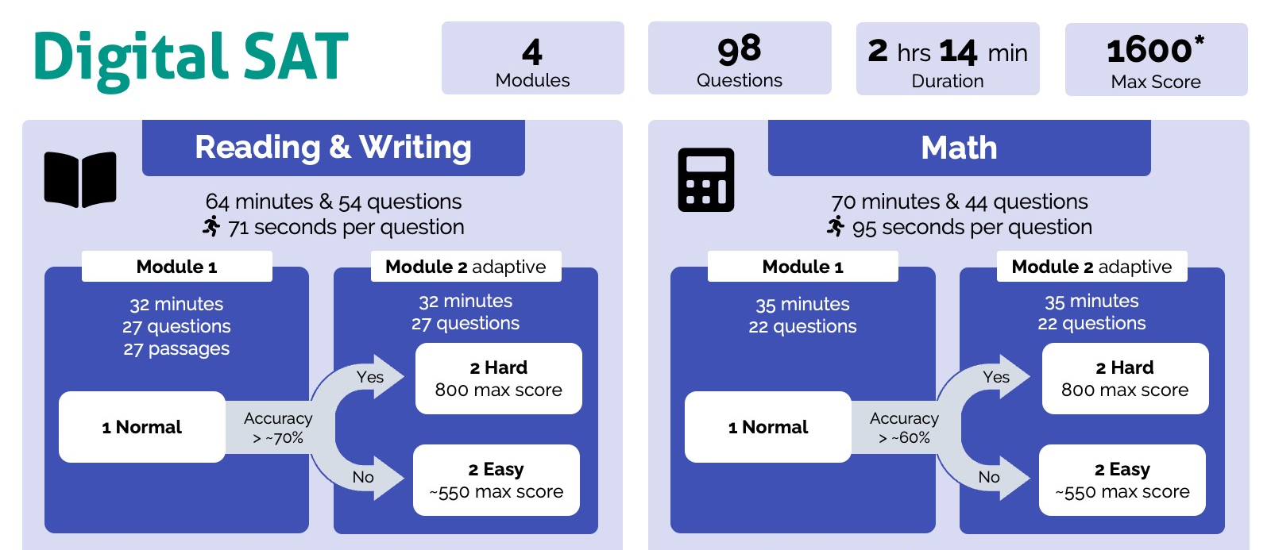

Evidence-Based Reading and Writing (EBRW) Structure

Item | Description
EBRW Question Types | - 100% 4-Option Multiple Choice  - Short passages (25–150 words)  - 1 Question per passage
Number of Questions | - Part 1: 27 questions, 32 min. - Reading  - Part 2: 27 questions, 32 min. – Writing & Language
Average Time Per Question | - 1 min. 11 sec. = 71 sec.

Content Domain | Measures | # Questions
1. Information and Ideas | - Comprehension, analysis, reasoning skills, and knowledge  - Locate, interpret, evaluate, and integrate information and ideas  - Texts and informational graphics (tables, bar graphs, and line graphs) | ~26%  12-14 questions
2. Expression of Ideas | - Revise texts to improve the effectiveness of written expression  - Meet specific rhetorical goals | ~20%  8-12 questions
3. Craft and Structure | - Comprehension, vocabulary, analysis, synthesis, and reasoning skills and knowledge  - Understand and use high-utility words and phrases in context  - Evaluate texts rhetorically  - Make connections between topically related texts | ~28%  13-15 questions
4. Standard English Conventions | - Edit text to conform to core conventions of Standard English  - Sentence structure  - Usage (grammar)  - Punctuation | ~26%  11-15 questions

Math Structure

Item | Description
Math Question Types | - 75% 4–Option Multiple Choice  - 25% Student Produced Format (SPF)
Number of Questions | - Part 1: 22 questions, 35 min.  - Part 2: 22 questions, 35 min.
Average Time Per Question | - 1 min. 35 sec. = 95 sec.

Content Domain | Measures | # Questions
1. Algebra | - Linear equations in 1 variable  - Linear equations in 2 variables  - Linear functions  - Systems of 2 linear equations in 2 variables  - Linear inequalities in 1 or 2 variables | ~35%  13-15 questions
2. Advanced Math (Precalculus) | - Equivalent expressions  - Nonlinear equations in 1 variable  - Systems of equations in 2 variables  - Nonlinear functions (absolute value, quadratic, exponential, polynomial, rational, radical) | ~35%  13-15 questions
3. Problem Solving and Data Analysis | - Ratios, rates, proportional relationships, and units  - Percentages  - One-variable data: distributions and measures of center and spread (Statistics)  - Two variable data: models and scatterplots (Statistics)  - Probability and conditional probability  - Inference from sample statistics and margin of error  - Evaluating statistical claims: observational studies and experiments | ~15%  5-7 questions
4. Geometry and Trigonometry | - Area and volume formulas  - Lines, angles, and triangles  - Right triangles and trigonometry  - Circles | ~15%  5-7 questions

Question Type Frequency
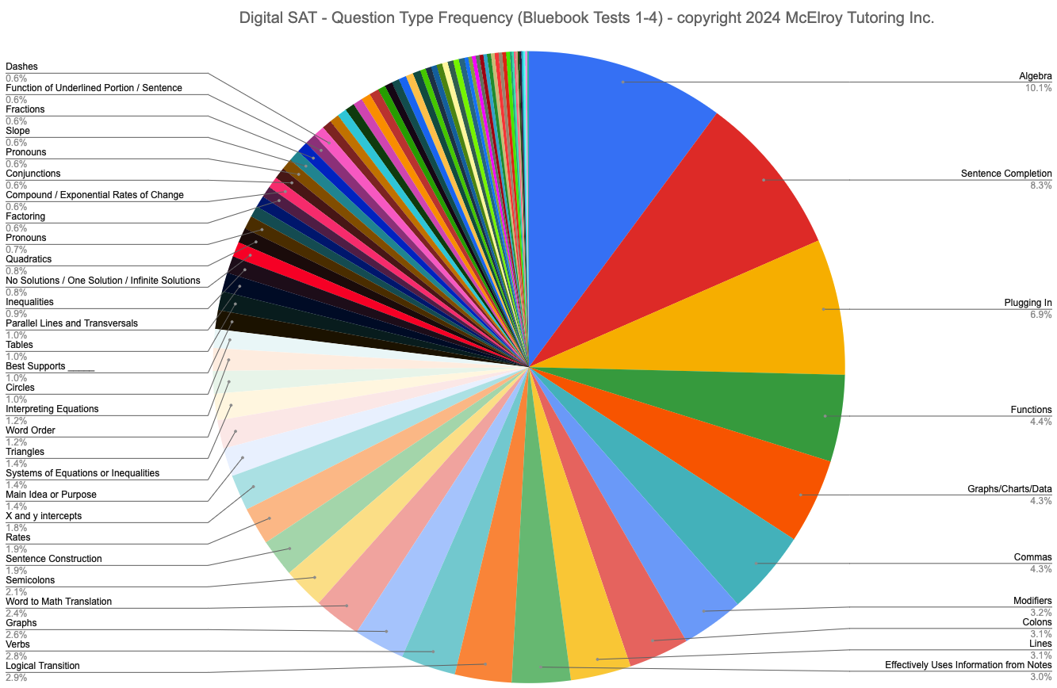

SAT Score Goals

Goal | Description
Realistic Target Score Goals | ~2.34 SAT points per hour of tutoring
Realistic Target Score Goals | Research on improvement from the first SAT exam  - ≥ 6–8 hours = +90 points  - ≥ 20+ hours = +115 points  - +21–39 points when students also:  - Took at least one full practice test  - Leveled up skills  - Followed personalized recommendations  Source: A joint College Board–Khan Academy technical report (2020)
Early Start Advantage | 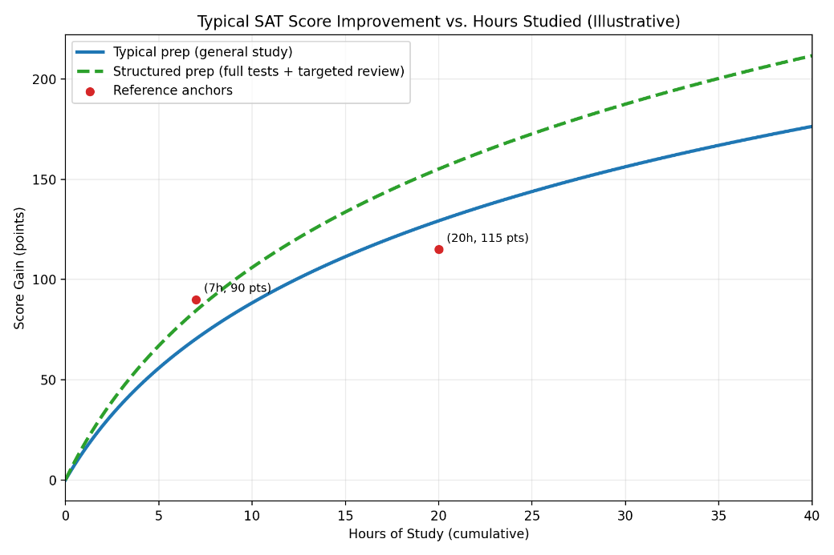
Score Boosting Strategy | Top strategies supported across all research sources:  - Start with an official diagnostic  - Use adaptive, digital practice to match real conditions  - Review your mistakes before taking another test  - Prioritize accuracy early in adaptive modules  - Study consistently, not crammed  - Track patterns: pacing, error types, and question categories
Score Levels  (approximate) | Total Score | Correct Answers | Math Error Rate | Suggested Reading Speed
Score Levels  (approximate) | 1150 | ~60–70% | miss 10–13 | 170–180 wpm
Score Levels  (approximate) | 1250 | ~65–70% | miss 8–10 | 180–190 wpm
Score Levels  (approximate) | 1350 | ~70–80% | miss 5–7 | 190–200 wpm
Score Levels  (approximate) | 1450 | ~80–90% | miss 2–4 | 200–220 wpm
Score Levels  (approximate) | 1550 | ~90–95% | miss 0–2 | 220+ wpm
Score Levels  (approximate) | 1600 | 98–100% | miss 0 | 220+ wpm
Prep Timeline | Best: 1x – 2x week for 9 weeks  Typical: 1x week for 6 weeks  Worst: 1x the week before the test
SAT Question Error Types

Skill | Error and Fix
1. Concept Gap | Error: The student simply doesn't know the underlying math or grammar rule.  Fix: Targeted concept review and practice.
2. Misread Error | Error: A careless mistake due to lack of focus, despite knowing the material.  Fix: Attention training and reading strategies.
3. Process Error | Error: The student knew the concept but didn't know how to set up the problem correctly.  Fix: Step-by-step process training.
4. Timing Error | Error: The student ran out of time or rushed and made a mistake.  Fix: Pacing strategies and time management.
5. Strategy Error | Error: The student used an inefficient or incorrect strategy, wasting time and effort.  Fix: Learn optimal strategies. Work smarter, not harder.

General Tips

Tip | Description
Adaptive Modules | The Digital SAT (DSAT) adapts.  - Module 1 difficulty is fixed  - Module 2 difficulty depends on Module 1 performance  - Higher difficulty → higher scoring potential (+250 points/module)  - If Math Module 1 score [1..16] then Easy Module 2  - If Math Module 1 score [17-22] then Hard Module 2
Penalty for Guessing | - The SAT does NOT deduct points for wrong answers.  - A wrong answer gives you 0 points, and a correct answer gives you +1 point—so guessing can only help you.
Fake Questions | Two (2) unidentified questions from each module are experimental, which means that they do not count toward your score.
Older Questions | Every year the SAT test questions become a little bit harder.  This is required to keep the top 10% at no more than 10%.  Practice with the most recent exams first.
Root Cause | Take the time to learn why you answered a problem incorrectly, then address that deficiency.
Structured Approach | The Digital SAT rewards process and strategy – not raw talent.  Specifically, it rewards consistency, accuracy, digital familiarity, and targeted practice, not brute-force memorization.
Trainable Competencies | The SAT measures trainable skills in Reading, Writing, and Math. It follows predictable patterns that can be learned through structured practice.
Timed | Practice under timed, adaptive conditions.
Start Early | Starting in 9th or 10th grade provides a strategic advantage, allowing for a lower-stress, more effective preparation schedule.
R&W Tips

Tip | Description
Common R&W Question Patterns | Examples:  - “Which choice best completes the text?”  - “Which choice best supports the claim?”  - “Which choice best improves the clarity?”
The 3-Step Framework | - INVESTIGATE the Blank: Read the sentence. What's missing?  - FIND the FOCUS: Compare choices. What changes? That = the rule being tested.  - ELIMINATE Errors: Apply the rule. Eliminate what breaks it. Plug in the winner.

R&W Grammar Rules

If the choices  change in... | The Rule is… | Golden Rule | Common Trap
1. Singular vs. Plural Verb  (run/runs, is/are) | Subject-Verb Agreement | Singular subject = singular verb.  Plural subject = plural verb. | Words between subject & verb.  The box of chocolates is full.
2. Pronoun Form  (it/they, his/their) | Pronoun-Antecedent Agreement | A pronoun must match its noun (antecedent) in number. | Unclear what pronoun  refers to.  The CEO told the manager he was wrong.
3. Verb Tense/Form  (to run/running/ran) | Verb Forms | Tense must be logical.  Use correct form (infinitive, gerund). | Wrong form after preposition.  - Known for be talented. --> being  - Interested in learn Spanish --> learning.
4. Phrase Placement  (phrase at start vs. end) | Modifier Placement | Modifier must be next to what it describes. | Dangling modifier  (subject missing).
5. Apostrophe Placement  (students/student's/students') | Plural vs. Possessive | Apostrophes show possession, NOT plurals. | Its = possessive.  It's = contraction for “it is”.
6. "To be" + Verb  (awarded / was awarded) | Active vs. Passive Voice | Active = subject does action.  Passive = subject receives action. | Passive is often wordy.
7. List Items  (filing, answering, to schedule) | Parallel Structure | Items in a list must have the same grammatical form. | Mixing -ing with infinitive.  filing, answering, to schedule
Math Tips

Tip | Description
Math Formula Sheet | The SAT provides a built-in math formula sheet.  Review it before taking the test or at least know what not to memorize.
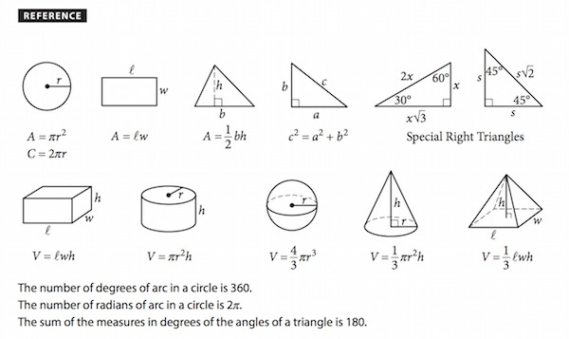
Calculators | Allowed  - Scientific calculators  - TI-83 Plus, TI-84 Plus, TI-84 Plus CE, TI-84 Plus CE Python  - TI-Nspire CX (non-CAS), TI-Nspire CX II (non-CAS)  - Graphing calculators (as long as they are non‑CAS)  - Desmos Calculator (built into the Bluebook app)  - Casio fx-9750GII / III, Casio fx-CGG50 (Prizm)  - HP-39, -40, -48, -50 series, HP Prime (in exam mode)  - Sharp EL-5200, EL-9200, EL-9300, EL-9600  Not Allowed  - Calculators with CAS (symbolic algebra)  - TI-Nspire CAS, TI-89 Titanium, TI-92 Plus  - HP 48Gii, HP 49G, HP 50G (CAS)  - Calculators with wireless/Bluetooth/internet  - Calculators with QWERTY keyboards  - Calculators with stylus input  - Mobile phone calculator apps  SAT Calculator Policy
Multiple Ways to Solve | Every SAT math question has at least three (3) different ways (how) it can be solved:  - Graphically (geometry, graph in Desmos, diagram, table)  - Algebraically (equation, model)  - Advanced Math (calculus)  - Calculator (TI-84 Plus C, Desmos)  - Intuition (If numbers are hard to add, pretend they are currency)  - Back Substitution, if non-obscured multiple choice  - Guess & Check
Trig Questions | If you have not taken Precalculus yet, know that each SAT math exam has no more than four (4) trigonometry questions.

Math Strategies

Tip | Description
1. Be Mindful of Set Up Time | S1: 30–45 Second Decision Rule (Flag & Return)  - If you cannot set up a clear plan in ~30–45 seconds, flag, make a best guess if needed, and move on. Return later.  - This addresses a Timing Error.
2. Backsolve | S2: Work with the Answers (Backsolve)  - Test answer choices in the original condition until one works.  - Start from the middle choice when ordered.  - Worst case, guess and check.  - This addresses a Concept Error.
3. Plug in Actual Numbers | S3: Plug In Real Numbers  - Replace variables with simple numbers that satisfy the relationship.  - For percent problems, choose 100 as a base.  - This addresses a Process Error.
4. Do Not Assume | S4: Target Control: “What are they asking?”  - A trap-avoidance habit.  - Many misses happen because students solve for the wrong quantity.  - This addresses a Misread Error.
5. Smart Use of Calculator | S5: Desmos/Calculator Smart Use (Solve/Visualize/Check)  - Use Desmos when it saves time:  - intersections  - roots / x-intercepts  - tables  - quick checking  - This addresses a Strategy Error.

Student Produced Response Format (SPR)

SPR Math Section: Answer Formatting Rules

Rule | Description
Allowed Characters | Yes Digits (0–9), decimal point (.), minus sign (–).  No fractions with slashes (/), percent signs (%), variables (x), units (ft/s), or commas (,).
Fractions to Decimals | All fractions must be converted to decimals.  Examples: 3/4 → 0.75, 1/8 → 0.125, 5/2 → 2.5
Rounding | Truncated or rounded at the fourth digit.  Example: 0.66 →0.6666
No Mixed Numbers | Convert mixed numbers into decimals.  Example: 1 1/2 → 1.5
Exact Values | Enter exact decimals unless rounding is explicitly required.  Example: √3 → 1.732 (if approximation is needed).
Rounding Rules | Round only when instructed.  Example: 0.6666… → 0.67 (if rounding to the nearest hundredth).
Leading/Trailing Zeros | Optional. All are accepted.  Examples: 0.5, .5, 0.50
Negative Answers | Allowed.  Example: –3.2

SPR Math Section: Examples of Unacceptable and Acceptable SPF Answers

Intended Answer | Unacceptable Answers | Reason | Acceptable Answers
3.5 | 31/2  3 1/2 | Mixed numbers should be entered as improper fractions or as decimal equivalents. | - 7/2 (improper fraction)  - 3.5 (decimal equivalent)
$$\frac{2}{3}$$ | 0.66  .66  0.67  .67 | Decimals that don’t fit the space provided should be truncated or rounded at the fourth (4) digit. | - 2/3 (fraction that fits the space)  - .6666 (decimal truncated at the fourth digit)  - .6667 (decimal rounded at the fourth digit)  - 0.666 (decimal truncated at the fourth digit, includes leading zero)  - 0.667 (decimal rounded at the fourth digit, includes leading zero)
$$-\frac{1}{3}$$ | -0.33 |  | - –1/3 (fraction that fits the space)  - –.3333 (decimal rounded or truncated at the fourth digit)  - –0.333 (decimal rounded or truncated at the fourth digit, includes leading zero)
$2.53 | $2.53 | Answers may not include symbols such as a dollar sign ($). | - 2.53
68,132 | 68,132 | Answers may not include symbols such as a comma (,). | - 68132
45% | 45% | Answers may not include symbols such as a percent sign (%). | - 0.45

SAT Prep Mistakes

Myth | Reality
1. It’s too early to start | Prep timeline is measured in months, not weeks.
2. Student is smart, they don’t need to prep | It’s also true for >80% of Frisco HS students. Competition is huge.
3. We’ll prep after the first SAT | The 1st SAT should demonstrate readiness, not a diagnostic.
4. Practice tests are enough | The real improvement comes from reviewing mistakes, which is often skipped in self-prep.
5. More hours will fix it | The quality and structure of study hours are far more important than the quantity.

SAT Prep Recommendations

Truth | Description
College Board’s Official Practice and Preparation Instructions | https://satsuite.collegeboard.org/practice  Getting Started:  - Build your study plan  - Take a practice test  - My Practice 101  - See study tips

Stress Management

Advice | Explanation
1. Do a “dry run” week | Take 1 full, timed practice test at the same time of day as your real SAT to reduce surprise stress.
2. Use box breathing | Use box breathing for 2–3 minutes before you start and anytime you feel panicky.  Box Breathing:  - Breath In 4 sec.  - Hold 4 sec.  - Breath Out 4 sec.  - Hold 4 sec.
3. Make a simple test-day checklist | Checklist:  - ID  - Admission ticket  - Laptop w/power adapter  - Pencils to take notes (scratch paper provided)  - Calculator (fully charged or with fresh batteries)  - Snack  - Water  - Hoodie  Pack it the night before.
4. Follow a sleep plan for 3 nights | Consistent bedtime/wake time; don’t try to “cram-sleep” only the night before.
5. Caffeine rules | Take no more caffeine than what you normally drink—no “extra” on test day (it can spike anxiety).
6. Warm up for 5–10 minutes | Warm up for 5–10 minutes with a few easy problems to get your brain going instead of jumping in cold.
7. Use a reset phrase | Use a reset phrase when you get stuck: “Skip, mark, return.” Move on quickly to protect your momentum.
8. Time checkpoints | Glance at the clock only at planned moments (e.g., every 10 questions) to avoid constant time anxiety.
9. Micro muscle release | Drop your shoulders, unclench your jaw, and relax your hands between passages/sections.
10. Break strategy | During breaks, stand up, sip water, eat a small snack, and take slow breaths—avoid post-mortem questions with others.
11. Hydration | Drink plenty of water. Dehydration can affect mental performance.

SAT Prep Resources – College Board

Resource (Links) | Description
College Board Bluebook App | Digital testing app.  Key Features:  - 11x Official SAT practice exams  - Desmos graphing calculator  - Performance analytics (My Practice)  - Locked-down, secure browser during actual test  - Countdown timer  - Math reference page with common formulas  - Mark for Review  - Annotate  - Zoom options
College Board Bluebook Practice Tests | Free. 11 Full practice exams that mimic the actual adaptive digital SAT exam.
SAT Question Bank | Free. Offers free online access to over 2,000 digital SAT (DSAT) and digital PSAT questions by category.
College Board Skills Insight Tool | College Board digital SAT (DSAT) tool that allows you to search for official DSAT practice questions across 1) Content categories, and 2) Specific score bands.
Printed SAT Books | - The Official SAT Study Guide, Second Edition (29 April 2025). 1154 pages. List price: $34.99.  - The Official Digital SAT Study Guide (29 August 2023). 630 pages. Available used on Amazon.com.

SAT Prep Resources – Other Sources

Resource (Links) | Description
Khan Academy Official SAT Practice | Free. Developed "in conjunction with" the College Board.
Google Gemini AI SAT Practice Tests | Practice tests in rigorously vetted content from leading education companies like The Princeton Review, to build a best in class experience for learners coming to Gemini.  https://gemini.google.com/app >> "SAT Practice Test"
IXL SAT Study Plan Creator | Create a personalized SAT study plan with IXL StudyWise.
Varsity Tutors | SAT: Master any subject with AI-powered tutoring, practice tests, and personalized learning paths.
TestprepKart Digital SAT Practice Tests (PDFs) | Free, but you are asked to provide contact info before downloading practice tests.  Download all SAT practice tests PDFs with answer keys:  - Digital SATs (2016–2025) – Updated Jan 2026  - Paper SATs (2007–2016)  - Legacy SATs (Pre-2005)
Question Bank Alternatives | Feature the same pool of questions in a more organized format. Saves your work. Includes DESMOS functionality. Includes a built-in timer:  - OnePrep  - 4x full SAT practice exams  - 3,287 practice SAT questions  - Free  - SATQuestionBank.org  - SATslayer.org  - 1600.lol  - Google Gemini (see The Princton Review)
Union Test Prep Free Study Guides | Free Study Guides:  - Reading/Writing  - Math  - Essay
Amrit SAT Prep Center - Frisco | 9-Week in-person bootcamps that provide a structured approach and guarantee a minimum of a 150-point increase.
McElroy Tutoring | Free. Elite academic prep. Practice tests.
Harold’s SAT Home | Harold’s Cheat Sheets and resources for both the PSAT and SAT Suite of exams. Includes a ZIP file with 25-years of official SAT Exams.
Printed SAT Books | - The Princton Review Digital SAT Premium Prep, 2026 (6 May 2025). 848 pages. List price: $21.68.

Sources
- College Board (2000). A joint College Board–Khan Academy technical report. https://satsuite.collegeboard.org/media/pdf/2020-osp-khan-academy-technical-report-executive-summary.pdf
- College Board (Aug 2024). Assessment Framework for the Digital SAT Suite, version 3.01. New York: College Board. https://satsuite.collegeboard.org/media/pdf/assessment-framework-for-digital-sat-suite.pdf
- College Board (2026). SAT Suite of Assessments. https://sat.collegeboard.org
- McElroy Tutoring (Feb. 2025). The New Digital SAT (DSAT) is Here: Everything You Need to Know. https://www.mcelroytutoring.com/blog-post.php?id=5210
- Microsoft Copilot (2026). Check for accuracy and completeness. https://copilot.microsoft.com/
- Piqosity (2026). https://www.piqosity.com/
  - Digital SAT Structure
  - SAT Reading and Writing Test Content Breakdown
  - SAT Math Test Content Breakdown
- Reddit (2024). Digital SAT Math Student-Produced Responses: Unacceptable and Acceptable Answers. https://www.reddit.com/r/DSATs/comments/193d7hv/digital_sat_math_studentproduced_responses/
- R&W Grammar Rules. https://drive.google.com/drive/folders/11-5H889GplxIAIF8uWtQihdgAeJIXnWh

