Harold’s Statistical Distributions
Cheat Sheet
22 October 2022

PDF Selection Tree to Describe a Single Population

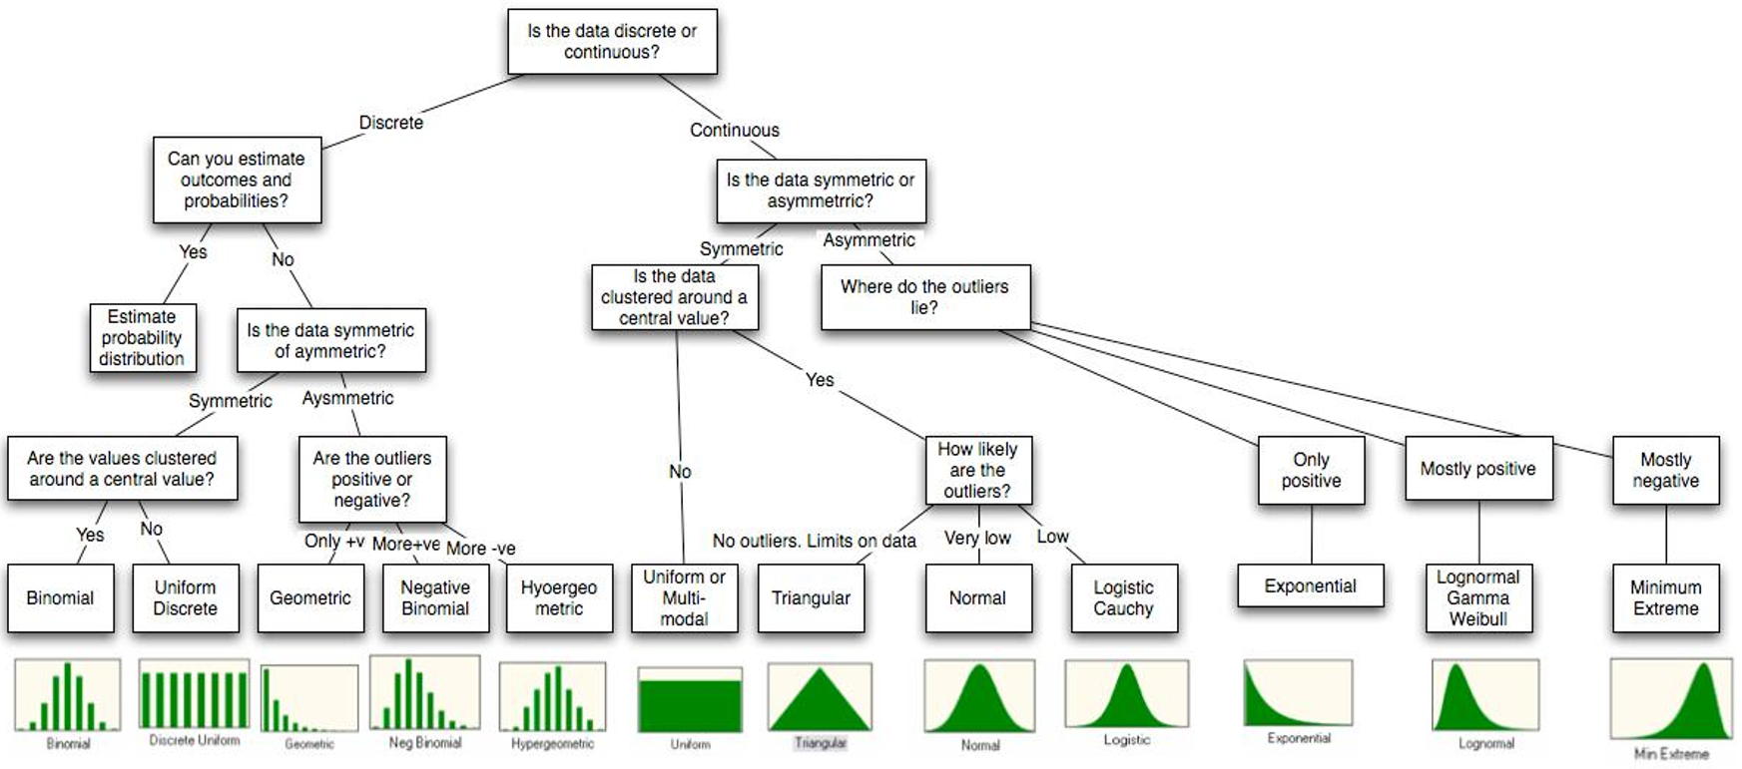
Qualitative
Quantitative

Discrete Definitions
Term | Definition | Description
Random Variable | $$X$$   | A rule that assigns a number to every outcome in the sample space, S.  $$X\left(a,b\right)=a+b=r$$  Example: Sum of a pair of dice  $$X(2, 4)=2+4=6$$  Derived from a probability experiment with different probabilities for each X.  Used in discrete or finite PDFs.
Event | $$X=r$$  $$X(s)=r$$ | An event assigns a value to the random variable X with probability:  $$P\left(X=r\right)$$  Example: Sum of a pair of dice  $$P(X=6)=\frac{5}{36}$$
Distribution | The distribution of a random variable is the set of all pairs (r, p(X = r)) such that r ∈ X(S). | Set of all outcomes with their probabilities.  $$(r, p(X=r))$$  Example: Sums of all pair of dice  $$\left\{\left(2, \frac{1}{36}\right), \left(3, \frac{1}{18}\right), ..., \left(12, \frac{1}{36}\right)\right\}$$
Sum of Probabilities | $$\sum_{r ∈ X(S)}{P(X=r) = 1}$$ | A random variable has some fractional probability value for every outcome in the sample space.
Histogram | Histogram of the distribution over the sum of two dice:  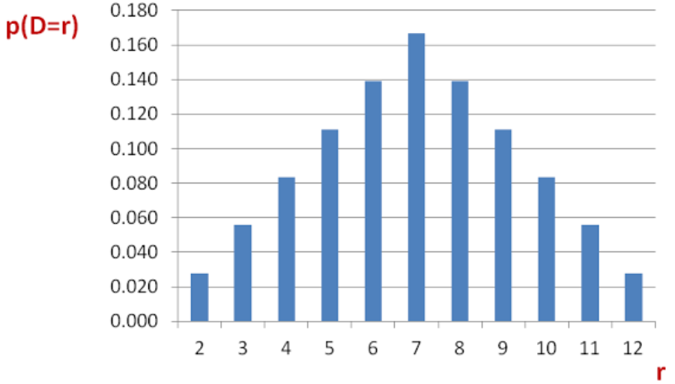
PMF | Probability Mass Function | Discrete, Qualitative
PDF | Probability Density Function | Continuous, Quantitative

Discrete Probability Mass Functions (Qualitative)
Probability Mass Function (PMF) | Mean | Standard Deviation
Uniform Discrete Distribution | 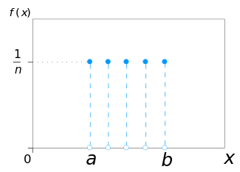
$$P\left(X=x\right)=\frac{1}{b-a+1}$$ | $$μ=\frac{a+b}{2}$$ | $$σ=\sqrt{\frac{{\left(b-a\right)}^{2}}{12}}$$
Conditions | - All outcomes are consecutive.  - All outcomes are equally likely.  - Not common in nature.
Variables | a = minimum  b = maximum
TI-84 | NA
Example | Tossing a fair die (n = 6)
Online PDF Calculator | http://www.danielsoper.com/statcalc3/calc.aspx?id=102

Probability Mass Function (PMF) | Mean | Standard Deviation
Binomial Distribution | 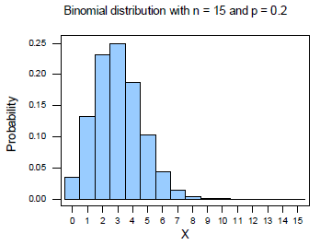
$$X \sim B\left(n,p\right)=B\left(k;n,p\right)=$$  $$P\left(X=k\right)=\left({n \atop k}\right)p^{k}{\left(1-p\right)}^{n-k}$$  where  $$\left({n \atop k}\right)={}_{n}^{ }{C_{k}}=\frac{n!}{k!\left(n-k\right)!}$$ | $$μ_{x}=np$$ |  | $$σ_{x}=\sqrt{np(1-p)}=\sqrt{npq}$$  $$np≥10 and nq≥10$$
 | $$μ_{\hat{p}}=p$$  p = probability of success  q = (1 – p) = probability of failure |  | $$σ_{\hat{p}}=\sqrt{\frac{p(1-p)}{n}}=\sqrt{\frac{pq}{n}}$$
$$P\left(X=k\right)≈\frac{1}{\sqrt{npq}}∙\frac{1}{\sqrt{2π}}∙e^{-\frac{1}{2} \frac{{\left(k-np\right)}^{2}}{npq}}$$ | Use for large $n (>15)$ to approximate binomial distribution.
Conditions | - n is ﬁxed.  - The probabilities of success ($p$) and failure ($q$) are constant.  - Each trial is independent.
Variables | n = fixed number of trials  p = probability that the designated event occurs on a given trial (Symmetric if p = 0.5)  $X$ = Total number of times the event occurs $\left(0≤X≤n\right)$
TI-84 | For one x value:  [2nd] [DISTR] A:binompdf(n,p,x) $P(X=k)$  [2nd] [DISTR] B:binomcdf(n,p,x) $P(X≤k)$  For a range of x values [j,k]:  [2nd] [DISTR] A:binompdf( [ENTER] n, p, [↓] [↓] [ENTER] [STO>] [2nd] [3] (=L3) [ENTER]  [2nd] [LIST] [→→ MATH] 5:sum(L3,j+1,k+1)
Example | Larry’s batting average is 0.260. If he’s at bat four times, what is the probability that he gets exactly two hits?  Solution:  n = 4, p = 0.26, x = 2  binompdf(4,0.26,2) = 0.2221 = 22.2%
Online PDF Calculator | http://stattrek.com/online-calculator/binomial.aspx
Probability Mass Function (PMF) | Mean | Standard Deviation
Geometric Distribution | 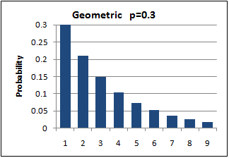
$$P\left(X≤x\right)=q^{x-1}p={(1-p)}^{x-1}p$$  $$P\left(X>x\right)=q^{x}={(1-p)}^{x}$$ | $$μ=E\left(X\right)=\frac{1}{p}$$ |  | $$σ=\frac{\sqrt{q}}{p}=\sqrt{\frac{1-p}{p^{2}}}$$
Conditions | - A series of independent trials with the same probability of a given event.  - Probability that it takes a specific amount of trials to get a success.  Can answer two questions:  a) Probability of getting 1st success on the $n^{th}$ trial  b) Probability of getting success on $≤n$ trials  Since we only count trials until the event occurs the first time, there is no need to count the ${}_{n}^{ }{C_{x}}$ arrangements, as in the binomial distribution.
Variables | p = probability that the event occurs on a given trial  $X$ = # of trials until the event occurs the 1st time
TI-84 | [2nd] [DISTR] E:geometpdf(p, x) $P(X=x)$  [2nd] [DISTR] F:geometcdf(p, x) $P(X≤x)$
Example | Suppose that a car with a bad starter can be started 90% of the time by turning on the ignition. What is the probability that it will take three tries to get the car started?  Solution:  p = 0.90, X = 3  geometpdf(0.9, 3) = 0.009 = 0.9%
Online PDF Calculator | http://www.calcul.com/show/calculator/geometric-distribution

Probability Mass Function (PMF) | Mean | Standard Deviation
Poisson Distribution | 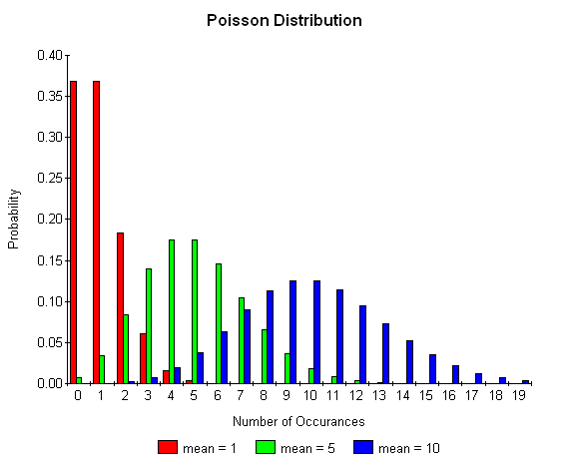
$$P\left(X=x\right)=\frac{λ^{x}e^{-λ}}{x!}, x=0,1,2,3,4,…$$ | $$μ=E\left(X\right)=λ$$ |  | $$σ=\sqrt{λ}$$
Conditions | - Events occur independently, at some average rate per interval of time/space.
Variables | $λ$ = average rate  $X$ = total number of times the event occurs  There is no upper limit on $X$
TI-84 | [2nd] [DISTR] C:poissonpdf($λ, X$) $P(X=x)$  [2nd] [DISTR] D:poissoncdf($λ, X$) $P(X≤x)$
Example | Suppose that a household receives, on the average, 9.5 telemarketing calls per week. We want to find the probability that the household receives 6 calls this week.  Solution:  $λ$ = 9.5, $X$ = 6  poissonpdf(9.5, 6) = 0.0764 = 7.64%
Online PDF Calculator | http://stattrek.com/online-calculator/poisson.aspx

Bernoulli | See  http://www4.ncsu.edu/~swu6/documents/A-probability-and-statistics-cheatsheet.pdf
tnomial
Hypergeometric
Negative Binomial
Continuous Probability Density Functions (Quantitative)
Probability Density Function (PDF) | Mean | Standard Deviation
Normal Distribution / Gaussian Distribution /  Bell-Shaped Curve | 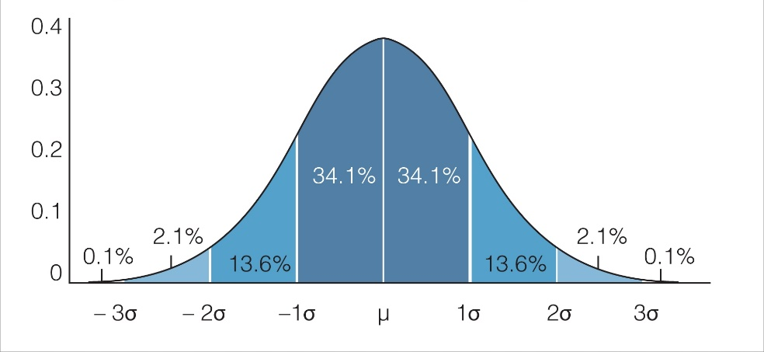
$$X \sim N\left(μ,σ^{2}\right)=N\left(x;μ,σ^{2}\right)=$$  $$Φ\left(x\right)=\frac{1}{σ\sqrt{2π}}e^{-\frac{1}{2} {\left(\frac{x-μ}{σ}\right)}^{2}}$$ | $$μ=E(x)=μ$$ | $$σ=σ$$
Special Case: Standard Normal  $$Z \sim N\left(0, 1\right)=N\left(x;0, 1\right)$$ | $$μ=0$$ | $$σ=1$$
z-Score of a Sample | $$z=\frac{\overline{x}-μ}{σ/{\sqrt{n}}}$$
Conditions | - Symmetric, unbounded, bell-shaped.  - No data is perfectly normal. Instead, a distribution is approximately normal.
Variables | $μ$ = mean (= median = mode)  $σ$ = standard deviation  $x$ = observed value (all real numbers)
TI-84 | Have scores, need area: $f\left(x\right)=P(X=x)$  z-scores: [2nd] [DISTR] 1:normalpdf(z, $0$, $1)$  x-scores: [2nd] [DISTR] 1:normalpdf(x, $μ$, $σ)$  Have boundaries, need area: $F\left(x\right)=P(X≤x)$  z-scores: [2nd] [DISTR] 2:normalcdf(left-bound, right-bound)  x-scores: [2nd] [DISTR] 2:normalcdf(left-bound, right-bound, $μ$, $σ$)  Have area, need boundary:  z-scores: [2nd] [DISTR] 3:invNorm(area to left)  x-scores: [2nd] [DISTR] 3:invNorm(area to left, $μ$, $σ$)
Python | import scipy.stats as st  mean, sd, z = 0, 1, 1.5  print(st.norm.cdf(z, mean, sd)) # P(z <= 1.5)  print(st.norm.sf(z, mean, sd)) # P(z >= 1.5)  mean, sd, x = 55, 7.5, 62  print(st.norm.cdf(x, mean, sd)) # P(x <= 62)  print(st.norm.sf(x, mean, sd)) # P(x >= 62)  # P(49 < t < 60)  print(st.norm.cdf(60, mean, sd) - st.norm.cdf(49, mean, sd))
Example | Suppose the mean score on the math SAT is 500 and the standard deviation is 100. What proportion of test takers earn a score between 650 and 700?  Solution:  left-boundary = 650, right boundary =700, μ = 500, σ = 100  normalcdf(650, 700, 500, 100) = 0.0441 = ~4.4%
Online PDF Calculator | http://davidmlane.com/normal.html

Standard Normal Distribution Table: Positive Values (Right Tail) Only

Z | +0.00 | +0.01 | +0.02 | +0.03 | +0.04 | +0.05 | +0.06 | +0.07 | +0.08 | +0.09
0.0 | 0.50000 | 0.50399 | 0.50798 | 0.51197 | 0.51595 | 0.51994 | 0.52392 | 0.52790 | 0.53188 | 0.53586
0.1 | 0.53980 | 0.54380 | 0.54776 | 0.55172 | 0.55567 | 0.55966 | 0.56360 | 0.56749 | 0.57142 | 0.57535
0.2 | 0.57930 | 0.58317 | 0.58706 | 0.59095 | 0.59483 | 0.59871 | 0.60257 | 0.60642 | 0.61026 | 0.61409
0.3 | 0.61791 | 0.62172 | 0.62552 | 0.62930 | 0.63307 | 0.63683 | 0.64058 | 0.64431 | 0.64803 | 0.65173
0.4 | 0.65542 | 0.65910 | 0.66276 | 0.66640 | 0.67003 | 0.67364 | 0.67724 | 0.68082 | 0.68439 | 0.68793
0.5 | 0.69146 | 0.69497 | 0.69847 | 0.70194 | 0.70540 | 0.70884 | 0.71226 | 0.71566 | 0.71904 | 0.72240
0.6 | 0.72575 | 0.72907 | 0.73237 | 0.73565 | 0.73891 | 0.74215 | 0.74537 | 0.74857 | 0.75175 | 0.75490
0.7 | 0.75804 | 0.76115 | 0.76424 | 0.76730 | 0.77035 | 0.77337 | 0.77637 | 0.77935 | 0.78230 | 0.78524
0.8 | 0.78814 | 0.79103 | 0.79389 | 0.79673 | 0.79955 | 0.80234 | 0.80511 | 0.80785 | 0.81057 | 0.81327
0.9 | 0.81594 | 0.81859 | 0.82121 | 0.82381 | 0.82639 | 0.82894 | 0.83147 | 0.83398 | 0.83646 | 0.83891
1.0 | 0.84134 | 0.84375 | 0.84614 | 0.84849 | 0.85083 | 0.85314 | 0.85543 | 0.85769 | 0.85993 | 0.86214
1.1 | 0.86433 | 0.86650 | 0.86864 | 0.87076 | 0.87286 | 0.87493 | 0.87698 | 0.87900 | 0.88100 | 0.88298
1.2 | 0.88493 | 0.88686 | 0.88877 | 0.89065 | 0.89251 | 0.89435 | 0.89617 | 0.89796 | 0.89973 | 0.90147
1.3 | 0.90320 | 0.90490 | 0.90658 | 0.90824 | 0.90988 | 0.91149 | 0.91308 | 0.91466 | 0.91621 | 0.91774
1.4 | 0.91924 | 0.92073 | 0.92220 | 0.92364 | 0.92507 | 0.92647 | 0.92785 | 0.92922 | 0.93056 | 0.93189
1.5 | 0.93319 | 0.93448 | 0.93574 | 0.93699 | 0.93822 | 0.93943 | 0.94062 | 0.94179 | 0.94295 | 0.94408
1.6 | 0.94520 | 0.94630 | 0.94738 | 0.94845 | 0.94950 | 0.95053 | 0.95154 | 0.95254 | 0.95352 | 0.95449
1.7 | 0.95543 | 0.95637 | 0.95728 | 0.95818 | 0.95907 | 0.95994 | 0.96080 | 0.96164 | 0.96246 | 0.96327
1.8 | 0.96407 | 0.96485 | 0.96562 | 0.96638 | 0.96712 | 0.96784 | 0.96856 | 0.96926 | 0.96995 | 0.97062
1.9 | 0.97128 | 0.97193 | 0.97257 | 0.97320 | 0.97381 | 0.97441 | 0.97500 | 0.97558 | 0.97615 | 0.97670
2.0 | 0.97725 | 0.97778 | 0.97831 | 0.97882 | 0.97932 | 0.97982 | 0.98030 | 0.98077 | 0.98124 | 0.98169
2.1 | 0.98214 | 0.98257 | 0.98300 | 0.98341 | 0.98382 | 0.98422 | 0.98461 | 0.98500 | 0.98537 | 0.98574
2.2 | 0.98610 | 0.98645 | 0.98679 | 0.98713 | 0.98745 | 0.98778 | 0.98809 | 0.98840 | 0.98870 | 0.98899
2.3 | 0.98928 | 0.98956 | 0.98983 | 0.99010 | 0.99036 | 0.99061 | 0.99086 | 0.99111 | 0.99134 | 0.99158
2.4 | 0.99180 | 0.99202 | 0.99224 | 0.99245 | 0.99266 | 0.99286 | 0.99305 | 0.99324 | 0.99343 | 0.99361
2.5 | 0.99379 | 0.99396 | 0.99413 | 0.99430 | 0.99446 | 0.99461 | 0.99477 | 0.99492 | 0.99506 | 0.99520
2.6 | 0.99534 | 0.99547 | 0.99560 | 0.99573 | 0.99585 | 0.99598 | 0.99609 | 0.99621 | 0.99632 | 0.99643
2.7 | 0.99653 | 0.99664 | 0.99674 | 0.99683 | 0.99693 | 0.99702 | 0.99711 | 0.99720 | 0.99728 | 0.99736
2.8 | 0.99744 | 0.99752 | 0.99760 | 0.99767 | 0.99774 | 0.99781 | 0.99788 | 0.99795 | 0.99801 | 0.99807
2.9 | 0.99813 | 0.99819 | 0.99825 | 0.99831 | 0.99836 | 0.99841 | 0.99846 | 0.99851 | 0.99856 | 0.99861
3.0 | 0.99865 | 0.99869 | 0.99874 | 0.99878 | 0.99882 | 0.99886 | 0.99889 | 0.99893 | 0.99896 | 0.99900
3.1 | 0.99903 | 0.99906 | 0.99910 | 0.99913 | 0.99916 | 0.99918 | 0.99921 | 0.99924 | 0.99926 | 0.99929
3.2 | 0.99931 | 0.99934 | 0.99936 | 0.99938 | 0.99940 | 0.99942 | 0.99944 | 0.99946 | 0.99948 | 0.99950
3.3 | 0.99952 | 0.99953 | 0.99955 | 0.99957 | 0.99958 | 0.99960 | 0.99961 | 0.99962 | 0.99964 | 0.99965
3.4 | 0.99966 | 0.99968 | 0.99969 | 0.99970 | 0.99971 | 0.99972 | 0.99973 | 0.99974 | 0.99975 | 0.99976
3.5 | 0.99977 | 0.99978 | 0.99978 | 0.99979 | 0.99980 | 0.99981 | 0.99981 | 0.99982 | 0.99983 | 0.99983
3.6 | 0.99984 | 0.99985 | 0.99985 | 0.99986 | 0.99986 | 0.99987 | 0.99987 | 0.99988 | 0.99988 | 0.99989
3.7 | 0.99989 | 0.99990 | 0.99990 | 0.99990 | 0.99991 | 0.99991 | 0.99992 | 0.99992 | 0.99992 | 0.99992
3.8 | 0.99993 | 0.99993 | 0.99993 | 0.99994 | 0.99994 | 0.99994 | 0.99994 | 0.99995 | 0.99995 | 0.99995
3.9 | 0.99995 | 0.99995 | 0.99996 | 0.99996 | 0.99996 | 0.99996 | 0.99996 | 0.99996 | 0.99997 | 0.99997
4.0 | 0.99997 | 0.99997 | 0.99997 | 0.99997 | 0.99997 | 0.99997 | 0.99998 | 0.99998 | 0.99998 | 0.99998
4.1 | 0.99998 | 0.99998 | 0.99998 | 0.99998 | 0.99998 | 0.99998 | 0.99998 | 0.99998 | 0.99999 | 0.99999
4.2 | 0.99999 | 0.99999 | 0.99999 | 0.99999 | 0.99999 | 0.99999 | 0.99999 | 0.99999 | 0.99999 | 1.00000

Probability Density Function (PDF) | Mean |  | Standard Deviation
Student’s t Distribution | 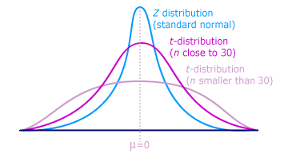  This distribution was first studied by William Gosset, who published under the pseudonym Student. It has a wider spread because of a slightly larger standard deviation.
Degrees of Freedom | df = degrees of freedom = $n-1$  A positive whole number that indicates the lack of restrictions in our calculations. The number of values in a calculation can vary.  e.g., $df=1$means 1 equation 2 unknowns  $$\lim_{ν→∞}{tpdf(x,df)}=normalpdf(x)$$
$$P(ν)=\frac{Γ\left(\frac{ν+1}{2}\right)}{\sqrt{νπ} Γ\left(\frac{ν}{2}\right)} {\left(1+\frac{x^{2}}{ν}\right)}^{\frac{-\left(ν+1\right)}{2}}$$ |  | $μ=E(x)=0$ (always) | $$σ=0$$
Where the Gamma function  $$Γ\left(s\right)=\int_{0}^{∞}{t^{s-1}e^{-t}dt}$$ |  | $$Γ\left(n\right)=\left(n-1\right)!$$ | $$Γ\left(\frac{1}{2}\right)=\sqrt{π}$$
t-Score of a Sample | $$t=\frac{\overline{x}-μ}{s/{\sqrt{n}}}$$
Conditions | - Is typically used:  - With small sample sizes or  - When the population standard deviation is unknown  - Similar in shape to the normal distribution. $Z \sim N\left(0, 1\right)$  - Used for inference about means (Use $χ^{2}$ for variance).
Variables | x = observed value  df = degrees of freedom = $n-1$
TI-84 | [2nd] [DISTR] 5:tpdf(x, df) $f\left(x\right)=P(X=ν)$  [2nd] [DISTR] 6:tcdf(-$∞$, t, df) $F\left(x\right)=P(X≤ν)$
Python | import scipy.stats as st  mean, sd, t, df = 0, 1, -0.25, 30  print(st.t.cdf(t, df, mean, sd)) # P(t <= -0.25)  print(st.t.sf(t, df, mean, sd)) # P(t >= 1.5)  # P(49 < t < 60)  print(st.t.cdf(60, df, mean, sd) - st.t.cdf(49, df, mean, sd))  print(st.t.ppf(0.135, df, mean, sd)) # P(t < t*) = p = 0.135  print(st.t.isf(0.405, df, mean, sd)) # P(t > t*) = p = 0.405
Example | Suppose scores on an IQ test are normally distributed, with a population mean of 100. Suppose 20 people are randomly selected and tested. The standard deviation in the sample group is 15. What is the probability that the average test score in the sample group will be at most 110?  Solution:  n=20, df=20-1=19, μ = 100, $\overline{x}$=110, s = 15  tcdf(-1E99, (110-100)/(15/sqrt(20)), 19) = 0.996 = ~99.6%
Online PDF Calculator | http://keisan.casio.com/exec/system/1180573204

Student’s t Distribution Table:

Cum. Prob. | $$t_{.50}$$ | $$t_{.75}$$ | $$t_{.80}$$ | $$t_{.85}$$ | $$t_{.90}$$ | $$t_{.95}$$ | $$t_{.975}$$ | $$t_{.99}$$ | $$t_{.995}$$ | $$t_{.999}$$ | $$t_{.9995}$$
1-tail α | 0.50 | 0.25 | 0.20 | 0.15 | 0.10 | 0.05 | 0.025 | 0.01 | 0.005 | 0.001 | 0.0005
2-tails α | 1.00 | 0.50 | 0.40 | 0.30 | 0.20 | 0.10 | 0.05 | 0.02 | 0.01 | 0.002 | 0.001
df
1 | 0.0000 | 1.0000 | 1.3764 | 1.9626 | 3.0777 | 6.3138 | 12.7062 | 31.8205 | 63.6567 | 318.3088 | 636.6192
2 | 0.0000 | 0.8165 | 1.0607 | 1.3862 | 1.8856 | 2.9200 | 4.3027 | 6.9646 | 9.9248 | 22.3271 | 31.5991
3 | 0.0000 | 0.7649 | 0.9785 | 1.2498 | 1.6377 | 2.3534 | 3.1824 | 4.5407 | 5.8409 | 10.2145 | 12.9240
4 | 0.0000 | 0.7407 | 0.9410 | 1.1900 | 1.5332 | 2.1318 | 2.7764 | 3.7469 | 4.6041 | 7.1732 | 8.6103
5 | 0.0000 | 0.7267 | 0.9195 | 1.1558 | 1.4759 | 2.0150 | 2.5706 | 3.3649 | 4.0321 | 5.8934 | 6.8688
6 | 0.0000 | 0.7176 | 0.9057 | 1.1342 | 1.4398 | 1.9432 | 2.4469 | 3.1427 | 3.7074 | 5.2076 | 5.9588
7 | 0.0000 | 0.7111 | 0.8960 | 1.1192 | 1.4149 | 1.8946 | 2.3646 | 2.9980 | 3.4995 | 4.7853 | 5.4079
8 | 0.0000 | 0.7064 | 0.8888 | 1.1081 | 1.3968 | 1.8595 | 2.3060 | 2.8965 | 3.3554 | 4.5008 | 5.0413
9 | 0.0000 | 0.7027 | 0.8834 | 1.1000 | 1.3830 | 1.8331 | 2.2622 | 2.8214 | 3.2498 | 4.2968 | 4.7809
10 | 0.0000 | 0.6998 | 0.8791 | 1.0931 | 1.3722 | 1.8125 | 2.2281 | 2.7638 | 3.1693 | 4.1437 | 4.5869
11 | 0.0000 | 0.6974 | 0.8755 | 1.0877 | 1.3634 | 1.7959 | 2.2010 | 2.7181 | 3.1058 | 4.0247 | 4.4370
12 | 0.0000 | 0.6955 | 0.8726 | 1.0832 | 1.3562 | 1.7823 | 2.1788 | 2.6810 | 3.0545 | 3.9296 | 4.3178
13 | 0.0000 | 0.6938 | 0.8702 | 1.0795 | 1.3502 | 1.7709 | 2.1604 | 2.6503 | 3.0123 | 3.8520 | 4.2208
14 | 0.0000 | 0.6924 | 0.8681 | 1.0763 | 1.3450 | 1.7613 | 2.1448 | 2.6245 | 2.9768 | 3.7874 | 4.1405
15 | 0.0000 | 0.6912 | 0.8662 | 1.0735 | 1.3406 | 1.7531 | 2.1314 | 2.6025 | 2.9467 | 3.7328 | 4.0728
16 | 0.0000 | 0.6901 | 0.8647 | 1.0711 | 1.3368 | 1.7459 | 2.1199 | 2.5835 | 2.9208 | 3.6862 | 4.0150
17 | 0.0000 | 0.689 | 0.8633 | 1.0690 | 1.3334 | 1.7396 | 2.1098 | 2.5669 | 2.8982 | 3.6458 | 3.9651
18 | 0.0000 | 0.6884 | 0.8620 | 1.0672 | 1.3304 | 1.7341 | 2.1009 | 2.5524 | 2.8784 | 3.6105 | 3.9216
19 | 0.0000 | 0.6876 | 0.8610 | 1.0655 | 1.3277 | 1.7291 | 2.0930 | 2.5395 | 2.8609 | 3.5794 | 3.8834
20 | 0.0000 | 0.6870 | 0.8600 | 1.0640 | 1.3253 | 1.7247 | 2.0860 | 2.5280 | 2.8453 | 3.5518 | 3.8495
21 | 0.0000 | 0.6864 | 0.8591 | 1.0627 | 1.3232 | 1.7207 | 2.0796 | 2.5176 | 2.8314 | 3.5272 | 3.8193
22 | 0.0000 | 0.6858 | 0.8583 | 1.0614 | 1.3212 | 1.7171 | 2.0739 | 2.5083 | 2.8188 | 3.5050 | 3.7921
23 | 0.0000 | 0.6853 | 0.8575 | 1.0603 | 1.3195 | 1.7139 | 2.0687 | 2.4999 | 2.8073 | 3.4850 | 3.7676
24 | 0.0000 | 0.6848 | 0.8569 | 1.0593 | 1.3178 | 1.7109 | 2.0639 | 2.4922 | 2.7969 | 3.4668 | 3.7454
25 | 0.0000 | 0.6844 | 0.8562 | 1.0584 | 1.3163 | 1.7081 | 2.0595 | 2.4851 | 2.7874 | 3.4502 | 3.7251
26 | 0.0000 | 0.6840 | 0.8557 | 1.0575 | 1.3150 | 1.7056 | 2.0555 | 2.4786 | 2.7787 | 3.4350 | 3.7066
27 | 0.0000 | 0.6837 | 0.8551 | 1.0567 | 1.3137 | 1.7033 | 2.0518 | 2.4727 | 2.7707 | 3.4210 | 3.6896
28 | 0.0000 | 0.6834 | 0.8546 | 1.0560 | 1.3125 | 1.7011 | 2.0484 | 2.4671 | 2.7633 | 3.4082 | 3.6739
29 | 0.0000 | 0.6830 | 0.8542 | 1.0553 | 1.3114 | 1.6991 | 2.0452 | 2.4620 | 2.7564 | 3.3962 | 3.6594
30 | 0.0000 | 0.6828 | 0.8538 | 1.0547 | 1.3104 | 1.6973 | 2.0423 | 2.4573 | 2.7500 | 3.3852 | 3.6460
40 | 0.0000 | 0.6807 | 0.8507 | 1.0500 | 1.3031 | 1.6839 | 2.0211 | 2.4233 | 2.7045 | 3.3069 | 3.5510
50 | 0.0000 | 0.6794 | 0.8489 | 1.0473 | 1.2987 | 1.6759 | 2.0086 | 2.4033 | 2.6778 | 3.2614 | 3.4960
60 | 0.0000 | 0.6786 | 0.8477 | 1.0455 | 1.2958 | 1.6706 | 2.0003 | 2.3901 | 2.6603 | 3.2317 | 3.4602
70 | 0.0000 | 0.6780 | 0.8468 | 1.0442 | 1.2938 | 1.6669 | 1.9944 | 2.3808 | 2.6479 | 3.2108 | 3.4350
80 | 0.0000 | 0.6776 | 0.8461 | 1.0432 | 1.2922 | 1.6641 | 1.9901 | 2.3739 | 2.6387 | 3.1953 | 3.4163
90 | 0.0000 | 0.6772 | 0.8456 | 1.0424 | 1.2910 | 1.6620 | 1.9867 | 2.3685 | 2.6316 | 3.1833 | 3.4019
100 | 0.0000 | 0.6770 | 0.8452 | 1.0418 | 1.2901 | 1.6602 | 1.9840 | 2.3642 | 2.6259 | 3.1737 | 3.3905
1000 | 0.0000 | 0.6747 | 0.8420 | 1.0370 | 1.2824 | 1.6464 | 1.9623 | 2.3301 | 2.5808 | 3.0984 | 3.3003
$∞$ → z | 0.0000 | 0.6745 | 0.8416 | 1.0364 | 1.2816 | 1.6449 | 1.9600 | 2.3263 | 2.5758 | 3.0902 | 3.2905
 | 0% | 50% | 60% | 70% | 80% | 90% | 95% | 98% | 99% | 99.8% | 99.9%
 | Confidence Level C

Probability Density Function (PDF) | Mean | Standard Deviation
F Distribution | 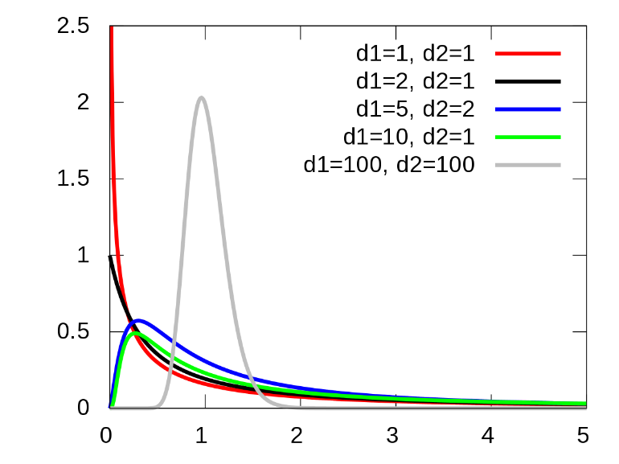  This distribution is also known as Snedecor's F distribution or the Fisher–Snedecor distribution (after Ronald Fisher and George W. Snedecor).
Parameters | d₁, d₂ > 0 degrees of freedom
$$P\left(x\right)=\frac{\sqrt{\frac{{(d_{1}x)}^{d_{1}} {d_{2}}^{d_{2}}}{{(d_{1}x+d_{2})}^{d_{1}+d_{2}}}}}{x B\left(\frac{d_{1}}{2},\frac{d_{2}}{2}\right)}$$ | $$μ=\frac{d_{2}}{\left(d_{2}-2\right)}$$  $$for d_{2}>2$$ | $$σ=\frac{d_{2}}{\left(d_{2}-2\right)}\sqrt{\frac{2\left(d_{1}+d_{2}-2\right)}{d_{1}\left(d_{2}-4\right)}}$$  $$for d_{2}>4$$
Conditions | - The F-distribution with d₁ and d₂ degrees of freedom is the distribution of $X=\frac{{S_{1}}/{d_{1}}}{{S_{2}}/{d_{2}}}$where $S_{1}$ and $S_{2}$ are independent random variables with chi-square distributions with respective degrees of freedom $d_{1}$ and $d_{2}$.  - Arises frequently as the null distribution of a test statistic, most notably in the analysis of variance (ANOVA) and other F-tests.
Variables | x = observed value
TI-84 | [2nd] [DISTR] 9: fpdf(x, $ν_{num}, ν_{denom}$) $f\left(x\right)=P(X=x)$  [2nd] [DISTR] 0: fcdf(-$∞$, t, $ν_{num}, ν_{denom}$) $F\left(x\right)=P(X≤x)$
Example
Online PDF Calculator | https://stattrek.com/online-calculator/f-distribution.aspx

Probability Density Function (PDF) | Mean | Standard Deviation
Gamma Distribution | 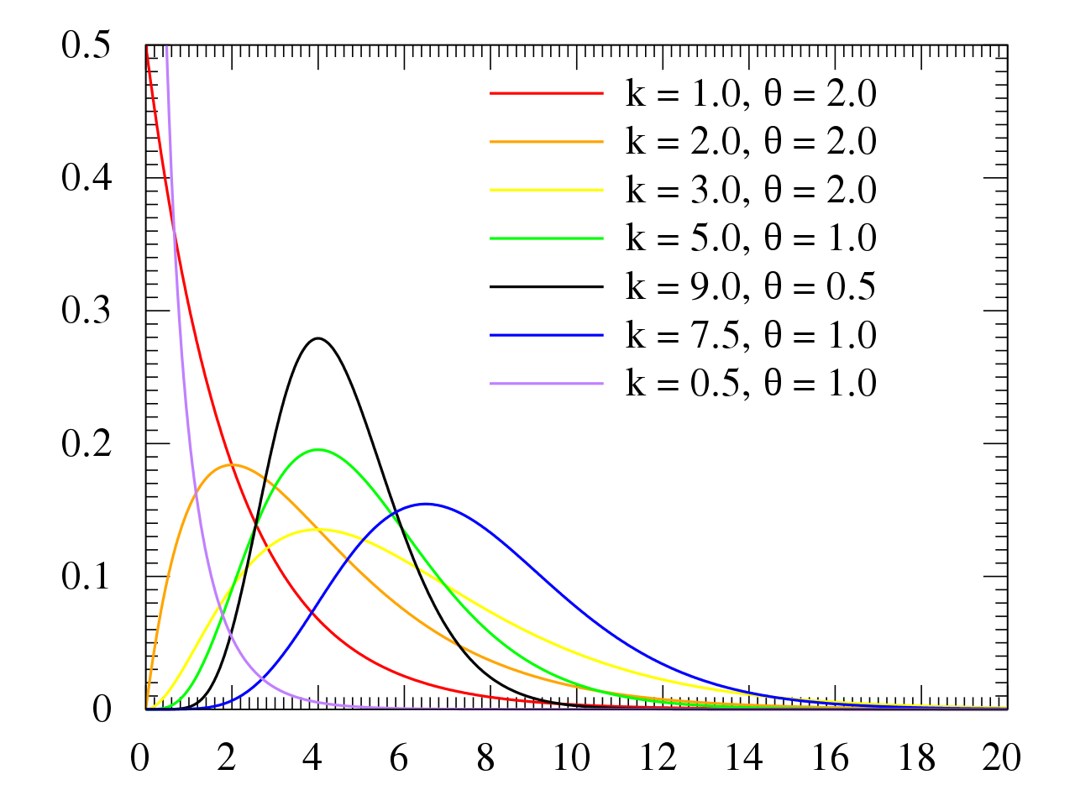  The gamma function is the continuous version of the discrete factorial function, n!.
Parameters | k > 0 shape  θ > 0 scale
$$f(x)=\frac{1}{Γ\left(k\right) θ^{k}} x^{k-1}{ e}^{-\frac{x}{θ}}$$ | $$μ=kθ$$ | $$σ=\sqrt{k} θ$$
Where the Gamma function  $$Γ\left(x\right)=\int_{0}^{∞}{t^{x-1}e^{-t}dt}$$ | $$Γ\left(n\right)=\left(n-1\right)!$$ | Where the Gamma function  $$Γ\left(x\right)=\int_{0}^{∞}{t^{x-1}e^{-t}dt}$$
Conditions | - The exponential distribution, Erlang distribution, and chi-square distribution are special cases of the gamma distribution.  - The gamma distribution is the maximum entropy probability distribution (both with respect to a uniform base measure and with respect to a 1/x base measure) for a random variable X for which E[X] = kθ = α/β is fixed and greater than zero, and E[ln(X)] = ψ(k) + ln(θ) = ψ(α) − ln(β) is fixed (ψ is the digamma function).
Variables | x = observed value
TI-84 | - GAMFUNC (Gamma function) PRGM  - GAMDSTR (Gamma distribution function) PRGM
Example
Online PDF Calculator | https://keisan.casio.com/exec/system/1180573217

Probability Density Function (PDF) | Mean |  | Standard Deviation
Chi-Square Distribution | 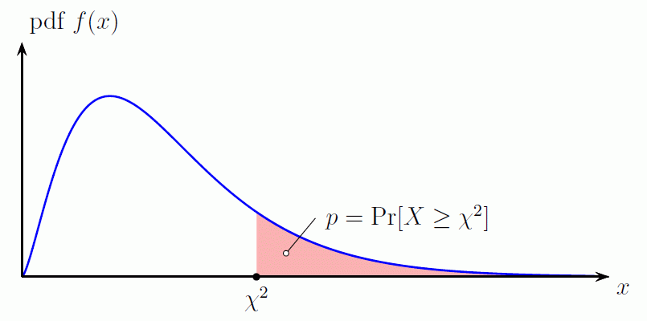  Skewed-right (above) have fewer values to the right, and median < mean.
$$χ^{2}\left(x,k\right)=\frac{1}{2^{\frac{k}{2}} Γ\left(\frac{k}{2}\right)}x^{\frac{k}{2}-1} e^{\frac{-x}{2}}$$ | $$μ=E\left(X\right)=k$$  $$μ=\sqrt{2}Γ\frac{\left(\frac{k+1}{2}\right)}{Γ\left(\frac{k}{2}\right)}$$  Mode = $\sqrt{k-1}$ | $$σ^{2}=\sqrt{2k}$$  $$σ^{2}=k-\frac{2Γ{\left(\frac{k+1}{2}\right)}^{2}}{Γ{\left(\frac{k}{2}\right)}^{2}}$$
Conditions | - Used for inference about variance in categorical distributions.  - Used when we want to test the independence, homogeneity, and "goodness of fit” to a distribution.  - Used for counted data.
Variables | x = observed value  $ν$ = df = degrees of freedom = $n-1$
TI-84 | [2nd] [DISTR] 7:$χ^{2}$pdf(x, $ν$) $f\left(x\right)=P(X=x,k)$  [2nd] [DISTR] 8:$χ^{2}$cdf(x, $ν$) $F\left(x\right)=P(X≤x,k)$
Example | $χ^{2}$pdf() is only used to graph the function.
Online PDF Calculator | https://stattrek.com/online-calculator/chi-square.aspx

Uniform | See  http://www4.ncsu.edu/~swu6/documents/A-probability-and-statistics-cheatsheet.pdf
Log-Normal
Multivariate Normal
F
Exponential
Gamma
Inverse Gamma
Dirichlet
Beta
Weibull
Pareto

Continuous Probability Distribution Functions
Cumulative Distribution Function (CDF) | Mean | Standard Deviation
$$P\left(X≤x\right)=\int_{-∞}^{x}{f\left(x\right) dx}$$ | If $f\left(x\right)=Φ\left(x\right)$ (the Normal PDF), then no exact solution is known.  Use z-tables or web calculator (http://davidmlane.com/normal.html).
$$\int_{-∞}^{∞}{f\left(x\right) dx=1}$$ | The area under the curve is always equal to exactly 1 (100% probability).
Integral of PDF = CDF (Distribution) | $$F\left(x\right)=\int_{-∞}^{x}{f\left(x\right) dx}$$ | Use the density function$f(x)$, not the distribution function$F(x)$, to calculate $E(X), Var\left(X\right)$ and $σ\left(X\right)$.
Derivative of CDF = PDF (Density) | $$f\left(x\right)=\frac{dF(x)}{dx}$$
Expected Value (Mean) | $$E\left(X\right)=\int_{a}^{b}{x f\left(x\right) dx}$$
Needed to calculate Variance | $$E\left(X^{2}\right)=\int_{a}^{b}{x^{2} f\left(x\right) dx}$$
Variance |  | $$Var\left(X\right)=E\left(X^{2}\right)-{E(X)}^{2}$$
Standard Deviation |  | $$σ\left(X\right)=\sqrt{Var\left(X\right)}$$

Discrete Distributions
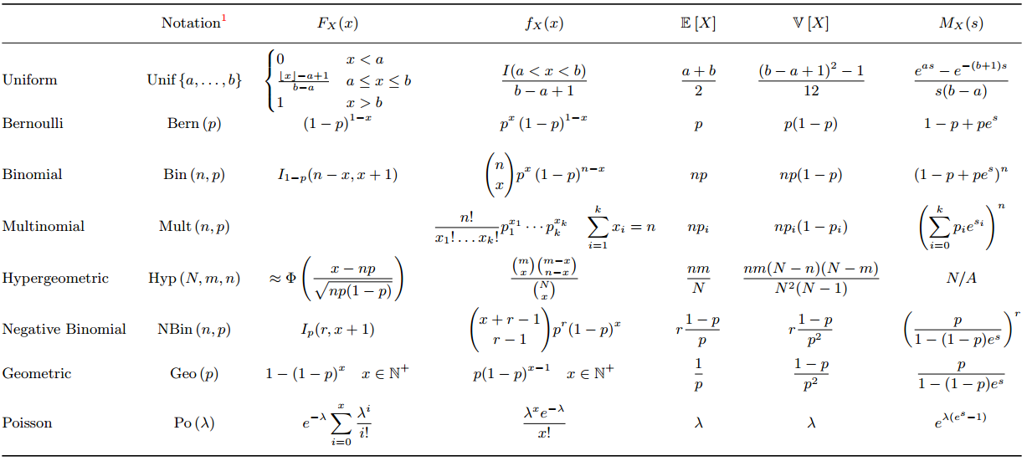
http://www4.ncsu.edu/~swu6/documents/A-probability-and-statistics-cheatsheet.pdf

Continuous Distributions
