Harold’s TI-84 Calculator
Cheat Sheet
8 September 2026

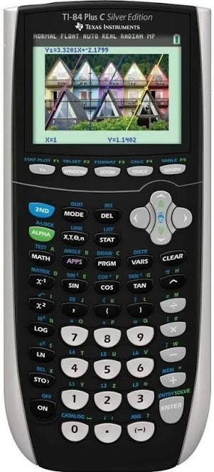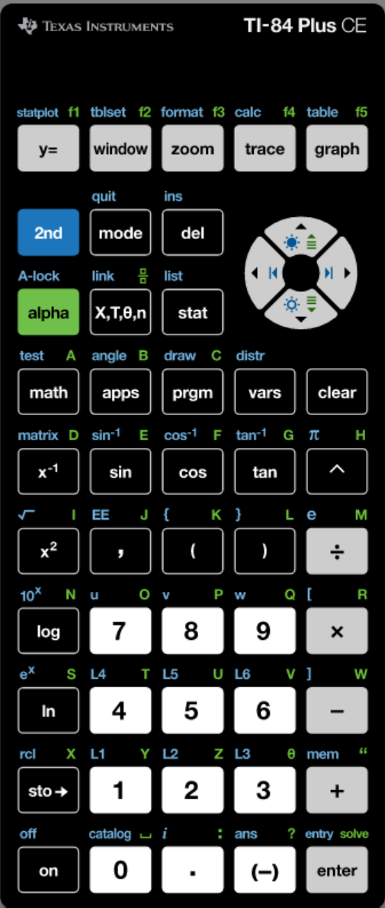

Algebra

Operation | Equation | Keystrokes
Parentheses | Use parentheses () liberally. Most errors can be avoided using parentheses.  $$\frac{-b±\sqrt{b^{2}-4ac}}{2a}$$ | Wrong:  [(-)] b+√b^2[►]–4*a*c [►]/2*a  Correct:  ([(-)] b+√b^2[►]–4*a*c [►])/(2*a)
Negative Sign | Negative is different than minus. | Negative: 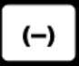 | Minus: 
Fraction | $$\frac{2}{5}$$ | Fraction Template :  [ALPHA][X,T,θ ,n]2[►]5[ENTER]  or  2[ALPHA]{F1][ENTER]5[►]  Decimal to Fraction:  2÷5[ENTER]  [MATH][ENTER][ENTER]  (uses [1:►Frac])  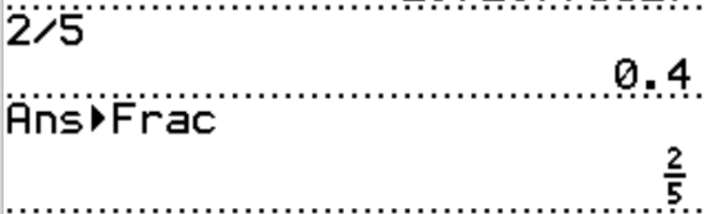
Power | To raise to a power, use ^.  $$2^{5}=32$$ | 2^5[ENTER] |  | 
Root | To find a root, raise to a fractional power using ^.  $$\sqrt[5]{32}={32}^{1/5}=2$$ | Fast Way:  32^(1/5)[ENTER]  Pretty Way:  [MATH][5:^{x}√]5[►]32[ENTER]
Edit | Enter the entire equation at once. Edit later.  $$2sin\left(45\right)-1$$ | To Enter:  2*sin(45)-1[ENTER}  To Edit:  [▲][▲][ENTER][◄ and ►]  Make changes.  Replaces char. for char. by default.  Use [INS] as necessary. [ENTER]
Clear Memory | Required for SAT and exams. | Fast Way:  [MEM]712[ENTER]  Normal Way:  [2nd][+][7:Reset…][1:All RAM…] [2:Reset]
Precalculus / Trigonometry

Operation | Equation | Keystrokes
Unit of Angle Measure | When using trigonometric functions, always check whether you're in degree or radian mode. | [MODE][▼][▼]RADIAN[ENTER][CLEAR]  or  [MODE][▼][▼][►]DEGREE[ENTER][CLEAR]
System of Equations | Solve for $n$ equations with $n$ unknowns.  Equation Form:  $$2x+y=5$$  $$-3x+6=0$$  Solution:  $$x=2$$  $$y=1$$  Augmented Matrix Form:  $$\left[\begin{matrix} 2 & 1 \\ -3 & 6\end{matrix}\left\lfloor \begin{matrix} 5 \\ 0\end{matrix}\right.\right]$$  Solution:  $$\left[\begin{matrix}1 & 0 \\ 0 & 1\end{matrix}\left\lfloor \begin{matrix} 2 \\ 1\end{matrix}\right.\right]$$ | [2nd][MATRIX][►][►][EDIT][1:[A]]  2[ENTER]3[ENTER]  2[ENTER]1[ENTER]5[ENTER]  -3[ENTER]6[ENTER]0  [MODE][CLEAR]  [2nd][MATRIX][►][MATH] [B:rref(][ENTER]  [2nd][MATRIX][NAMES][1:[A] 2x3] ) [ENTER]  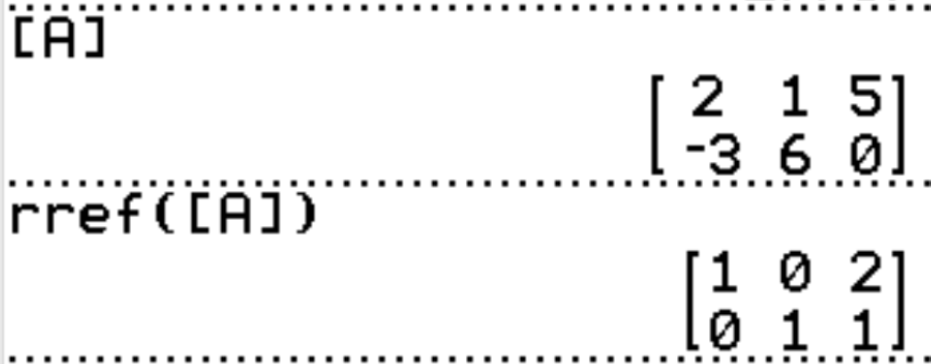
Parametric Art Grid | See Harold’s TI-84 Grid for Parametric Art Cheat Sheet
Parametric Art Paintbrushes | See Harold’s Precalculus Formulas Cheat Sheet >> Last Column “Parametric”
Graphs | $$y=\frac{1}{2}x^{2}+1$$ | [Y=][CLEAR]  1[ALPHA][F1][ENTER]2[►]  [X,T,θ ,n][x²]+1  [GRAPH]  [TRACE][◄ and ►]  [2nd][QUIT]
Graphs | 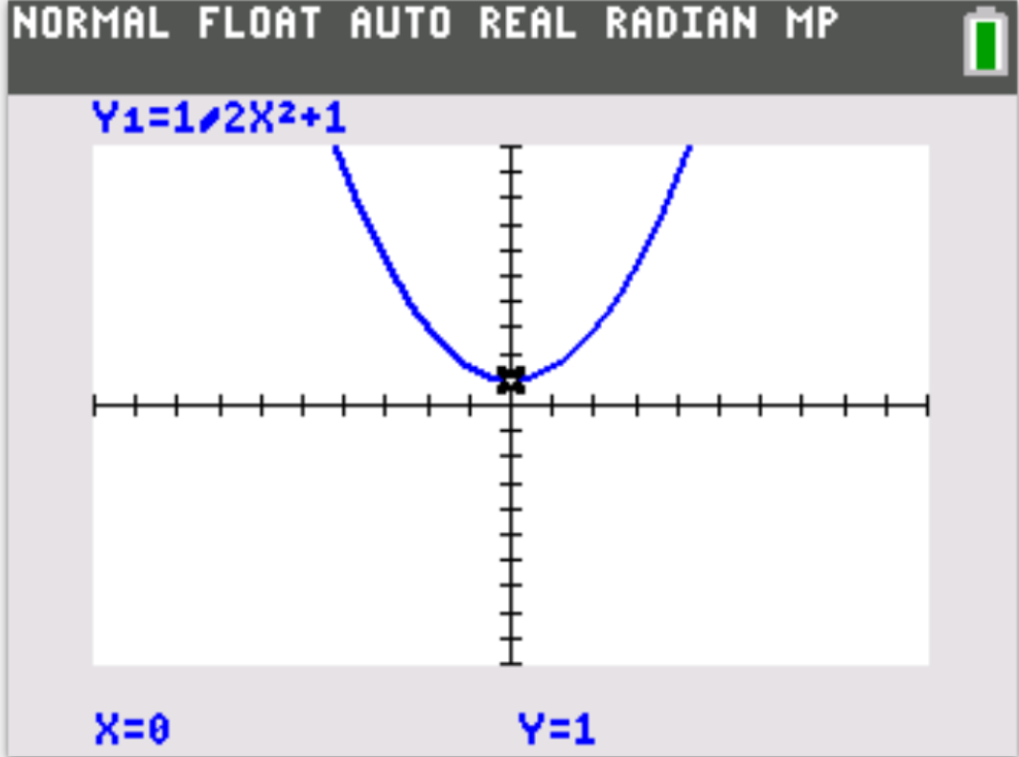
Calculus

Operation | Equation | Keystrokes
CAS | TI-84 solves numerically.  TI-nspire CX CAS solves symbolically. | Computer Algebra System (CAS) calculators are not allowed on the SAT exam.
Derivative | $$\left.\frac{d}{dx}2e^{x}+7 \right|\begin{matrix} \\ x=1\end{matrix}$$  $$=2e ≈ 5.436564563$$ | [MATH][8:nDeriv(]  [X,T,θ ,n]2e^[X,T,θ,n][►]+7  [►]1[ENTER]
Integral | $$\int_{0}^{1}{x^{2} dx}=\frac{1}{3}$$ | [MATH][9:fnInt(]  0[►]1[►]  [X,T,θ,n]^2[►][►][X,T,θ,n][ENTER]

Programming

Operation | Equation | Keystrokes
Quadratic Formula | $$ax^{2}+bx+c=0$$  $$x=\frac{-b±\sqrt{b^{2}-4ac}}{2a}$$ | Creating the Program:  [PGRM][►][►] NEW]  [1:Create New]  PROGRAM  Name=QUADFOR  :ClrHome  :Disp “AX²+BX+C=0”  :Prompt A,B,C  :B²-4ACD  :(-B+√(D))/(2A)X  :(-B-√(D))/(2A)Y  :Disp X,Y  [QUIT]  Running the Program:  [PGRM]QUADFOR[ENTER]

Sources
- Texas Instruments (2021). TI-84 Plus Guidebook. https://education.ti.com/en/downloads
- Texas Instruments (2026). TI-SmartView CE for the TI-84 Plus Family. https://education.ti.com/en/products/computer-software/ti-smartview-ce-for-84
- TI84CalcWiz (August 9, 2018). Program the Quadratic Formula on the TI-84 Plus CE. https://www.ti84calcwiz.com/program-the-quadratic-formula-on-the-ti-84-plus-ce/
Statistics

Operation | Equation | Keystrokes
Mean and Standard Deviation | Unordered Data:  1, 0, 1, 4, 1, 2, 0, 3, 0, 2, 1, 1, 2, 0, 1, 1, 3 | - [STAT][1] selects the list edit screen  - Move the cursor up to L1  - [CLEAR][ENTER] erases L1  - Repeat for L2  - Enter $x$ data in L1 and $f$ data in L2  - [STAT][1] to select 1-Var Stats  - [2nd][1][ENTER] for L1  - [2nd][2][ENTER] for L2  - Calculate [ENTER]
Mean and Standard Deviation | Ordered Data: | Output:  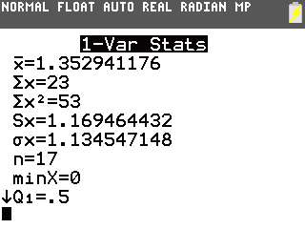
  $$x$$ | $$f$$
  0 | 4
  1 | 7
  2 | 3
  3 | 2
  4 | 1
Exponential Regression | [mode] STAT DIAGNOSTICS: [ON][ENTER]  [STAT][EDIT][1: Edit] L1…L2…  [STAT][CALC][0:ExpReg][ENTER]  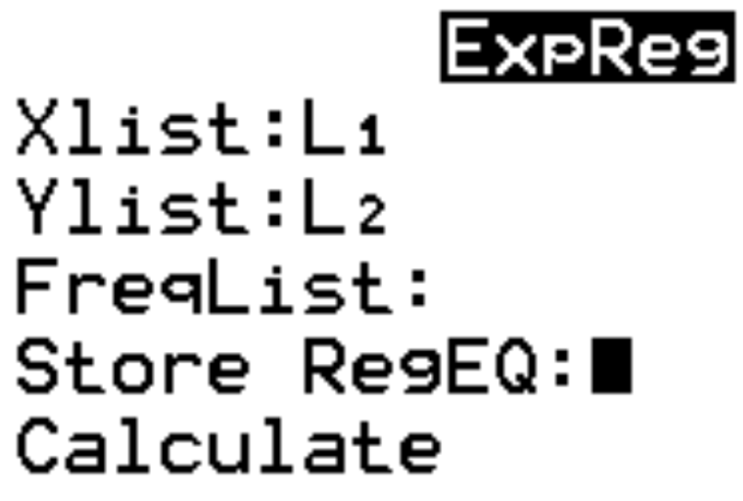  [Calculate] [ENTER]  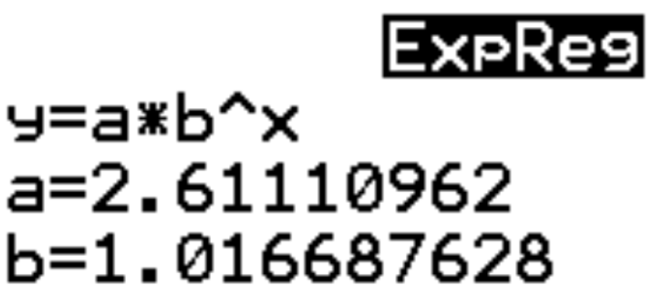 | Example Data:  