64
62
60
58
56
54
52
50
48
46
44
42
40
38
36
34
32
30
28
26
24
22
20
18
16
14
12
10
8
6
4
2
0
2 4 6 8 10 12 14 16 18 20 22.24.26.28.30.32.34.36.38.40. 44 48 52 56 60 64 68 72 76 80 84 88 92 96
64
62
60
58
56
54
52
50
48
46
44
42
40
38
36
34
32
30
28
26
24
22
20
18
16
14
12
10
8
6
4
2
0

2 4 6 8 10 12 14 16 18 20 22.24.26.28.30.32.34.36.38.40. 44 48 52 56 60 64 68 72 76 80 84 88 92 96

64 |  |  |  | 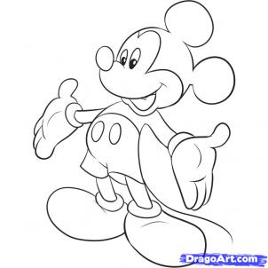
62
60
58
56
54
52
50
48
46
44
42
40
38
36
34
32
30
28
26
24
22
20
18
16
14
12
10
8
6
4
2
0
2 4 6 8 10 12 14 16 18 20 22.24.26.28.30.32.34.36.38.40. 44 48 52 56 60 64 68 72 76 80 84 88 92 96
64 |  |  |  |  |  |  |  |  |  | 
62
60
58
56
54
52
50
48
46
44
42
40
38
36
34
32
30
28
26
24
22
20
18
16
14
12
10
8
6
4
2
0
2 4 6 8 10 12 14 16 18 20 22.24.26.28.30.32.34.36.38.40. 44 48 52 56 60 64 68 72 76 80 84 88 92 96
64 |  |  |  |  |  |  |  |  | 
62
60
58
56
54
52
50
48
46
44
42
40
38
36
34
32
30
28
26
24
22
20
18
16
14
12
10
8
6
4
2
0
2 4 6 8 10 12 14 16 18 20 22.24.26.28.30.32.34.36.38.40. 44 48 52 56 60 64 68 72 76 80 84 88 92 96
64 |  |  |  |  |  | 
62
60
58
56
54
52
50
48
46
44
42
40
38
36
34
32
30
28
26
24
22
20
18
16
14
12
10
8
6
4
2
0
2 4 6 8 10 12 14 16 18 20 22.24.26.28.30.32.34.36.38.40. 44 48 52 56 60 64 68 72 76 80 84 88 92 96
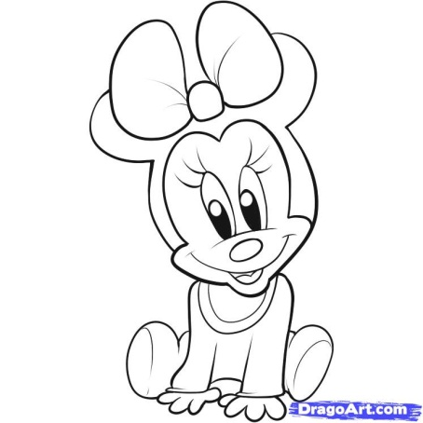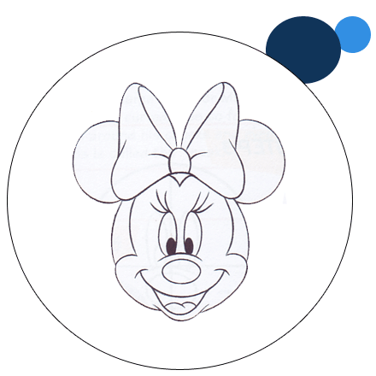

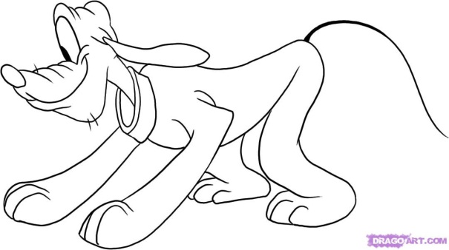
URL: http://www.dragoart.com/disney-c292-1.htm


