Harold’s Times Tables
Cheat Sheet
9 February 2025

Digit | Fill-In Tips | How to Spot | Prime Factoring Tips
1 | Copy n | Same as n | See prime numbers (2,3,5,7,11,13,17,19,23,29,31, …)
2 | Double n | If the last digit is even $\left\{0, 2, 4, 6, 8\right\}$ | Cut in half. Keep if the result is an integer.  Factors: $\left\{2, …, m\right\}$
3 | Triple n | See 9’s Rule below | Divide by ‘3’. Keep if the result is an integer.  Factors: $\left\{3, …, m\right\}$
4 | Double n twice | If the last digit is even, then a candidate | Cut in half twice. Keep if the result is an integer.  Factors: $\left\{4, …, m\right\}→\left\{2, 2, …, m\right\}$
5 | Add a trailing ‘0’ to n, then cut in half | If the last digit is a ‘0’ or ‘5’ | See 10’s Rule below if trailing ‘0’.  Divide by ‘5’ if trailing ‘5’.  Factors: $\left\{5, …, m\right\}$
6 | Triple n, then Double | 6, 12, 18, 24, 30, 36, 42, 48, 54, 60, … | Cut in half, then divide by ‘3’.  Keep if the result is an integer.  Factors: $\left\{6, …, m\right\}→\left\{2, 3, …, m\right\}$
7 | Memorize | Hardest | Divide by ‘7’ after trying all other factoring tips.  Factors: $\left\{7, …, m\right\}$
8 | Double n 3 times | If the last digit is even, then a candidate | Cut in half three times.  Keep if the result is an integer.  Factors: $\left\{8, …, m\right\}→\left\{2, 2, 2, …, m\right\}$
9 | If n ≤ 10, then  _(n-1)__(9-(n-1))_ | Digits add up to ‘9’ or multiples of ‘9’ (9m) | Add up all digits, then divide by ‘9’.  If the result is an integer, then ‘9’ is a factor.  Factors: $\left\{9, …, m\right\}→\left\{3, 3, …, m\right\}$
10 | Add a trailing ‘0’ to n | If the last digit is a ‘0’ | Drop trailing zero to get the factors $\left\{2, 5\right\}$.  Factors: $\left\{10, …, m\right\}→\left\{2, 5, …, m\right\}$
11 | If n ≤ 9, then  _n_n_ | You see double-digits | Divide by ‘11’. Keep if the result is an integer.  Factors: $\left\{11, …, m\right\}$
12 | 12 · 12 = 144 | Is even and large | Cut in half twice, then divide by ‘3’.  Keep if the result is an integer.  Factors: $\left\{12, …, m\right\}→\left\{2, 2, 3, …, m\right\}$
Mental Math
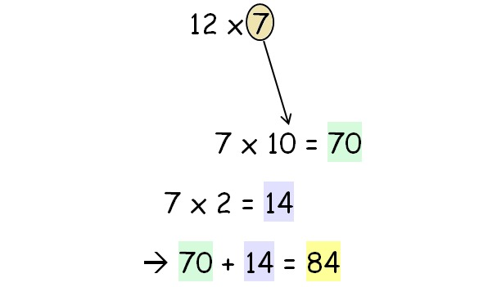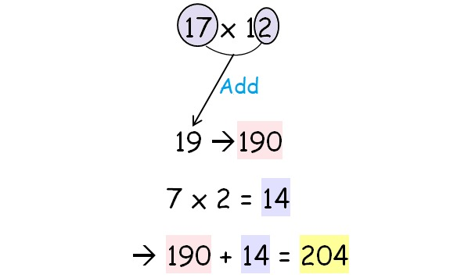

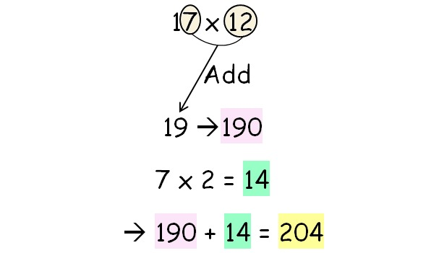
Multiplication Table – 12 ⨯ 12
⨯ | 1 | 2 | 3 | 4 | 5 | 6 | 7 | 8 | 9 | 10 | 11 | 12
1 | 1 | 2 | 3 | 4 | 5 | 6 | 7 | 8 | 9 | 10 | 11 | 12
2 | 2 | 4 | 6 | 8 | 10 | 12 | 14 | 16 | 18 | 20 | 22 | 24
3 | 3 | 6 | 9 | 12 | 15 | 18 | 21 | 24 | 27 | 30 | 33 | 36
4 | 4 | 8 | 12 | 16 | 20 | 24 | 28 | 32 | 36 | 40 | 44 | 48
5 | 5 | 10 | 15 | 20 | 25 | 30 | 35 | 40 | 45 | 50 | 55 | 60
6 | 6 | 12 | 18 | 24 | 30 | 36 | 42 | 48 | 54 | 60 | 66 | 72
7 | 7 | 14 | 21 | 28 | 35 | 42 | 49 | 56 | 63 | 70 | 77 | 84
8 | 8 | 16 | 24 | 32 | 40 | 48 | 56 | 64 | 72 | 80 | 88 | 96
9 | 9 | 18 | 27 | 36 | 45 | 54 | 63 | 72 | 81 | 90 | 99 | 108
10 | 10 | 20 | 30 | 40 | 50 | 60 | 70 | 80 | 90 | 100 | 110 | 120
11 | 11 | 22 | 33 | 44 | 55 | 66 | 77 | 88 | 99 | 110 | 121 | 132
12 | 12 | 24 | 36 | 48 | 60 | 72 | 84 | 96 | 108 | 120 | 132 | 144

Multiplication Table – 12 ⨯ 12
⨯ | 1 | 2 | 3 | 4 | 5 | 6 | 7 | 8 | 9 | 10 | 11 | 12
1
2
3
4
5
6
7
8
9
10
11
12

Multiplication Table – 25 ⨯ 25
⨯ | 1 | 2 | 3 | 4 | 5 | 6 | 7 | 8 | 9 | 10 | 11 | 12 | 13 | 14 | 15 | 16 | 17 | 18 | 19 | 20 | 21 | 22 | 23 | 24 | 25
1 | 1 | 2 | 3 | 4 | 5 | 6 | 7 | 8 | 9 | 10 | 11 | 12 | 13 | 14 | 15 | 16 | 17 | 18 | 19 | 20 | 21 | 22 | 23 | 24 | 25
2 | 2 | 4 | 6 | 8 | 10 | 12 | 14 | 16 | 18 | 20 | 22 | 24 | 26 | 28 | 30 | 32 | 34 | 36 | 38 | 40 | 42 | 44 | 46 | 48 | 50
3 | 3 | 6 | 9 | 12 | 15 | 18 | 21 | 24 | 27 | 30 | 33 | 36 | 39 | 42 | 45 | 48 | 51 | 54 | 57 | 60 | 63 | 66 | 69 | 72 | 75
4 | 4 | 8 | 12 | 16 | 20 | 24 | 28 | 32 | 36 | 40 | 44 | 48 | 52 | 56 | 60 | 64 | 68 | 72 | 76 | 80 | 84 | 88 | 92 | 96 | 100
5 | 5 | 10 | 15 | 20 | 25 | 30 | 35 | 40 | 45 | 50 | 55 | 60 | 65 | 70 | 75 | 80 | 85 | 90 | 95 | 100 | 105 | 110 | 115 | 120 | 125
6 | 6 | 12 | 18 | 24 | 30 | 36 | 42 | 48 | 54 | 60 | 66 | 72 | 78 | 84 | 90 | 96 | 102 | 108 | 114 | 120 | 126 | 132 | 138 | 144 | 150
7 | 7 | 14 | 21 | 28 | 35 | 42 | 49 | 56 | 63 | 70 | 77 | 84 | 91 | 98 | 105 | 112 | 119 | 126 | 133 | 140 | 147 | 154 | 161 | 168 | 175
8 | 8 | 16 | 24 | 32 | 40 | 48 | 56 | 64 | 72 | 80 | 88 | 96 | 104 | 112 | 120 | 128 | 136 | 144 | 152 | 160 | 168 | 176 | 184 | 192 | 200
9 | 9 | 18 | 27 | 36 | 45 | 54 | 63 | 72 | 81 | 90 | 99 | 108 | 117 | 126 | 135 | 144 | 153 | 162 | 171 | 180 | 189 | 198 | 207 | 216 | 225
10 | 10 | 20 | 30 | 40 | 50 | 60 | 70 | 80 | 90 | 100 | 110 | 120 | 130 | 140 | 150 | 160 | 170 | 180 | 190 | 200 | 210 | 220 | 230 | 240 | 250
11 | 11 | 22 | 33 | 44 | 55 | 66 | 77 | 88 | 99 | 110 | 121 | 132 | 143 | 154 | 165 | 176 | 187 | 198 | 209 | 220 | 231 | 242 | 253 | 264 | 275
12 | 12 | 24 | 36 | 48 | 60 | 72 | 84 | 96 | 108 | 120 | 132 | 144 | 156 | 168 | 180 | 192 | 204 | 216 | 228 | 240 | 252 | 264 | 276 | 288 | 300
13 | 13 | 26 | 39 | 52 | 65 | 78 | 91 | 104 | 117 | 130 | 143 | 156 | 169 | 182 | 195 | 208 | 221 | 234 | 247 | 260 | 273 | 286 | 299 | 312 | 325
14 | 14 | 28 | 42 | 56 | 70 | 84 | 98 | 112 | 126 | 140 | 154 | 168 | 182 | 196 | 210 | 224 | 238 | 252 | 266 | 280 | 294 | 308 | 322 | 336 | 350
15 | 15 | 30 | 45 | 60 | 75 | 90 | 105 | 120 | 135 | 150 | 165 | 180 | 195 | 210 | 225 | 240 | 255 | 270 | 285 | 300 | 315 | 330 | 345 | 360 | 375
16 | 16 | 32 | 48 | 64 | 80 | 96 | 112 | 128 | 144 | 160 | 176 | 192 | 208 | 224 | 240 | 256 | 272 | 288 | 304 | 320 | 336 | 352 | 368 | 384 | 400
17 | 17 | 34 | 51 | 68 | 85 | 102 | 119 | 136 | 153 | 170 | 187 | 204 | 221 | 238 | 255 | 272 | 289 | 306 | 323 | 340 | 357 | 374 | 391 | 408 | 425
18 | 18 | 36 | 54 | 72 | 90 | 108 | 126 | 144 | 162 | 180 | 198 | 216 | 234 | 252 | 270 | 288 | 306 | 324 | 342 | 360 | 378 | 396 | 414 | 432 | 450
19 | 19 | 38 | 57 | 76 | 95 | 114 | 133 | 152 | 171 | 190 | 209 | 228 | 247 | 266 | 285 | 304 | 323 | 342 | 361 | 380 | 399 | 418 | 437 | 456 | 475
20 | 20 | 40 | 60 | 80 | 100 | 120 | 140 | 160 | 180 | 200 | 220 | 240 | 260 | 280 | 300 | 320 | 340 | 360 | 380 | 400 | 420 | 440 | 460 | 480 | 500
21 | 21 | 42 | 63 | 84 | 105 | 126 | 147 | 168 | 189 | 210 | 231 | 252 | 273 | 294 | 315 | 336 | 357 | 378 | 399 | 420 | 441 | 462 | 483 | 504 | 525
22 | 22 | 44 | 66 | 88 | 110 | 132 | 154 | 176 | 198 | 220 | 242 | 264 | 286 | 308 | 330 | 352 | 374 | 396 | 418 | 440 | 462 | 484 | 506 | 528 | 550
23 | 23 | 46 | 69 | 92 | 115 | 138 | 161 | 184 | 207 | 230 | 253 | 276 | 299 | 322 | 345 | 368 | 391 | 414 | 437 | 460 | 483 | 506 | 529 | 552 | 575
24 | 24 | 48 | 72 | 96 | 120 | 144 | 168 | 192 | 216 | 240 | 264 | 288 | 312 | 336 | 360 | 384 | 408 | 432 | 456 | 480 | 504 | 528 | 552 | 576 | 600
25 | 25 | 50 | 75 | 100 | 125 | 150 | 175 | 200 | 225 | 250 | 275 | 300 | 325 | 350 | 375 | 400 | 425 | 450 | 475 | 500 | 525 | 550 | 575 | 600 | 625

Multiplication Table – 25 ⨯ 25
⨯ | 1 | 2 | 3 | 4 | 5 | 6 | 7 | 8 | 9 | 10 | 11 | 12 | 13 | 14 | 15 | 16 | 17 | 18 | 19 | 20 | 21 | 22 | 23 | 24 | 25
1
2
3
4
5
6
7
8
9
10
11
12
13
14
15
16
17
18
19
20
21
22
23
24
25

