Harold’s Triangles Cheat Sheet
21 January 2026

Trig Laws and Formulas

Law | Equation
Reference Triangle | 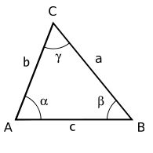
Law of Sines | $$\frac{sin(A)}{a}=\frac{sin(B)}{b}=\frac{sin(C)}{c}$$ | $$\frac{a}{sin(A)}=\frac{b}{sin(B)}=\frac{c}{sin(C)}$$
Law of Cosines | $$a^{2}=b^{2}+c^{2}-2bc∙cos\left(A\right)$$  $$b^{2}=a^{2}+c^{2}-2ac∙cos\left(B\right)$$  $$c^{2}=a^{2}+b^{2}-2ab∙cos\left(C\right)$$
Law of Tangents | $$\frac{a-b}{a+b}=\frac{tan\left[\frac{\left(A-B\right)}{2}\right]}{tan\left[\frac{\left(A+B\right)}{2}\right]}$$  $$\frac{b-c}{b+c}=\frac{tan\left[\frac{\left(B-C\right)}{2}\right]}{tan\left[\frac{\left(B+C\right)}{2}\right]}$$  $$\frac{a-c}{a+c}=\frac{tan\left[\frac{\left(A-C\right)}{2}\right]}{tan\left[\frac{\left(A+C\right)}{2}\right]}$$  $$tan(A)∙tan(B)∙tan(C)=tan(A)+tan(B)+tan(C)$$
Law of Cotangents | $$\frac{cot\left(\frac{A}{2}\right)}{s-a}=\frac{cot\left(\frac{B}{2}\right)}{s-b}=\frac{cot\left(\frac{C}{2}\right)}{s-c}$$  $$cot(A)∙cot(B)∙cot(C)=cot(A)+cot(B)+cot(C)$$
Pythagorean Theorem | If a right triangle, then  $$c^{2}=a^{2}+b^{2}$$  Special Case: Same as Law of Cosines with angle C = 90°.  $$c^{2}=a^{2}+b^{2}-2ab∙cos\left(90°\right)$$  $$c^{2}=a^{2}+b^{2} -2ab∙0=a^{2}+b^{2}$$
Sum of Angles | $$A°+B°+C°=180°$$  $$C°=180°-(A°+B°)$$ | $A+B+C=π$ radians  $$C=π-(A+B)$$
Area Formula | $$A=\frac{1}{2}bh=\frac{1}{2}ab∙sin(C)$$ | 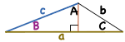
Semi-Perimeter | $$s=\frac{a+b+c}{2}$$
Heron’s Formula | $$A=\sqrt{s(s-a)(s-b)(s-c)}$$
Mollweide’s Formula | $$\frac{a+b}{c}=\frac{cos\left[\frac{\left(A-B\right)}{2}\right]}{sin\left(\frac{C}{2}\right)}$$

Solving for Angles, Sides, and Area

Order of Use | Comments
1. Sum of Angles | Easiest formula.
2. Pythagorean Theorem | Use if one of the angles is a right angle (90°).
3. Law of Sines | Least complex. Use before Law of Cosines, if possible.
4. Law of Cosines | More complex. Use only once, then use Law of Sines.
5. Heron’s Formula | Use for area if all three sides are known.
6. Law of Tangents | Very complex and seldom used.
7. Law of Cotangents | Most complex and seldom used.

Given | Find
Given | Angle | Side | Area
SSS | Law of Cosines | Given | Heron’s Formula
SAS | NA | Law of Cosines | $$A=\frac{1}{2}ab∙sin(C)$$
SSA | Law of Sines | NA | $$A=\frac{1}{2}bh$$
ASS | Law of Sines | NA | $$A=\frac{1}{2}bh$$
SAA | Sum of Angles | Law of Sines | $$A=\frac{1}{2}bh$$
ASA | Sum of Angles | Law of Sines | $$A=\frac{1}{2}bh$$
AAS | Sum of Angles | Law of Sines | $$A=\frac{1}{2}bh$$
AAA | Given | Unsolvable. Not unique. One side needed.
Ambiguous Cases for SSA

Scenario | # of Solutions | Illustrations
SSA | 0 – 2 Solutions | 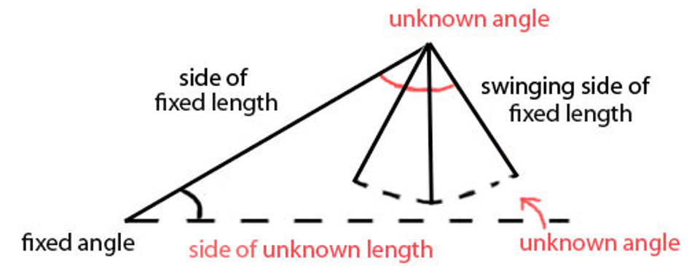  $$h=a\sin{θ}$$
$$b<h$$ | No Solution | 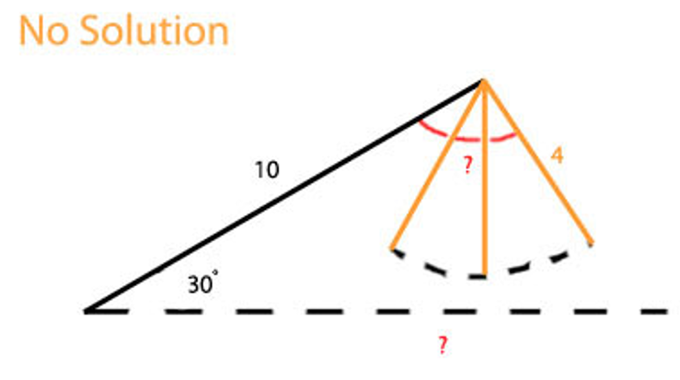
$$b=h$$ | One Solution | 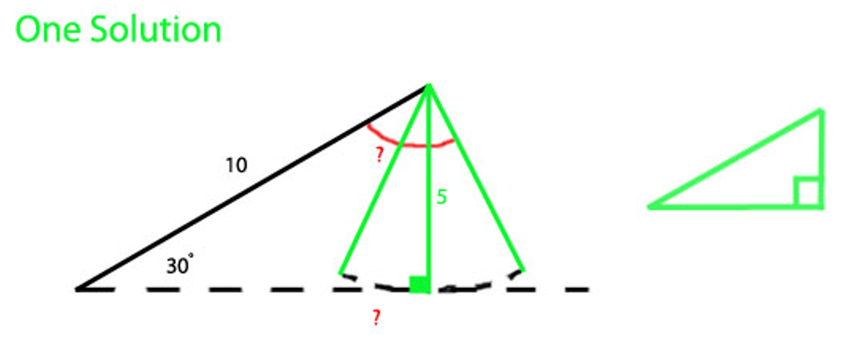
$$b>h$$ | Two Solutions | 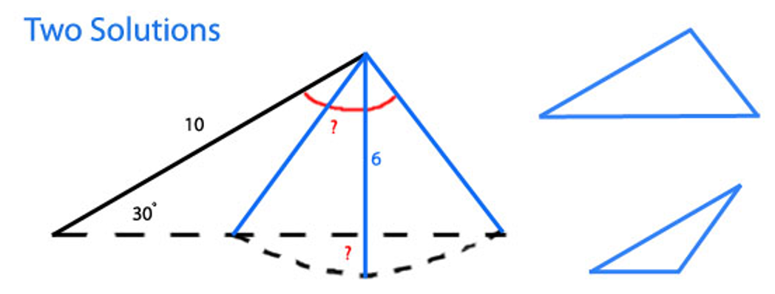
$$b>h$$ | Two Solutions | $$\frac{b}{sin (B)}= \frac{b}{sin (180°-B)}$$ | 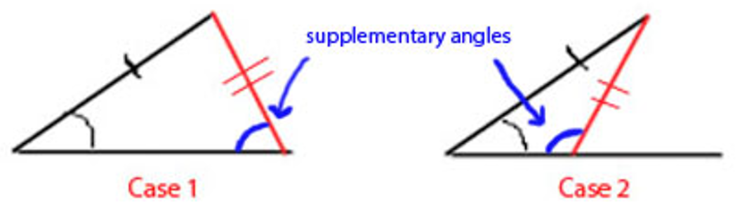
a ≥ b | One Oblique Solution | 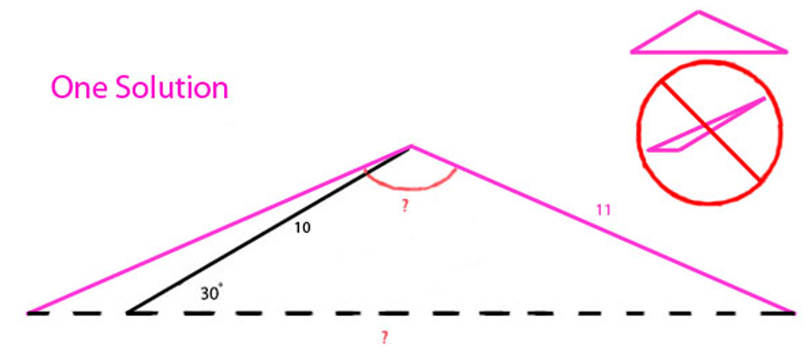
a ≥ b | One Oblique Solution | When a = b, equilateral / isososocles  When a > b, obtuse

Interesting Trig Lengths on a Unit Circle
Trig Graphically
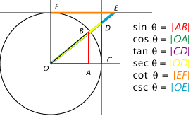 | 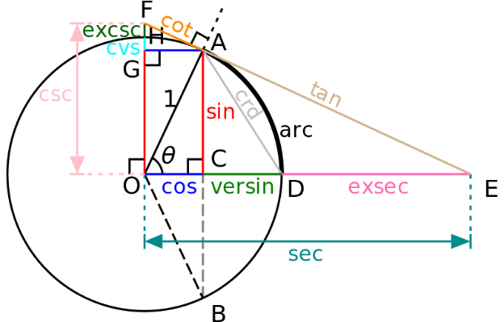

Radians and Arc Length
Radian = arc length (s) of a unit circle  s = r $\text{θ}$  C = $π$ D = $π$ (2r) = 2$π$r  Proof:  If r = 1 (unit circle)  then s = $(1)\text{θ = θ}$ and C = $2π \left(1\right)=2π$  Therefore, 360° = 2$π$ radians  To convert degrees to radians:  n° x $\left(\frac{π rad}{180°}\right)$ = m radians  To convert radians to degrees:  m rad x $\left(\frac{180°}{π rad}\right)$ = n° | 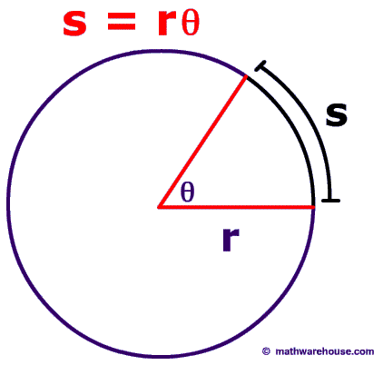

Sources
- SAS Triangle images. https://mathimages.swarthmore.edu/index.php/Ambiguous_Case

Fixed Angles Triangles
45-45-90 Triangle | 30-60-90 Triangle
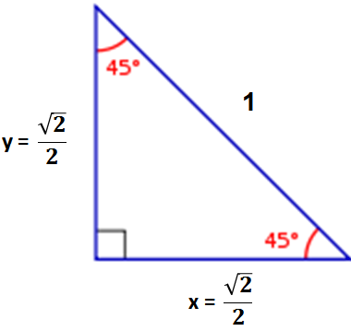 | 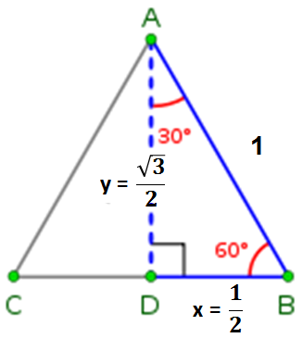
Proof:  a² + b² = c²  x = y  x² + x² = 1²  2x² = 1  x² = ½  $$\sqrt{x^{2}}= \sqrt{\frac{1}{2}}$$  $$x= \frac{\sqrt{2}}{2}$$ | Proof:  a² + b² = c²  x = ½c  y² + (½)² = 1²  y² + ¼ = 1  y² = ¾  $$\sqrt{y^{2}}= \sqrt{\frac{3}{4}}$$  $$y= \frac{\sqrt{3}}{2}$$

Fixed Sided Triangles
Pythagorean Triples
A Pythagorean triple is a right triangle with only integer sides.  The examples on the right are expressed in the lowest form.  You can scale any of these with an integer (e.g., 2,3,4,5) to generate a family of similar triangles.  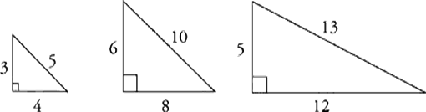 | 3 : 4 : 5  5 : 12 : 13  7 : 24 : 25  8 : 15 : 17  9 : 40 : 41  11 : 60 : 61  12 : 35 : 37  13 : 84 : 85  15 : 112 : 113  16 : 63 : 65  17 : 144 : 145  19 : 180 : 181  20 : 21 : 29  20 : 99 : 101  21 : 220 : 221  23 : 264 : 265 | 24 : 143 : 145  28 : 45 : 53  28 : 195 : 197  32 : 255 : 257  33 : 56 : 65  36 : 77 : 85  39 : 80 : 89  44 : 117 : 125  48 : 55 : 73  51 : 140 : 149  52 : 165 : 173  57 : 176 : 185  60 : 91 : 109  60 : 221 : 229  65 : 72 : 97  68 : 285 : 293 | 69 : 260 : 269  84 : 187 : 205  85 : 132 : 157  88 : 105 : 137  95 : 168 : 193  96 : 247 : 265  104 : 153 : 185  105 : 208 : 233  115 : 252 : 277  119 : 120 : 169  120 : 209 : 241  133 : 156 : 205  140 : 171 : 221  160 : 231 : 281  161 : 240 : 289  204 : 253 : 325

