Harold’s Trigonometry
Cheat Sheet
29 April 2025

Unit Circle |  |  | Trig Chart
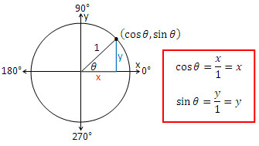 |  |  | (Quadrant I only)
  Degrees | 0° | 30° | 45° | 60° | 90°
  Radians | 0 | $π$/6 | $π$/4 | $π$/3 | $π$/2
  $\text{Sin (θ)}$ | $$0$$ | $$\frac{1}{2}$$ | $$\frac{\sqrt{2}}{2}$$ | $$\frac{\sqrt{3}}{2}$$ | $$1$$
  $\text{Cos (θ)}$ | $$1$$ | $$\frac{\sqrt{3}}{2}$$ | $$\frac{\sqrt{2}}{2}$$ | $$\frac{1}{2}$$ | $$0$$
  $\text{Sin (θ)}$ Pattern | $$\frac{\sqrt{0}}{2}$$ | $$\frac{\sqrt{1}}{2}$$ | $$\frac{\sqrt{2}}{2}$$ | $$\frac{\sqrt{3}}{2}$$ | $$\frac{\sqrt{4}}{2}$$
  Tan$\text{ (θ)}$ Pattern | $$0$$ | $$\frac{{(\sqrt{3})}^{1}}{3}$$ | $$\frac{{(\sqrt{3)}}^{2}}{3}$$ | $$\frac{{(\sqrt{3})}^{3}}{3}$$ | Und
Graphical Representation Of The Six Trig Functions
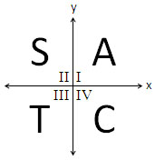
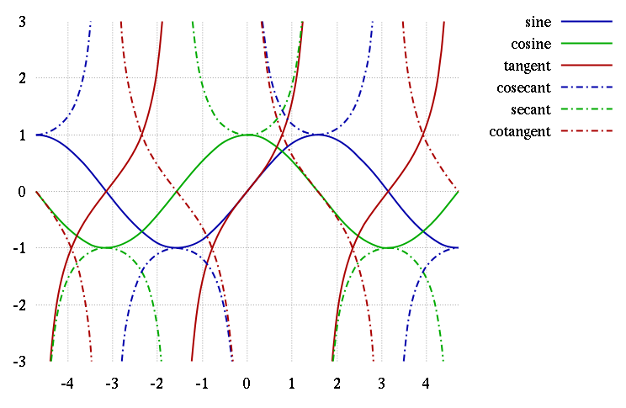
π
$-$π
$$\frac{3π}{2}$$
$$\frac{-3π}{2}$$
$$\frac{-π}{2}$$
$$\frac{π}{2}$$
$$\frac{π}{2}$$
“All Students Take Calculus”

The Six Trig “Levers” | y = a sin (b (x - h)) + k | Graphing Tips |  | Notes
- Move up/down ↕ | k (Vertical translation) | $$k= \frac{(max + min)}{2}$$ |  | If k = f(x) then x-axis is replaced by f(x)-axis
- Move left/right ↔ | h (Phase shift) | ‘+‘ shifts right |  | $$\sin{(x)}=\cos{(x-π/2)}$$
- Stretch up/down ↕ | a (Amplitude) | $$a= \frac{(max – min)}{2}$$ |  | a is NOT peak-to-peak on the y-axis
- Stretch left/right ↔ | b (Frequency $⦁$ 2$π$) | $$T=\frac{2π}{\left|b\right|}= \frac{1}{ƒ}$$ |  | T = peak-to-peak on the $θ$-axis  $T=\frac{π}{|b|}$ for $tan (bx)$ and $cot (bx)$
- Flip about y-axis | b → –b | f(x) → f(-x) |  | Even Function: $\cos{(x)}=\cos{(-x)}$
- Flip about x-axis | a → –a | f(x) → –f(x) |  | Odd Function: $\sin{(x)}=-sin{(-x)}$

Unit Circle
$$(x, y) = (cos θ, sin θ)$$ | $$π rad={180}^{⁰}$$

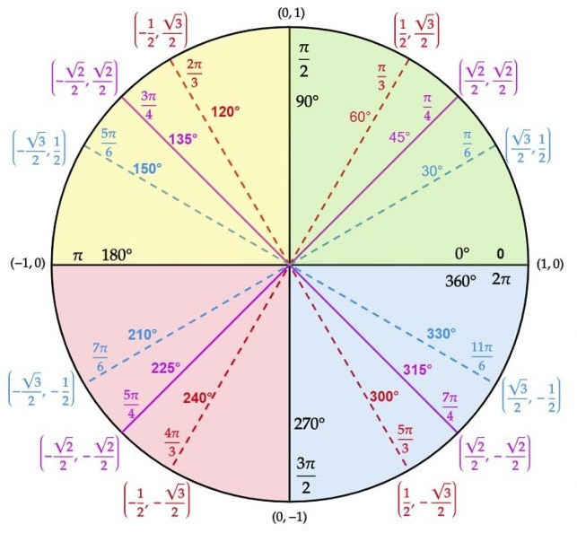

Source: Unit Circle Quick Lesson - Matter of Math
https://matterofmath.com/trigonometry/unit-circle/

